How To Change Notifications on Showbie

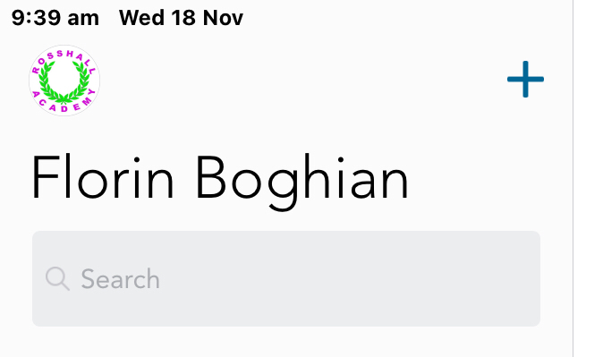
Click on the icon to the left of your name

Click on Notification Preferences

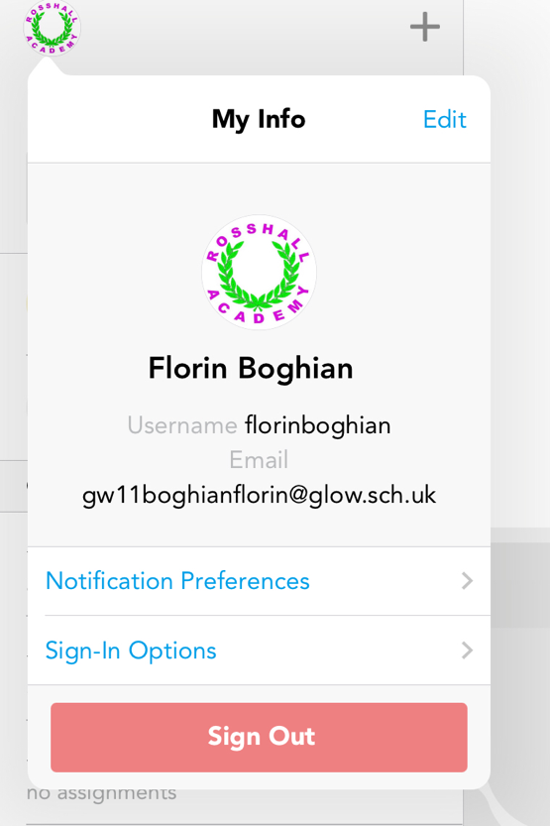

Select which notifications you want to change

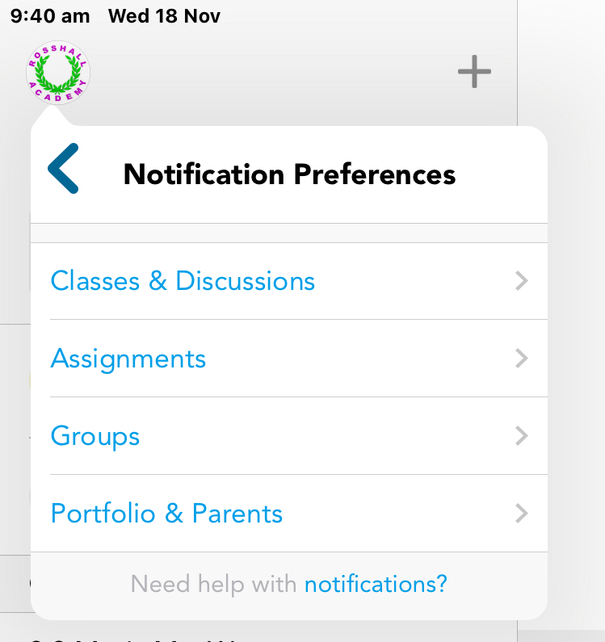

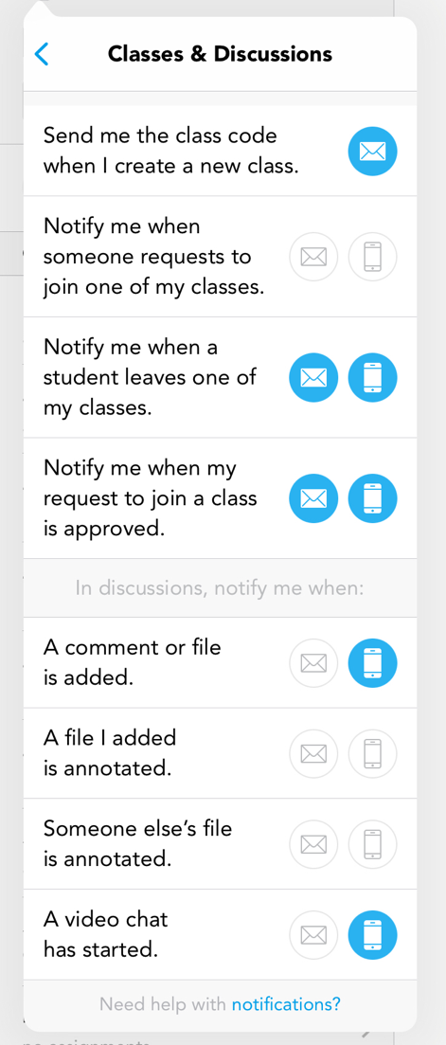
Use the icons to decide when/how you will get these notifications.

