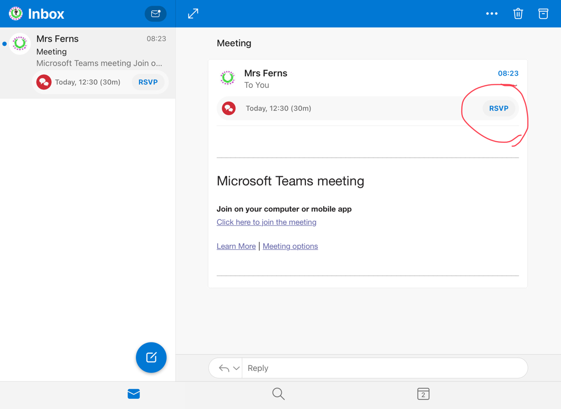**How to join a Teams Meeting**

1. 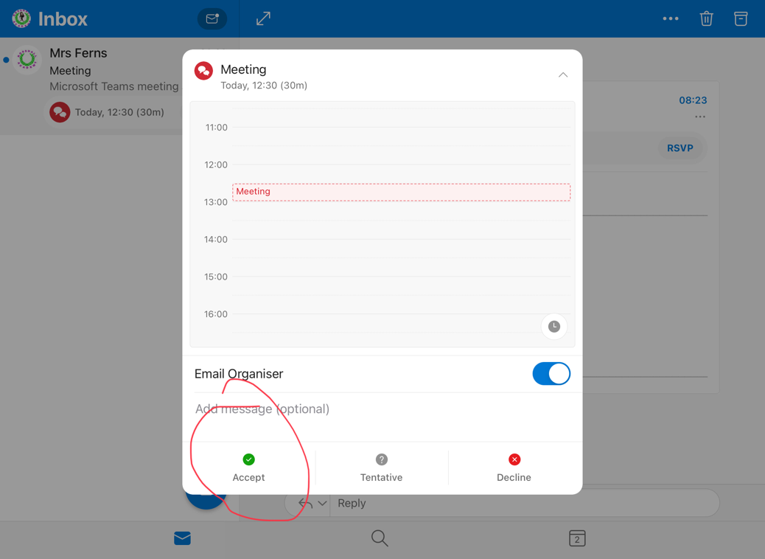**Open up the email invitation in your Outlook app**
2. **Accept the invitation**



1. **Open up the Teams app**
2. **Go to Calendar at the right time**

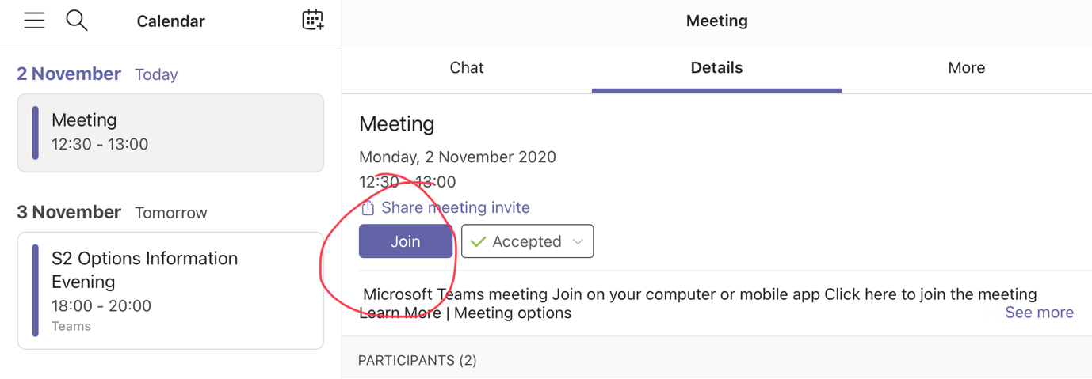

1. 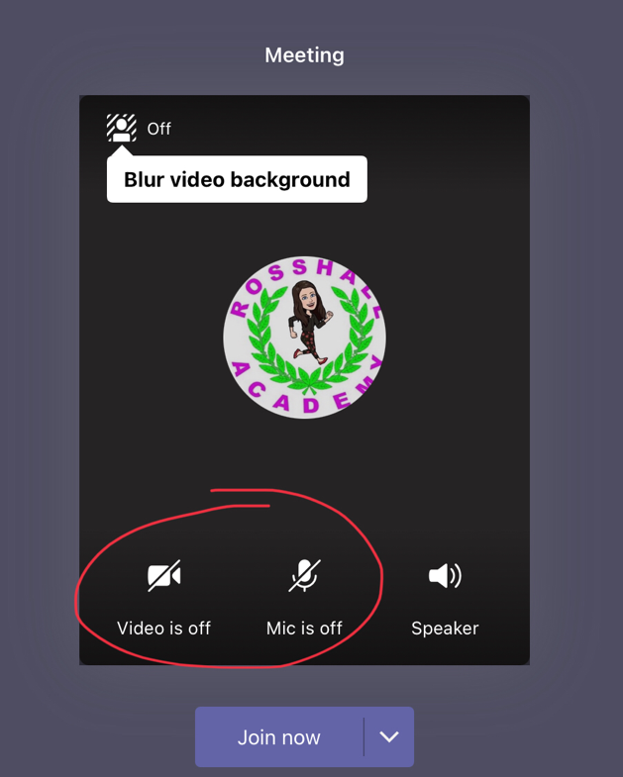**Click join now**
2. **Make sure your microphone and camera are off**