**How to Set Up Outlook and Teams**

**Outlook:**

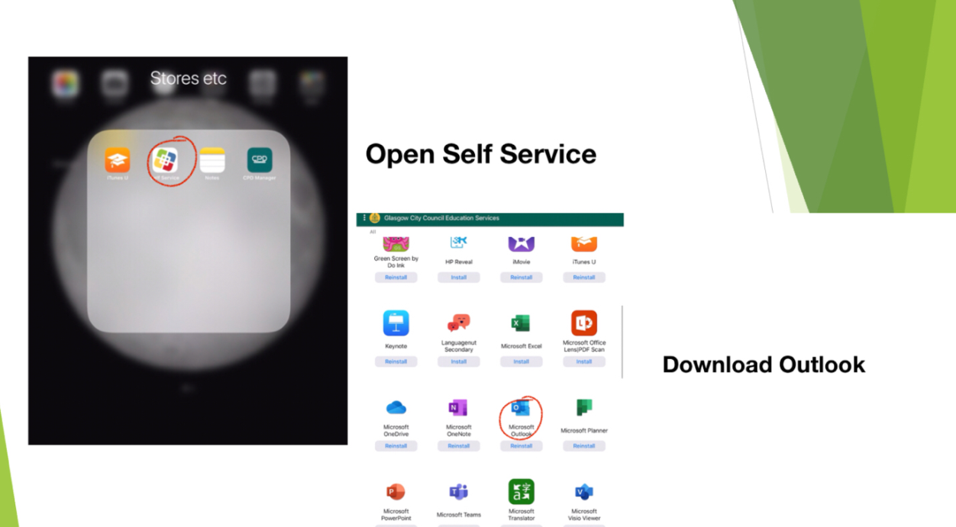

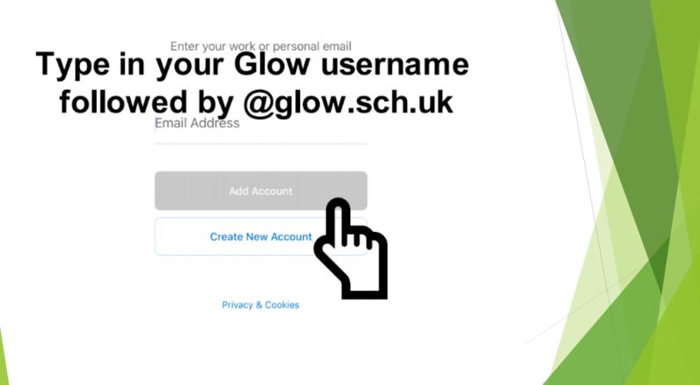

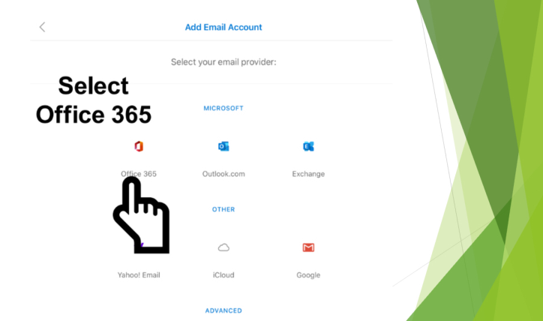

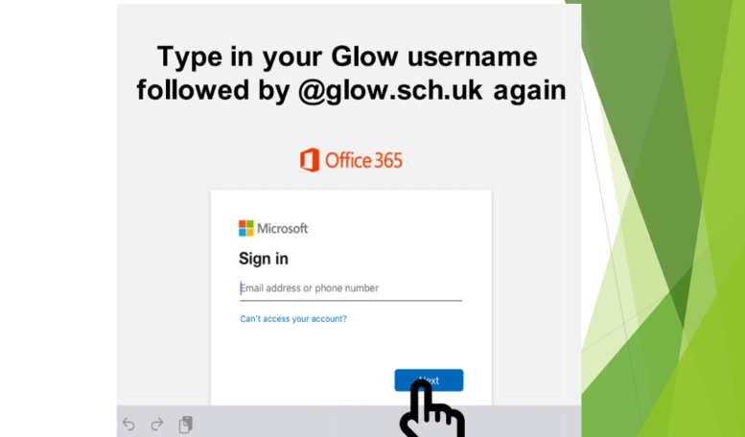

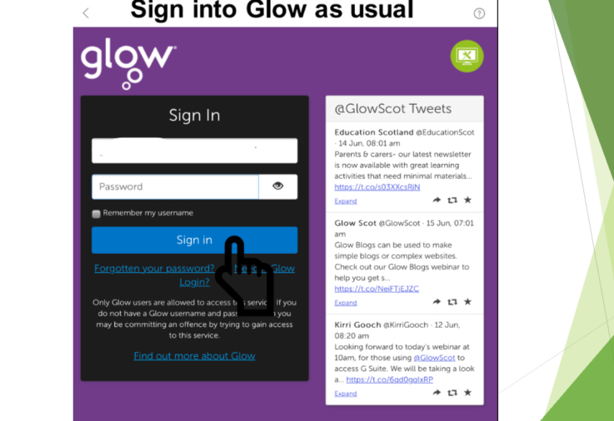

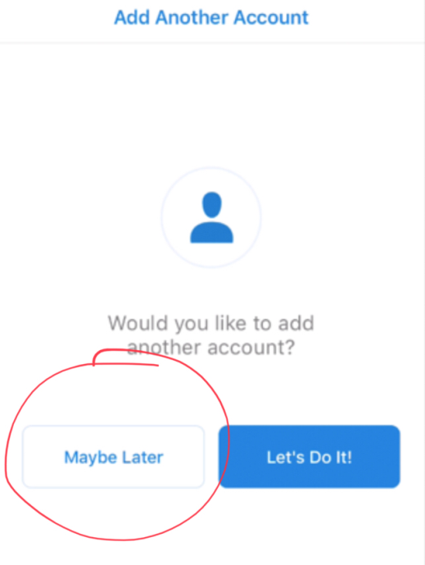

**Teams: Once you have fully set up Outlook, Teams is a very quick process!**

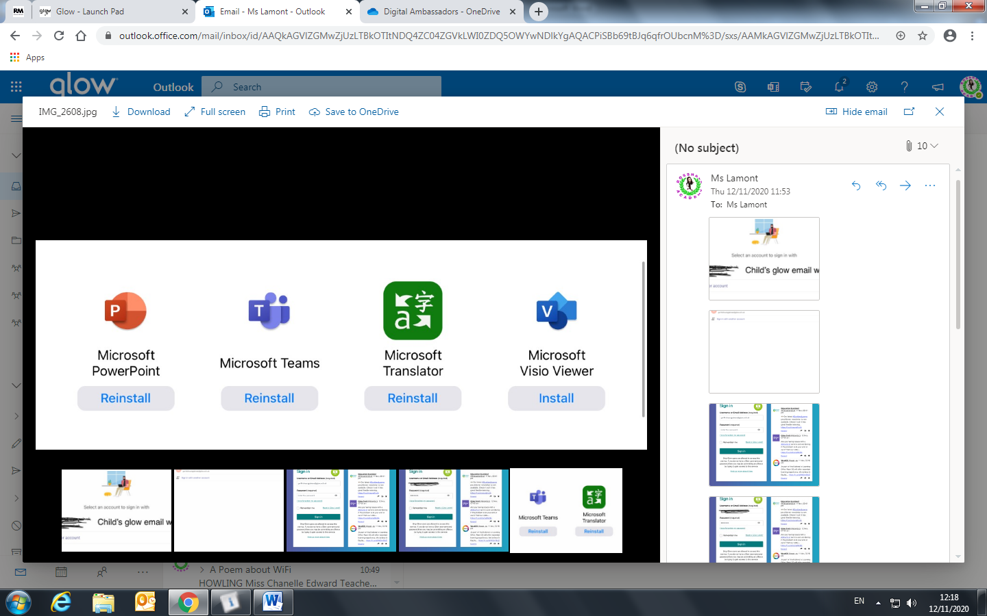

Download Teams from Self Service

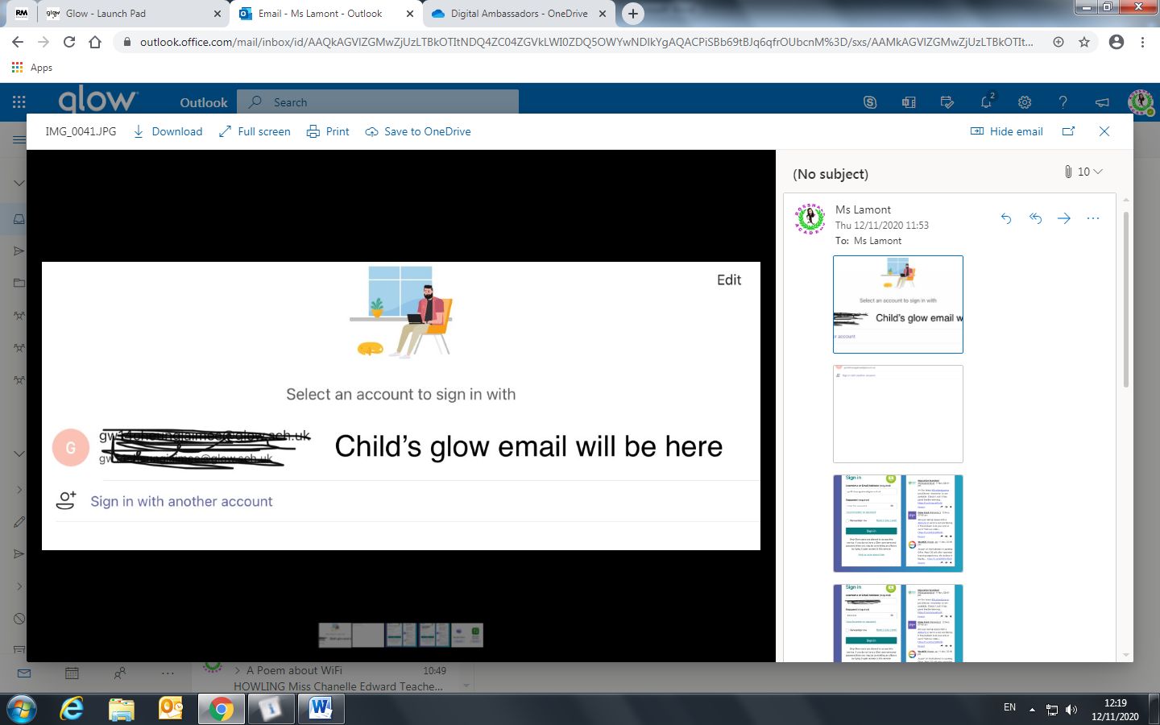

You will see your/your child’s email here. Click on it to proceed. This should take you through 3 skippable pages then be fully set up! Or…

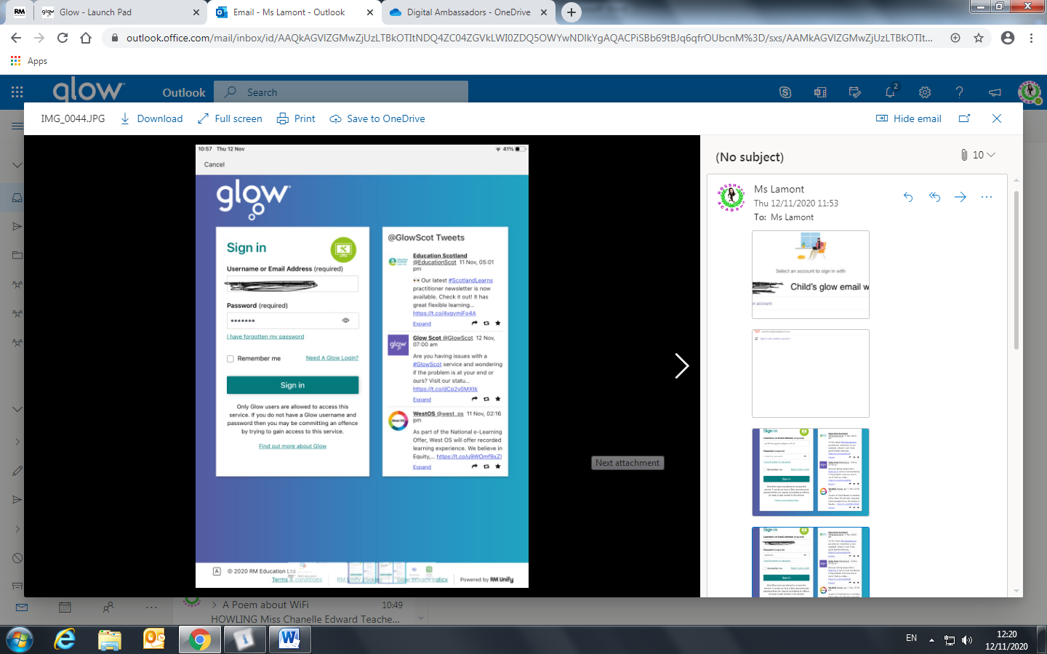

You may see the Glow page. Sign in with the child’s Glow as normal, then skip through the 3 skippable pages and you are good to go!