Primary 4
Newsletter Term 1

Dear Parent / Guardian
Welcome back to Fernielea School! My name is Miss Bain and I am the class teacher for P4. Our Pupil Support Assistant for this year is Mrs Rhodie. We are very much looking forward to working with you and your child this year.

Numeracy and Maths
This term, we will be focusing on measurement, estimation and rounding in Maths. We will also be developing mental math strategies to improve speed recall. (Learn Its for P4 found on the school website)
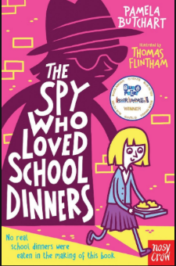
Literacy
This term our class novel is ‘The Spy Who Loved School Dinners’ by Pamela Butchart. We will be completing reading activities linked to this book. In Writing, we will be focusing on diaries and recounts. We will also be working to improve the level of connectives, openers and punctuation pupils can use in their pieces of writing.

Health and Wellbeing
This term we will be expanding our emotional vocabulary and having a better understanding of these emotions. We will look at how different emotions can make us feel and what can trigger them. We will also be working on developing resilience and the ability to bounce back. Health and hygiene will also be a big focus this term as pupils adjust to being back in the school building.
Homework
When homework starts it will be through google classroom. Please support your child to log in independently as they will need to do this when we use electronic devices in school.
P.E.
Currently pupils are unable to access changing rooms at school so are required to wear P.E. kit to school on P.E. days. P4 has P.E. every Thursday. This alternates between P.E. with me and P.E. with Mrs Webster our P.E. specialist. P.E. will be happening outdoors so it is important that your child brings a waterproof jacket with them.
Clothing and Personal Belongings
All items of clothing, packed lunches and water bottles should be clearly labelled with your child’s name. This is to ensure that personal belongings are not mixed up. Each pupil has been given their own stationery pack in school so there is no need to bring pencil cases in from home.
Twitter
If you have twitter please follow https://twitter.com/bainmiss for updates and to see what we are learning about and doing in P4.

Kind regards,
Miss Bain

