

Promoting
Equality and Diversity
Policy



Noss Primary School

Contents
Policy Statement | 3
Background and Legislation | 3-4
Key Principles | 4-5
Curriculum for Excellence; The Four Contexts of Learning | 5-6
Embedding equality and diversity in the Curriculum | 6
Leadership, roles and responsibilities for equality and diversity | 6-7
Monitoring, quality assurance, training and review | 7
Appendices:  - Nos Primary’s Equalities and Diversity Framework  - Examples of how schools can promote equality and diversity  - Reflective questions  - Resources  - Highland Council Steer: Developing an Equalities and Diversity Policy  - Checklist | 8  9  10  11  12  13
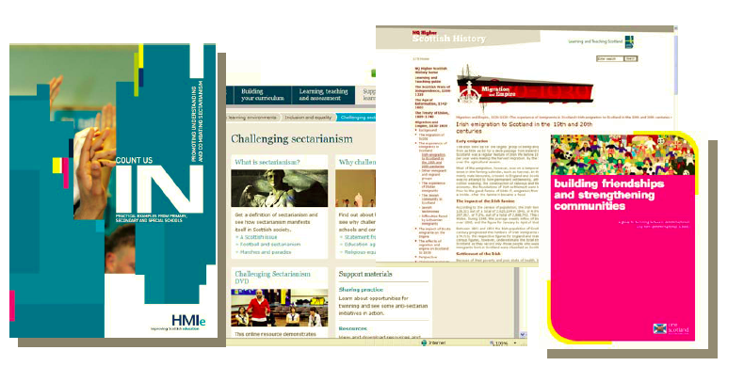
Promoting Equality and Diversity
Policy statement
Our children and young people live in a diverse society in 21st century Scotland. Noss Primary School is committed to creating an environment for the whole school community that demonstrates shared values of inclusion, equality, fairness and respect.
Our school recognises and celebrates difference within a culture of respect and fairness, and aims to meet the needs of every child in line with the principles of Getting it Right for Every Child (GIRFEC).
We work together with our children and young people, families and staff to ensure that inclusion and equality are part of all our activities. Our policy aims to:
- Promote positive attitudes and behaviours towards equality and diversity
- Promote understanding of equality and diversity through the school curriculum and ethos
- Help the school to meet these aims and fulfil our legal obligations
We are committed to meeting the statutory duties of the Equality Act 2010 and this policy includes information about how we will comply with our duties and also provides guidance about our approach to promoting equality and diversity.
We recognise that these duties also reflect international human rights standards as expressed in the UN Convention on the Rights of the Child, the UN Convention on the Rights of People with Disabilities, and the Human Rights Act 1998.
We also have equality commitments to our staff under the Highland Council HR policies.
This policy will be reviewed every 3 years.
Background and Legislation
This policy has been written as part of our school’s on-going commitment to demonstrating good practice, advancing equality and valuing diversity. This reflects the commitment of the Highland Council and its role as an Education Authority.
Equality and Diversity
- Equality is about creating a fairer society, where everyone can take part and where everyone has the opportunity to be all they can be. Equality of opportunity has a legal framework to ensure protected groups are not discriminated against.
- Diversity is about recognising and valuing difference, where everyone is respected for who they are.
Equality Act 2010 and schools

The Equality Act 2010 (the Act) replaces previous separate equality legislation in Britain with a single, harmonised Act. The Act provides a modern and accessible framework of discrimination law which protects individuals from unfair treatment and promotes a fair and more equal society.

The Act protects people from discrimination on the basis of the following protected characteristics:
- age*
- disability
- gender reassignment
- marriage and civil partnership*
- pregnancy and maternity
- race
- religion or belief;
- sex
- sexual orientation.

*Age and marriage and civil partnership are not protected characteristics for the schools provision. However, in general, the Act applies across all the protected characteristics in a consistent way.

The Act, and the principle of non-discrimination, covers all the activities in the life of a school including:
- Admissions
- Provision of education
- Access to any benefit, facility or service
- Exclusions
- It is also unlawful to harass or victimise a pupil or applicant

The Act also introduces a single Public Sector Equality Duty (the general duty). As a school this means we have to give “due regard” to the 3 elements of the duty in all our activities:
- Eliminate discrimination, harassment and victimisation;
- Advance equality of opportunity between people who share a protected characteristic and those who do not; and
- Foster good relations between those who share a protected characteristic and those who do not.

In Scotland, the general duty is supported by a set of specific duties on schools and public bodies to help them secure positive outcomes in line with the equality legislation.

Related legislation and Rights of the Child:

Additional Support Needs: Schools are expected to make reasonable adjustments under the Act to provide auxiliary aids and services for disabled pupils under the Act. Provision for pupils requiring additional support in schools is covered by:
- The additional support for learning (ASL) framework (Education (Additional Support for Learning) (Scotland) Act, 2004 and 2009);
- Accessibility strategies (The Education (Disability Strategies and Pupils’ Educational Records) (Scotland) Act 2002)

Children’s Rights
- Human Rights Act 1998
- United Nation's Convention on the Rights of the Child (UNCRC) was ratified by the UK in 1991. It aims to recognise the rights of all children up to age 18 and ensure that children grow up in the spirit of peace, dignity, tolerance, freedom, equality and solidarity.
- Children and Young People’s (Scotland) Bill was agreed in February 2014. It introduces new duties for Ministers and public sector to promote children’s rights.

Equality and Diversity Policy: key principles

We work in partnership with other services, agencies and families to deliver integrated services for children, families and young people. Our Integrated Children’s Plan, ‘For Highland’s Children’, uses the principles of GIFREC (Getting It Right for Every Child) which sets out our commitment to improve and develop services against the key SHANARRI themes (Safe, Healthy, Achieving, Nurtured, Active, Respected, Responsible and Included), to achieve:

- Enhanced support to children and families, when they need it
- Improved services and improving outcomes for Highland’s children
Our approach to equality and diversity is based on the following key principles:

1. All learners are of equal value irrespective of their race; gender and gender identity; religious or belief; or sexual orientation. However, this does not mean we treat everyone the same, sometimes it means giving people extra help so that they have the same opportunities and outcomes as others.

2. We recognise, respect and value difference and understand that diversity is a strength. We take account of differences and strive to remove barriers and disadvantages which people may face, in relation to disability, ethnicity, gender, religion, belief or faith and sexual orientation. We believe that diversity is a strength, which should be respected and celebrated by all those who learn, teach and visit here.

3. We foster positive attitudes and relationships. We actively promote positive attitudes and mutual respect between groups and communities different from each other.

4. We foster a shared sense of inclusion and belonging. We want all members of our school community to feel a sense of belonging within the school and wider community and to feel that they are respected and able to participate fully in school life.

5. We observe good equalities practice for our staff. We ensure that policies and procedures benefit all employees and potential employees in all aspects of their work, including in recruitment and promotion, and in continuing professional development.

6. We have the highest expectations of all our children. We expect that all pupils can make good progress and achieve/attain to their highest potential.

7. We work to raise standards for all pupils, but especially for the most vulnerable. We believe that improving the quality of education for the most vulnerable groups of pupils raises standards across the whole school.

8. Challenging prejudice and stereotyping
We tackle negative prejudice and stereotyping. We challenge and report all incidents of prejudice based bullying, for example racist, homophobic or bullying of people because of a disability. We will also challenge gender-based and other stereotypes.

Curriculum for Excellence: the “four contexts for learning”
This Policy celebrates and recognises the work that our school is undertaking to promote diversity and equality through all aspects of planned learning, which is an important aspiration of Curriculum for Excellence. Our school aims to meet the challenge to develop children and young people as responsible citizens who:

- show respect for others; who understand different beliefs and cultures;
- are developing informed, ethical views of complex issues;
- know why discrimination is unacceptable and how to challenge it; and
- understand the importance of celebrating diversity and promoting equality.

Building the Curriculum 3 defines the curriculum as “the totality of all that is planned for children and young people throughout their education”, including:
- ethos and life of the school as a community;
- curriculum areas and subjects;
- interdisciplinary learning (IDL);
- opportunities for personal achievement.
We promote learning within a positive ethos and climate of respect and trust based upon shared values across the school community:

- including parents, whether for young people in school or those not in school;
- All members of staff contribute through open, positive, supportive relationships where children and young people will feel that they are listened to;
- promoting a climate in which children and young people feel safe and secure;
- modelling behaviour which promotes effective learning and wellbeing within the school community;
- being sensitive and responsive to each young person’s wellbeing.

Our young people are encouraged to contribute to the life and work of the school and, from the earliest stages, to exercise their responsibilities as members of a community. This includes opportunities to participate responsibly in decision-making, to contribute as leaders and role models, offer support and service to others and play an active part in putting the values of the school community into practice.

Embedding Equalities and Diversity in the Curriculum

Curriculum areas and subjects
We promote learning which children and young people should experience through their broad general education and the Senior Phase. These experiences and outcomes are organised into eight curriculum areas. We encourage the curriculum to be organised and planned in creative ways which encourage deep, sustained learning and which meet the needs of their children and young people.

Interdisciplinary learning IDL

We encourage effective IDL to take the form of individual one-off projects or longer programmes of study which:
- is planned around clear purposes;
- is based upon experiences and outcomes drawn from different curriculum areas or subjects within them;
- ensures progression in skills and in knowledge and understanding;
- provide opportunities for mixed stage learning which is interest-based.

To deepen understanding we aim for our curriculum to include space for learning beyond subject boundaries, so that children and young people can make connections between different areas of learning. Interdisciplinary studies, based upon groupings of “experiences and outcomes” from within and across curriculum areas, can provide relevant, challenging and enjoyable learning experiences and stimulating contexts to meet the varied needs of children and young people.

Leadership, roles and responsibilities for equality and diversity
The Head Teacher will ensure that:
- The policy is fully implemented and promoted, making certain that all staff are aware of their responsibilities and are given appropriate training and support.
- Appropriate action is taken in any cases of unlawful discrimination.
- All prejudice-based bullying incidents are recorded and that appropriate action is taken.
- Take a lead role in the school’s self-evaluation procedures and staff development for equality and diversity
- Information is collected and monitored on attainment, attendance and exclusion in terms of equality.
- The Council’s recruitment and selection policies are adhered to.
- Independent contractors, volunteers and visitors to the school are aware of this policy.

The Equality and Diversity Co-ordinator will:
- Develop and maintain up to date knowledge of equality law and best practice
- Co-ordinate the implementation of the equality and diversity policy
- Take a lead role in communicating the policy to other staff and monitoring outcomes
- Review and disseminate enrolment data
- Take a lead role in addressing prejudice–based bullying incidents including the recording and investigation.

All Staff will:
- Maintain the highest expectations of achievement for all pupils
- Promote an ethos in the classroom that values equality, inclusion and diversity
- Challenge prejudice and discriminatory behaviour
- Deal fairly and professionally with any prejudice-based bullying incidents
- Plan lessons that reflect the school commitments to equality and diversity
- Keep up to date with the law on equality and any changes to policy.

The Parent Council will:
- Promote the policy to all parents/carers and the wider community.

Monitoring and Quality Assurance
Commitment

Promoting diversity and equalities is the responsibility of all and will be reviewed regularly.

- Equalities and Diversity staff training must take place within a three year cycle.
- Equality and diversity training must be included in induction processes for new staff.
- Policy Review must take place within a three year cycle.

Diversity and Equality is monitored by the Senior Management Team as part of internal quality assurance procedures as these relate to improvement planning, classroom visits and sampling of pupils’ work.
The school will review practice and policy with regard to Equality and Diversity as part of its on-going procedures of self-evaluation.
Day-to-day monitoring of the policy in action is the responsibility of the School Senior Management Team and Equality and Diversity Co-ordinator.

Appendix 1 – Noss Primary School’s Diversity and Equalities Framework
IDL Interdisciplinary learning

Curricular subject links made where appropriate:
Rights and Responsibilities
Relationships
Life in India/Africa etc
Self-Awareness
Resilient Kids
Circle Time

Curricular Areas

Mathematics
Languages (including 1+2)
Health and Wellbeing
Social Studies
Religious and Moral Education
Sciences
Expressive Arts
Technologies

Ethos and life of the school as a community

Inclusion
Behaviour/Code of Conduct Policy
Anti-Bullying Policy
Buddy System
Global/Sustainable Education
Recognising Achievements
Religious Observance
Use of EVOLVE to plan trips

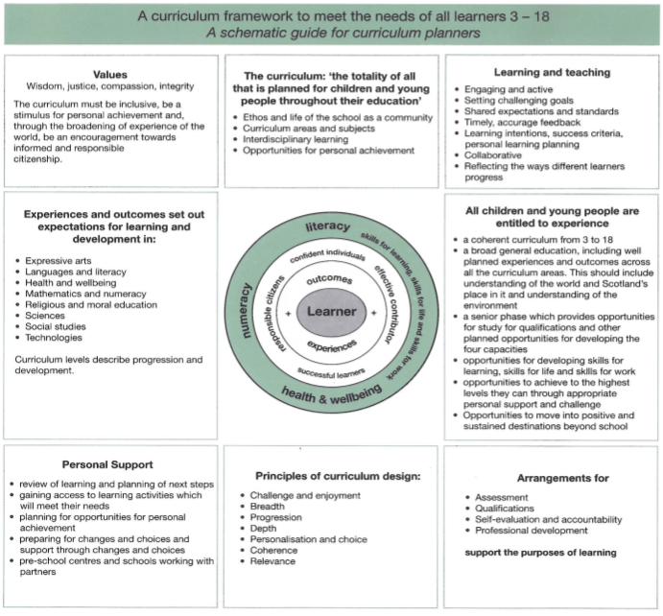
Diversity and Equality Partners
- Parents/carers
- School Nurse
- Speech and Language Therapist
- Social Work
- Eco School Partners
- Pupil Support Service
- Show Racism the Red Card
- Local faith groups
- John Muir Trust
- Active Schools
- Other GIRFEC Partners

Opportunities for personal achievement

- Awards/Rewards
- Merit Stickers and Stamps
- Class Points
- House Points
- Certificates
- School Noticeboard

Sports/Recreation
- School clubs/activities
- Local Sports Clubs
- Active Schools Co-ordinator
- School/local/authority/national competitions

Outdoor learning
- Use of local environment
- Active Schools activities
- Countryside Ranger led activities

Appendix 2 - Examples of how schools can promote equality and diversity

- Assessing, planning for and meeting the needs of children who experience barriers to learning.
- Providing support for children for whom English is an additional language.
- Access to a range of professional services, e.g. Speech & Language Therapy, Occupational Therapy, Physiotherapy, Social Work Services, and Psychological Services.
- Meeting the educational needs of children from Gypsy/Traveller families.
- Use of assistive technology to improve access to education, for example for children with sight loss, dyslexic pupils.
- Alternatives to pencil and paper recording for pupils with sensory / communication / motor difficulties.
- Provision for Deaf and hard of hearing pupils to access information.
- Access to additional help or support for a wide range of learning difficulties.
- Making arrangement for pupils who wish to opt out of inclusion in elements of religious education or worship.
- Making arrangements for pupils who are required to wear a particular form of dress, or have dietary requirements because of their religion or belief.
- Maximising opportunities to influence school policies through the Parent Council, and where required, providing information in the parent/ carer’s first language or provision of an interpreter.
- Organising school trips using the electronic tool EVOLVE which promotes inclusion and includes a check and extensive information on equality.
- Displaying Stonewall posters and information.
- Accurate reporting and recording of prejudiced based bullying,

Working with organisations including:

- Highland Children’s Forum: developing ways to hear the voice of children in need
- Enquire: Scottish advice service for additional support for learning
- CHIP: offers information, support and advice to the families and carers of children and young people with additional support needs, and to professionals who work with them in Highland.
- STEP: supports education for Travelling people within Curriculum for Excellence
- Show Racism the Red Card: UK’s anti-racism educational charity

Appendix 3 - Reflective questions

This Appendix to the School Equal Opportunities Policy provides examples of reflective questions for Noss Primary to consider how well they are improving their promotion of diversity and equality. They will be used as a starting point to stimulate and inform discussion and debate with a view to raising confidence in understanding diversity and equality and promoting improved outcomes.

Reflective Questions

- How successful is our school in welcoming all learners and parents irrespective of their race; disability; gender and gender identity; religion or belief; or sexual orientation?
- Is there an identified senior member of staff (Equality and Diversity Co-ordinator) with responsibility for coordinating the implementation of the equality and diversity policy?
- How does the school ensure that all staff understand and implement the key requirements of the equality and diversity policy?
- Does the school collect information on race, disability and gender with regards to both pupils and staff, e.g. pupil achievement, attendance, exclusions and staff training? Is this information used to inform the lessons plans, additional support, training and activities the school provides?
- How does the school ensure it improves accessibility for pupils, staff, parents or carers, and visitors to the school – this would include physical access, language barriers (including BSL), information in suitable formats?
- Is the school able to provide additional support to ensure all pupils achieve the same outcomes and ensure barriers to learning and all school related activities are addressed?
- How does the curriculum include positive opportunities for all pupils to understand and celebrate diversity and difference?
- Do staff use the health and wellbeing experiences and outcomes, including social, emotional and mental wellbeing to recognise, value and promote diversity?
- Are all groups of pupils are encouraged to participate in school life and/or the wider to community and make a positive contribution, e.g. through assemblies and the pupil council?
- Does the school monitor reported incidents of prejudice-based bullying and harassment of pupils and take action if there is a cause for concern?
- How does the school ensure there is an ethos and culture of inclusion, participation and positive behaviour across the school? Are staff and pupils encouraged to challenge negative attitudes and prejudice related to different groups?
- Do school materials, visual displays and multi-media resources reflect the diversity of the wider Scottish community?
- Are minority ethnic, disabled and both male and female role models and those of vulnerable groups promoted positively in lessons, displays, discussions and assemblies?
- Does the school take part in annual events such as Black History Month, Deaf Awareness Week, One World Week etc. to raise awareness of issues around equality and diversity?
- Is the parent council is representative of the community it serves?
- Do learners, parents and carers and staff feel that they are treated with respect and in a fair and just manner?
- What opportunities do learners have to explore the rights to which they and others are entitled? How successful are they in exercising these rights appropriately and accepting the responsibilities that go with them? How well do they show respect for the rights of others?
- How does the current improvement plan ensure progressive development of the school’s work on education about differences among people?
- How effectively do we track and monitor the contribution learners make to their school community to ensure it is one which values individuals equally and is a welcoming place for all?
- How effectively do we work towards eliminating discrimination, advancing equality of opportunity and fostering good relations among different individuals and groups?
Appendix 4 – Resources

- How good is our school? Promoting Race Equality (HMIe 2004)
- How Good is our School? Taking a closer look at Inclusion and Equality – meeting the needs of Gypsies and Travellers (HMIe 2005)
- Count Us In: Promoting understanding and combating sectarianism, Education Scotland (2007)
- Promoting Diversity and Equality: Developing Responsible Citizens for 21st Century Scotland. Education Scotland 2013
- Education Scotland: Inclusion and equality
- Promoting Diversity and Equality: Developing Responsible Citizens for 21st Century Scotland
- EHRC Schools Technical Guidance - Scotland
- EHRC Reasonable adjustments for disabled pupils Scotland
- EHRC Teaching resources - secondary
- EHRC Teaching resources - primary
- Together Scotland Scottish Alliance for Children’s Rights
- Children’s Rights Alliance (England) and Resources for young people:
- Equality Matters for Children
- Holocaust Memorial Day
- Scottish Travellers Education Programme
- Sense Over Sectarianism
- Show Racism the Red Card
- Stonewall
- Children in Scotland
- Centre for Research in Education Inclusion and Diversity
- Centre for Studies on Inclusive Education
- Cbeebies:The Equality Act and disabled children in school or nursery
- For Scotland’s Disabled Children (FSDC)
- Education Scotland resources
- Inclusion and Equality in CLD
- Inclusion and equality
- Respect Me
- Understanding of the United Nations Convention on the Rights of the Child (UNCRC): http://www.educationscotland.gov.uk/resources/r/childrensrightsresource.asp
- A Fairer Highland Equality Plan 2012 – 2017
- Working Towards a Fairer Highland Mainstreaming Equality Report

STEER – Developing an Equalities and Diversity Policy
KEY ACTIONS TO BE TAKEN BY SCHOOL | Related  QIs | Action taken ü  On-going or x | Planned  Timescale
- Working with staff, pupils and parents, create a Diversity and Equalities Policy which focuses promoting diversity and equality through all aspects of planned learning and describes what Diversity and Equality ‘looks like’ in your school now and what it will look like in 2017.  - The policy should support the Protected Characteristics of: disability; gender reassignment; pregnancy and maternity; race, religion or belief; sex, and sexual orientation.  - The policy should promote: tackling racism and sectarianism and respecting rights; disability awareness; developing vision, values and aims; children and young people learning about their own and other cultures; building relationships; be representative of all groups; challenging gender stereotypes; tackling homophobic bullying; developing global citizenship and respecting children’s rights. | 5.1  5.3  5.9 6.1
- Ensure the Diversity and Equalities Policy includes:  - Learning within the four contexts of CfE, the eight curricular areas; personal achievement; the ethos and life of the school, and inter-disciplinary learning.  - The use of the following learning contexts: outdoor learning, sustainable development, citizenship, enterprise, creative education. | 5.1
- Work with a range of partners to implement and review aspects of the Diversity and Equalities Policy. | 8.1
- Diversity and Equalities Staff Training and Policy Review must take place within a three year cycle. This review must include the completion of the Diversity and Equalities Steer Template /Equalities checklist. | 7.3 8.1  9.1 5.9
SUPPORT IN PLACE
The Highland Council priorities in the School Improvement Plan template provide a framework. The attached link to HMIE Improving our Curriculum through Self-Evaluation may also be useful: http://www.hmie.gov.uk/documents/publication/iocts.pdf
- Promoting Diversity and Equality: Developing Responsible Citizens for 21st Century Scotland, A report to support schools and centres in promoting diversity and equality through all aspects of planned learning Transforming lives. Education Scotland 2013.
- Examples of Highland / other schools’ curricular plans or rationales.
Appendix 5 – Steer
Appendix 6 - Supporting Staff with Promoting Equality and Diversity Checklist

Area | Comfortable  √ | Requiring re-assurance/  Awareness raising √ | Requiring CPD  (Outline details)
The Equality Act 2010

The Protected Characteristics:
- age;
- disability;
- gender reassignment;
- marriage and civil partnership;
- pregnancy and maternity;
- race;
- religion or belief;
- sex;
- sexual orientation.

Promoting Diversity and Equality across the 4 contexts of learning
Leadership for diversity

Auditing the promotion of equalities

Embedding equalities in education
Strengthening equalities education

Improving confidence

