


STANDARDS AND QUALITY REPORT 2025-26 AITHISG INBHEAN IS CÀILEACHD

Noss Primary School and ELC



In this report the following words are used to describe the numbers and proportions used:
All | Almost all | Most | Majority | Less than half | Few
100% | Over 91% | 75% - 90% | 50% - 74% | 15% - 49% | Up to 15%

School Profile
Pròifil na Sgoile

The following information can be found on Parentzone Scotland. It is important to remember that statistical data alone is not a measure of how well we are doing. All schools are unique. To understand how well we are doing it is important for us to look at a range of different data sources.

Attendance  93.5% |  | Average Class Size  27 |  | Meeting PE Target  Target Met
Pupil Numbers (inc nursery)  300 (+86 ELC pupils) |  | Teacher Numbers  16 |  | Pupil Teacher Ratio  18.6

N3  10.2% | N4  11.% | P1  14.5% | P2  12.5% | P3  14.5% | P4  12.1% | P5  10.8% | P6  15.8% | P7  19.9%

SIMD Q1  20-30% | SIMD Q2  20-30% | SIMD Q3  20-30% | SIMD Q4  10-20% | SIMD Q5  0-10% | Unknown  0-10%

ASN  0-40% | No ASN  60-70% | FSM  0-40% | No FSM  60-70% | EAL  0-10% | No EAL  90+%

2024/25 Proportions of pupils achieving Curriculum for Excellence Levels (P1, P4, P7 combined):
Reading |  | Writing |  | Listening and talking |  | Numeracy
Majority |  | Majority |  | Almost all |  | Majority

We have had no exclusions this year.

Overall children are making the following progress:
Reading |  | Writing |  | Listening and talking |  | Numeracy
Good progress |  | Good progress |  | Very good progress |  | Good progress

School vision, values and aims
Lèirsinn, luachan agus amasan na sgoile

Vision
Our vision is to develop happy learners in a secure learning environment where they are nurtured, valued and inspired.

Values (Refreshed March 2026)
Ready, Respectful, Safe and Determined

Aims
Noss Primary School and ELC will aim to:

- deliver a broad, balanced and inclusive curriculum which allows each child to achieve
their full potential
- create a happy, safe and stimulating environment in which children can learn, develop and be treated fairly
- promote and encourage a healthy lifestyle to all learners and the learning community
- allow pupils to participate in a variety of positive, memorable experiences
- ensure that children will have a greater self-knowledge and a greater understanding of the views and needs of others
- foster positive relationships at all levels of our school and ELC
- be a learning community which supports learners, families and staff in lifelong learning and,
- make a positive contribution to the life of the community.

Review of progress for session
Ath-sgrùdadh air adhartas airson an t-seisein

These projects are linked to the vision and priorities for Scottish Education based on delivering excellence and equity. Parent/Carer information is available here.
School Priority 1: Literacy - National Improvement Writing Programme (NIWP)
School Improvement Plan Priority 1
Summary of progress | Next steps | Stakeholder Views
This session, we have made very good progress within this priority implementing NIWP approaches in P2/3, P3/4, P4 and P5.  Staff teaching at these stages use the NIWP approach to raise attainment in Writing.  Teacher professionalism improved. Our Class Teachers attended collegiate sessions across the school year led by colleagues from The Highland Council (HC) and The Scottish Government (SG).  At September inset, the school, itself, was a venue for training in the north which allowed for colleagues from across Caithness and Sutherland to attend. The Head Teacher led training in partnership with HC and SG colleagues. In our school, children in identified classes have improved their skills in punctuation, conjunctions, openings, vocabulary, clarity, presentation and spelling. Staff and pupils speak confidently about Writing in school.  In Term 1, the school held an open afternoon for parents and carers to attend to discuss childrens’ work and new writing approach.  In 2025/26, the school also used a targeted intervention approach to support excellence and equity in writing attainment to improve and achieve positive outcomes for all children . The Senior Leadership Team (SLT) used the school tracking and monitoring database to positively discriminate pupils, using various data fields and allocate further support from a PEF funded additional class teacher. | Pupils in Primary 3, 4 and 5 will continue to take part in lessons using the NIWP.  Class Teachers who are not trained and teach at Primary 3, 4 and 5 will undergo training. | “We have been working on learning how to punctuate direct speech. Before the children add this to their writing, we have been doing work as a class on the board as well as completing and checking over worksheets together. Once we get our learners statements written, we will be able to start incorporating direct speech into our writing and get back to the run chart.”  Miss Suzanne Mackenzie, P5 Class Teacher  “Children have better understanding of the rules of grammar and punctuation.  Story writing is more descriptive and also well plotted.  More children are able to write independently, in complete sentences and can spell most common words.  More children can revise and redraft their own work.  General written work is well structured and well presented.”  Mrs Agnieszka Beattie, P4 Class Teacher  “I have found the NIWP has provided a good structure for writing and has set the children in a routine with writing more regularly. Pupils seem to enjoy writing and engage well with the visual of seeing their progress each day on the graph. Pupils are confident in knowing what their targets are, and the self-checking slips have provided pupils with the tools and ability to review their own work and know they have met the target or what they need to continue working on. Writing daily has provided a number of opportunities to incorporate class topics, events, science, health etc into literacy lessons in a meaningful way. Pupils are able to look at their jotters and see progress with the amount of detail they can include in the 15 minutes compared to the start of the year. Overall, as a class we have enjoyed engaging in this writing program and have found it provided good structure for regular writing and confidence in writing skills.”  Mrs Laura Manson, P3/4 Class Teacher  Writing has got easier because I started off getting lots of mistakes but not so much now. I’ve got Star Writer quite a few times.”  Pupil A, Primary 4  “Writing is good because at the start, I would forget to add punctuation and capital letters for proper nouns but now, I’m better at that.”  Pupil B, Primary 4  “I can start sentences in different ways.” Pupil C, Primary 3/4  “I can spell better.” Pupil D, Primary 3/4." Pupil D, Primary 3/4
Impact
Impact
As a result:
- 77% of P3 pupils had experienced an improvement in Writing attainment
- 78% of P4 pupils have experienced an improvement in Writing attainment
- 50% P5 pupils have experienced an improvement in Writing attainment.

School Priority 2: Reading
School Improvement Plan Priority 2
Summary of progress | Next steps | Stakeholder Views
This session, we have made very good progress within this priority.  The staff team’s professional knowledge and understanding improved specific to contemporary children literature. This enabled staff to be able to recommend and discuss a range of reading materials relevant to the needs, interests and experiences of all their learners  By introducing Drop Everything Everyone Read (DEER) very good progress has been made at developing peer-to-peer reading chat, encouraging learners to discuss and evaluate texts amongst themselves, developing individual reading identities and helping learners to share reading materials they enjoy.  In Term 2, we hosted a school/ ELC Family learning event specific to Reading. Over 200 parents/ carers attended from across the school and ELC. This provided the opportunity to take books home, read with their child and take part in Literacy activities.  In 2025/26, the school also used a targeted intervention approach to support attainment to improve Reading attainment. The Senior Leadership Team (SLT) used the school tracking and monitoring database to positively discriminate pupils, using various data fields and allocate further support from a PEF funded additional class teacher. | Expected outcomes:  Continue to Rebrand ERIC time in class with DEER (drop everything everyone read) to work like a brain break  School challenge, A Million  Minutes of Reading,  Book swap and access to books using a swap trolley outside reception in the morning and at home time for parents and pupils to swap.  Parental involvement tips on a weekly basis on Class Dojo.  Continued targeted intervention to  boost Reading attainment | 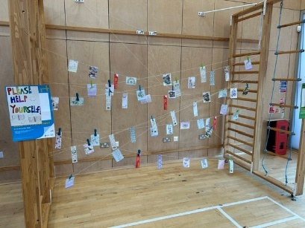  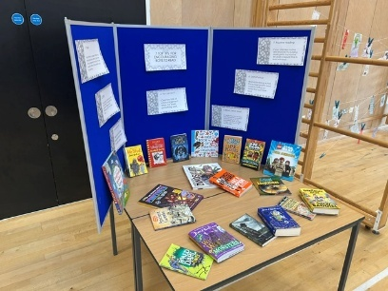  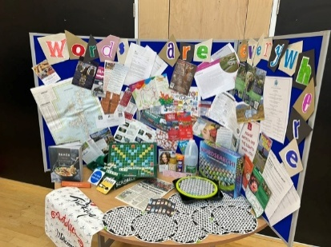  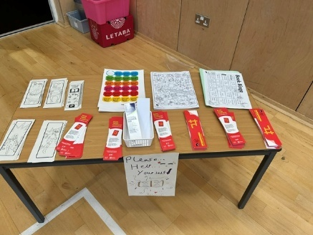  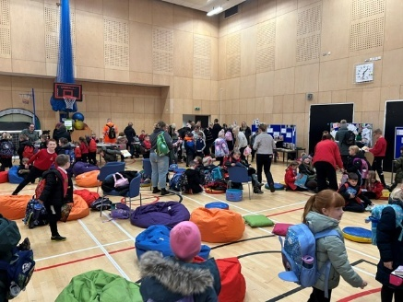  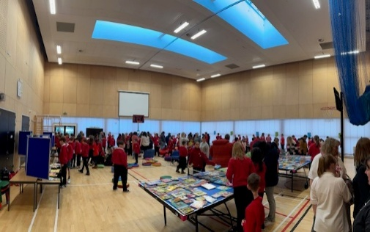
Impact
This session, the improvement work that has been carried out has continued to support the general trend that attainment in Reading is increasing attainment across P1, 4 and 7 each year:

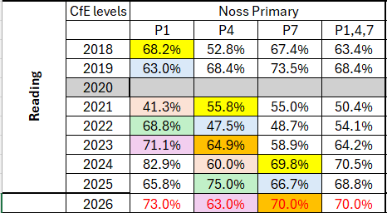

School Priority 3: Rights Respecting Schools – Journey to Gold
School Improvement Plan Priority 2
Summary of progress and impact | Next steps | Stakeholder Views
This session, we have made satisfactory progress within this priority. In March 2026, we received a Gold accreditation visit. The visit recognised good practice in school and the assessors provided constructive feedback to action to achieve the Gold award.  Teachers attended collegiate sessions to improve their knowledge of RRS practice.  Monthly assemblies which educate pupils around rights.  Each class created a Class Charter  Each pupil is part of a pupil group/ committee | - Staff to ensure that rights and specific articles are explicitly linked to curriculum planning documents  - Explore ways in which children's rights are  impacted globally and why rights might sometimes be denied or not met  - Develop creative ways of making articles and rights displays even more visible and high profile around the school, for example, signposting where rights are met, where they have been taught, and how children have advocated for rights.  - Continue to support staff (including new colleagues) to have the knowledge and confidence to effectively teach about the CRC and model rights respecting language and attitudes.  - Support parents/carers, families and the wider community to learn about and understand the UNCRC and engage with the school’s Rights Respecting journey.  - Work with the ELC and Scope unit to embed Rights Respecting practice into these settings too.  - HT to involve pupils in developing systems and policies to ensure their rights are met.  - Ensure consistency across charters, ensuring the role of duty bearers and rights holders is explicit and providing actions for each  - Explore with staff, children and young people the concept of dignity and how it underpins policies, actions and interactions between everyone at school. | See below
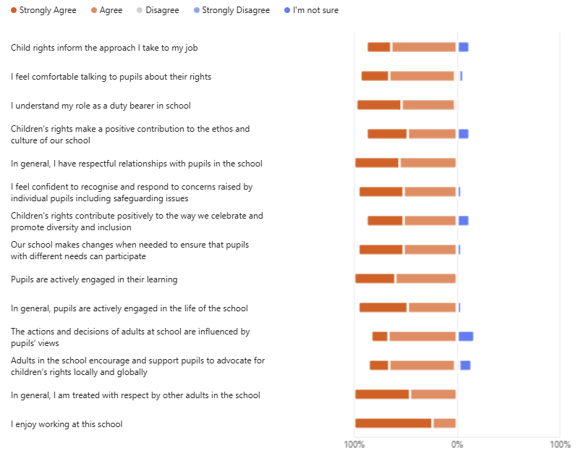
Impact

ELC Action Plan

WHAT WE NEED TO IMPROVE  Reference the relevant National Standard criterion. Include any recommendations and requirements from the Care Inspectorate Report. | ACTIONS  How will we make this happen? | RESPONSIBILITY  Who will have responsibility for making this happen? | TIMESCALE  When will we complete this action? | STRATEGIES/EVIDENCE TO MONITOR PROGRESS  How will we check how well this is progressing? | EVALUATION AND IMPACT  What has improved? | Next Steps
Deployment of staff outside | Staff to be aware of their positioning outside to be able to supervise and also engage with children to enrich and extend play.  ELC staff to be more aware of this happening and remedy it. Discuss this at the Team meeting in T2 and T3 if still pertinent. | All ELC staff  DHT/HT/SEYP to monitor | 30th January 2026 | HT/DHT/SEYP daily walkarounds  Support and supervision  Team meetings  QI Staff skills, knowledge, values and deployment  * Level 5 illustration and challenge questions for Staff deployment | Discussion of positioning was discussed again at the T2 team meeting.  Staff noted that often children do not want to engage with staff outside, particularly when the bikes are being utilised.  18/12 – Staff have started to look at self-evaluation of QI. | Staff need to be continually aware of where other staff members are and of the importance of their positioning.  Staff to continue to offer engagement to children when outdoors  Continue with evaluating QIs
Deployment of staff inside | Ensure that staff tasks such as children’s personal care still leave sufficient staffing levels for both supervision and learning to be supported. | All ELC staff  HT/DHT/SEYP  PCCM | 30th January 2026 | HT/DHT/SEYP walkarounds  Monitoring observations  ELC staff to discuss in team huddles | 3/3/26 - HT/DHT/acting SEYP have not noticed any issues with staffing levels on informal walkarounds | Continue monitoring staffing levels on informal and formal visits
Staff understanding of their responsibilities | Ensure good communication between leadership and ELC staff.  Staff show accountability for any actions/next steps and these are completed in a timely manner. | HT/DHT/SEYP  ELC staff | 23rd December 2025 | ELC staff are reading/signing the items in the communication folder and ensuring that any next steps or actions are completed | 12/12/25 - Reminder given to staff to check the communication folder weekly to ensure nothing is missed. | SEYP/DHT to check that next steps which have been given are being completed in T3.
Effectively monitor the work of each member of staff and the service as a whole | Staff support and supervision in terms 2, 3 and 4 and enhanced if required. Dates all meetings to be completed by in ‘timescale’ column.  Formal room observations will take place three times this session. Staff to self-evaluate and written feedback given. Actions identified in observations need to be undertaken by ELC staff.  Informal discussions to be had if senior staff notice anything that needs to be addressed on their walkarounds. | DHT/SEYP  DHT/SEYP  HT/DHT/SEYP | T2 - 12/12/25  T3 - 13/3/26  T4 - 5/6/26.  First obs for each room to be completed by 5/12/25  Ongoing | Completed S+S records to be kept by each staff member. Actions identified and completed.  Checked by HT/DHT and SEYP on informal visits.  Staff are getting immediate feedback in an informal way to help improve practice. | T2 – all S+S meetings completed by SEYP and DHT. T3 – S+S meetings to be completed in w/b 2/3 and 9/3. All DHT. All S+S completed by 18/3/26.  All rooms have had their initial formal observation. Due to staff illness, feedback to staff was delayed but was completed by 17/12/25.  Visit 2 to take place in March 2026. Red/green completed w/b 9/3/26. Blue room – completed 25/3  HT/DHT/Temp SEYP are talking to staff on informal walkarounds. | T4 – all S+S to be completed by 5/6/26  Carry out a third visit in term 4 for all rooms.  Continue this informal feedback on a regular basis
Leadership groups | ELC staff need to ensure that developments in the four areas are moving forwards appropriately and are being recorded in the working group floor books. Staff can push forwards with developments in their own rooms and then meet collectively to share ideas. | EYPs  (Overseen by DHT/SEYP) | All year  Staff to evaluate progress and set new targets at the end of each term | HT/DHT/SEYP to look at floor books and also look for evidence in the rooms/outdoors when completing formal and informal visits. | Working groups given time on in-service day 18/2 to meet. Some groups have had a change of staff/staff absence so are just starting. Other groups are more settled/established. All floorbooks have been started.  Temp SEYP met with KM from red room as she was needing some support for the numeracy group. Other EYPs have left and she is struggling to get time to complete. | Use additional setting SDT time approved for the curiosity/home working group to further develop staff skills  Additional 3 hours per week been granted for setting from 18/3 for time to allow staff to work on the priorities
Staff huddles | These have been well received. EYPs and SWs need to ensure that staff are all aware of their responsibilities and the joint team approach to improving the quality of the setting and outcomes for children. | All ELC staff | All year – ensure all rooms stick to the planned timetable for huddles | Staff huddle sheets to be kept in the rooms’ communication folders. SEYP/DHT to continue attending huddles whenever possible and to read huddle sheets. | Some meetings are out of synch due to staff absences etc. Staff need to try to get back onto the agreed dates as soon as they can. | Teams are back on track with the room huddles. Continue in term 4.
Safeguarding procedures  SIMOA Safety Awareness | All staff are clear about the process to use when they have a Child Protection concern to report.  HT/DHT to speak to all staff individually to check understanding.  Acting SEYP and staff will speak with children throughout the day of importance of safety in the ELC.  Info on Class Dojo to explain to parents/carers the meaning about SIMOA and its goal. | HT  ELC staff  SEYP, all staff, all Service users | By 5/12/25  29/05/2026 | ELC staff are following the correct procedure when reporting a Child Protection concern  All staff have read, signed and dated the child protection policy and procedures.  Child protection scenario used at team meetings in T3 and T4 to check understanding.  All shall remind children about the importance of safety in nursery; Service users shall be told about SIMOA via Dojo and verbal communication from staff. Children shall be able to recognise and find visuals of SIMOA the elephant around the nursery environment. Children shall learn to take ownership and responsibility about safety such as ‘walking feet’ in nursery and how we can prevent accidents/incidents happening. | Dec 5th - all staff have been spoken to individually by either HT or DHT to ensure understanding of the process.  The Child Protection policy is due for a review in March 2026.  Child protection scenario given via QR code on in-service day 18/2.  New staff have been told about Child Protection procedures at their induction.  All staff are reminding children about the importance of safety in nursery; Service users are being told about SIMOA from their children. Children are pointing out the SIMOA elephant visuals around the nursery environment. Children are taking responsibility to remind peers about safety such as ‘walking feet’ in nursery showing SIMOA the areas of the nursery.  23/04/2025 | Continue to discuss CP scenarios at Team Meetings.  Reviewed in March 2026 and given to staff to read. Will be put into policy folder once all staff have read.  HT has results. All staff in post on 18/2 have completed this.  All new staff have been briefed in their induction meetings.  Continue term 4 to implement into practice LINKING TO SHANARRI indicators, Create a floor about SIMOA. Include SIMOA into safety checks with children for outdoors.
Staffing arrangements are not sufficient to meet the needs of the children. | Nov 25 -Two SW posts to cover SWs taking on EYP posts are still to be advertised (39 hours in total). This is leading to inconsistent adults for the children as we are using supply staffing to cover this temporarily.  Highland Council have agreed to an additional 30 hours SW post in January. We will also have an additional eleven children so we will need to ensure that this additionality is sufficient to meet the needs of all the children. | Highland Council  PCCM and EYO  Highland Council PCCM and EYO | We would like these two posts to be filled by 7/1/25  We would like this post to start on 7/1/25 along with the new start children | HT/SEYP to continue checking with HR as to when these posts will be advertised  Discussions with staff, observations by HT/DHT/ SEYP on formal and informal visits | 12th Dec- the 24 hour post has now been advertised, closing date 22/12 so interviews will not be able to take place until after the holidays. No advert for 15 hours post yet.  12th Dec- interviews held and staff member appointed (KM) for the 30 hr per week post commencing on January 7th 2026.  Additional staff in covering acting SEYP floor time hours 23/2/2026 Started EW & KR.  Cover for EL Wed-Fri sourced to cover her secondment until the summer holidays. | Both 24 hour and 13 hour posts filled. HB and CG both started in their posts on 18/2/26.  KM started in her post on 7/1/26.  RM and RS still both off, cover sourced for all five days. (RM returned on 22/4 for a phased return)
Ensure all EYPs are knowledgeable and understand how to complete personal care plans | DHT to meet with all EYPs individually to complete the PCP/LJ audit.  Personal care plans need to reflect the children’s current needs.  Strategies of support for individual children are developed and implemented by staff. These are reviewed regularly and further actions identified if necessary.  Storage of PCPs – HC say some of the information needs to be stored in LJs, CI do not agree with this. Still awaiting clarification from PCCM who was going to bring this up with Hayley Brown. | DHT and EYPs  EYPs  EYPs and all staff in rooms  Highland Council to advise on storage arrangement  PCCM | By 21/11/25  These will be audited again (DHT+EYPs) on w/b 9th Feb  30th Jan 2026  30th Jan 2026 | Staff to self-evaluate PCPs alongside DHT in term 3 and term 4  Progress has been made from the previous audit and children’s current needs are reflected  Support strategies can be observed during formal and informal visits. Evidence of strategies are shared in room huddle minutes.  Contact with Miss Burnett by mid January if this has still not been actioned | 28/11/25 - All EYPs have had a one-to-one meeting with DHT to audit a sample care plan. Actions and next steps identified for each EYP.  Acting SEYP did this again in term 3. Completed March 26.  Social stories developed to support individual children’s needs.  15/12/25 – Update from PCCM to report that Hayley Brown will take this to the next CI relationship meeting to clarify, as it was previously agreed these could be stored in children’s profiles. | Marea B/Maria A invited into ELC to do a full PCP audit – 22/1/26  Laura Miller (temp SEYP) is continuing with individual meetings in term 3.  Continue to review impact on children. SEYP communicating with staff.
Observations of children’s learning including using developmental overviews | DHT to formulate new ‘next steps’ sheet which should be completed once meeting with PT to do tracking has been done. Then next steps need to be linked to the children’s current interests and /or developmental needs.  DHT to meet individually with all EYPs to look at the Learning Journeys and offer support in writing meaningful observations which show progression of children’s learning in all curricular areas.  Training from Early Years Educational psychologist around ‘tuning in to children’ | DHT  To be completed by EYPs following tracking meetings  DHT and EYPs  All staff | Start to start using at November 25 tracking  All audits to be completed by 7th Nov  18th Feb 2026 | PT to ensure all EYPs have completed the ‘Next Steps’ sheets accurately and these are reviewed at the next tracking meeting.  DHT will see increased confidence from EYPs at the next LJ audit (Feb 26) * (Temp SEYP is doing these in term 3 to allow DHT to do all the S +S meetings.)  Impact of training to be discussed at S+S meetings | All EYPs have completed the ‘next steps’ sheets with support from the PT.  28/11/25 - All EYPs had a one-to-one meeting with DHT to audit a sample learning journey – actions and next steps identified for each EYP. Acting SEYP continued this in T3.  Training completed 18/2/26. | Pt to continue with tracking T3 and T4. Use developmental overviews to formulate next steps.  Continue in term 4. Acting SEYP to do this as DHT doing S+S meetings with all staff.
Planning | Using information gained from the developmental overviews to inform planning and next steps for children.  Planning that builds on children’s interests and provides progression and challenge. | EYPs/SEYP  EYPs | 30th Jan 2026  30th Jan 2026 | SEYP will be able to see the link between the developmental overviews and the environment planning.  28/1/26 – HT/DHT/SEYP/ PCCM/EYESO will evaluate planning to ensure breadth and depth of learning and consistency | Temp SEYP has put up sheets to support staff in identifying the learning taking place. Environments are looking more homely and inviting for children to play.  Planning wasn’t looked at today (28/1) due to EYESO illness. DHT has asked PCCM to look at this in one of her March visits. She has said she will ask EYESO to do this. | Continue to make improvements to environment/playrooms to enhance children’s learning expereince’s  Feeback received from Maria A regarding planning. Feedback received on 17/3 in person. Most staff attended.
Quality of the environment indoors | Use of the indoor quality audit every term - share this with staff along with next steps/actions  All staff to be aware and use language specific to SIMOA  Ensure there are sufficient resources to allow children to be involved in stimulating play. Replenishing of core resources needs to be done regularly.  Ensure the environment is comfortable and homely. EYPs are encouraged to use their initiative and everyone is to have this as an ongoing priority.  Make sure all areas are fresh and inviting to the children to develop children’s engagement and sense of belonging. Children need to help to look after the different areas and develop their sense of pride in their room.  Cleanliness of some area of the ELC needs to be improved. ELC staff are responsible for soft furnishings, cupboard doors, inside of windows if there are Sellotape marks etc.  HC cleaning staff can help with a deep clean of the carpets. | DHT/SEYP Ts1+2  EYPs to also be involved in auditing this in terms 3 and 4  All staff  EYPs  EYPs  All room staff  All room staff  HT/DHT to speak with HC cleaning staff regarding the carpets. | Audits completed by:  T2 – 23/12/25  T3 - 27/2/26  T4 – 15/5/26.  Ongoing  30/1/26  30/1/26  30/1/26  Ongoing  30/1/26 | Next steps/actions should decrease each time the audit is completed.  Term 1 was 7 for Red, 8 for Blue, and 8 for Green.  EYPs to monitor the use of core resources and ensure this is sufficient to engage children  HT/DHT/SEYP walkarounds. EYPs to discuss in huddles  HT/DHT/SEYP walkarounds. EYPs to discuss in huddles  HT/DHT/SEYP walkarounds. EYPs to discuss in huddles  HT/DHT/SEYP - See if deep cleaning of the carpets helps the rooms to look more inviting. Deep cleaning of carpets is scheduled for Jan 26. | T2 audit not completed by SEYP. T3 audits were completed by PCCM, nearly all actions were still outstanding. Term 3 was 8 for Red, 7 for Blue, and 9 for Green. All rooms given feedback sheet and asked to action the points.  All rooms were given £500 and have been improving the inside environment/ updating resources. Temp SEYP has also helped with ideas and sourced some resources.  New resources bought and areas in the room have been reconfigured/resourced. Children reminded about keeping areas tidy.  ELC have been working hard on making sure areas under their responsibility are kept clean.  ELC staff have been tidying up and cleaning areas in their remit.  One room was completed in Jan 26 but the results were disappointing so a halt was put on the other two rooms.  DHT emailed MB (cleaning/FM) on 3/2/26 regarding the state of the ELC kitchen floor.  ELC staff brought up at team meeting on 2/3/26 the general cleanliness of the rooms/toilets/kitchen. | Repeat again in term 4.  Utilise new resources and continue to build on this.  Continue to monitor use and adapt when necessary.  Children receive regular reminders about keeping the areas tidy.  Staff to keep on top of this regularly.  Marea B (CCFM) has been emailed on a number of occasions regarding the standard of the ELC cleaning. She is aware of this and once a vacant post is filled, she will move the cleaner from the ELC area.
Improve staff confidence and skill in using provocations and invitations | HT/DHT/SEYP to look at this as the small test of change for the CI Improvement Programme they are taking part in. | HT/DHT/SEYP  Along with one staff member from each room initially, if successful roll out further | Ongoing this session. | HT/DHT/SEYP along with EYPs to evaluate success and then ‘adopt, adapt or abandon’. | Initial surveys to gauge staff confidence completed by 23/12/26  Small test of change with three EYPs, one from each room. | EYESO met with the team on 18/2 and has agreed for these staff to have two hours each week to meet together. (Wed 12-2) starting 4/2/26. Curiosity group is going well, working together to create inviting areas of play and learning in the rooms, staff are also setting up invitations/provocations linked to children’s ongoing interests. Term 4 – EL now left so other staff from the Blue Room are taking turns to go to the meetings.
Quality of outdoor environment | Use of the outdoor quality audit twice annually, in December 25 and May 26.  Include outdoor provision as part of each room’s formal observations. | DHT/SEYP  DHT/SEYP | T2 by 23/12/26 T4 by 5/6/26  Ongoing | DHT/SEYP to evaluate and offer next steps/actions  Staff will have clear actions to follow to improve the outdoor areas | Outdoor audit was completed 11/12/25 along with members of the outdoor working group. | Revisit this in term 4 once the better weather is here. Next year have an outdoor audit timetabled for term 1 as December was too late.
Quality of interactions indoors and outdoors | All staff have now completed or revisited the Words-up key messages. These now need to be embedded into the daily practice of staff, both indoors and when outdoors.  Case studies at the start of each term in session 25-26. Revisit the same children T1 and T3 and a different set of children in T2 and T4.  Staff need to be aware of the importance of their interactions in providing support, breadth and challenge to children’s play.  Staff should spend the minimum amount of time needed on task driven activities or on ‘supervising’ (particularly when outside) and the majority of their time is spent providing quality interactions with the children. | All ELC staff  DHT/SEYP  All room staff  All room staff | Ongoing  End of session 25-26  23/12/25  Ongoing | HT/DHT/SEYP walkarounds and on formal monitoring observations  The follow-up observation for the case study should show an improvement in the child’s needs being met and the quality of the interactions.  Discussions at staff support and supervision meetings in term 3 and 4.  HT/DHT/SEYP will see a decrease in time spent on task driven activities and more quality interactions with the children. | Key messages are looked for when completing room observations. Feedback in individual folders.  T1 and T2 case studies all completed.  T3 case studies completed.  S +S meetings to take place w/b 2/3 and 9/3. All term 3 S+S meeting have been finished.  This is looked for when completing room observation and on informal walkarounds. Feedback in individual folders. | Continue to look for key messages being used in all rooms by all staff. Encouarage new staff to complete the videos.  Revisit the same children in T3 and T4.  Term 4 S+S meetings to be completed.
Self-evaluation using the new core Qis | Staff have now been given sufficient time to read over the five new CI QIs and now need to begin to use the new QIs for self-evaluation in term 2. | SEYP and all ELC staff  DHT to monitor and support processes | By 23/12/25 for T2 and by 27/2/26 for T3.  T3 and 4 | QI Leadership of continuous improvement  * Pedagogical leadership level 5 illustration and challenge question  SEYP to ensure self-evaluation has been completed by the end of term 2 and again by the end of term 3.  Floor book monitoring | DHT set up self-evaluation formats and this was started by ELC staff on 18/2/26 on the in-service day.  - High quality spaces  - Playing, learning and developing  - Nurturing care and support  Staff to complete these when they get the opportunity. Completed March 26. One group did not put any next steps so this still needs to be done. | Next steps tasked to CC and KL to complete.  May in-service day -  - Leadership and management of staff and resources  - Staff skills, knowledge, values and deployment  - Learning, teaching and assessment

Progress and impact of Pupil Equity Fund
Adhartas agus buaidh Maoin Cothromas Sgoilearan

Intervention | Data summary against targets | Impact/ progress summary | Intervention Resource allocation used (breakdown)
Pupil Support Assistant (PSA) | To date, our Breakfast Club has served over 10,000 breakfasts. The club attracts over 150 pupils each week and allows our parents/ carers a safe space to drop off pupils before school and children to have a meal before they start the school day. | Parent – “Breakfast Club provides a safe space for drop-off before work.”  Parent – “It’s a fantastic service with no cost involved to families.”  Pupil – “I get to see my friends. We get a choice of cereal and or toast. I get to play with my friends outside or we can do puzzles and draw.” | 29019
Teacher |  | This session, Miss Sinclair carried out targeted intervention work with pupils who were off track in our tracking and monitoring system.  Miss Sinclair supported small groups of pupils in Reading, Writing and Numeracy across the school.  Across the majority of target groups, there were increases in attainment based on the interventions carried out.  Where no increase was recorded, the team were positive around the impact of the work and felt that this will support future increase in attainment. | 54805
  Stage | Reading | Writing | Numeracy
  P2 (6) | 17% | 17% | 50%
  P3 (5) | - | - | 40%
  P4 (4) | 25% | 25%
  P5 (7) | - | - | 57%
  P6 (15) | 14% | - | 7%
  P7 (14) | 43% | 29% | 50%

Wider achievements
Coileanaidhean nas fharsainge

At Noss Primary School and ELC, we pride ourselves on helping our pupils, families and staff to develop and deliver outcomes for themselves and the community.

Over the last couple of years, we have established a new house system and a wide range of pupil groups which provides opportunities to develop their leadership skills.

Our Bike Train has a become a well-publicised and popular feature of life at Noss. Every Friday in Term 1 and Term 4, our pupils staff and families cycle to school using a dedicated route. This now regularly attracts 100 cyclist each week and we offer Bikeability to our pupils in Primary 5, 6 and 7. This compliments the expansive range of clubs and activities that we offer before school, during school and after school. Breakfast Club remains a key feature of our school and our Wake-up Dance Club which is pupil-led takes place every Wednesday. We also benefit from having a large base of volunteers who dedicate their spare time to supporting such opportunities in our school. As a result, participation is increasing in clubs, in various activities, across the county.

Our school has enjoyed visiting and hosting other schools in sports matches such as Netball and Football.

STEM opportunities have increased in school. This year, STEM Ambassadors from Dounreay have supported P7 pupils to build and race a Goblin Car. Our senior pupils also represented the school at Thurso College UHI in the Lego Challenge League where they developed their computer science and programming skills. Our younger pupils took part in Lego Builders which was a break time club led by senior pupils. The school hosted the Caithness Science Festival with pupils from other schools visiting whilst the school held its very own Science Day with pupils from the ELC and each school stage attending.

Every June, our pupils take part in the Caithness Festival and have the opportunity to learn the piano and chanter during school. We also have visits from Feis Ros for music. Every December, our pupils present a performance spanning three performances which is always well-attended. We held our annual talent competition Noss Has Got Talen in March. Mrs Anderson organised Nick Morgan, singer/ songwriter to perform No Scotland No Party at a whole school event in which schools from across the county attended.

This session, we have progressed how connect and support our families by hosting and facilitating four Family Learning Events across each term in Numeracy, Reading, Writing and Additional Support Needs.

Other wider achievements:

- World Book Day
- Blythswood Shoebox Appeal
- Foodbank donations and visits
- Santa Dash
- Book Swap Trolley
- Easter Deer Challenge
- Space Station Talk from Wick High School Radio Club
- Wick ASG P7 Transition Disco
- Links to Wick Heritage Centre
- Visits from local businesses such as RDI Renewables
- RDA Horse riding sessions
- Smoking Cessation Nurse – Class visits
- Childsmile Visits
- School swimming lessons
- Class visits to SSE/ Beatrice Windfarm
- Wick Voices
- DYW
- Reiss Gardening
- Wick Gala celebration links

Comments from learners, families, stakeholders and staff
Beachdan bho luchd-ionnsachaidh, teaghlaichean, luchd-ùidhe is luchd-obrach

Pupils
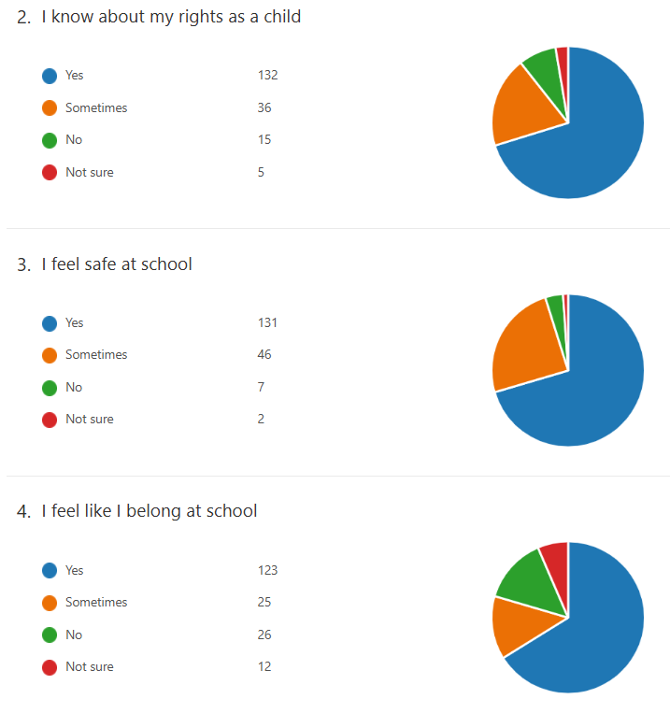
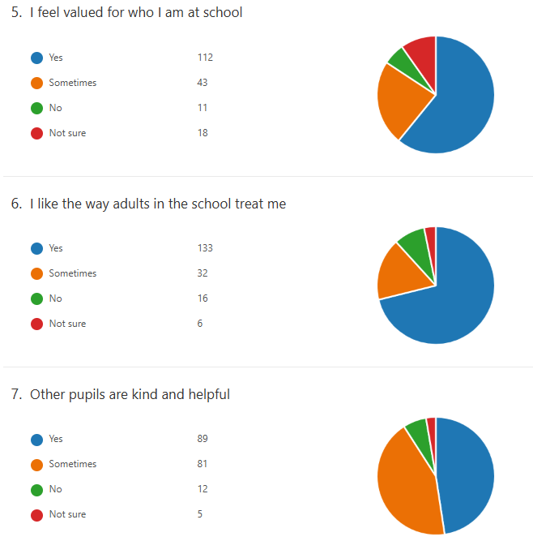
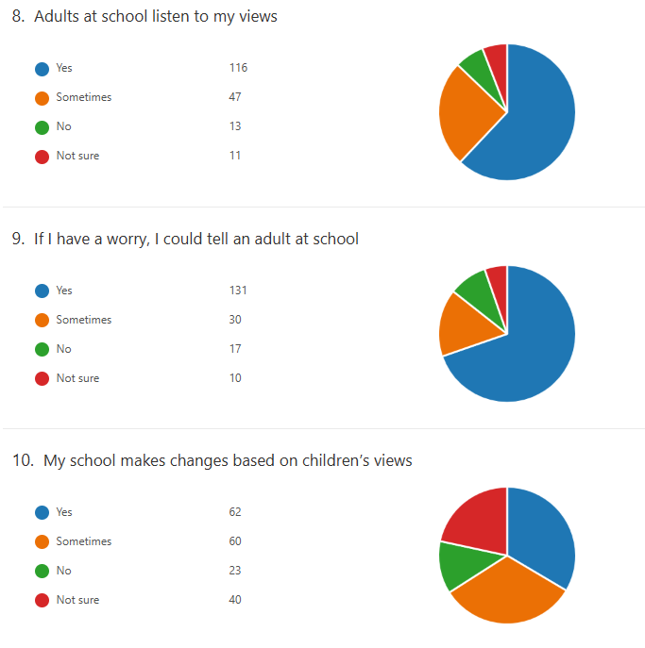
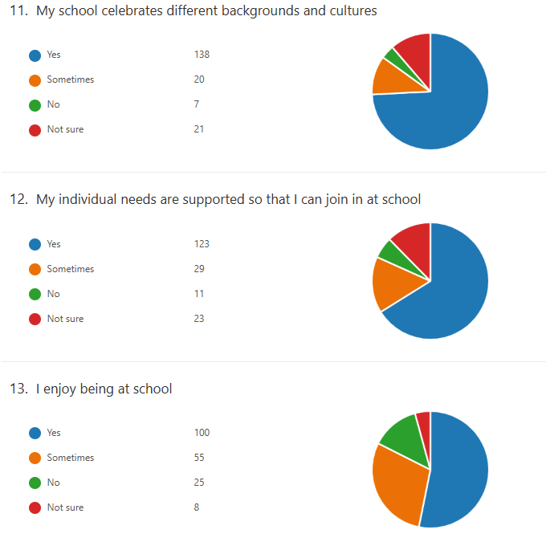
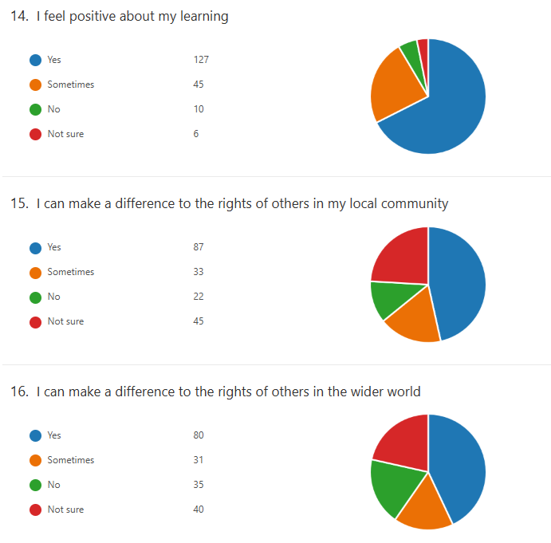
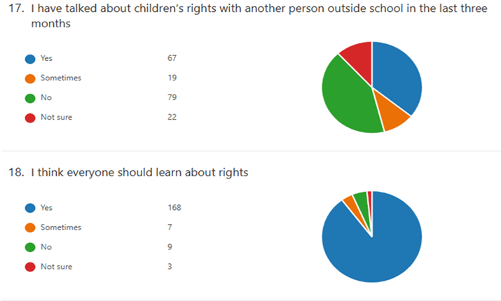

Staff
For pupils to be involved in planting in the playground- flowers, fruit and vegetables.
More opportunities for outdoor learning.
More community involvement.
New novels for P3-P7. Roald Dahl novels to be replaced for younger classes to use as copies are getting old/missing.” Staff member A

ELC front garden, grass cut and strimmed regularly.” Staff member B

"I'd love to see more permanent outdoor learning resources. Mud kitchens, water trays, sand trays, reading sheds. etc
It would also be amazing to have good storage for outdoor toys and for this to be well stocked and available for use. Skipping ropes, outdoor chalks, equipment for tennis, badminton, netball, rounders. Etc” Staff member C

“Music outside would be amazing.” Staff member C

“Big planters with flowers planted by each class - bulbs that come back each year.
New outdoor netball nets.” Staff member D

"Parent helpers back supporting photocopying and laminating etc.” Staff member E

“Some areas need a good tidy up and cleaned.” Staff member F

“Improved communication between management and staff. Staff who teach and/or are working with specific children (often vulnerable), are not aware of incidents at home or in the community that may be effecting the child. Staff are completely in the dark about a child’s home life unless the child discloses to a staff member.” Staff member G

Parents/ Carers
“I think it would be amazing to revive more texts from the teacher as so many different things get posted all the time and often not to do with the children under our care, I think that way it’s good to ensure busier family’s are still upto date and aware of things .
Green spaces planted up by the children … fruit and vegetables as well as flowers. Maintained by them too. Involving parents and the wider community to help out. Taking pride in their surroundings.” Parent/ Carer A

“I feel the school provides a very positive environment in many respects, and I appreciate the work that goes into this. As a suggestion for further improvement, I would welcome greater clarity and transparency around how potential conflicts of interest, particularly where family relationships exist within the ELC setting are managed. Strengthening this area could help reassure families around fairness, consistency, and safeguarding practices. I also think it is lovely to see children’s achievements being celebrated, which is clearly done with positive intentions. However, I am unsure whether sharing these regularly on platforms such as ClassDojo is always beneficial. At times, it may unintentionally create comparisons between children or leave some families feeling their child is not achieving as much. It might be worth considering how achievements are shared in a way that feels inclusive and supportive for all families.” Parent/ Carer B

“Improved liaison with parents and kids over the composite classes and trying to reduce splitting up children from close friends where possible. Kids are now becoming anxious each year on being separated with friends and it’s not fair to not have that consistency and security of knowing what is coming at these young ages, particularly in those pre-high school years at P6 & P7.” Parent/ Carer C

“Grass cutting, strimming by Janitors in the nursery playground and something done about the grass area as in general as it’s very poor and muddy.! Something soft underfoot to maybe replace all the grass area could be an idea.” Parent/ Carer D

“My child quite often comes out with shoes on the wrong feet and absolutely covered in paint etc. An apron would be good and also a check on the footwear before leaving.” Parent/ Carer E

Partners
“The partnership between Noss Community council and Noss Primary School/ELC has created a collaborative community, fostering a welcoming and inclusive environment for all families. The community council’s proactive approach, combined with the school’s dedication, ensures that parents’ voices are not just heard but actively contribute to school improvements. This close relationship, characterised by open communication and shared goals, directly enhances the wellbeing and educational experience of the children.”
Mrs Kirsty Wright, Co-chair, Noss Community Council

“The relationship between Noss and the Educational Psychology service is positive. Staff are very keen to engage with our service and are always very welcoming when I am in the school. The school are quick to respond to concerns they have regarding a child’s learning and development and seek out advice and support at an early stage which allows advice/intervention to be put in place at the earliest opportunity. There are open lines of communication and I find the school provides our service with good evidence of staged intervention on request for educational psychology assistance. All these personal and systemic factors contribute to a positive working relationship.”
Mrs Kirsty Henry, Educational Psychologist (North)
“Noss leadership team has taken a very proactive approach in their improvement journey, increasing their pace of change with clear strategic direction and drive. Leadership team are very visible to children, staff and families creating positive ethos, support and direction for self-evaluation and improvement priorities. In such a very short time there has been rapid change in standards for children in Noss ELC within quality of interactions, experiences for children with the creation of curiosity and enquiry spaces for play both indoors and outdoors.”
Mrs Maria Aitken, Education Support Officer (North)
“It has always been a pleasure working with Mr Thomson and staff at Noss. Over time, we have forged strong links between our school communities which have benefitted both establishments. Our main focus is, of course, the transition of Noss pupils to us here at Wick High School and this has always been a perfect example of partnership working thanks Noss staff’s professionalism and dedication to their pupils.”
Mr Grant Mackenzie, Depute Rector, Wick High School

Capacity for continuous improvement
Comas airson leasachadh leantainneach

Using indicators from ‘How Good is our School 4’ together with learner, parent, carer, partner and community feedback we believe we have made the following progress this session:

 | ELC | PRIMARY
QI 1.3  Leadership of change | Very good | Very good
QI 2.3  Learning, teaching and assessment | Good | Very good
QI 3.1  Wellbeing, equality and inclusion | Very good | Excellent
QI 3.2  Raising attainment and achievement/Securing children’s progress | Good | Very good
Other QIs reviewed
This session and in accordance with our self-evaluation framework, we have reflected on indicators 1.1, 1.3, 2.2, 2.5, and 2.7

Our overall evaluation of our capacity for continuous improvement is: Very Good
We are confident in our capacity for continous improvement.

Key priorities for improvement planning
Prìomhachasan airson planadh airson leasachadh

Overview of school priorities 2026-2027
Establishment Improvement Priorities | Link to National and Local Priorities | Please detail the information / data which has prompted this work
National Improvement Writing Programme (See above NIWP) | See above | Please see SSES document
Rights Respecting Schools | See above | Please see SSES document
Reading Schools | See above | Please see SSES document
Improving our ELC | See above | Please see SSES document
ASG Improvement Priorities
Curriculum Improvement Cycle | Curriculum and Assessment | Local guidance
Teaching, Learning, Assessment Cycle | Curriculum and Assessment | National and local practice

Planning ahead
A’ planadh air adhart

Full details of the school’s 2026/27 improvement priorities and actions are detailed on the school improvement plan, which can be accessed on our website or by contacting the school office.

SIMD – The Scottish Index of Multiple Deprivation (SIMD) is a relative measure of deprivation.
ASN – Additional Support Needs
FSM – Free school meal entitlement
EAL – English as an additional language

