
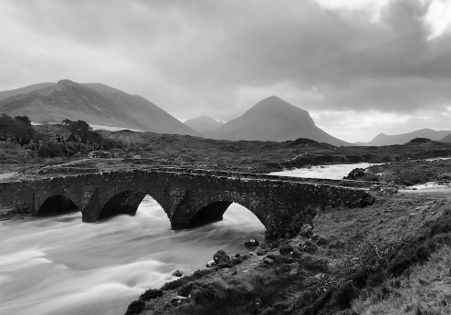
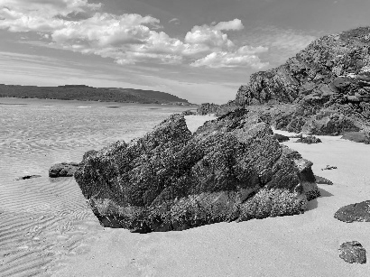
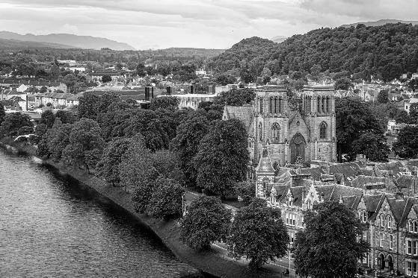
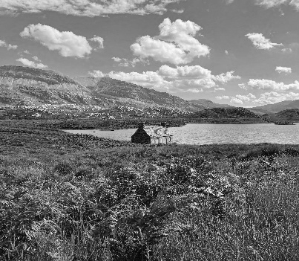

Noss Primary School and ELC

Noss Pupils Improvement Plan
SESSION 2026-2027
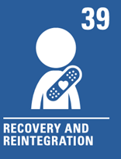

Overview of school priorities 2026-2027

Establishment Improvement Priorities | Link to National and Local Priorities | Please detail the information / data which has prompted this work
National Improvement Writing Programme (See above NIWP) | See above | Please see SSES document
Rights Respecting Schools | See above | Please see SSES document
Reading Schools | See above | Please see SSES document
Improving our ELC | See above | Please see SSES document
ASG Improvement Priorities
Curriculum Improvement Cycle | Curriculum and Assessment | Local guidance
Teaching, Learning, Assessment Cycle | Curriculum and Assessment | National and local practice
CIRCLE Framework | Curriculum and Assessment | National and local practice

How can we make our school better?
“We would like to redevelop our pond area.”
“In our playground, we could have an area were people can go if they are stressed such as a Calm Corner.”
“Some of the pupils would like, larger, permanent goal posts.”
“We can keep trying to encourage people to read. We could have an area in the playground.”
“I would like an Art Teacher.”
“We could have lines on our football pitch.”
“Better pencils, better stationery.”
“More modern Numeracy resources.”
“More/ New books for the library.”
“We need to add the value Determined to the lighthouse.”
“Replace the music equipment.”
“More litter picking equipment.”

What’s working well?
“Rota for climbing frame.”
“Goals rota.”
“School charter give us an idea of how to do things and consequences if they are not followed.”
“Clubs”
“Equipment outside and raising money to buy ourselves.”
“Having a buddy was good.”
“Reading has been good fun.”
“The family learning events were good. We got people to start reading books.”
“The school offers lots of clubs and activities.”
“We feel safe here.”
“There are lots of teachers and areas in school to help us learn.”

What kind of Outdoor Learning resources would you like?
“Play equipment in the tree area”
“Bug hotel”
“Basketball hoops in the infant playground”
“Seated/ Eating outdoor area”
“Forest Hut”
“A bike pump track in our playground”
“A go-kart track”
“We could paint out hut”
“Tree stumps to sit on”
“Play box/ Den building equipment”
“Obstacle Course”
“Get rid of the nettles in the forest”

Considering all of this, what are we going to do now?
Action | Timeframe | Persons | Evaluation
Apply for outdoor learning resources grant  Resource outdoor areas with learning and activity equipment | 2026-27 session | Pupils, Noss Community Council, Senior Leadership Team (SLT), Teachers
Add the value Determined to our school charter | 2026-27 session | Mrs Bullen and RRS committee
Implement full use of the Article 12 box and evidence changes made | 2026-27 session | Pupils, Class Teachers, HT, DHT, Support Staff
Embed a routine for the library and ensure consistency across the year | 2026-27 session | Library committee, pupils, staff

