

Newton Farm Primary School Newsletter - April 2026
Dear Parents and Carers,
Once again we have come to the end of a term in what feels like the blink of an eye. Thank you for all your help and support with school events this term. We are currently investigating the technical issues that have occurred with our reports being sent to you this week, thank you for your patience with this and we hope to have a resolution to the issues soon. I hope you all enjoy the break over the next couple of weeks, and we will keep our fingers crossed that the weather improves for us all.
Take care and enjoy your holiday,
Mrs C Meechan

Euro Quiz
Well done to our Primary 6 Euroquiz team who participated in the South Lanarkshire heats here at Newton Farm on Thursday. They worked very hard learning all about Europe and achieved an impressive score participating alongside another 25 schools. Mrs Stewart was very proud of her team, thanks to her for her hard work too! Thanks also to some of our House Captains who welcomed and helped all our visitors throughout the event. Our visitors were very impressed with their efforts.

Digi Inventors
Our P7 pupils all took part in the #DigiInventors Challenge, facilitated by City of Glasgow College, RAiSE and The Digital Health and Care Innovation Centre. The pupils were asked to design a digital solution to a problem affecting children in Scotland. One of our teams have been chosen as runners up out of all the teams across Scotland who entered. The successful team was for the invention 'Co-Bot' which helps people who are colour blind. The winning pupils Callum, Rocco, Eirini and Sophia have been invited to attend an awards ceremony in City of Glasgow College later this month. Well done to all of the pupils who worked so hard on their inventions and to the staff who helped guide them through the process.

Sharing Success

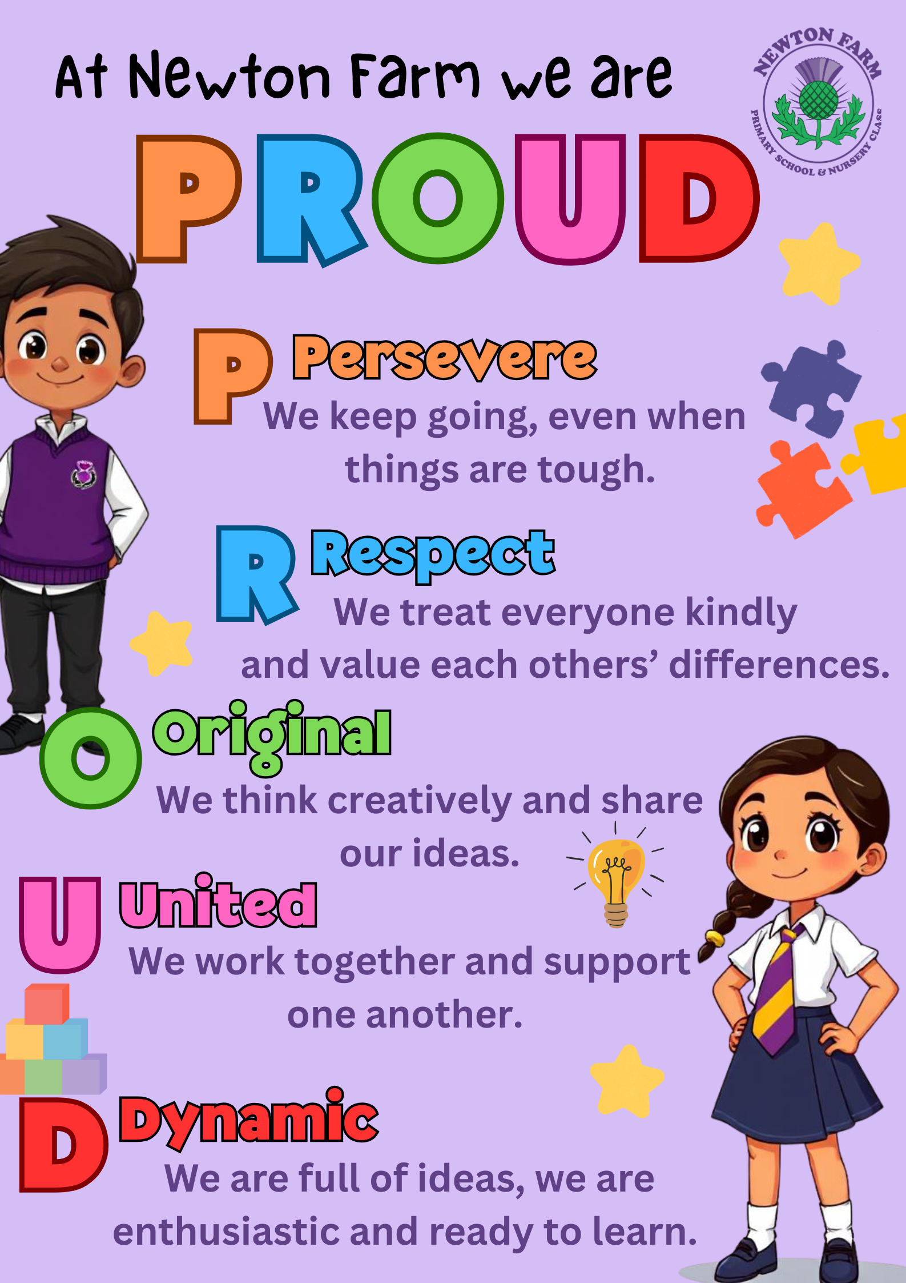




Big Band Concert – Over 20 of our school choir members attended the SLC Big Band concert in Rutherglen Town Hall in March and performed four songs with the band. It was a fantastic night and the girls in the choir were amazing! We were invited to take part by SLC music team and were happy to accept this offer as it was such a unique experience for the pupils to have. Thank you to Mrs Webber and well done to all of the girls!

At Newton Farm we are PROUD

Winning Author One of our P6 pupils, Zoe, was chosen as a winner in a writing competition organised by local MP Michael Shanks. Her story “Elizabeth and the Big Bubble” will be included in a book of stories written by local children featuring places in the local area. Zoe attended a presentation in Rutherglen Library to receive her certificate and a copy of the book. Well done Zoe!

P3/4 Showcase
Primary 3, 4 and Room 7 welcomed in their family in friends in February to showcase all that they have been learning in class. The children had a great time planning and organising this and loved seeing all their loved ones in their class. Thank you to all that were able to attend, your continued support is always appreciated.

Can you help?
School Outings
We have now completed all class outings for this year and would like to say a huge thank you to all of our parent helpers who came along to help supervise pupils on these trips, we can’t do this without you so thank you so much!
If you have any free time during the week and would be willing to help out with any trips organised by the school, in the future, please let us know as we are always looking for new volunteers! You will need to complete a PVG application for the school and once this has been authorised, we will call you if we are trying to organise any trips on the days you are available. You may not be asked to go with your child’s class. Your help with this opens up many more opportunities for us to take children out of school and expand their learning by participating in real life experiences.




Attendance
Did you know?
Attendance monitoring is a key aspect of our role here in Newton Farm Primary and in all other schools. As you will have seen in recent publicity from SLC, monitoring and maximising school attendance is fundamental to ensuring every child has the opportunity to succeed. When pupils attend school consistently, they benefit from structured learning, build positive relationships with peers and staff, and develop essential life skills such as resilience, responsibility, and teamwork. At Newton Farn we endeavour to support our learners and families the best that we can. If you would like to discuss any ongoing concerns with your child's attendance, please don’t hesitate to get in touch via our school office. Further information on South Lanarkshire’s maximising attendance strategy can be found via the following link https://www.southlanarkshire.gov.uk/attendance

Biscuit and Blether
This event is an opportunity to chat to members of the management team
–with some tea and biscuits – so if you have any questions about school or
just wish to meet some of the team or parents you might not yet know,
please feel free to come along. The last two dates for this year are Tuesday
5th May and Tuesday 2nd June from 9.20am – 10.20am.

Fun Run and Health Week
As you will know from the year plan on our school blog, our Health
Week begins on May 18th, when we will have various health and
wellbeing events for pupils including sports day (weather permitting)
on Wednesday 20th May. This year the pupils in our Sport’s
Committee and Mrs Sheed have also planned a fun run for all pupils
and you will receive a letter with more details about this today. The
fun run will take place on Friday the 15th of May at 10am.

Tuesday 17th - P7 Leavers’ Service 9.30- P7 Leavers party evenin
Communication – Parents and carers can contact us at any time and we are always pleased to hear your views and for you to update us on any concerns you or your child has. We would much rather you let us know as soon as you or your child are worried so we can help as best we can. Please don’t wait but contact us on 0141 642 0333 for school or email gw17newtonfarmoffice@glow.sch.uk and your query will be dealt with by the relevant member of staff.

Diary
Thursday 2nd April | School closes at 2.30pm
Monday 20th April | School reopens at 9am
Thursday 30th April | P2 Showcase 1.40pm
Monday 4th May | Holiday
Tuesday 5th May | Biscuit & Blether 9.20am Parents welcome to come and have tea and a chat with SMT
Wednesday 6th May | Parent Council Meeting 6.30pm in school
Thursday 7th May | Inservice Day– pupils do not attend school
Thursday 14th May | Parents’ Night
Friday 15th May | School Fun Run
May 18th – 21st | Health Week
Wednesday 20th May | Sports Day
Friday 22nd May and Monday 25th May | Holiday





