

Newton Farm Primary School Newsletter - May 2026
Dear Parents and Carers,
We have had a busy few weeks here in school with our last showcase afternoon of the year, new P1 pupils and families visiting, parents’ night taking place and health week fun events all happening. Thank you to everyone who came along and supported our events – especially at sports day yesterday - thankfully the weather was kind to us all and we didn’t get too much rain. We are now entering the last part of our school year where we review all that has happened this session and make plans for the year ahead. We will be issuing a parent questionnaire to ask you for some feedback on your experience of NFPS so far and this information will be used to help us improve as we move into session 26/27 I hope you all have a lovely holiday weekend and that we get to enjoy some sunnier weather. Take care
Mrs Meechan

Mrs C Meechan

Room 5 & 6 Showcase
A huge thank you to all the parents and carers of Rooms 5 and 6 who joined us for our latest Learning Showcase. It was wonderful to see the classrooms so full of energy and to watch the children take such pride in sharing their hard work with everyone. This was the final showcase of the session, and they have all been so successful. Opportunities for "shared learning" help our pupils build confidence and reflect on their own progress. Your presence and encouragement make a world of difference to their engagement and self-esteem.

P1 Induction
This month, we were delighted to welcome our new P1 children and their families to our induction sessions. The parents and children had the opportunity to visit the school, meet staff, and become familiar with the school environment. It was wonderful to see everyone beginning to feel part of our school community. The children spent time in the classroom taking part in a variety of fun activities. This gave them a chance to meet new friends, explore their learning space, and experience some of the exciting activities they will enjoy when they start school. We would like to thank all families for attending and look forward to welcoming them on Tuesday for our final session.

Sharing Success

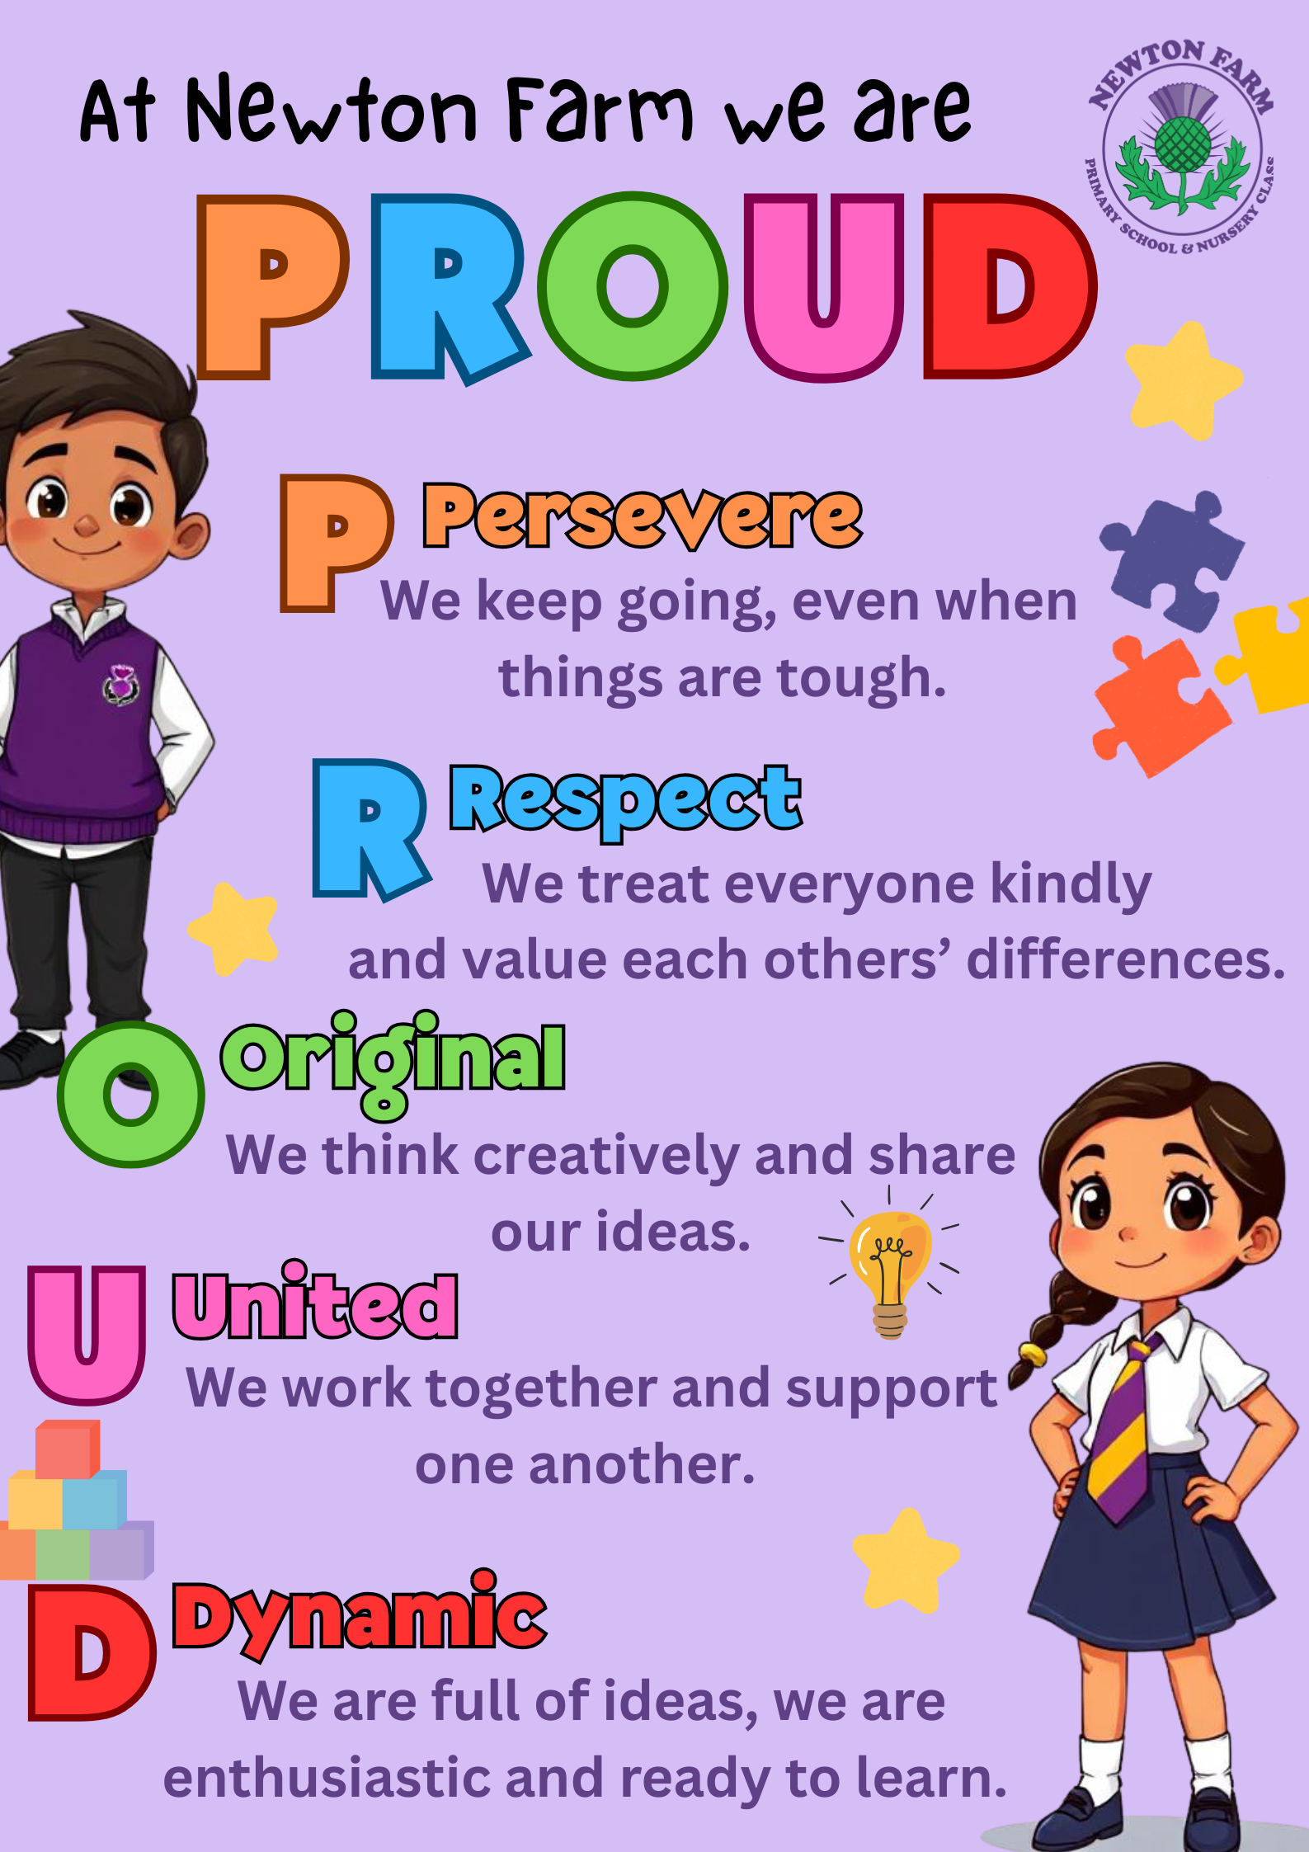




Dance Team Performance
Our P7 Dance Club recently performed at the SLC Dance Showcase in Rutherglen Town Hall and did our school proud with an outstanding performance. The group danced to Dancing Through Life from Wicked and impressed the audience with their energy, confidence and enthusiasm. They were all amazing on the night and truly stole the show! A huge well done to all the performers for their hard work and dedication, and a special thank you to Miss White for all the time and effort she put into preparing the group for such a fantastic performance.

At Newton Farm we are PROUD

School Fun Run - Last Friday, our school Fun Run was a success and created wonderful memories for all the children involved. It was great to see such enthusiasm, determination and school spirit throughout the event. We are delighted to share that we raised over £3000 which will go towards new PE equipment and future sporting events for the school. Thank you to all families and friends for your generous support. A special thank you goes to Up and Running Events who helped make the morning feel extra special and exciting for the children. They provided a finishing arch, a starting horn, snacks at the finish line and medals for every finisher, helping to create a real race-day atmosphere for everyone to enjoy. Also, well done to Mrs Sheed for putting everything together. Thank you to all our pupils for taking part and making the event such a success! If you would still like to donate you can do so through ParentPay.

Parking
We would like to remind all parents and carers to park considerately in the surrounding residential areas during school drop-off and collection times. Please take care not to block driveways or park near corners and crossings.
By parking responsibly, you help to keep our pupils, families, and local residents safe. Thank you for your ongoing support and cooperation in helping to maintain a safe environment around our school community.
Biscuit and Blether
This event is an opportunity to chat to members of the management team
–with some tea and biscuits – so if you have any questions about school or
just wish to meet some of the team or parents you might not yet know,
please feel free to come along. Our final date for this year is Tuesday 2nd
June from 9.20am – 10.20am.

Health Week
Our pupils enjoyed a fantastic and busy Health Week filled with a wide range of exciting activities and experiences. Throughout the week, children had the opportunity to take part in rugby, taekwondo, yoga and of course, Sports Day, encouraging teamwork, fitness and fun.
We were also delighted to welcome visitors from Scottish Action for Mental Health, who spoke to the children about the importance of wellbeing and looking after their mental health.
To round off the week, pupils enjoyed African drumming and storytelling sessions today, which were full of energy, creativity and culture.
A huge thank you to Mrs Cowie, Mrs Ventre, Mrs Sheed and the Health and Wellbeing Pupil Voice group who helped make Health Week such a memorable and enjoyable experience for our pupils.




Tuesday 17th - P7 Leavers’ Service 9.30- P7 Leavers party evenin
Communication – Parents and carers can contact us at any time and we are always pleased to hear your views and for you to update us on any concerns you or your child has. We would much rather you let us know as soon as you or your child are worried so we can help as best we can. Please don’t wait but contact us on 0141 642 0333 for school or email gw17newtonfarmoffice@glow.sch.uk and your query will be dealt with by the relevant member of staff.

Diary
Friday 22nd May and Monday 25th May | Holiday
Tuesday 26th May | New P1s Induction Session 3 Group 1
Wednesday 27th May | New P1s Induction Session 3 Group 2
Tuesday 2nd June | Biscuit & Blether 9.20am Parents welcome to come and have tea and a chat with SMT
Wednesday 3rd June | Parent Council Meeting 6.30pm in school
Friday 5th June | P7 Colour Run
Monday 15th June | Holiday
Tuesday 16th June | P7 Leavers’ Service
Wednesday 24th June | Nursery End of Year Celebration
Thursday 25th June | School Closes at 1pm





