

Newton Farm Primary School Newsletter - January 2026
Sharing Success

Dear Parents and Carers,
Welcome back and Happy New Year to you all! The month of January has passed by so quickly and I think we have had almost every type of weather since we have come back. When it is particularly cold, Scott works hard to grit as much of the area outside the school entrance and a path round to the playground but please continue to be very careful when dropping off and picking up as it can still be very icy. We would ask if possible to ensure that your contact details and emergency contacts are up to date at our office. This makes it much quicker for staff to send texts or to contact you should we need to in an emergency. The pupils and staff have returned to a busy term with Panto performances, showcase events, sports events and another episode of our school podcast. We are all looking forward to a busy and productive 2026, and we look forward to seeing you here in school and working with you in the months ahead.
Take care,
Mrs C Meechan

House and Vice Captains
Our House and Vice Captains planned a Sports Event for P4s and P5s following on from the success of the P6 and P7 quiz in November. The event was a chance for pupils to have fun and earn some points for their houses. The House and Vice Captains are great at encouraging pupils to demonstrate our school values in order to earn house points, with their message being - "Keep up the good work, everyone!".

Benedetti Mass Strings Day
On Friday, 23rd January, our Primary 6 violinists were invited to a day of music-making for stringed instruments. Ran by the Benedetti Foundation, 364 pupils from all over South and North Lanarkshire took part; learning new music, making new friends and having fun.
We are so proud of our violinists and glad that they were able to enjoy such a fantastic opportunity. Thank you too, to Mrs Robertson, their violin teacher, for all of her hard work with the children.


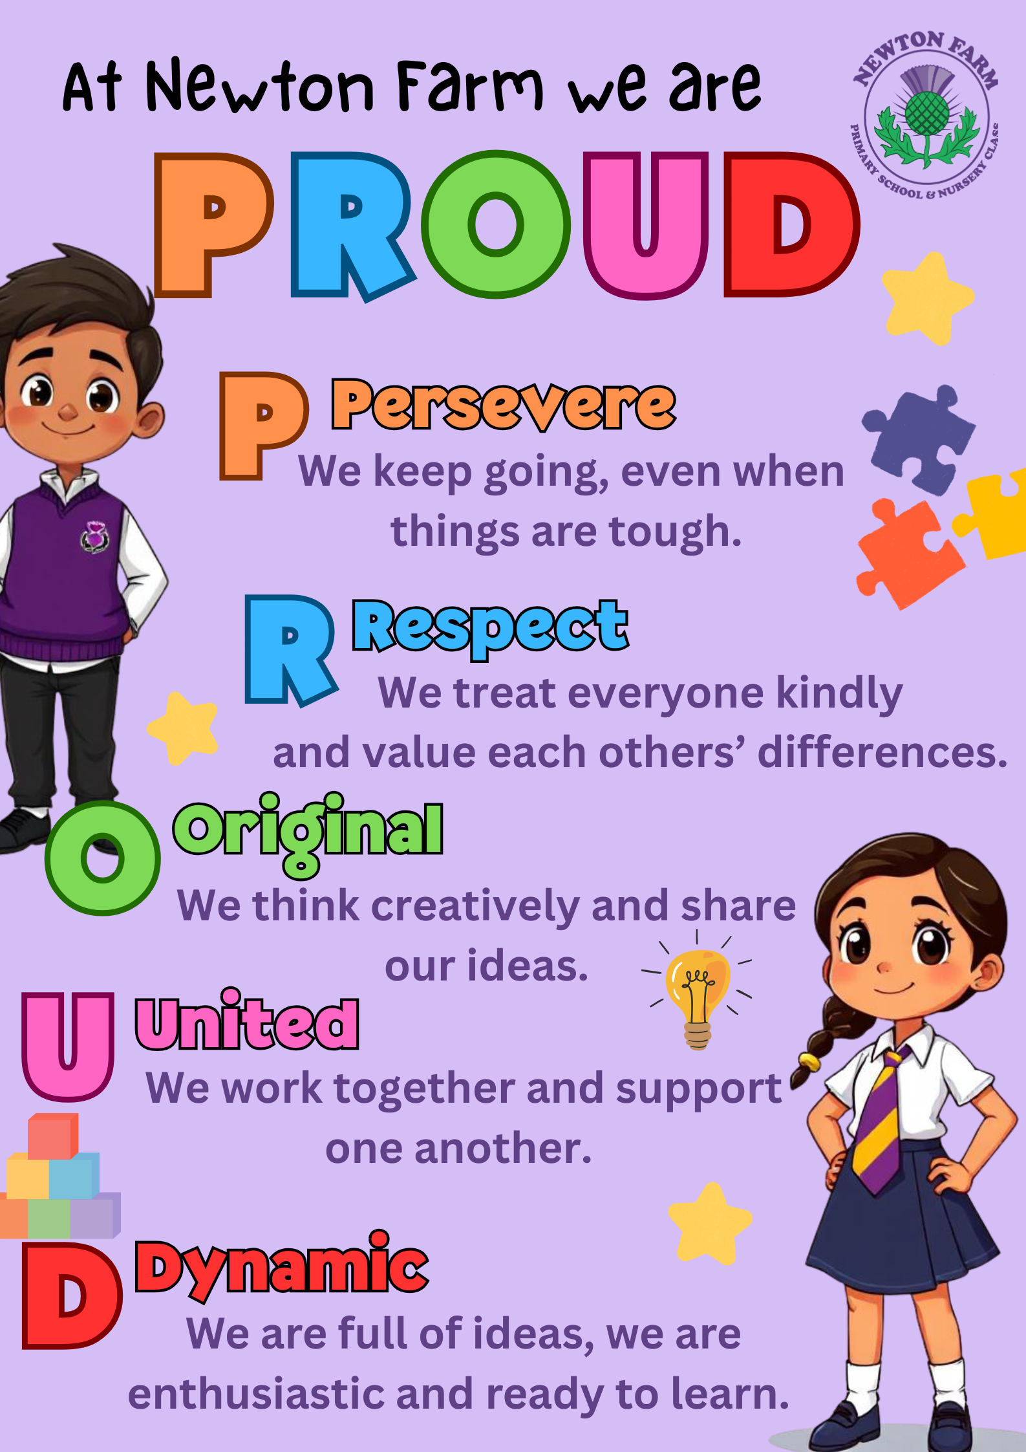




At Newton Farm we are PROUD

Primary 7 visit to Uddingston Grammar
Our Primary 7 pupils visited Uddingston Grammar where they got the chance to visit classrooms, meet staff and try out new subjects. The P7s all came back having had a great time and are looking forward to their two-day visit in May.

Celebrating Scotland!
During January Primary 1 and 2 have been celebrating all things Scottish. They have been learning about Robert Burns - who he was and why he is so famous. There has been lots of Scottish singing and dancing and learning some Scots dialect. Some children even tried some haggis, neeps and tatties and there were mixed responses! Some of the children designed their own tartans and there were lots of Scottish stories and poems shared. It's been a lot of fun! The Primary 2s will be continuing to learn much more about Scotland during their topic.
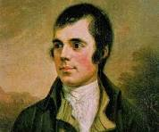

January has started off with a bang with all our classes starting to think about and plan their class trip. We have lots of exciting outings coming up over the next few months, including a visit to The Burrell Collection. Kelvingrove, the Windfarm, Hampden and St Mungo’s. Keep an eye on your emails if you haven’t already heard where your child(ren) will be going! All our children will have had the opportunity this session to attend an educational visit, which, through consultation with our whole school community, will mostly be funded with our Participatory Budget (PB) money. We would like to thank all our parents/carers/family members who have offered to give up their time to accompany our pupils.

This term the children within our supported classes are taking part in a 10-week block of music delivered by Fiona Clark who is an arts development officer. Fiona has been delivering weekly singing and percussion lessons to all 4 classes, and the children have been enjoying taking part.

South Lanarkshire have given each school a budget to spend on sensory equipment, we used this to buy equipment to revamp our sensory room which is currently in production. We are very excited to open this up to our learners very soon.

Our next Supported Classes parent’s coffee meeting will be on Friday 13th February at 9.30am. This will just be an informal catch up (no guest speakers).



Tuesday 17th - P7 Leavers’ Service 9.30- P7 Leavers party evenin
Communication – Parents and carers can contact us at any time and we are always pleased to hear your views and for you to update us on any concerns you or your child has. We would much rather you let us know as soon as you or your child are worried so we can help as best we can. Please don’t wait but contact us on 0141 642 0333 for school or email gw17newtonfarmoffice@glow.sch.uk and your query will be dealt with by the relevant member of staff.

Diary
Friday 30th & Saturday 31st January | Parent Council Kpop event – information issued to ticket holders by Parent Council
Tuesday 2nd February | Biscuit & Blether 9.20am Parents welcome to come and have tea and a chat with SMT
Wednesday 3rd February | Parent Council Meeting 6.30pm in school
Thursday 4th February | P4 & Rm 11 Showcase 1.40pm
Monday 16th &  Tuesday 17th February | Holiday
Wednesday 18th February | Inservice Day – pupils do not attend school
Thursday 26th February | P3 & Rm 7 Showcase 1.40pm

- Upcoming school outings - parents will be contacted with information specific to their child’s class.

Thank you to Hopscotch Theatre group who came into school on 12th January and performed The Wizard of Oz for us. The children and staff enjoyed the performance (the actors put on three performances for us to fit us all in!) A huge thank you to our Parent Council who paid for this event for our pupils. It was a lovely way to round off the festive period.



