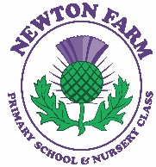
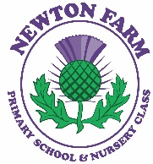
Newton Farm Primary School Newsletter - December 2025

Newton Farm Launches Its Very Own Radio Station!
We are excited to announce that Newton Farm is introducing its brand-new in-house radio station, led by Mr Allen and our enthusiastic Primary 5 pupils! This will take the form of a fun and engaging podcast, created by our pupils, for our pupils.

Each weekly episode will feature a fantastic mix of birthday shout outs, jokes, school news, song requests, and plenty more surprises along the way. It’s a wonderful opportunity for pupils to develop confidence, creativity, and communication skills while keeping our school community connected.

The Newton Farm Radio podcast will officially launch during the week beginning 15th December. Stay tuned, exciting things are on the air!

P1 Enrolment
If your child will turn five between 1 March 2026 and 28 February 2027, you need to register them for starting school. You should complete the online registration form from Monday 5 January 2026.
Once you have submitted the form, your catchment school will contact you to arrange a discussion between Monday 12 January and Friday 16 January 2026.

If you would like your child to attend a school other than their catchment school, you must register them at the catchment school first. Enrolling at the catchment school is required for every child. Once this is done, you can then submit a placing request.

To enrol your child at school please see the link below - https://www.southlanarkshire.gov.uk/info/200186/primary_school_information/392/enrolling_your_child_for_school

Athletics Team Sponsorship
We are delighted to share that United Sports has generously sponsored our school athletics team. Thanks to their support, the team will be kitted out with 30 purple T-shirts and 30 pairs of black shorts, helping our pupils look and feel their best as they represent the school.

The new kit will be produced by Prism, and we look forward to seeing our athletes wearing it with pride. A huge thank you to United Sports for their generosity, we are very excited for the season ahead!

Dear Parents and Carers,
I would like to extend my heartfelt thanks to all parents and carers for your support during my time as Acting Head Teacher at Newton Farm. I have truly loved working with your children over the last few months, and I am so grateful for the warm welcome I received from the entire school community.

My last day at Newton Farm will be 19th December, after which I will return to my role as Head Teacher at Burgh Primary following the Christmas break.

Thank you once again for your kindness and support. I wish you all a wonderful and festive holiday season.
Take care, Mrs L Easton



Bikes and Scooters on School Grounds
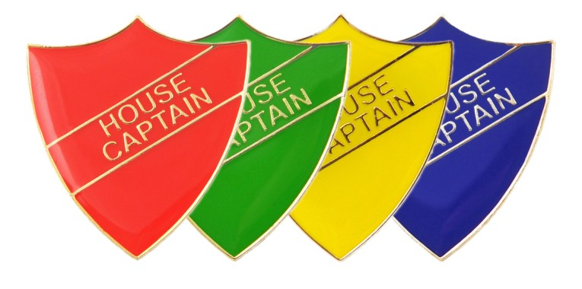


P7 Residential at Inverclyde

Our Primary 7 pupils had a wonderful time on their recent residential trip to Inverclyde. The 92 children who attended enjoyed the chance to take part in a wide range of both indoor and outdoor activities, helping them build confidence, teamwork, and unforgettable memories.

A thank you goes to our dedicated staff and parent volunteers whose support and enthusiasm helped make this experience so successful. We truly appreciate everything you do.

Children in Need

A huge thank you to all our parents, carers, and pupils for your fantastic support of Children in Need on the 14th November. From dressing down to taking part in our “guess the sweets in the jar” competition, your involvement helped make the day a great success.

We are delighted to share that we raised a fantastic total of £520.19, all of which will go directly towards supporting children in need across the UK. Thank you once again for your generosity and community spirit!

House Captains Led Their First School Event!

Our House Captains and Vice Captains successfully led their first whole school event of the year a fantastic House Quiz specially created for our P6 and P7 pupils. With a wide range of engaging categories, the captains put together an exciting challenge that was enjoyed by all.

Congratulations to Air House, who emerged as the winners and added valuable points to their overall total!

The leadership team is already busy preparing their next responsibility: organising the Winning House Treat for Term 1, which will take place during the week beginning 15th December. We can’t wait to see what they plan!

Wear It Bright Day

On the 21st of November, our pupils took part in ‘Wear It Bright’, a special day organised by our Junior Road Safety Officers alongside Miss Napier. The purpose of the event was to remind everyone of the importance of being visible during the darker winter months, when daylight is limited and road conditions can make it harder for drivers to see pedestrians.

Our pupils certainly embraced the theme, filling the school with colour and raising awareness in a fun and meaningful way. Thank you to everyone who took part and helped promote road safety this winter!

P6 Violinists

On 8th December, our Primary 6 violinists visited Uddingston Grammar to rehearse in preparation for their performance at the Christmas Concert held at Uddingston Old Parish on the evening of 9th December. This was a wonderful opportunity for our pupils to collaborate with others and experience performing as part of a larger ensemble.

Well done to all pupils involved—your hard work and musical talent make us incredibly proud!


Football Team Trip to Manchester City – 4th January

We are delighted to share that 45 pupils from our school football teams, along with 5 staff members, will be attending the Manchester City vs Chelsea match on the 4th of January. This is a fantastic opportunity for our young footballers to experience a top-level game and be inspired by professional players in action.

We hope everyone attending has a wonderful time and enjoys this exciting sporting experience!


Parent Council

The Parent Council has generously funded our new friendship bench, which will help promote friendship, inclusion, and kindness across the playground. We are eagerly awaiting its delivery and look forward to sharing it with the children.

They also provided the ‘Wear It Bright’ safety packs for every child in the school, helping to keep our pupils visible and safe during the darker winter months.

A special thank you, too, for the organisation of a fantastic Christmas Fayre. The event was a huge success, bringing families together and creating a wonderful festive atmosphere. We truly appreciate the countless hours of planning and preparation that went into making it such an enjoyable community celebration.

Thank you once again to our Parent Council for everything you do, your support is invaluable.


Network Rail Christmas Trip

On Friday 5th December, pupils from Rooms 10, 12, 22 and 25 enjoyed a fantastic festive trip funded by Network Rail. Pupils and their parent/carers were given the wonderful opportunity to travel by train from Newton to Glasgow Central, where the journey was made extra special with songs and games on board.

Once in the city, everyone enjoyed some food together before returning to Newton after a memorable day out. It was a joyful experience that brought families and classes together. A huge thank you to Network Rail for making this trip possible!


Proud Clouds

We are excited to share that we have introduced Proud Clouds across all classes. These clouds are earned when pupils demonstrate our school values, helping to celebrate everyday achievements.
Here’s how Proud Clouds work:

- SMT award Proud Clouds to pupils around the school
- Every 20 Proud Clouds earns a class reward, chosen by the class
- Working together helps our school shine!

We are already seeing fantastic teamwork and enthusiasm as classes work towards achieving clouds.
Diary – December
Wednesday 10th December | Christmas Concerts -  9.30am - Rms 4, 5, 6  10am - Rms 7 and 8  11am - Rms 9 and 11  Whole School Christmas lunch  Nursery Parties
Thursday 11th December | Christmas Party –  1.30pm - Rms 22, 23, 24, 26 and 27
Friday 12th December | Christmas Parties –  9.15am - Rms 13, 14 and 15  11am - Rms 16, 17 and 18  1.30pm - Rms 19, 20 and 21
Monday 15th December | Christmas Parties –  11am - Rms 4 (P2s), 5 and 6  1pm - Rms 7, 8, 9 and 11
Tuesday 16th December | Christmas Party –  9.30am - Rms 1-4 (P1s)
Wednesday 17th December | Nursery Nativity
Thursday 18th December | Winning House Treat
Friday 19th December | School closes 2.20pm (Supported classes)  School closes 2.30pm

Communication

Parents and carers can contact us at any time and we are always pleased to hear your views and for you to update us on any concerns you or your child has. We would much rather you let us know as soon as you or your child are worried so we can help as best we can. Please don’t wait but contact us on 0141 642 0333 for school or email gw17newtonfarmoffice@glow.sch.uk and your query will be dealt with by the relevant member of staff.




