

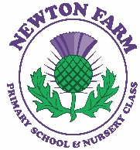
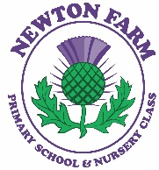
Newton Farm Primary School Newsletter - September 2025

Dear Parents and Carers,
I would like to begin by sincerely thanking you all for the warm welcome I have received since joining Newton Farm Primary School and Nursery Class. It has been a real pleasure getting to know your children and being part of such a caring and supportive school community.

It has been a fantastic start to the month, and I’ve enjoyed visiting classrooms, chatting with pupils, and witnessing the wonderful learning and enthusiasm that fills our school every day.

A very warm welcome to all the new children and families who have joined us over the past few weeks. I would also like to extend a special welcome to Miss Welsh, who has joined our staff team to cover in Room 9 while Mrs Riley is on maternity leave.
Take care, Mrs L Easton
School Improvement Plan

Every session, we establish our school improvement priorities for the year ahead. These priorities are identified through a rigorous process of self-evaluation, ensuring they reflect our commitment to continuous improvement and the evolving needs of our school community. Our priorities for 2025/2026 are as follows:

Strategic Priority 1: To raise attainment in writing through the Improving our Writing project
Participate in the More Than Words Project (Supported Classes)

Strategic Priority 2: To continue to increase parental engagement and involvement

Strategic Priority 3: To embed skills-based learning throughout the school

Homework
Homework will commence from the week beginning 29th September. Primary 1 and Primary 2 pupils will be issued with paper copies/jotters. Pupils from Primary 3 to Primary 7 can access their homework via Google Classroom, which is available through your child’s Glow account at https://glow.rmunify.com/.

Due to GDPR regulations, we are unable to send passwords home, but all children have been practising accessing their Glow accounts at school. If you have any questions or need assistance, please do not hesitate to contact the school.

Celebrating Success
At Newton Farm, we love celebrating success! Every week during our assemblies, we recognise the achievements of our pupils. If your child has any accomplishments or special achievements from home that they’d like to share, please encourage them to bring these along on Fridays. Alternatively, you can email the details to the school office, and we’ll be delighted to celebrate their success with the whole school community.


Bikes and Scooters on School Grounds
Lost Property
We encourage all parents and carers to check our lost property at their earliest convenience. The items are located at the front of the school and currently include jackets, jumpers, water bottles, packed lunch boxes, and bags.
Participatory Budget Survey – Your Voice Matters!
As part of the Pupil Equity Fund (PEF), we are inviting parents and carers to take part in a survey to help decide how 10% of the PEF budget will be spent to support the wellbeing of all pupils at Newton Farm.

Voting is already underway within the school, with children and staff choosing from the following options:

- Playground toys and games
- Resources to develop play in classrooms
- School trips and workshops
- Chromebooks and iPads
- School resources

We now invite you to have your say by following the link in the email to cast your vote. Every option is valuable in helping us promote equity and wellbeing for all our pupils.

Parent Council Halloween Disco Tickets – Now Available!
Don’t forget to purchase your tickets for the Parent Council Halloween discos! Tickets are available to buy online at https://www.pta-events.co.uk/newtonfarm until Sunday 22nd October. The cost is £4 per child.

The discos will take place on:
- Monday 27th October for P1 and P4/5
- Tuesday 28th October for P2/3 and P6/7

We look forward to seeing all the children join in the fun!

Help Us Grow Our School Garden!
As part of our Outdoor Committee’s ongoing efforts, we are excited to be developing our school garden to create a vibrant green space for all pupils to enjoy. The garden will provide valuable hands on learning experiences, helping children explore nature, develop gardening skills, and understand the importance of growing flowers and vegetables.

To support this project, we are kindly asking for donations of pre-loved garden tools, gloves, and seeds for planting. If you have any items you can contribute, please send them into school by Friday 13th October.

Thank you in advance for your generosity and support in helping us cultivate a beautiful and educational outdoor environment for our children.

Extra-Curricular Clubs
We are pleased to share that two extra-curricular clubs are currently running, led by Active Schools. Multi Sports takes place on Tuesdays at lunchtime for Primary 4 pupils, while Sidekicks runs on Wednesdays for Primary 7 pupils.

More opportunities for children to participate in a variety of clubs will be available throughout the session. Please keep an eye out for further updates and information.

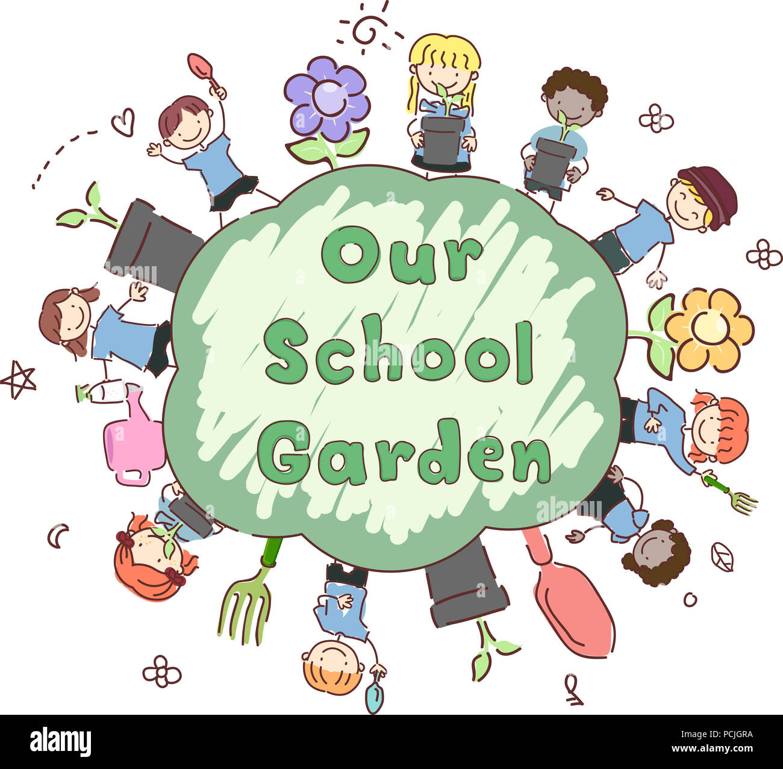



Any items not collected by Thursday 10th October will be either added to our pre-loved clothing collection or donated to a local charity on behalf of Newton Farm Primary School and Nursery Class.

Thank you for your support in helping us manage lost property and reduce waste.

Bikes and Scooters on School Grounds
We kindly ask that all children dismount from their bikes and scooters as soon as they enter the school grounds. This helps to keep everyone safe and prevents any accidental bumps or injuries.

Thank you for helping us maintain a safe environment for all.

Nursery Class
We are delighted to welcome our newest nursery children to Newton Farm! Since starting, they have been busy creating, exploring, and developing their natural curiosity every day. We look forward to watching them grow and learn as part of our wonderful nursery community.

The nursery will continue to keep parents and carers informed through their SWAY presentations, which will be shared regularly on Learning Journals.


Parent’s Night – Thursday 9th October
A reminder to all parents and carers to please book your Parent’s Night appointment for Thursday 9th October. This is a valuable opportunity to discuss your child’s progress and learning with their class teacher. If you haven’t yet booked your slot, we encourage you to do so as soon as possible to ensure you secure a time that suits you.

Diary – September/October
Friday 26th September | HOLIDAY
Monday 29th September | HOLIDAY
Wednesday 1st October | Parent Council Meeting – 6.30pm
Thursday 9th October | P1-P7 Parents’ Evening
Monday 13th – Friday 17th October | October Week Holiday
Tuesday 28th October | Biscuit and a Blether Drop In  9.10am – 10.10am
Wednesday 29th October | Parent Council Meeting – 6.30pm

Communication – Parents and carers can contact us at any time and we are always pleased to hear your views and for you to update us on any concerns you or your child has. We would much rather you let us know as soon as you or your child are worried so we can help as best we can. Please don’t wait but contact us on 0141 642 0333 for school or email gw17newtonfarmoffice@glow.sch.uk and your query will be dealt with by the relevant member of staff.

