Literacy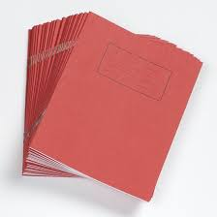

This week in literacy we did a phoneme story about the phoneme ‘j’.After we had to highlight all the j sounds.We also got the chromebooks out to do a sheet about halloween in preparation for our writing.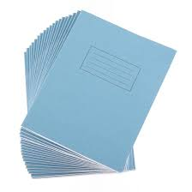

Maths

In maths this week we did the 2, 3 and 4 time tables.With Miss O Brian we made a halloween timetable for what we will do on Monday afternoon.After we had to make our own one up.

Reading

This week in reading we got a sheet with lots of tasks to do about our class novel Mr. Skip.



Health And Wellbeing

In health and wellbeing this week we learned about gratitude.

We loved this week and we will look forward to next week.We are always ready for next week!!!