
Education Resources

Newton Farm Primary School
and Nursery Class
Handbook
2024

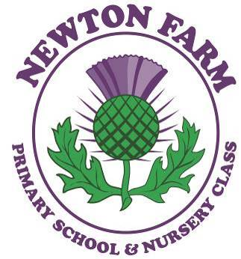

Contents

- Introduction
- About our School
- School Ethos
- Staff List
- Attendance
- Parental Involvement / Parent Council
- The Curriculum
- Assessment and Tracking Progress
- Reporting
- Enrolment andTransitions
- Support for Pupils

- School Improvement
- School Policies and Practical Information
- General Data Protection Regulation as supplemented by the Data Protection Act 2018 (GDPR)

If you need this information in another language or format, please contact us to discuss how we can best meet your needs.

Phone: 0303 123 1023 Email: education@southlanarkshire.gov.uk.

- Introduction by the Head Teacher

In Newton Farm Primary School and Nursery Class we aim to create a secure, safe environment in which every child feels happy, confident and valued as an individual. All members of staff encourage each child to realise his / her potential.

Emphasis is placed on the teaching and learning of skills such as reading, writing, spelling and mathematics, as well as giving experiences in all other areas of the primary school curriculum. Following Curriculum for Excellence, we provide opportunities for a wide range of experiences in sport, music, art and community involvement to enable pupils to develop relationships, good citizenship, and care and thought for others.

We encourage all of our school community to recognise and follow our school values which are

Respect, Inclusive, Confidence, Honesty, Nurturing and Friendship

We aim to encourage children to think for themselves and acquire self discipline and self confidence.

We hope that all parents and friends of pupils will wish to join with the school, its staff and the Parent Group in helping each child to achieve his/her full potential.

South Lanarkshire Council is the fifth largest authority in Scotland. It covers the following main areas; Clydesdale in the south which features extensive rural areas, Cambuslang, Rutherglen, Blantyre and Uddingston to the north as well as the towns of East Kilbride and Hamilton.

The Council’s Plan Connect sets out the Council’s Vision which is, “to improve the quality of life for all within South Lanarkshire”.

For Education Resources this means delivering services of the highest quality as well as striving to narrow the gap. It is about continually improving the services for everyone at the same time as giving priority to children, young people, families, and communities in most need. The priorities for schools and services are set out in the Education Resources Plan which confirms the commitment to provide better learning opportunities and outcomes for children and young people.

- About our school

School Name: Newton Farm Primary School and Nursery Class
Address: Harvester Avenue
Cambuslang
G72 6AA
Phone Number: 0141 642 0333 - School
0141 642 0469 - Nursery
Email Address: office@newtonfarm-pri.s-lanark.sch.uk
Web Site : https://blogs.glowscotland.org.uk/glowblogs/newtonfarm/

Head Teacher: Mrs. Catherine Meechan

Present School Roll: 690

Stages Covered: Nursery – Primary 7

Denominational Status: Non-denominational

Early Years: There is a nursery in Newton Farm Primary School and Nursery Class, which provides sessions for 2,3 and 4 year olds.

Supported classes in the school: From August 2017 there have been supported classes for pupils within the school.

Schools Modernisation As part of South Lanarkshire Council’s investment in improving school buildings, our new school opened for pupils in August 2017.

Parent Contact The class teacher or a member of the school management team should be the first point of contact for parents who wish to discuss their child. Emails can be sent to the main office or telephone messages left there for staff. All enquiries received from parents are then passed on to be dealt with by the relevant member of staff. Our aim is to resolve issues at a local level as quickly as possible. Parents are always welcome to contact the school to discuss any aspect of their child’s education. Any concerns or complaints can be discussed with the relevant Depute Head Teacher or with the Head Teacher directly. If the issue still remains unresolved, parents can contact the SLC Education Helpline on 0303 123 1023.

Medical / Health Issues When a child takes ill or has an accident in school, parents are notified as quickly as possible by telephone to their home or to the emergency contact listed on the child’s record card. The parent or a responsible adult is expected to collect the child on those occasions. No child is ever sent home from school during school hours on their own.
Parents should inform the school of any particular medical requirements their child may have. Children who require to take medicine during school hours will be given a form to be completed authorising staff to help administer this.

3. School Ethos

Newton Farm Primary School aims to be a school which operates, in partnership with parents and the local community, to provide pupils with an education which will allow them to contribute to the wider world both now and in the future. We have a supportive and encouraging ethos which celebrates success in all areas of school life as well as success outwith school. This allows pupils to make connections between their school learning and the wider world and transfer skills to other aspects of their lives. We encourage input from specialists, parents and friends of the school through special events, specific lessons and educational outings. Pupils are involved in the life of the school and have a Pupil Council and Health / Eco Committee. We are a Sport Scotland Gold School Sport Award holder, Health Promoting and Eco School and we aim to allow our pupils to recognise the impact they have on the wider world, how to appreciate the community they live in and how to work with others around the world. Here are a few comments from some of our pupils on our school:

At Newton Farm Primary, we work hard to make sure everyone is happy and safe. Brandon

Our school is a bright environment which makes it a fun place to learn Niamh

Pupils at Newton Farm Primary are encouraged to work hard. Charlotte

I love our after school clubs. They are the best. Lucy
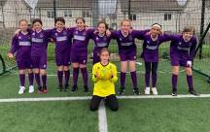



Our P7 girls’ football team. We LOVE reading in Newton We celebrate successes in Farm Primary School! and out of school.

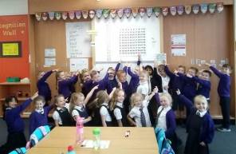

We won two prizes for Beat the Street! We love learning new things!

We started off as a building site but in August 2017 we were ready and welcomed pupils into our beautiful new school.

Everyone in Newton Farm is really friendly. Aaron

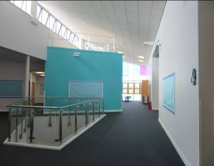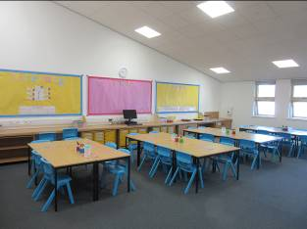
We love our bright and airy corridors and classrooms, especially when the sun is shining.

Teachers are upbeat and plan lots of fun lessons for us. Jack

In Newton Farm Primary School, mistakes are proof that we are trying! Nusaibah

Our corridors are full of displays to show off what we have been learning in class.
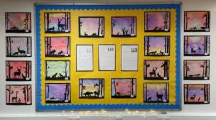
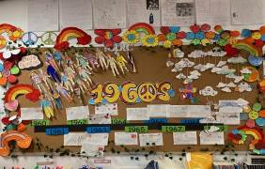

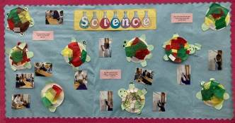
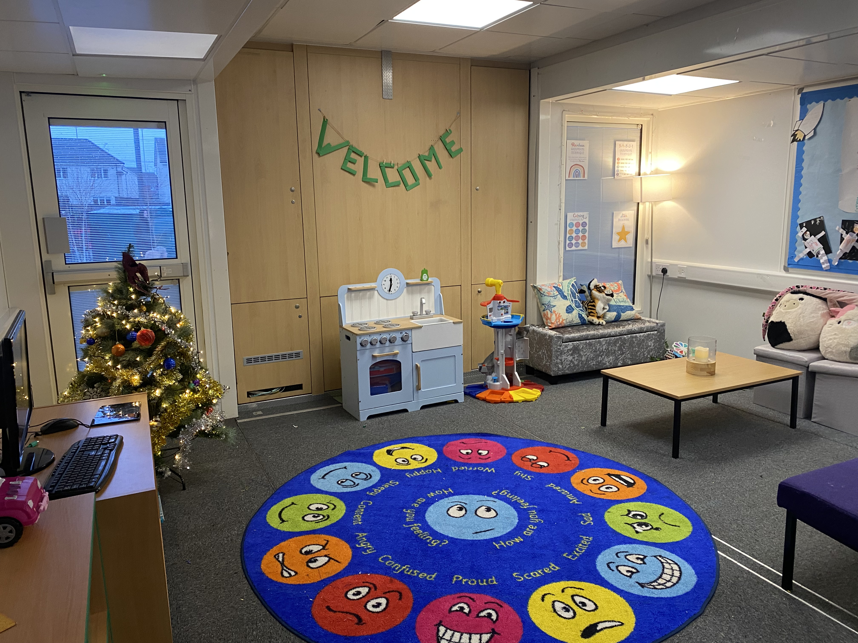

Newton Farm Primary has the best teachers ever. They are respectful and caring towards us. Reiss

In Newton Farm, everyone works to make sure that no one has anything to worry about. Macey
I like making new friends. Leah There are plenty of spaces to do activities. Aaron

I like using the MUGA outside to play football. Daniel I love the school food. Brodie

Staff in our school really look out for us and take care of us. Caiden

I like that the teachers are very nurturing and make sure you are ok. Evie

I like coming to Newton Farm Primary School because it makes me feel safe. Evan

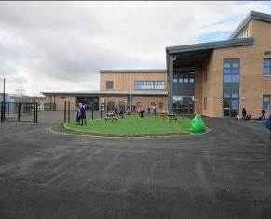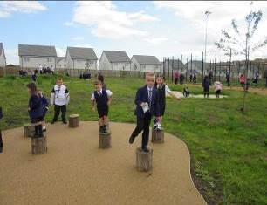
Our playground is a great place to play with all of our new friends.

I like the trim trail in the playground because of the different obstacles. Zachary

Learning at Newton Farm Primary School is really fun! Brodie
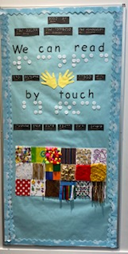
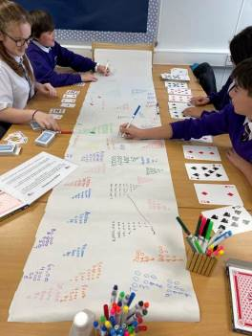

There are lots of opportunities to go outside of school through clubs, leadership events etc. Innes

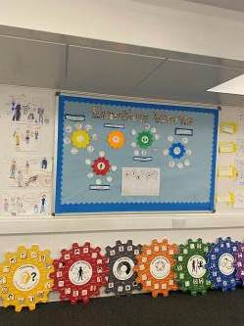

We have lots of good jobs and roles within the school such as head pupils, pupil council, maths ambassadors, language ambassadors. Evie

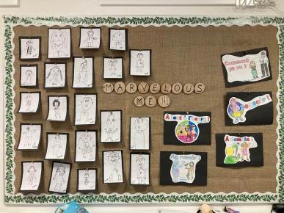


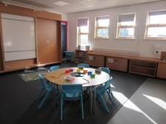

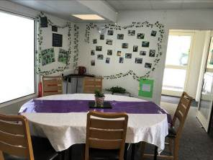

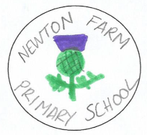


Our school badge and school uniform were designed by two of our pupils, Katie and Emily. Katie’s badge was then used to create our school logo.

We asked some of our parents what they thought of our school. Here are some of their responses…

“Everybody at Newton Farm works as a team – class teachers, management, support and clerical staff.”

“We all love the school. There is a positive and supportive culture and staff and pupils work to promote a welcoming atmosphere.”

“We love that the school gives all children the chance to be independent and that children are openly encouraged to discuss and express their thoughts and feelings.”

“Everyone is treated fairly and there is an ethos of inclusion. Dynamic and active learning opportunities are evident everywhere.”

“The presence of teachers at the beginning and end of the day, as well as knowing the children’s names, adds a personal touch and a feeling of being valued and part of the school community. Nurture is a huge part of everything the school does. It’s not just about teaching and learning.”

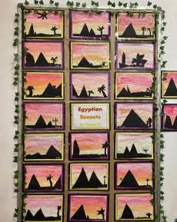
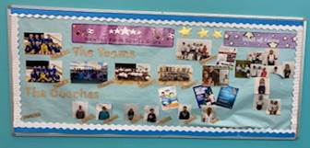
Our school is very proud of our Sports Scotland Gold School Sports Award.

We love to look at displays to learn from each other.

“My child wasn’t doing well at his last school, but since
moving here, he’s a different boy.”

“Pupils take part in key events throughout the year such
as World Book Day, Walk to School Week etc.”

Early Years
The school has a nursery which provides a learning environment for young children. Parents from any area may apply to attend the nursery class. To find out more about the nursery please contact staff on 0141 642 0469. However, it should be noted that if you register your child for a nursery in a school this does not mean that they will automatically be enrolled at this school when they are ready to start primary school. All children who move from early years to primary education must register separately for school in the month of January. More information is included on enrolement in section 12.

Newton Farm Primary School and Nursery Class provides sessions for 2, 3 and 4 year olds. Parents may complete an application form for their child by telephoning the Nursery to arrange an appointment with a member of staff. Our Nursery email address is gw20nfnursery@glow.sch.uk

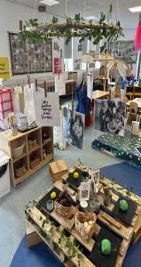
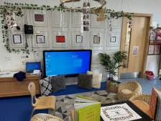
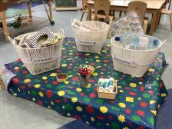

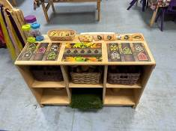

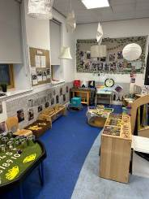

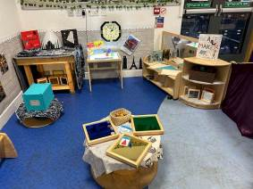

4.School Staff – January 2024

Mrs. Meechan Head Teacher
Mrs. Robinson Depute Head Teacher, P1-2
Mrs. Calder Depute Head Teacher P3-4
Mrs. Webber Depute Head Teacher, P4-7
Mrs Cowie Depute Head Teacher, ASN
Miss. McIntyre Depute Head Teacher, Early Years

Principal Teachers
Miss. Macfarlane
Mr. Allen

Class Teachers
Room 1 Mrs Ventre
Room 2 Miss Lockhart
Room 3 Mrs Kelly
Room 4 Mrs Norton
Room 5 Miss Mulreany
Room 6 Mrs Rae
Room 7 Miss Laird
Room 8 Mrs Kerr
Room 9 Mr Allen
Room 10 Mrs Young
Room 11 Miss Campbell
Room 12 Mrs Low
Room 13 Mrs Forster
Room 14 Miss Kennedy
Room 15 Miss Sutherland
Room 16 Mr McCourt and Miss Riley
Room 17 Miss White
Room 18 Miss Tighe
Room 19 Mrs Stewart
Room 20 Mr Jasnoz-Clark
Room 21 Miss Napier
Room 22 Miss Capper
Room 23 Miss McIver
Room 24 Miss Stark
Room 25 Mrs Readie
Room 26 Miss Henderson
Room 27 Miss Higgins

Miss Gray, Mr Dalling, Curriculum Specialists (Non Class Contact Time Cover)
Miss Smith, Miss Finch Curriculum Specialists (Non Class Contact Time Cover)
Mrs Kane Additional support needs teacher
Miss Macfarlane Nurture teacher
Mr Mackay, Ms O’Brien Additionality teachers
Miss Riley, Mr Dalling Additionality teachers

Early Years Workers Ms Erskine (Team Leader) Miss Watt
Miss Egan Miss Taylor
Mrs Maxwell Miss Harper
Miss Clark Mrs McGill
Miss Sutherland Miss Smith
Miss Bramwell Mr Gilchrist
Miss McGeady Miss Hassan
Early Years Support Staff Mrs Stewart Miss Black Mrs Nicol Miss Hannah

School Support Staff
Team Leader Mrs Nelson
Classroom Assistants Mrs Mitchell Mrs Anderson
Mrs Keenan Miss Gailey
Mrs Ferguson Mrs McAteer
Mrs Trainer Mrs Spiers
Mrs McCann Mrs Beattie
Mrs Graham Mr Sutherland
Mrs Muir Mrs Wooley

Janitor Mr Jackson
Catering Manager Ms Brown

5. Attendance

Every effort should be made to ensure that your child attends school during term time. Please contact the school as soon as possible if your child is unable to attend school. It is important for the school to work with parents/carers in encouraging children to attend school. All absences are required by law to be recorded. Absences will normally fall under two categories – authorised or unauthorised absence. In cases where your child is unable to attend school parents are asked to:

Enter absence reporting procedure here for your school.
Example – If your child is unable to attend school you are asked to let us know by xx on the first day of absence.

It is important for the school to work with parents in encouraging all children to attend school. All absences from school are required by law to be recorded. Absences will normally fall under two categories – authorised or unauthorised absence. In cases where your child is unable to attend parents are asked to:-

- please tell someone at the school if you know in advance of any reason why your child is likely to be absent from school, e.g. if you know they have a hospital/dental appointment. Please telephone the office or let us know in writing. Please also give your child a note on his /her return to school, telling of the reason for absence;

- if your child is going to be absent, please notify the school first thing in the morning. Please let the office staff know the likely date of return and keep them informed if the date changes;

- inform the school of any change to the following:-
  - home telephone number
  - mobile number
  - emergency contact details

Requests for your child to be absent from school to make an extended visit to relatives either in the UK or overseas must be made in writing to the head teacher, detailing the reason, destination and duration of absence and arrangements for their continuing education. On these occasions the pupil will be marked as an unauthorised absence.

Parents may request that their children be permitted to be absent in order to celebrate recognised religious events. Advance notice should be provided to the school when children will be absent. Appropriate requests will be granted, and the pupil noted as an authorised absentee in the register. (See section 7).

Information on emergencies
We make every effort to ensure the school remains open during term-time for
pupils. However, on occasions circumstances may arise which can affect the
school. Schools may be affected by, for example, severe weather, power
failures or through any other circumstances that may impact on the school day. In such cases we shall do all we can to let you know as soon as possible. We shall keep in touch by the most appropriate method at the time normally through text message, and via our social media channels.

In cases of severe weather in the morning such as snow and a heavy frost and if there is a reason the school cannot open in the morning at the normal time, we will adopt the protocol for a delayed start until 10am.

If this is the case a message via social media and on the council’s website will be posted.

The Council’s website www.southlanarkshire.gov.uk will be used to let you know if the school is closed or has a delayed start. Further information will be provided later in the day as to whether the school will be open as normal the next day.

Things we need you to do:

- It is important for parents/carers to let the school know of any change to your mobile/home telephone number and change of address.

- If for any reason, you are unsure if the school is open visit the website www.southlanarkshire.gov.uk or email education@southlanarkshire.gov.uk

a.Your commitments
We ask that you:
- support and encourage your child’s learning – ask them what they have been doing.
- respect and adhere to the school’s policies and guidance.
- accept your responsibility to respect staff who work in the school and for the school to be proactive in taking forward its commitment to care for and educate your child.

Family holidays during term time
Every effort should be made to ensure that your child attends school during term time. Please contact the school as soon as possible if your child is unable to attend school.

Family holidays should be avoided during term time as this both disrupts the child’s education and reduces learning time. If holidays are taken during times when the school is open parents should inform the school in advance by letter.

If your child is taken on a family holiday during term time, then in line with Scottish Government advice this will be classified as an unauthorised absence. However, in exceptional circumstances schools may register a family holiday during term time as an authorised absence when for example, parents are able to demonstrate they have been unable to obtain leave during the school holiday period.

Clearly, absence with no explanation from parents will mean that the absence will be recorded as unauthorised.

In our approach to raising attainment and achievement it is recognised that attendance at school is something that should be continuously encouraged. Parents/carers, children and the school all have a part to play in encouraging and stressing the importance of attendance at school.

The school holiday dates, and in-service dates are available from the website www.southlanarkshire.gov.uk

- Parental involvement (Parent Forum / Parent Council / PTA)

South Lanarkshire Council recognises the importance of parents as partners in the education of their child and has published a strategy entitled, ‘Making a difference – working together to support children’s learning’. This is available from the Council’s website: www.southlanarkshire.gov.uk/downloads/file/13457/parents_as_partners_-_strategy_2019

Parents, carers and family members are by far the most important influences on children’s lives. Children between the ages of 5 and 16 children spend only 15% of their time in school! Research shows that when parents are involved in their child’s learning, children do better at school and throughout life. Parental involvement can take different forms but we hope you share the same aims and agree that by working together we can be partners in supporting children’s learning.

As a parents/carers we want you to be:

- Welcomed and given an opportunity to be involved in the life of the school;
- Fully informed about your child’s learning;
- Encouraged to make an active contribution to your child’s learning;
- Able to support learning at home;
- Encouraged to express your views and involved in forums and discussions on education related issues.

Every parent with a child at school is automatically a member of our parent forum. The Parent Council is a formal group, with a constitution, and acts as the Parent Voice of the school.
To find out more on how to be a parent helper, or a member of the Parent Council just contact the school or visit our website https://blogs.glowscotland.org.uk/glowblogs/newtonfarm/

Parentzone Scotland is a unique website for parents and carers in Scotland, from early years to beyond school. The website provides up-to-date information about learning in Scotland, and practical advice and ideas to support children’s learning at home in literacy, numeracy, health and wellbeing and science. Information is also available on Parentzone Scotland regarding additional support needs, how parents can get involved in their child’s school and education.

Parentzone Scotland also has details about schools, including performance data for school leavers from S4-S6 and links to the national, local authority and school level data on the achievement of Curriculum for Excellence levels.

- The Curriculum

Curriculum for Excellence is the name given to the curriculum in Scotland for all children and young people aged 3-18. It is a forward looking, coherent, more flexible and enriched curriculum that provides young people with opportunities to engage with the knowledge, skills and attributes they will need if they are to flourish in life, learning and work.

The curriculum places learners at the heart of education and at its centre are four fundamental capacities - successful learners, confident individuals, responsible citizens, and effective contributors. It includes all of the experiences that are planned for children and young people to support the development of their skills, wherever they are being educated, for example in the family and community, pre-school centre, nursery, and school.

In taking this forward our school will work closely with South Lanarkshire Education Resources and other services to enrich the curriculum, to provide the best possible education for all children and young people. We wish you to feel confident that your child is encouraged and supported to develop their literacy, numeracy and other skills whilst they attend our school.

The curricular areas are as follows:
- Expressive arts
- Languages and literacy
- Health and wellbeing
- Mathematics and numeracy
- Religious and moral education
- Science
- Social studies
- Technologies

If you want to know more about Curriculum for Excellence, please visit Scotland's Curriculum for Excellence (scotlandscurriculum.scot)

Our learning and teaching activities are based on the outcomes and experiences in the guidelines that all schools have for Curriculum for Excellence.

Level Stage
Early The pre-school years and Primary 1 or later for some.

First To the end of Primary 4, but earlier or later for some.

Second To the end of Primary 7, but earlier or later for some.

Languages and Literacy - Reading, Writing, Listening and Talking

The curriculum places a high priority to developing children’s ability to use language accurately and appropriately, to communicate with others for a variety of purposes and to examine their own and others’ experiences, feelings and ideas. We follow a programme of Active Literacy and a variety of core materials and teaching methods are used to equip pupils with knowledge about language. We also have a strong focus on reading for enjoyment for all pupils.

Additional Languages - Children are taught French as part of the Curriculum as our second language in school. This helps provide a good start for further learning in Uddingston Grammar and in future life. We are also learning Makaton which is a sign language used in our supported classes and around the whole school.

Mathematics and Numeracy
The curriculum presents Mathematics as a problem solving activity, supported by a body of knowledge, involving pupils in discovering, discussing, ordering, classifying, generalising, drawing and measuring. Through work in these areas pupils will learn the concepts, facts and techniques required to use and apply Mathematics in different contexts. Many resource materials and
learning strategies are used to teach these subject areas including New Scottish Heinemann Maths, Mathletics and Number Talks.

Social Studies
We aim to teach our children to understand, care for, and appreciate the world around them through Social Studies. They require to have an understanding and awareness of the environment which should relate to the part they play and will play, as a member of society.

Whenever possible educational outings are included in the children’s programme of study.

Online resources and television programmes are used where appropriate, and opportunities are provided for the practice of skills learned in other curricular areas.

Expressive Arts
The curriculum includes regular teaching of Music, Art and Design and Drama. Each has its own range of skills and techniques to be learned.
Music: The school aims to ensure that all children have the opportunity to create, perform and respond positively to music. A variety of tuned and untuned percussion instruments is available at all stages.
Art and Design: Pupils are given the opportunity to explore, create and learn about Art and Design. Pupils make use of many different materials to express themselves e.g. paint, crayon, ink, clay, and work is displayed in the classrooms, open areas and corridors throughout the year. Children are also given opportunities to learn about famous artists and paintings.

Drama: Each year pupils will take part in a variety of drama activities. These lessons will provide another means for learning and expression. At the early stages this begins with role play and progresses to improvisation, taking part in
small plays, choral speaking etc.
Health and Well Being
Physical Education: The school uses movement as a medium for learning and
expression. We wish to encourage pupils to recognise from an early age the
importance of exercise in maintaining healthy bodies. To this end the curriculum
includes games skills, active health, dance and inventive movement using large
apparatus. There is a wide range of apparatus and equipment in the school and
every effort is made to ensure that children are trained from an early age to
use these correctly and safely. Our annual sports day is held in the last term and
all children have an opportunity to participate with their classmates. We have an Active School Coordinator who constantly looks for opportunities for children of all ages to be more active.

Personal and Social Development is included in pupils’ programme through discussions, circle time, drama, etc. Through the programme we encourage fairness, sharing, helping and caring and discourage bullying, fighting, etc, through positive reinforcement of good behaviour.

Health education is taught throughout the stages through topic work and specific lessons. However Health Education is also taught as required on a daily basis and at specific times of year such as Bonfire Night. This allows staff to highlight issues such as road safety, healthy eating, home safety and drug awareness. Health and Well Being is an integral part of all aspects of school life.

Religious and Moral Education
Religious and Moral Education is undertaken by class teachers and is based on Council and Scottish Government requirements. Lessons include stories from the Bible, themes which encourage concern and care for others, and the study of other world religions, e.g. Islam and Judaism.

Weekly assemblies take place in school for pupils. The local ministers and Chaplaincy team participate in school life regularly.

Spiritual, social, moral and cultural values (religious observance)
Rights of Parents / Carers
Scottish Government Ministers consider that religious observance complements religious education and is an important contribution to pupils’ development. It should also have a role in promoting the ethos of a school by bringing pupils together and creating a sense of community.

There is a statutory provision for parents to withdraw children from participation in religious observance. This right of parents’ wishes will be respected. Where a child is withdrawn from religious observance, schools will make suitable arrangements for the child to participate in a worthwhile alternative activity. Parents may request that their children be permitted to be absent in order to celebrate recognised religious events. Advance notice should be provided to the school when children will be absent. Appropriate requests will be granted and the pupil noted as an authorised absentee in the register.

- Assessment and Tracking Progress

Assessment is an essential part of learning and teaching at every stage in Newton Farm Primary School. Children are routinely assessed by staff to enable us to find out whether:-
- teaching objectives have been achieved
- pupils are making steady progress
- and to focus on pupil’s learning needs and plan for supports and challenges as required.

Assessment takes a variety of forms. It can be formal or informal. It can be observations, specific assessment tasks or a review of completed work. We collect information on what we see and on what pupils say, write and do.
Children are also encouraged to peer and self assess their work and their class mates’ work and effort as they go through school, saying if they found tasks easy or difficult, and how they can improve. This allows pupils to learn how they learn and recognise their own and others’achievements.
We want to share with you on how your child’s learning is progressing. We do this through informal feedback, written reports and formal parents meetings each session.

- Reporting

Newton Farm Primary School recognises that good partnership working between parents, children and school is the key to a successful education for your child.

Reporting will be ongoing and comprises of a range of activities which can include children presenting their learning, newsletters with class updates, our school blog updates and ongoing oral discussions.

Parents receive information from class teachers and specialist support staff of any particular challenges a child may be having.

We also have parents’ evening during the school year where parents have the opportunity to chat to the class teacher about their child’s progress.

Our ‘learner reports’ will help you to get to know more about the curriculum which each child follows and will describe their strengths, achievements and areas for development so you know what encouragement and support you can give.

We welcome any comments or additional information from parents to help us provide the best possible education for your child.

Home School Links
In May and June each session, pre school children have the opportunity to visit our school, to see our building and help them understand what to expect when they start school in August. Each child receives a “starter pack” and we hope to provide an opportunity to see the P1 teachers at this time. Parents have an opportunity to express an interest in joining the Parent Council and to meet various partners who work with us here in school.

Information about our school evenets and general school matters is posted on our Blog or directly to parents on Parent Portal. Bulletins are issued regularly on our Blog and updates from classes are posted weekly. Parental consultations are held each school year to give parents and staff an opportunity to discuss each child’s progress, we have a Meet the Teacher event at the start of term to explain what routines take place in your child’s classroom. Throughout the year parents are given opportunities to support the children with class work, and support school events and fun days. We have a school blog, Parent Portal and Twitter account to help build communication links with the community and share what we do here in Newton Farm and celebrate our successes.

Our Parent Council has worked hard over the past few years helping to provide funds for educational materials and fun events for the children. Each year workshops have been held for parents on curricular areas and school developments and we hope to continue this in a different format in the year ahead. We also look for help from all parents in the wearing of school uniform, attendance and discipline.

Towards a safer school
Newton Farm Primary School places a strong emphasis on pupil safety and parents may wish to know that an adult presence is provided in playgrounds at break times in terms of the Schools (Safety and Supervision of Pupils) (Scotland) Regulations 1990.

- Enrolment and Transitions

Enrolment – how to register your child for school.

To register your child for school you should complete our online registration form. This can be done using the South Lanarkshire website.

www.southlanarkshire.gov.uk/info/200186/primary_school_information/392/enrolling_your_child_for_school
If you have any difficulty in identifying your catchment school, please email Edsuppserv.helpline@southlanarkshire.gov.uk

The online registration form will ask you to provide each child’s full birth certificate and two pieces of recent official documentation both containing your permanent home address for example a utility bill, council tax statement, housing rent card, child benefit documentation.

Proof of where the child lives may also be needed.

If your child is due to start school in August 2024, you can enrol online from Monday 8 January 2024. Your catchment school will contact you between Monday 15 to Friday 19 January 2024 to confirm your enrolment.

If your child attends the nursery of your catchment school, please do not assume that they will automatically be transferred. You must register them as normal at the school that is in the catchment area for your home address

If parents want their child to go to another school, they must enrol in the first instance with their catchment school and intimate that they wish to make a placing request. An online placing request form is available from the SLC website – www.southlanarkshire.gov.uk or by contacting edsuppserv.helpline@southlanarkshire.gov.uk or phone 0303 123 1023.

Change of School/Placing Request
Normally children attend the school in their catchment area. However, there are times when parents may wish their children to go to other schools. If you wish your child to go to another school then you may make what is known as a ‘placing request’. If you live in South Lanarkshire and decide to submit a ‘placing request’, we are unable to reserve a place in your catchment school until the Council have made a decision on the ‘placing request’. Please note if your ‘placing request’ application is unsuccessful and all places at your catchment school are filled you will be offered a place at the next nearest appropriate South Lanarkshire School.

Please note that if an application for a ‘placing request’ is successful then school transport is not provided.

If you move outwith your catchment primary school a ‘request to remain form’ must be completed. If you move outwith your catchment primary, this may affect your right to transfer to the associated Secondary School. Please note the secondary school is determined by the pupil’s permanent home address and chosen denomination. If you require further information, please contact Education Support Services on edsuppserv.helpline@southlanarkshire.gov.uk or 0303 123 1023.

Transition from primary to secondary school

Pupils normally transfer from primary to secondary school between the ages of 11½ and 12½, so that they will have the opportunity to complete at least 4 years of secondary education. Arrangements are made by the school to transfer children to the associated secondary school as determined by their home address. Parents of P7 children will be informed of the transfer arrangements made for their child to attend secondary school.

We will also provide you with information at this time on events designed to support P7 children before they move on to secondary school.

- Support for Pupils

Getting it right for every child.
Getting it right for every child (GIRFEC) supports families by making sure children and young people can receive the right help, at the right time, from the right people. The aim is to help them to grow up feeling loved, safe and respected so that they can realise their full potential.
Most children and young people get all the help and support they need from their parent(s), wider family and community but sometimes, perhaps unexpectedly, they may need a bit of extra help. GIRFEC is a way for families to work in partnership with people who can support them, such as teachers.

If you have any concerns about your child’s wellbeing, you can speak to the named person who will work with you to provide support and decide how to move forward. Your school will let you know who this is. It is likely to be the Head Teacher in a primary school and a principal teacher (pupil support) in Secondary.

More information can be found on:
www.scotland.gov.uk/gettingitright

Support for All (Additional Support Needs)
Throughout our continuous assessment programme children with learning difficulties are identified and an appropriate learning programme is set up for them. If the difficulties are moderate, the learning programme will be supported by the class teacher with possibly the support of the school specialist support teacher. Should further information and support be required, with parental permission, further advice will be sought from the Educational Psychologist. Parents are encouraged to keep in close contact with the school at this stage and to help as much as possible at home.

We have always found that parents are very co-operative as we work together in partnership for the best interests of children.

To assist some children’s learning, Single Agency Assessments, Additional Support Plans or Co-ordinated Support Plans are kept to record the progress children make towards specific targets. These are completed with input from pupils, education staff and parents.

The school building provides suitable facilities for pupils with additional support needs e.g. those with physical and sensory impairment. Pupils may receive support from the Visual and Hearing Impairment Units, Speech Therapists, Occupational Health Therapists or Behaviour Support Staff while remaining in our school.

From August 2017, there have been supported classes within the school for children with a variety of support needs. These children work with members of their own classroom and with peers in other classes and participate in all aspects of the wider life of the school with all other pupils.

South Lanarkshire Education Resources have published a series of leaflets available which cover information for parents and carers about the Additional Support for Learning Acts.

Enquire is funded by the Scottish Government to provide information on the framework for supporting children who require additional support for learning and to encourage positive partnerships between families, schools and local authorities to ensure children get the right support.

Enquire – the Scottish advice service for additional support for learning

Enquire offers independent, confidential advice and information on additional support for learning through:

Phone Helpline: 0345 123 2303

Address : Enquire
Children in Scotland
Rosebery House
9 Haymarket Terrace
Edinburgh
EH12 5EZ

Email Enquiry service: info@enquire.org.uk

Advice and information is also available at www.enquire.org.uk

Enquire provides a range of clear and easy-to-read guides and fact sheets including The parents’ guide to additional support for learning.

If you would like to order our leaflets, postcards or guides to share with parents and carers of pupils in your school, please contact us on info@enquire.org.uk

Attachment Strategy for Education Resources

Attachment – what we do to support children and young people

South Lanarkshire Council Education Resources is committed to improving outcomes for children and young people by creating emotionally supportive learning experiences in our nurseries and schools.

The Education Resources Attachment Strategy supports the action in the ‘Getting it Right for Every Child in South Lanarkshire’s Children Services Plan 2021-23’, following the launch of the Attachment Strategy in 2020, to provide staff training in Attachment and Trauma based practice.

What does it set out to do?

The aim of the strategy is to promote better experiences of attachment for South Lanarkshire’s children and young people and to ensure that all education practitioners understand the importance of attachment theory and its application and how positive relationships can make a difference to outcomes.

How can I find out more?

South Lanarkshire Council Education Resources have published a series of leaflets and posters for establishments and for parents/carers which aim to share information on attachment theory and on how this informs the ways in which we support children and young people.

These are available in schools and on the SLC Staff Learning Centre Sway accessible by teachers and staff.

- School Improvement

Each year our school produces an Improvement Plan to allow us to improve the service we provide for our pupils and families. It is a strategic plan which highlights which areas we will focus on and how we will take the improvements forward. Copies of the plan can be obtained from the office on request and can also be found on the school Blog website https://blogs.glowscotland.org.uk/glowblogs/newtonfarm/

This year we are reviewing and adapting our Active Literacy Writing programme, ensuring a clear and consistent approach to writing across all stages of the school. We will also be developing plans to increase parental involvement and developing a play pedagogy from Nursery to P7

Well-being continues to be a constant feature of developments in our school. We work with partners to share information with pupils and parents on issues that are current in the area and we encourage staff to continue to develop their skills and knowledge in this area as it is such a crucial part of our work in Newton Farm. We continue tol focus on Nurture and Attachment theory as the main tools in supporting our pupils and we have used our pupil equity funding to increase staffing to have nurture as a focus throughout the school. Our Pupil Equity funding is used to provide a full time Nurture teacher and to support pupil engagement in learning and literacy, health and wellbeing and maths. Our parents as well as our pupils are asked to decide on how our Participatory budget is used and this year the pupils and parents decided to fund an educational outing for each class.

We will continue to improve all aspects of our school and will ask parents to be included and give us feedback on all areas of development.

- School Policies and Practical Information

Nursery
All children attending a local authority nursery will be provided with a free lunch. In addition, if your child attends long mornings or afternoons e.g., over 4 hours 30 minutes they will be provided with a ‘brunch’ or ‘afternoon tea’.

Nursery lunches and snacks are based on nutritional requirements from the NHS “Setting the Table” guidance.

Nursery age children will also receive milk and a healthy snack free of charge under the Milk and Healthy Snack scheme 2021. This will be provided by the establishment

Primary pupils
Healthy eating is something that the school supports and a range of meals are available at lunchtime that meet the Nutritional Requirements for Food and Drink in Schools (Scotland) Regulations 2020

For their lunch each day pupils have the option to choose from two hot meal options plus a snack option. These are all served with vegetables or side salad. All meals also come with fresh chilled drinking water, salad, seasonal fruit and depending on the day - soup or a dessert.

Milk will be available for those pupils entitled to free school meals through the free school meal eligibility scheme at morning break or lunchtime.

Pupils in:
Primary 1 - 5 receive a free school lunch.
Primary 6 - 7 meal cost is £2.05.

School lunches and milk can be paid for through your Parentpay account or Paypoint facilities in local shops.

NB School Meal prices are reviewed annually and may be subject to change

Adapted diets
If your child within Nursery, Primary or Secondary requires an adapted diet for medical reasons please speak to the school/nursery office who will provide the request form for you to complete. In addition, if you have a halal or vegan diet request for your child, please speak to the school office who will provide you with a request form.

Free School Meals
Children of parents who receive the following benefits are entitled to a free lunchtime meal for their child:

Income Support, Universal Credit (where your take home pay is less than £726 per month), Job Seeker’s Allowance (income based), Employment and Support Allowance (income related), Working Tax Credit and Child Tax Credit (where your gross annual income does not exceed £8,717 as assessed by the HM Revenues and Customs), Child Tax Credit Only (where your gross annual income does not exceed £18.725 as assessed by the HM Revenues and Customs) or receive support under Part VI of the Immigration and Asylum Act 1999.

If you are in receipt of Housing Benefit and/or Council Tax Reduction from us there is no need for you to apply online, we will use the information we hold to automatically award free school meals (P6 to S6) and/or school clothing grants (P1 to S6) to eligible families.

We would encourage parents of children who are in receipt of any of the above benefits to take up this opportunity of having a meal provided for their child when they are at school. Arrangements are in place so that children who receive free meals are not singled out and we encourage all children to remain in school at lunch time.

South Lanarkshire Council also offers a free Breakfast service.:- the service runs from 8.15am to 8.45am each school day.

School Uniform

Our uniform consists of the following:
- navy skirt/trousers white blouse/shirt/ polo shirt
- purple cardigan/pullover striped school tie
- school sweat shirt (purple)
We ask all parents/carers to support the school by encouraging your child(ren) to adhere to the agreed dress code and the wearing of our school uniform. The wearing of a school uniform helps promote the identity of the school in the local community and helps create an ethos of sharing and pride in the school.

In addition, the wearing of a uniform helps towards increasing the protection of all pupils. The wearing of a uniform helps staff and the pupils to distinguish between who belongs to the school and those who may be visitors. This enables staff to approach and identify visitors more readily and helps in trying to offer a safer environment for pupils and teachers alike.

Equality of opportunity is an important aspect of the life of the school. Any proposals on the dress code and on what constitutes the school uniform will be the subject of discussion with the Parent Council and where appropriate consultation with parents, pupils and staff.

There are forms of dress which are unacceptable in all schools such as:
- the wearing of football colours
- clothing with slogans that may cause offence (anti-religious, symbolism or political slogans)
- clothing which advertises alcohol, tobacco or drugs
- clothing which can be deemed unsuitable in terms of health and safety grounds such as shell suits, combat style clothing, dangling earrings, loose fitting clothes particularly in practical classes
- articles of clothing that could be deemed to inflict damage on other pupils or be used by others to do so
- footwear that may damage flooring.

Allergies
A significant number of children and young people in our schools will have allergies and it is important that parents keep the school fully informed on these matters.

Allergies can present in a variety of ways and can occur at any point in a person’s life. Symptoms range from mild to severe. Children and young people known to have an allergy with moderate to severe symptoms will likely have a Health Care Plan drawn up by the NHS. This will detail symptoms and appropriate interventions.

It is vital that parents share this information with the school and continue to provide any updated information.

Where symptoms are mild and a Health Care Plan is not in place, parents should still continue to liaise regularly with the school on any new triggers, medications and actions required.
In all cases, our employees need to know your child’s symptoms, treatments and any actions required to help prevent exposure to the allergen and minimise the risk of allergic reactions.

Employees in schools will receive training on allergies and will liaise with parents and NHS on any additional specialist training required.

In supporting children and young people with allergies, school employees will operate in accordance with South Lanarkshire Council’s Safe Systems of Work / risk assessment and national guidance on the administration of medicines.

Support for parent/carers

Clothing grant
In certain circumstances the Council provides support to parents/carers for the purchase of school wear. This also now includes nursery children aged 3 and 4 years old.

Applications can be made online at www.southlanarkshire.gov.uk. If you are required to submit evidence of your Tax Credit income it is important that a copy of this evidence is attached to your online application. Should you require further information, or you are unable to submit an application online then please contact the helpline number 0303 123 1011 (option 5).

School Transport
Pupils in Newton Farm Primary who qualify for the service, use the school bus as well as taxis to get to and from school each day. South Lanarkshire Council has a policy of providing school transport to primary pupils who live more than one mile by the recognised shortest walking route from their catchment school. This policy is more generous than the law requires. This means that the provision of transport could be reviewed at any time. Parents who consider they are eligible should complete a form onlinewww.southlanarkshire.gov.uk or contact 0303 123 1023 These forms should be completed and returned before the end of March for those pupils beginning the school in August to enable the appropriate arrangements to be made. Applications may be submitted at any time throughout the year and will be considered by Education Resources.

A privilege transport scheme is operated for mainstream school contracts where a pupil is not entitled to free school transport. Privilege transport will only be granted providing there is spare capacity on an existing school contract and will be from and to designated pick up and drop off points. Privilege transport will not be provided where a service bus is used on the school run. Any spare capacity will be allocated using agreed priorities. More information on school transport is available www.southlanarkshire.gov.uk/info/200188/secondary_school_information/545/school_transport or phone 0303 123 1023.

Pick-up points
Where school transport is provided it may be necessary for pupils to walk a certain distance to the vehicle pick-up point. Walking distance in total, including the distance from home to the pick-up point and from the drop-off point to the school in any one direction, will not exceed the authority’s distance limit for school transport. A school bus to and from Newton Farm Primary operates each day for pupils in this category.

It should be noted that it is the parent’s responsibility to ensure their child behaves in a safe and acceptable manner while travelling in and alighting from the vehicle. Misbehaviour can result in your child losing the right to school transport.

Parents are asked to note that South Lanarkshire Council does not provide transport for those pupils who attend school via a placing request.

Insurance for schools – pupils’ personal effects
South Lanarkshire Council is concerned at the level of claims being received for loss or damage to pupils’ clothing or personal effects. Parents are asked to note the Council’s position in terms of insurance for pupils’ personal effects:

(i) Theft/loss of personal effects
The Council is not liable for the loss or theft of pupils’ clothing or personal effects for example mobile phones, tablets etc. and any items are therefore brought into the school at the pupil/parents’ own risk.

Parents can assist by ensuring that valuable items and unnecessarily expensive items of clothing are not brought to school.

Teachers and other staff have been advised not to accept custody of any such items.

The same principle applies to musical instruments and other equipment used for activities within the school, which belong to the pupil, but are brought into the school. Parents should be aware that if such equipment is left in school, it is done at the pupil/parents’ own risk.

In the case of valuable items such as musical instruments, parents should ensure that these items are covered by their own household insurance.

(ii) Damage to clothing
The Council is only liable for damage caused to pupils’ clothing where the damage has resulted from the negligence of the Council or one of its employees. Claims arising otherwise will not be accepted by the Council’s insurers.
Promoting Positive Behaviour
It is the responsibility of staff within the school to ensure that parent council members, parents and pupils are involved in the creation of a positive school ethos that encourages good behaviour. Equally, the school whilst trying to promote positive behaviour must support young people should incidents or bullying occur. Parents have a significant role to play in working with the school so that teachers, parents and pupils know what is expected of them in trying to change the behaviour and attitudes that contribute to bullying behaviour.

Our approach is to create an environment where better behaviour will encourage better learning. The school, along with the support of parents, can work together to create a learning environment which young people can enjoy and feel safe.

Incidents of bullying should be reported to the school immediately so that each alleged incident can be looked at. Together we can work towards creating a safer school for children and staff.

In addition, a guideline (Promoting Positive Relationships and Behaviour) has been produced to support all teaching and support staff and inform them of their roles and responsibilities in respect of dealing with the small number of children and young people who display challenging behaviour. Early identification is crucial so that intervention can be provided to support children and young people to help them address their issues and concerns. Staff training is provided to help develop the skills needed to respond to and manage challenging behaviour. A wide range of appropriate staff development opportunities has been developed for this purpose.

Child Protection
All staff in educational establishments in South Lanarkshire Council receive an annual Child Protection update and are required to follow the advice and guidance contained within relevant Education Operating Procedures. They must also complete a mandatory Learn on Line Course “Child Protection in Education”.

South Lanarkshire’s children’s services partnership works together to support children, young people and their families so that children grow up in communities where they are safe, healthy, active, achieving, respected, responsible and included, and have the opportunity to achieve their full potential. They are committed to continuously improve our services to ensure children, young people and their families get the right support at the right time.

Sometimes children and young people need additional help to make sure that they are “cared for and protected from abuse and harm in a safe environment in which their rights are respected” (CPC South Lanarkshire Child Protection shared vision). The Child Protection Committee has the overarching responsibility to ensure that agencies individually and collectively work to protect children and young people as effectively as possible.

All staff have a responsibility to report any suspicions that a child has been abused or is at risk of harm, abuse, or neglect. Robust procedures and guidance are in place to support education staff to: -
- be alert to signs that a child may be experiencing risks to their wellbeing,
- report concerns to the head of establishment or the child protection coordinator without delay.
- be actively engaged in support and protection and development of wellbeing.

If you would like more information, or have a concern of a child protection nature, please contact the head of the educational establishment which your child attends.

The Child Protection Committee’s website has a range of useful information for parents/carers to help them keep their children is safe. www.childprotectionsouthlanarkshire.org.uk

General Data Protection Regulation as supplemented by the Data Protection Act 2018 (GDPR)

Information on pupils, parents and guardians is held by the school to enable the teaching, registration and assessment of pupils as well as associated administrative duties. The information is stored and used as per the requirements of the GDPR, with South Lanarkshire Council defined as the data controller. The Council have established a data protection policy that applies to all of its school. Education Resources has also prepared a privacy notice (below) which sets out how we will deal with personal information as part of our statutory function as an education authority. For more information please contact the school.

Privacy Notice

Introduction
In line with the General Data Protection Regulation (GDPR) we have produced this privacy notice to inform you how we deal with personal information as part of our statutory function as an education authority.

The Council has a legal obligation to deliver effective education services to children, young people and adult learners in South Lanarkshire. In order to do this we need to collect personal information about children, young people and their families so that we can help them to learn and keep them safe.

Using your personal information
The Council is a “controller” of the personal information you provide when enrolling for a nursery or school, applying for an education service or participating in groups or activities provided by Education Resources.

Information we collect from you about you and your child at enrolment
When you enrol for a nursery or school, we ask for the following information:
- parent/carer contact details (name, address, phone, email);
- the child’s name, date of birth, gender and address;
- information about medical conditions, additional support needs, religion and ethnicity;
- any information you may wish to provide about family circumstances.

Information we collect at other times
We will also collect information at other times such as when you apply for a benefit, request a services or other support. We will provide an additional privacy notice at these times.
- If you apply for an education service or benefit, such as school transport, free school meals, clothing grant, placing request or EMA, we will also ask for personal information as set out above. We will also ask for information about your income for education benefits applications.

- If you make a request for additional support such as an educational psychologist or other support for learning we will ask for more detailed information to allow us to provide the most appropriate support for your family. This may include information about family circumstances or medical conditions.

- If there are concerns about your child’s wellbeing and/or your child has needs that may require additional support, we will wish to work with you to collect and consider information to enable us to help you get the right support at the right time in line with the Getting it right for every child approach.

We require this information to ensure that children and young people are educated appropriately, supported, and that we take account of their health and wellbeing. We will also ask you to update this information annually and to tell us when there are changes to your details.

Information that we collect from other sources
As an education authority and as part of our statutory function in accordance with our legal obligations, we receive information from other sources such as the SQA, the NHS or Social Work about you or your child, this includes:
- exam results and assessment information;
- information about health, wellbeing or child protection.

Why do we need this information?
We need this information so the Council can ensure it is delivering education services appropriately to all learners:
- for the education of children, young people and adult learners;
- for teaching, enrolment and assessment purposes and to monitor the educational progress of children, young people and adult learners ;
- to keep children and young people safe and provide guidance services in school;
- to identify where additional support is needed to help children, young people and adult learners with their learning;
- to maintain records of attendance, absence and behaviour of children and young people (including exclusions);
- to support children and young people moving on each year from nursery to primary, primary to secondary and when they move or leave school;
- to help us develop and improve education services provided for young people, adult learners or families
- In accordance with our legitimate interests as an education authority we will also use your information to create statistical reports.

We will share your information with:
As an education authority and as part of our statutory function in accordance with our legal obligations we will share information with other bodies or parts of the Council, including:
- The Scottish Government and bodies such as Education Scotland, Scottish Qualifications Authority, Skills Development Scotland and other organisations that support children and young people’s learning;
- Other parts of the Council when required for services such as school meals, school transport, education benefits and with Social work in connection with any child protection concerns we become aware of;
- The NHS, to support health initiatives in accordance with the legal obligation on the Council in terms of section 39(3) of the National Health Service (Scotland Act 1978;
- South Lanarkshire Leisure and Culture Limited, where children and young people are participating in sports and leisure activities;
- Other schools/local authorities – if a child moves or transfers to another school the Council has an obligation to pass on information with regards to pupil records to the new school/local authority.

You have the right to access your personal information as well as the rights of rectification, erasure, restriction and the right to object. For information on these rights and how to exercise them or for information about how we manage your personal information, you can get a copy of our full privacy notice from our website: (https://www.southlanarkshire.gov.uk/info/200235/meta/1730/general_privacy).
Our full privacy notice will also provide information on how to make a complaint or to request a paper copy of the privacy notice from the Data Protection Officer.


Education Resources

School holiday Dates Session 2024/2025
Break | Holiday dates
First Term | Teachers In-service | Monday | 12 August 2024
 | In-service day | Tuesday | 13 August 2024
 | Pupils return | Wednesday | 14 August 2024
September Weekend | Closed on  Re-open | Friday  Tuesday | 27 September 2024  1 October 2024
October Break | Closed on  Re-open | Monday  Monday | 14 October 2024  21 October 2024
 | In-service day | Monday | 11 November 2024
Christmas | Closed on  Re-open | Monday  Monday | 23 December 2024  6 January 2025
Second Term
February break | Closed on | Monday & Tuesday | 17 February 2025  18 February 2025
 | In-service day | Wednesday | 19 February 2025
Spring break/Easter | Closed on  Re-open | Monday  Tuesday | 7 April 2025  22 April 2025
Third Term
 | In-service day | Thursday | 1 May 2025
Local Holiday | Closed | Monday | 5 May 2025
Local Holiday | Closed on  Re-open | Friday  Tuesday | 23 May 2025  27 May 2025
Summer break | Close on | Wednesday | 25 June 2025
Proposed in-service  days | 15 & 16 August 2024

Notes
- Good Friday falls on Friday 18 April 2025

- Lanark schools will close Thursday 12 June and Friday 13 June 2025

- Schools will close at 2.30pm on Friday 20 December 2024 and Friday 4 April 2025

- Schools will close at 1pm on Wednesday 25 June 2025

Pupils attend school for 190 days and teachers attend for 195 days.

Appendix A

This annex gives a list of useful information and the links to the content is now available from the Council’s website by accessing the following link
http://www.southlanarkshire.gov.uk/info/200186/primary_school_information/1264/curriculum_for_excellence/3

Contact Details

Education Scotland’s Communication Toolkit for engaging with parents

The Scottish Government guide Principles of Inclusive Communications provides information on communications and a self-assessment tool for public authorities

Choosing a School: A Guide for Parents - information on choosing a school and the placing request system

A guide for parents about school attendance explains parental responsibilities with regard to children’s attendance at school

Parental Involvement
Guidance on the Scottish Schools (Parental Involvement) Act 2006 provides guidance on the act for education authorities, Parent Councils and others

Parentzone provide information and resource for parents and Parent Councils
National Parent Forum for Scotland; www.npfs.org.uk

School Ethos
Supporting Learners - guidance on the identification, planning and provision of support

Journey to Excellence - provides guidance and advice about culture and ethos

Health and wellbeing guidance on healthy living for local authorities and schools

Building Curriculum for Excellence Through Positive Behaviour and Relationships outlines the Scottish Government’s priority actions around positive behaviour in schools and is also a source of support

Scottish Catholic Education Service’s resource ‘This is Our Faith’ which supports the teaching and learning of Catholic religious education
Curriculum
Information about how the curriculum is structured and curriculum planning

Information about the outcomes a learner can expect to experience and achieve across literacy, numeracy and health and wellbeing, as well as the 8 curricular areas

Advice, practice and resources to support the experiences and outcomes on literary, numeracy and health and wellbeing

Broad General Education in the Secondary School – A Guide for Parents and Carers

Information on the Senior Phase

Information on Skills for learning, life and work

Information around the Scottish Government’s ‘Opportunities for All’ programme

Information for organisations responsible for the planning, management and delivery of career information, advice and guidance services

The Skills Development Scotland website ‘My World of Work’ offers a number of tools to support career planning

Assessment and Reporting
Building the Curriculum 5: a framework for assessment provides guidance around the assessment framework

Information about Curriculum for Excellence levels and how progress is assessed

Curriculum for Excellence factfile - Assessment and qualifications

Information on recognising achievement, reporting and profiling

The Scottish National Standardised Assessment- in Scotland, pupils in P1, P4, P7 and S3 complete online standardised assessments in literacy and numeracy as part of their everyday learning and teaching.

Transitions
Curriculum for Excellence factfile - 3-18 Transitions - provides information on the transitions children and young people will face throughout their education and beyond

Career Information, Advice and Guidance in Scotland - A Framework for Service Redesign and Improvement provides guidance on career information, advice and guidance strategy

Choices and changes provides information about choices made at various stages of learning

The Additional support for learning page provides links to relevant legislation and guidance, including the arrangements that should be in place to support pupils with additional support needs

Supporting Children's Learning Code of Practice includes specific requirements on education authorities and others under the new legislation in relation to transition

Enquire is the Scottish advice service for additional support for learning

Parenting Across Scotland offers support to children and families in Scotland

Support for Pupils
The Additional support for learning page provides links to relevant legislation and guidance, including the arrangements that should be in place to support pupils with additional support needs

Information about the universal entitlement to support that underpins Curriculum for Excellence

Supporting Children's Learning Code of Practice (Revised edition) - provides Statutory guidance relating to the Education (Additional Support for Learning) (Scotland) Act 2004 as amended

Getting It Right For Every Child and Young Person, is essential reading for anyone involved or working with children and young people, including practitioners working in adult services with parents and carers

School Improvement

Scottish Schools Online - provides a range of school information, including contact details, school roll, facilities, website, inspection reports

Education Scotland’s Inspection and review page provides information on the inspection process

Scottish Credit and Qualifications Framework (SCQF)

Scottish Qualifications Authority provides information for teachers, parents, employers and young people on qualifications

Amazing Things - information about youth awards in Scotland

Information on how to access statistics relating to School Education

School Policies and Practical Information

National policies, information and guidance can be accessed: from the Scottish Government website on www.gov.scot with an update on school inspection outcomes being available via the Education Scotland website.

