Makaton Signs of the Week

Christmas

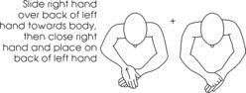

Christmas card

Christmas pudding

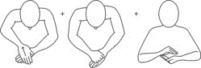

Santa/Father Christmas

