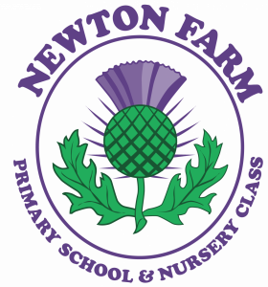****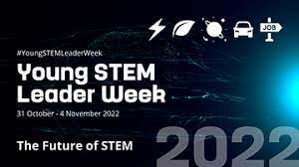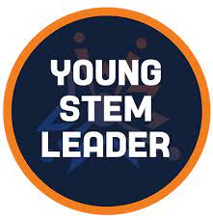

**Young STEM Leaders**

**The Young STEM Leader Programme is a nationwide award scheme that allows for pupils to gain knowledge and confidence in their STEM skills through facilitating and delivering STEM experiences across our school. Our STEM Leaders are a group of P6/7 pupils who have planned and led STEM activities for pupils from P1-P7. This culminated in them creating and leading all of our British Science Week celebrations. These pupils will receive accreditation for their participation in this programme.**

**How is STEM delivered?**

**STEM subjects are delivered both discretely and through interdisciplinary learning here at Newton Farm. Education and training in STEM helps pupils acquire some of the following skills and capabilities: an understanding of the world around us, interpreting and analysing data, research and critical enquiry, problem solving and risk assessment, experimentation and exploration, collaboration, innovation and creativity. STEM subjects are taught mostly through active learning to allow pupils to use their skills in new and different ways.**

**What is covered?**

**Science is taught across our school over a 3-year programme to ensure pace and progression within the learning. For example, P1 pupils learn about day and night, P3 pupils learn about the sun, the moon, and the earth and then P6 pupils learn about the entire solar system. Technologies involves learning how to use a computer, coding language and processors such as Excel. We use both iPads and chrome books as well as coding robots like the Sphero Indi to facilitate this learning. Engineering is taught mainly in line with technologies to allow pupils to develop design and problem solving. Pupils learn maths discretely but also through STEM learning. Here they mainly use their numeracy skills to analyse data and make measurements.**

**Newton Farm PS**

**STEM: Science, Technologies, Engineering and Maths**



**Celebrating STEM at Newton Farm**

**We celebrate STEM skills, subjects and learning throughout the school year through the following events.**

**P1-7 pupils take part in a range of fun activities to develop and celebrate their STEM learning during these events. The Young STEM Leaders also help to plan and run these celebrations.**

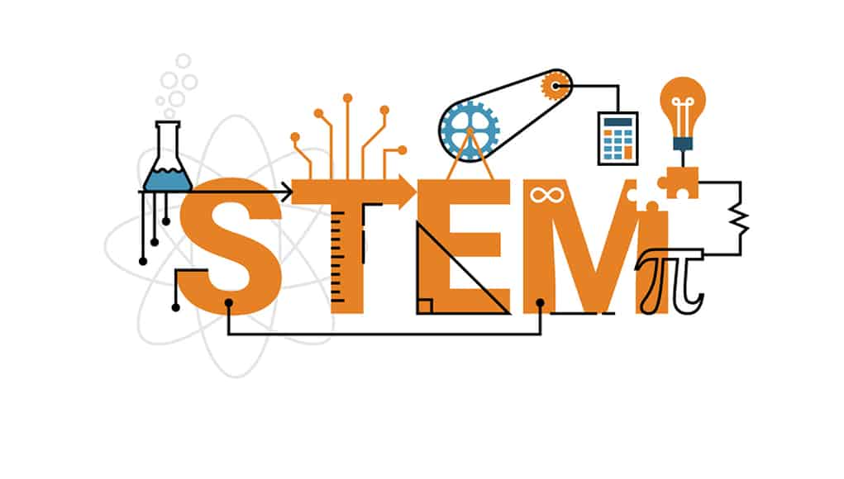

STEM subjects are extremely important as many of the jobs our children will go on to do will involve STEM subjects and skills. STEM learning not only increases the employability of our young people, but it equips them with the transferable skills required for many different activities.

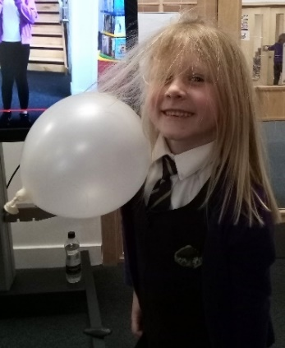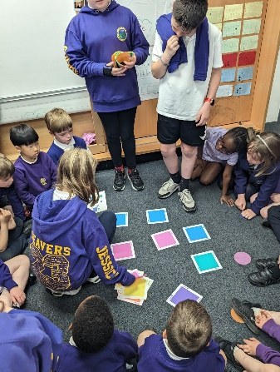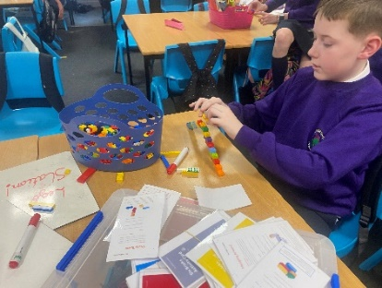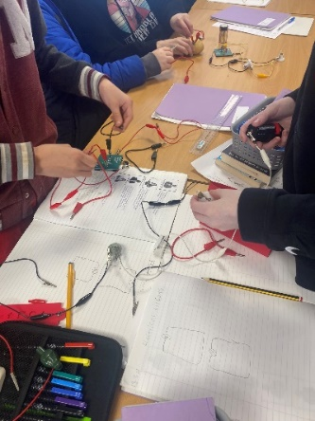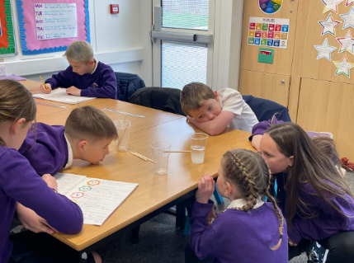

**Throughout the school year, our Young STEM Leaders organise and lead STEM activities and experiences for all pupils. The pupils in our school love learning with the Young STEM Leaders.**

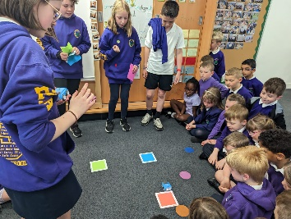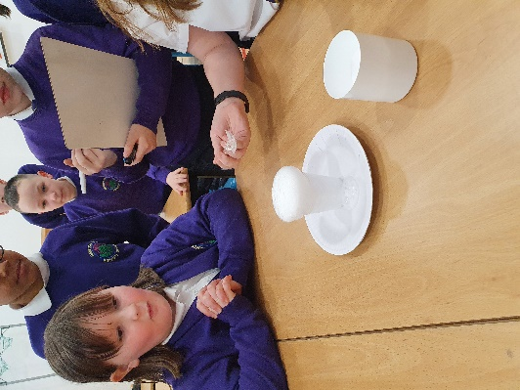

**The children love using their collaborative skills and showcasing what they have learnt.**

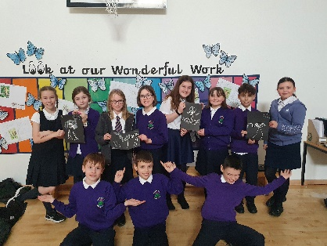

**STEM Learning**

**at Newton Farm Primary School**

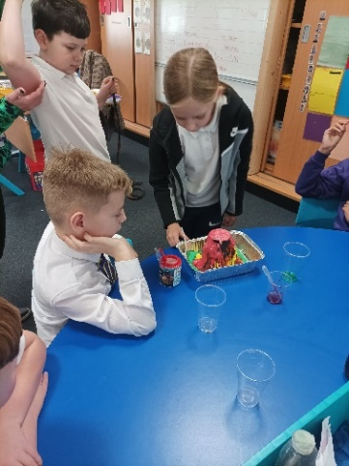

**The pupils at Newton Farm have the opportunity to take part in all sorts of STEM experiences from coding robots, to conducting chemical experiments to building electrical circuits.**

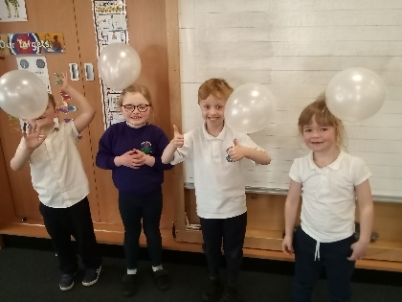

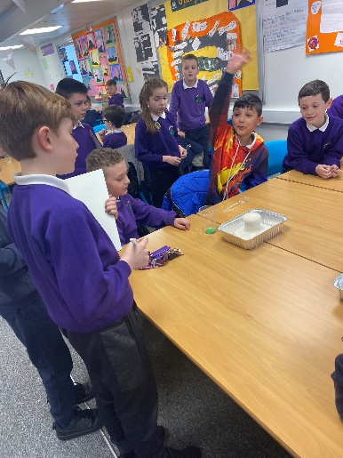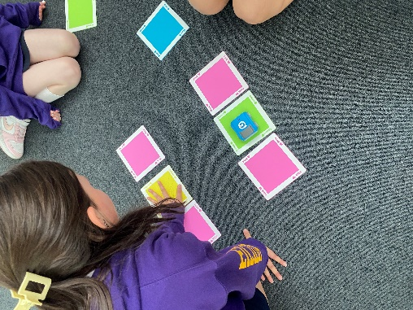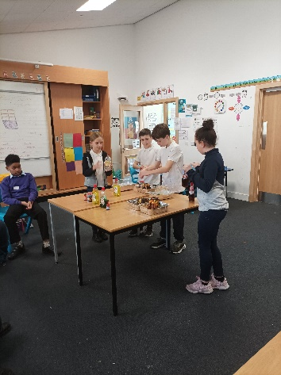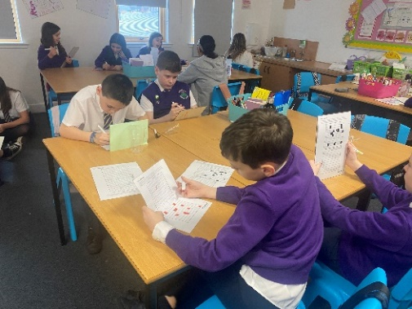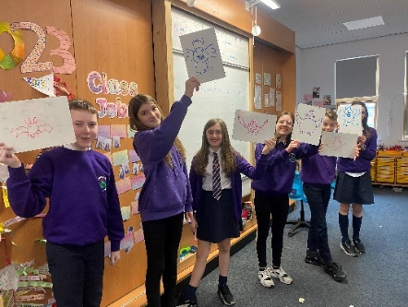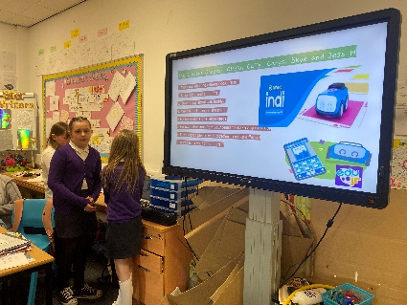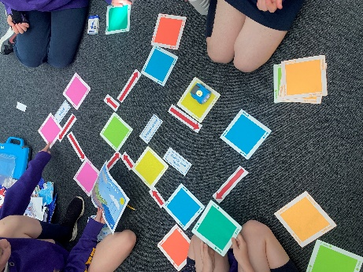

**The pupils have enjoyed taking part in unplugged activities to help them develop their computing science skills.**