

Quality Assurance for MVP School Leads
Supporting Documents




MVP Vision
- Mentors in Violence Prevention (MVP) is a secondary school peer education programme aimed at reducing gender-based violence, developing healthy relationships and promoting safe learning environments through a bystander approach.
- This is achieved through linking closely with local authority coordinators to support the programme delivery in secondary schools. Local authority coordinators are an active link between school leads and the national team.
- Resource development is on-going, and the programme is evaluated in partnership with practitioners, external agencies, third sector stakeholders and learners ensuring the programme remains relevant and meets the evolving needs of Scotland’s children and young people.
- This document will be updated each year to ensure that materials and information are up to date and relevant.

April 2025

MVP Aims
- To increase the safety and inclusion of Scotland’s young people by raising awareness of and challenging gender-based violence (GBV).
- To equip learners with the skills and confidence to be active bystanders.
- To promote positive relationships.
- To create positive learning environments.

MVP Objectives 2025 – 2026

Objective 1 - To extend the reach of MVP
- Staff will increase their understanding of GBV and will report increased confidence in teaching about GBV through participation in the Mentor Support team professional learning.
- Staff will increase their understanding of GBV and will report increased confidence in teaching about GBV through participation in the Mentor Support team professional learning.
- In 2025/2026 more young people than in 2024/2025 will have the opportunity to deliver/receive peer education related to GBV.

Objective 2 – MVP quality assurance
- More school staff teams and trainers will use quality assurance measures to support improvement.
- More examples of good practice will be available for practitioners.
- Accessibility of materials will be improved.
- More robust evaluative data for MVP will be available allowing better implementation
- Materials will be kept relevant and up to date.

Objective 3 Gender-based violence: Early Intervention
  - Staff in Primary and Early Learning and Childcare settings will increase their understanding of GBV
  - Staff in Primary and Early Learning and Childcare settings will increase their understanding of how to prevent GBV through the totality of the curriculum
  - Staff in Primary and Early Learning and Childcare settings will implement small changes in their setting following their professional learning
  - School leads will be aware of how to implement peer mediation in the primary setting
  - The Everyone’s Included materials will be promoted.

MVP Roles
See quality assurance timeline and overview for more detail.

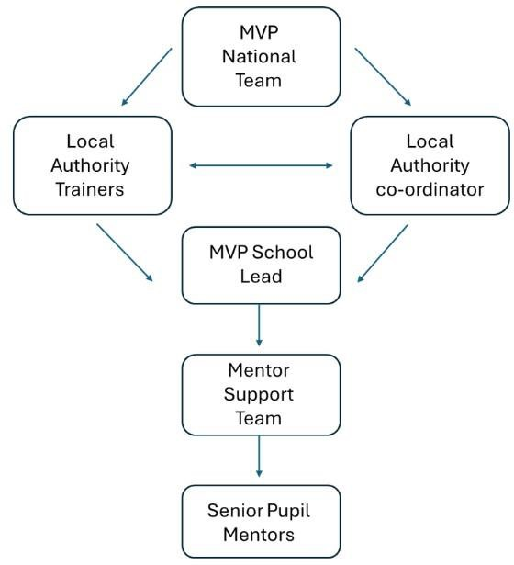

Materials
    - MVP Implementation Guidance.
    - Scenario Delivery Form – Optional*
    - Example of a Scenario Delivery Plan

    - School Lead Delivery Survey (Dec).
    - School Lead Delivery Survey Preview of Questions.
    - School Lead Impact Survey (May 2026).
    - School Lead Impact Survey Preview of Questions.
    - Pre Mentor Survey*
    - Post Mentor Survey*
    - Pre Mentee Survey*
    - Post Mentee Survey*
    - How to duplicate a form

    - Lesson Observation Checklist - Optional.
    - Mentor Logbook - Optional

    - Mentor Focus Group Prompt Questions Optional
    - Mentee Focus Group Prompt Questions Optional

* Please duplicate these forms so that you have access to your own impact data which can be used to inform next steps within
MVP. Please ensure that the information gathered is then shared as a spreadsheet with both your local authority co-ordinator and MVP national team - Pauline.lynch@educationscotland.gov.scot

Quality Assurance Timeline & Overview
 | National Team | Local Authority  Coordinator | Trainers | School Lead / Mentor Support Team
August |  |  | Attend Trainers’ network (August)  Send out pre course learning  Deliver professional learning  Notification to national team when professional learning is planned and once it has been completed via form  Use professional learning evaluation survey before &  after training  Attend Trainers’ network (April) | Pre-Mentor Survey (before mentor training)
September | Chair Local Authority Coordinator Network | Attend Local Authority Coordinator Network |  | Pre-Mentee Survey (before mentor delivery)
October
November | Send out Local Authority Coordinator survey  Send out School Lead delivery survey | Send School Lead delivery survey to  schools |  | Post-Mentee Survey (after mentor delivery)
December | Chair Local Authority Coordinator Network | Submit Coordinator survey Attend Local Authority Coordinator  Network |  | Complete & submit School Lead delivery survey to Local Authority Lead (1 per school). Possible mentee focus group
January
February |  |  |  | Post-mentor survey (before exam leave)  Possible mentor focus group
March | Chair Local Authority Coordinator Network | Attend Local Authority Coordinator Network |  | Send copies of excel sheets of pre & post mentor & mentee surveys to Local  Authority Co-ordinator & National Team*
April | Send School Lead impact survey to Local Authority Coordinator | Send School Lead impact survey to schools
May |  |  |  | Complete practitioner Impact survey (more than 1 per school if appropriate).
June | Chair Local Authority Coordinator Network | Attend Local Authority Coordinator Network |  | Pre-Mentor Survey (before mentor training)

*Pauline.lynch@educationscotland.gov.scot

Glossary of Terms / Acronyms
    - MST - Mentor Support Team (staff team).
    - Mentors - Senior pupils who are MVP trained.
    - Mentees - Junior pupils who receive peer education.
    - Local Authority Coordinator - Member of staff who oversees MVP in a local authority.
    - GBV - Gender Based Violence.
    - T4T – Training to become a local authority MVP trainer (can deliver MST training to staff).
    - ESAS - Equally Safe at School.
    - MST capacity building (CB) training - Mentor support team 1-day training for schools who already deliver MVP but want to grow their staff team.
    - MST 2-day training - Mentor support team 2-day training for schools who want to launch the MVP programme. This training focuses on content & implementation.



