**MVP Local Authorities Network 3/12/24**

**Updates from co-ordinators**

* MA (Glasgow City Council).
* RMc (Argyll and Bute Council).
* LR (Moray Council).
* AM (East Renfrewshire Council).
* CT (Edinburgh City Council).
* LS (Fife council).
* CO’N (East Ayrshire).
* LK (North Ayrshire).
* KR (South Lanarkshire).
* D MCH (North Ayrshire).
* LMcM (Midlothian Council).
* JD (East Lothian Council).
* DW (Aberdeen City).

**Local Authority Training Needs**

A reminder to coordinators to make their MVP Development Officer aware of any training being delivered and that they are available top support both staff and mentor training.

**Train the Trainer Event**

The next event will be on the 4th and 5th March in the Optima Building, Glasgow.

**Staffing – New DO links**

Information was shared with co-ordinators detailing who their MVP Development Officer link is. This will be emailed out.

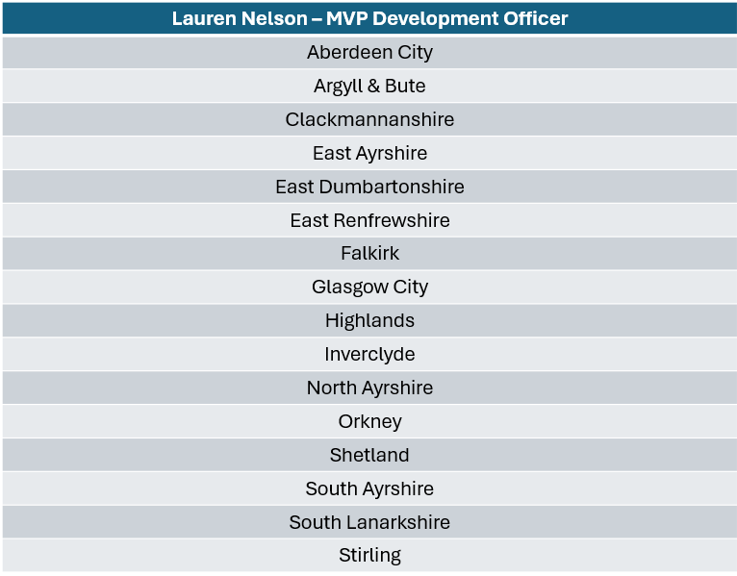

**Primary Pilot Results and Next Steps**

PL shared information about the primary pilot including which authorities were involved and the breakdown of staff involved.

* The majority of staff trained were senior leaders.
* Feedback showed that nearly all staff reported an increased knowledge around GBV.
* Many staff were not aware of relevant RSHP resources available for use within lessons.
* No direct resources are provided however there are many available that schools are currently using.
* The Everyone’s Included resource was discussed, this was mentioned as a resource at the primary training.
* Training dates identified for staff who want to deliver in their authority - 4th February in Glasgow (all day) and provisional date of the 18th March (all day) – Staff should be HWB lead or GBV lead.
* PL is the lead contact, and all any enquiries should be directed to her.

**Working with Equally Safe Update**

* LN provided an update on Equally Safe and how MVP aligns with this.
* A document is to be produced by the National Team and ESAS to map how MVP fits within the overarching theme of Equally Safe.
* There was discussion about the rich data that ESAS surveys can provide, providing schools with good baseline data.
* LS Suggested utilising sketch notes.

**Quality Assurance of MVP**

LN shared the plan moving forward which details the need to streamline the documentation and make it more accessible for all.

* There is a need for improved QA of MVP and robust data to show the impact of the programme.
* There will be an updated document providing clear responsibilities of all involved as well as a Quality Assurance Framework.
* Reintroduce the use of pre & post surveys. Schools will have access to own their own data which should be shared with their Local Authority co-ordinator and National team.
* Question prompts will be created for use with MVP focus groups to allow for rich qualitative data collection.