Mentors in Violence Prevention

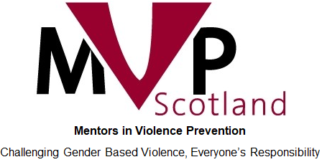
Implementation Guidance

This document serves as guidance for MVP School Leads and Practitioners for successful implementation of the MVP programme.
This is supplementary information for schools to use as a framework for implementation, as well as ongoing self-reflection and forward planning.
This guide will detail the implementation timeline discussed during full 2-day MVP training and provides some further advice and examples for good practice.

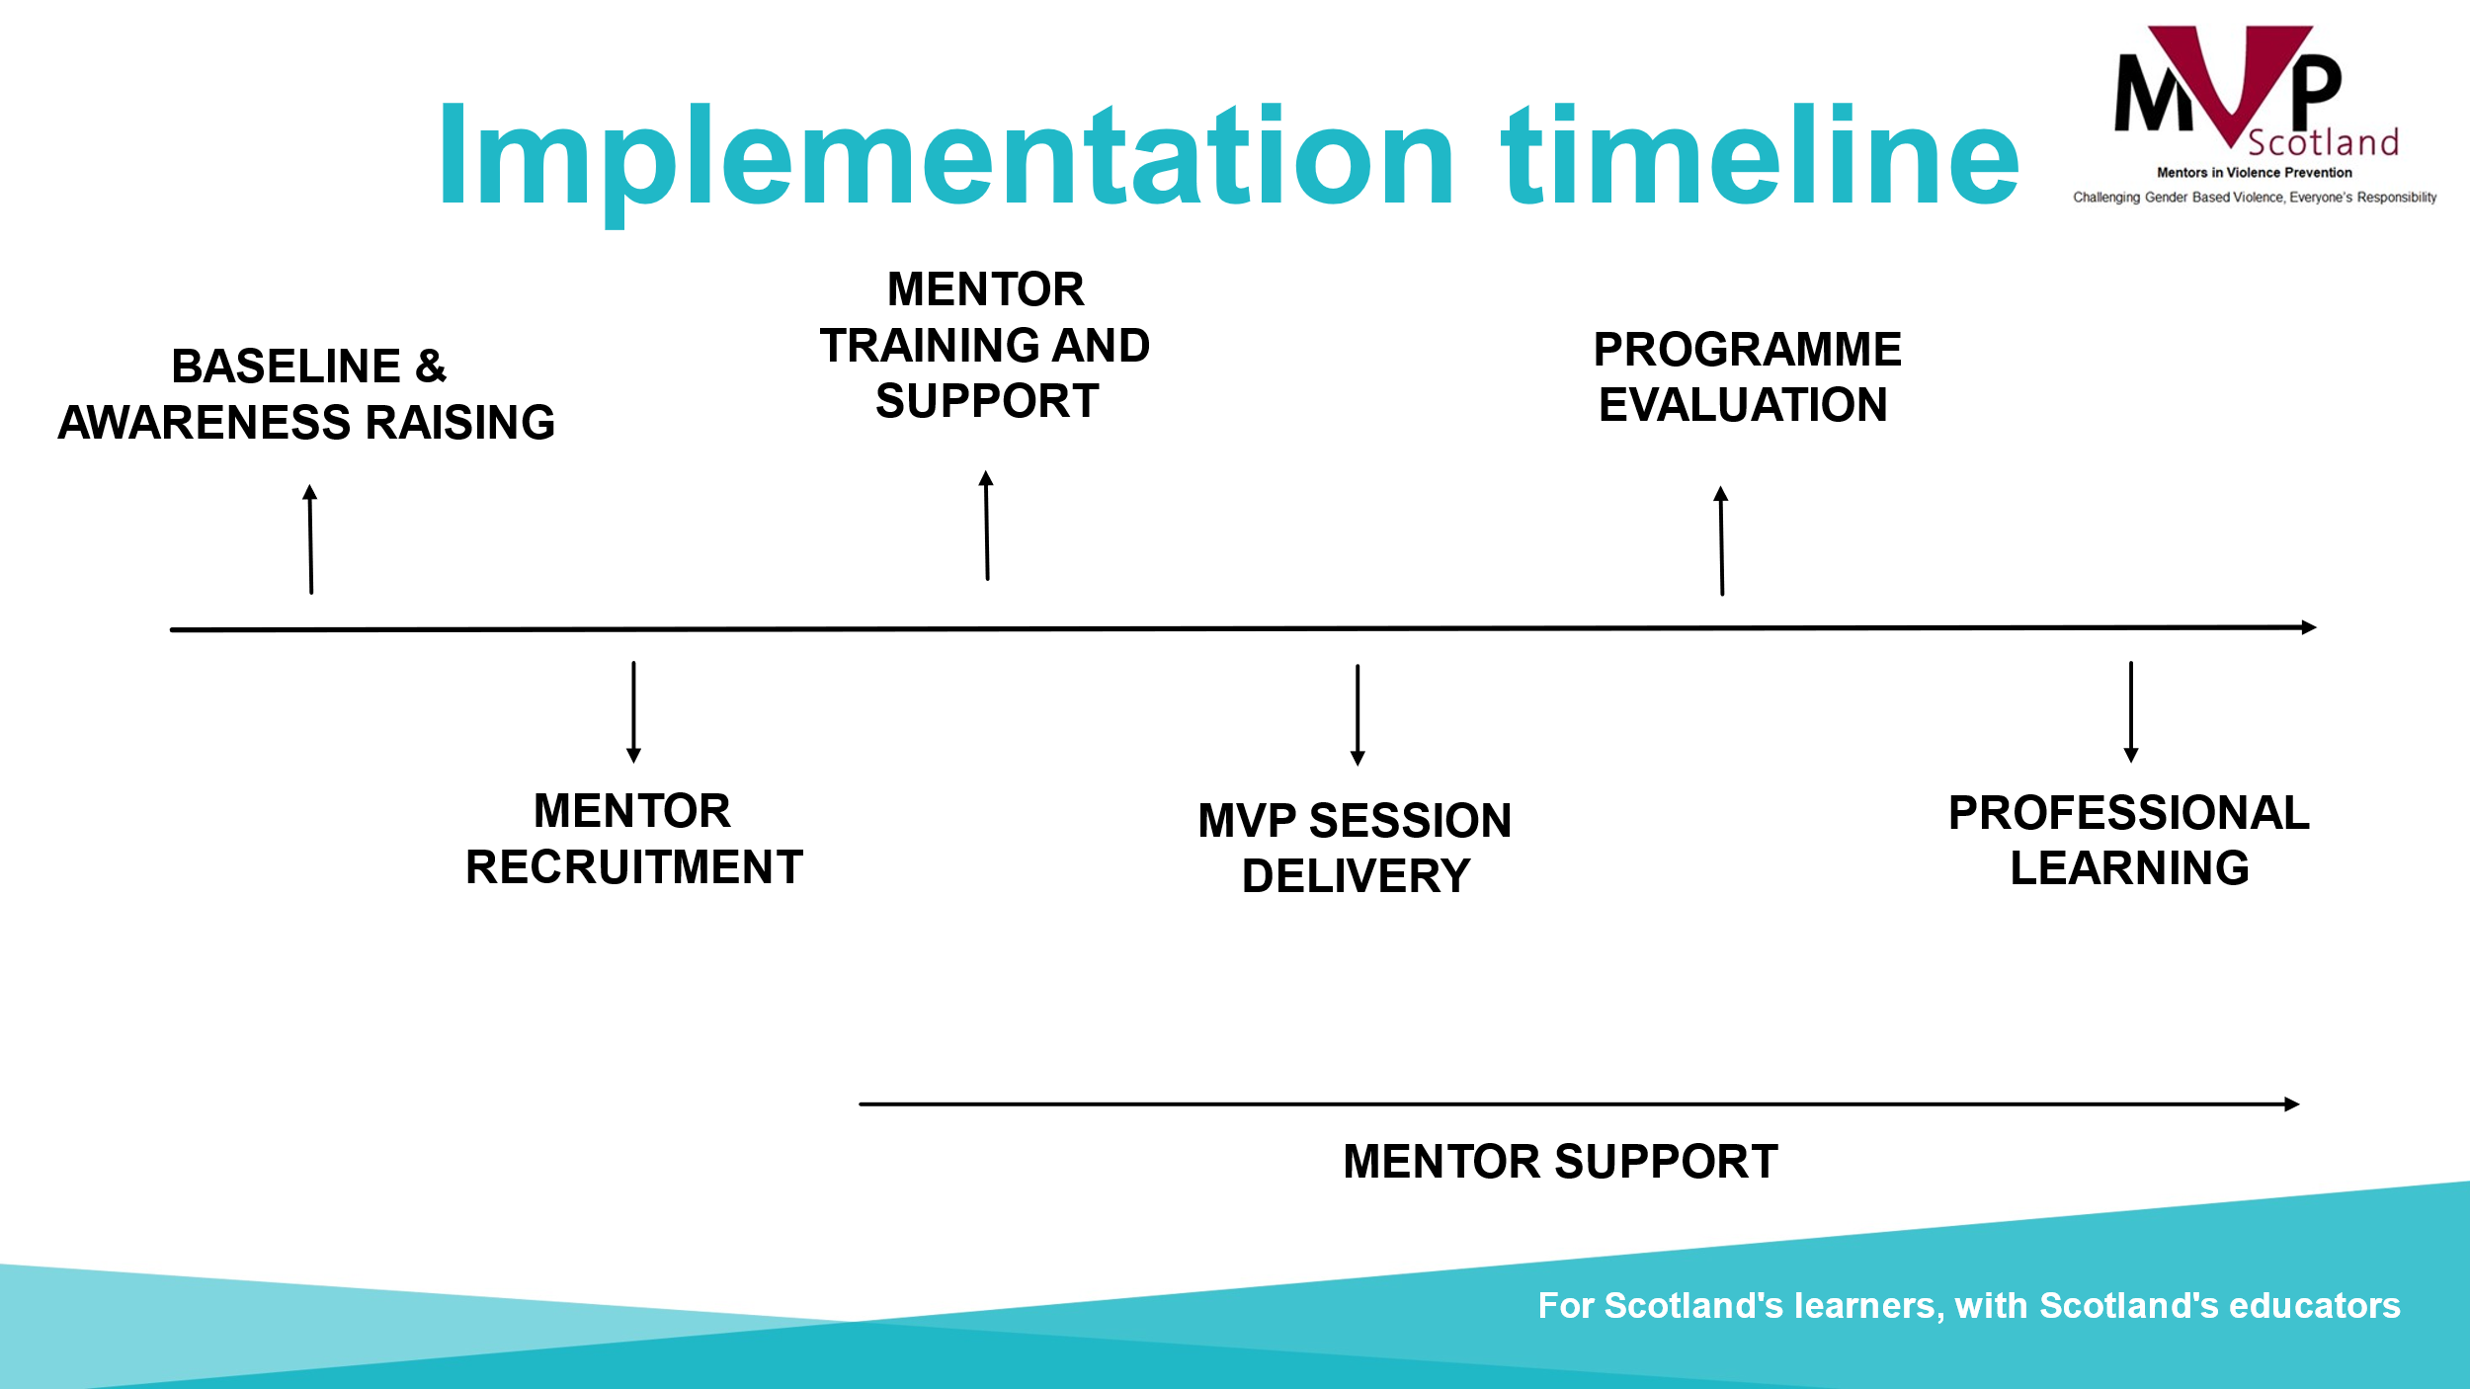

Baseline & Awareness Raising

At the beginning of your MVP journey after completing training, it is good practice to do some baselining of where your school community is currently, in order to assess the impact of the programme when revisiting this data. Some examples of baseline data could include:
- Bullying incidents
- Referrals
- Exclusions
- Absence
- Pupil attitude surveys
Some schools have also developed bespoke pupil surveys which they use to gather information on the level of knowledge of gender-based violence issues amongst their pupils (similar to the mentor/mentee post-delivery survey they should complete which can be found here).

Awareness-raising of the MVP programme should also take place before recruiting mentors and beginning MVP delivery. A sample awareness-raising PowerPoint is available for use and can be adapted to suit your school. You should consider the following members of the school community when planning for awareness-raising sessions:
- School senior leadership team (they should have already seen the senior leadership readiness checklist)
- All school staff (including non-teaching staff)
- Partners
- Parents and carers (sample info leaflet is available here)
- Wider learning community

Once baselining and awareness-raising is complete, next you should focus on recruiting mentors, and there are a number of considerations to make in doing so.
Mentor recruitment
- Which year group(s) will mentors be?
- Can mentors take on roles beyond solely lesson delivery e.g tech support, admin, social media?
- How many mentors will you need? This will depend on the number of classes that will receive MVP lessons and if they are timetabled at the same time e.g mentor group 1 linked to class 1A1. Please note we recommend mentors deliver in groups of at least 3.
- How and when to recruit? E.g assemblies, class visits, message boards, tannoy announcements, direct approaches, application form?
- How to engage a broad demographic of young people, including ensuring a gender balance within groups? How will you engage mentors who won’t volunteer themselves? Please note film on engaging boys and men and relevant information on our website.
- Will mentors have the chance to be accredited for taking part in MVP e.g through the SCQF Leadership Award or similar? More information on Accreditation can be found here.

Mentor training and support

Mentor support should be ongoing throughout the school year, ideally with mentor groups being assigned a ‘link’ member of staff from the Mentor Support Team (MVP trained staff) to liaise with regularly. This ‘link’ should at least check-in with their assigned mentors before they are due to deliver any MVP session to ensure all resources, including tech, are in place and mentors are prepared for the session. A reminder of safeguarding measures will also be beneficial.

Mentor training materials are located here and on the MVP Practitioners Forum on Teams. These should be followed with fidelity to the content to ensure equitable training of mentors across the country and effective engagement with core components. When preparing for the initial mentor training once recruitment has been completed, you should think about the following:
- Mentor Training should take place over 2 full days, ideally consecutively, by the MVP trained staff in school. The training materials are designed to cover 2 full school days and include all of the core components from the staff MVP training (day 1), as well as session delivery practice, child protection/safeguarding and facilitation/group work skills (day 2).
- Training should take place before mentors deliver any MVP lessons but ideally not too far in advance.
- Can training take place off-campus? Can it be non-uniform?
- Ensure to invite MVP trained partners (e.g Womens Aid/Police/Rape Crisis/CLD workers) along to aide with training mentors and to support ongoing implementation of the programme.

MVP session delivery

MVP is a peer-education programme so sessions should be delivered mainly by mentors (trained senior pupils) to mentees (junior pupils), with the exception of the ‘Party’ and ‘Expectations’ scenarios, which we advise are only delivered by adults e.g by MVP trained staff when delivering mentor training. In addition to mentor delivery, MVP scenarios can be delivered to any pupils in school by MVP trained staff as part of ongoing Personal, Social and Emotional education, provided the Core Sessions are delivered first.
Consider the following for session delivery:
- Which year groups will mentors deliver to? e.g S5 deliver to S1, S6 to S2 (this allows for continuation of relationships as pupils progress through school)
- When and how will lessons be delivered? Minimum of 4 per school year, can take place either as a block or spread out throughout the year. Core Session 1 and 2 must be delivered first, before any of the scenarios.
- Which scenarios will be delivered? In line with current emerging issues? Planned to fit in with PSE/RSHP curriculum topics? Pupils choose?
- Will mentors use their study periods/core classes/other classes to deliver?

Programme evaluation

It is important to evaluate the impact and effectiveness of MVP each year to ensure that the programme can continue to be successful in your school community. You will find a helpful evaluation table at the end of this document which your team can use at the end of the year to evaluate and plan for the following year.
It will also be important at this point in your journey to ensure that pupils complete their evaluation surveys provided by Education Scotland. These can be found here (mentor and mentee) and are extremely useful in reporting the impact of the MVP programme to the Scottish Government to ensure we continue to be able to support schools. The information and comments gathered form mentors and mentees is invaluable.

At this point it can be useful to revisit the school-specific baseline data gathered at the beginning of your MVP journey, so you can measure any impact on these figures. Note that you may initially see an increase in referrals etc. due to active bystanders being more inclined to report incidents to adults or mentors.

In addition to the evaluation table found at the end of this document, as a Mentor Support Team you will be asked to complete 2 surveys for the national team (one in November and one in May) which will be sent out via your local authority co-ordinator and may also be promoted on social media and the national MVP Practitioners Forum on Teams. The information from these surveys allows us to report on the reach and impact of the programme across the country and shapes our national planning each year.

Professional learning

It is important to consider sustainability of the programme and in doing so, further professional learning may be requested. As staff move on or remits and responsibilities shift, your Mentor Support Team may decrease but it is important to maintain at least 4 members of staff trained and involved at any time. This can include partners such as local Women’s Aid workers, Police, CLD. If you feel your team would benefit from additional members, please contact your local authority co-ordinator to request Capacity Building training for any colleagues.

In addition to this, the national team offer annual ‘Training for Trainers’ which allows Mentor Support Team staff to become MVP Local Authority Trainers (meaning you can train other members of staff as Mentor Support Team). This training occurs at least once per year and usually takes place in a central location, close to public transport links. The offer of training will be sent via local authority co-ordinators, promoted on social media and on the MVP Practitioners Forum on Teams. If you’ve been involved with the programme for at least a year and would like to take on the role as Trainer – please look out for this training opportunity!

MVP Best Practice – top tips!

Programme Governance & Delivery:
- Ethos and vision of school promotes equality to challenge discrimination (e.g School Improvement Plan)
- A gender-based violence (GBV) policy is embedded including signposting and support for anyone experiencing GBV (use the gender-based violence framework for schools to support with this).
- MVP supports ongoing Personal and Social Education including in the Primary curriculum and across Secondary (e.g Everyone’s Included, Gender 10, RSHP resources)
- The Mentor Support Team (MST) evaluates MVP delivery and completes improvement planning activity annually

Local Partnership Working:
- MVP School Lead liaises with partners regularly to ensure they are involved in the ongoing sustainability planning of the programme including being involved in further training opportunities
- Partners have the opportunity to deliver bespoke lesson inserts for mentors/mentees on their topic(s) of expertise which complement the MVP offering

Communication:
- MVP School Lead communicates with the Local Authority MVP Co-ordinator regularly (details can be found here)
- Members of the MVP MST attend Local Authority Steering Group meetings where possible
- Members of the MVP MST are engaged with the work of the MVP National Team through social media and through the Practitioners Forum on Teams (code ieafgwh)
- Members of the MVP MST and Mentors have opportunities to be involved with Local Authority and National MVP events e.g 16 Days of Activism, National Mentor Steering Group

Below is a table detailing various aspects of MVP programme implementation that as a Mentor Support Team you may with to reflect on in order to plan for the following year.
Self-reflection and planning

Features of highly effective practice | Impact | Next Steps
- MVP is in the School Improvement Plan
- MVP values are promoted across the school
- Pupils feel safe, included and respected in school
- There is a gender-based violence policy for our school
- Leadership staff aware of protocols to support staff and pupils who may be experiencing gender-based violence
- Supports and signposts are in place for those who require it
- Pupils can identify healthy and unhealthy relationship behaviours and know where to seek support
- Pupils understand the power of bystanders and are using that power in a positive way
- Trained MVP staff are using MVP materials out with the core peer education delivery to enhance the health and wellbeing curriculum
- We are using a broad range of topic-based sessions
- Pupils evaluate the programme positively
- Partners have been identified and engaged from the following services/groups:
-Parents
-Police
-Women’s organisations (Women’s Aid / Rape Crisis) and the local Violence Against Women Partnership
-Community Learning & Development (CL&D) staff / youth work staff
-Health staff
-Sports staff
-Third sector
-Sports clubs / groups
- Partners attend MVP meetings and annual programme planning and evaluation meetings
- MST staff representatives attend local MVP steering group or practitioner meetings
- Respond to co-ordinator requests for progress updates and/or evaluation data
- Contribute to local authority and national MVP developments/initiatives where possible
- Members of the MST join MVP Scotland Practitioners Forum on Teams (code
ieafgwh) to keep updated on news and professional learning opportunities
- Member of MST follow @MVPScot on X
- Mentors given the opportunity to be involved in local and national events including the national mentor steering group

