Benefits of MVP
“It made me more aware of situations that are going on. I have the power to have an influence.”
(mentor)

“It made me think about the consequences of actions and how they can affect other people. It has changed my behaviour ‘cause I think more now, before I say something.”
(mentee)

(teacher)
“MVP has made us feel like we are making some sort of difference and that feels good”
(teacher)

“you feel that MVP is doing something special”
(Youth worker)

MVP Across Scotland
The Mentors in Violence Prevention programme is currently expanding across schools in Scotland. There are over 170 schools now delivering the work, with more expected to be trained in the coming years.
The work is supported by the Education Scotland, the Scottish Violence Reduction Unit and the Scottish Government.
Useful links
More information on the work of MVP Scotland can be found on the website:
Mentors in Violence Prevention in Scottish Schools | Challenging gender based violence (glowscotland.org.uk)
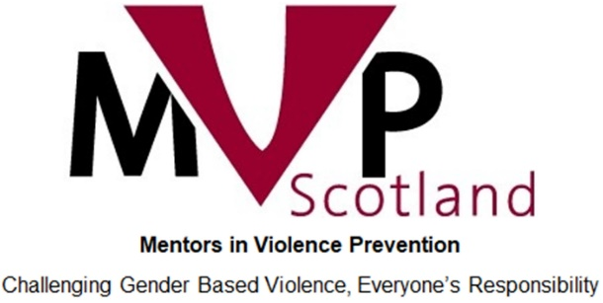
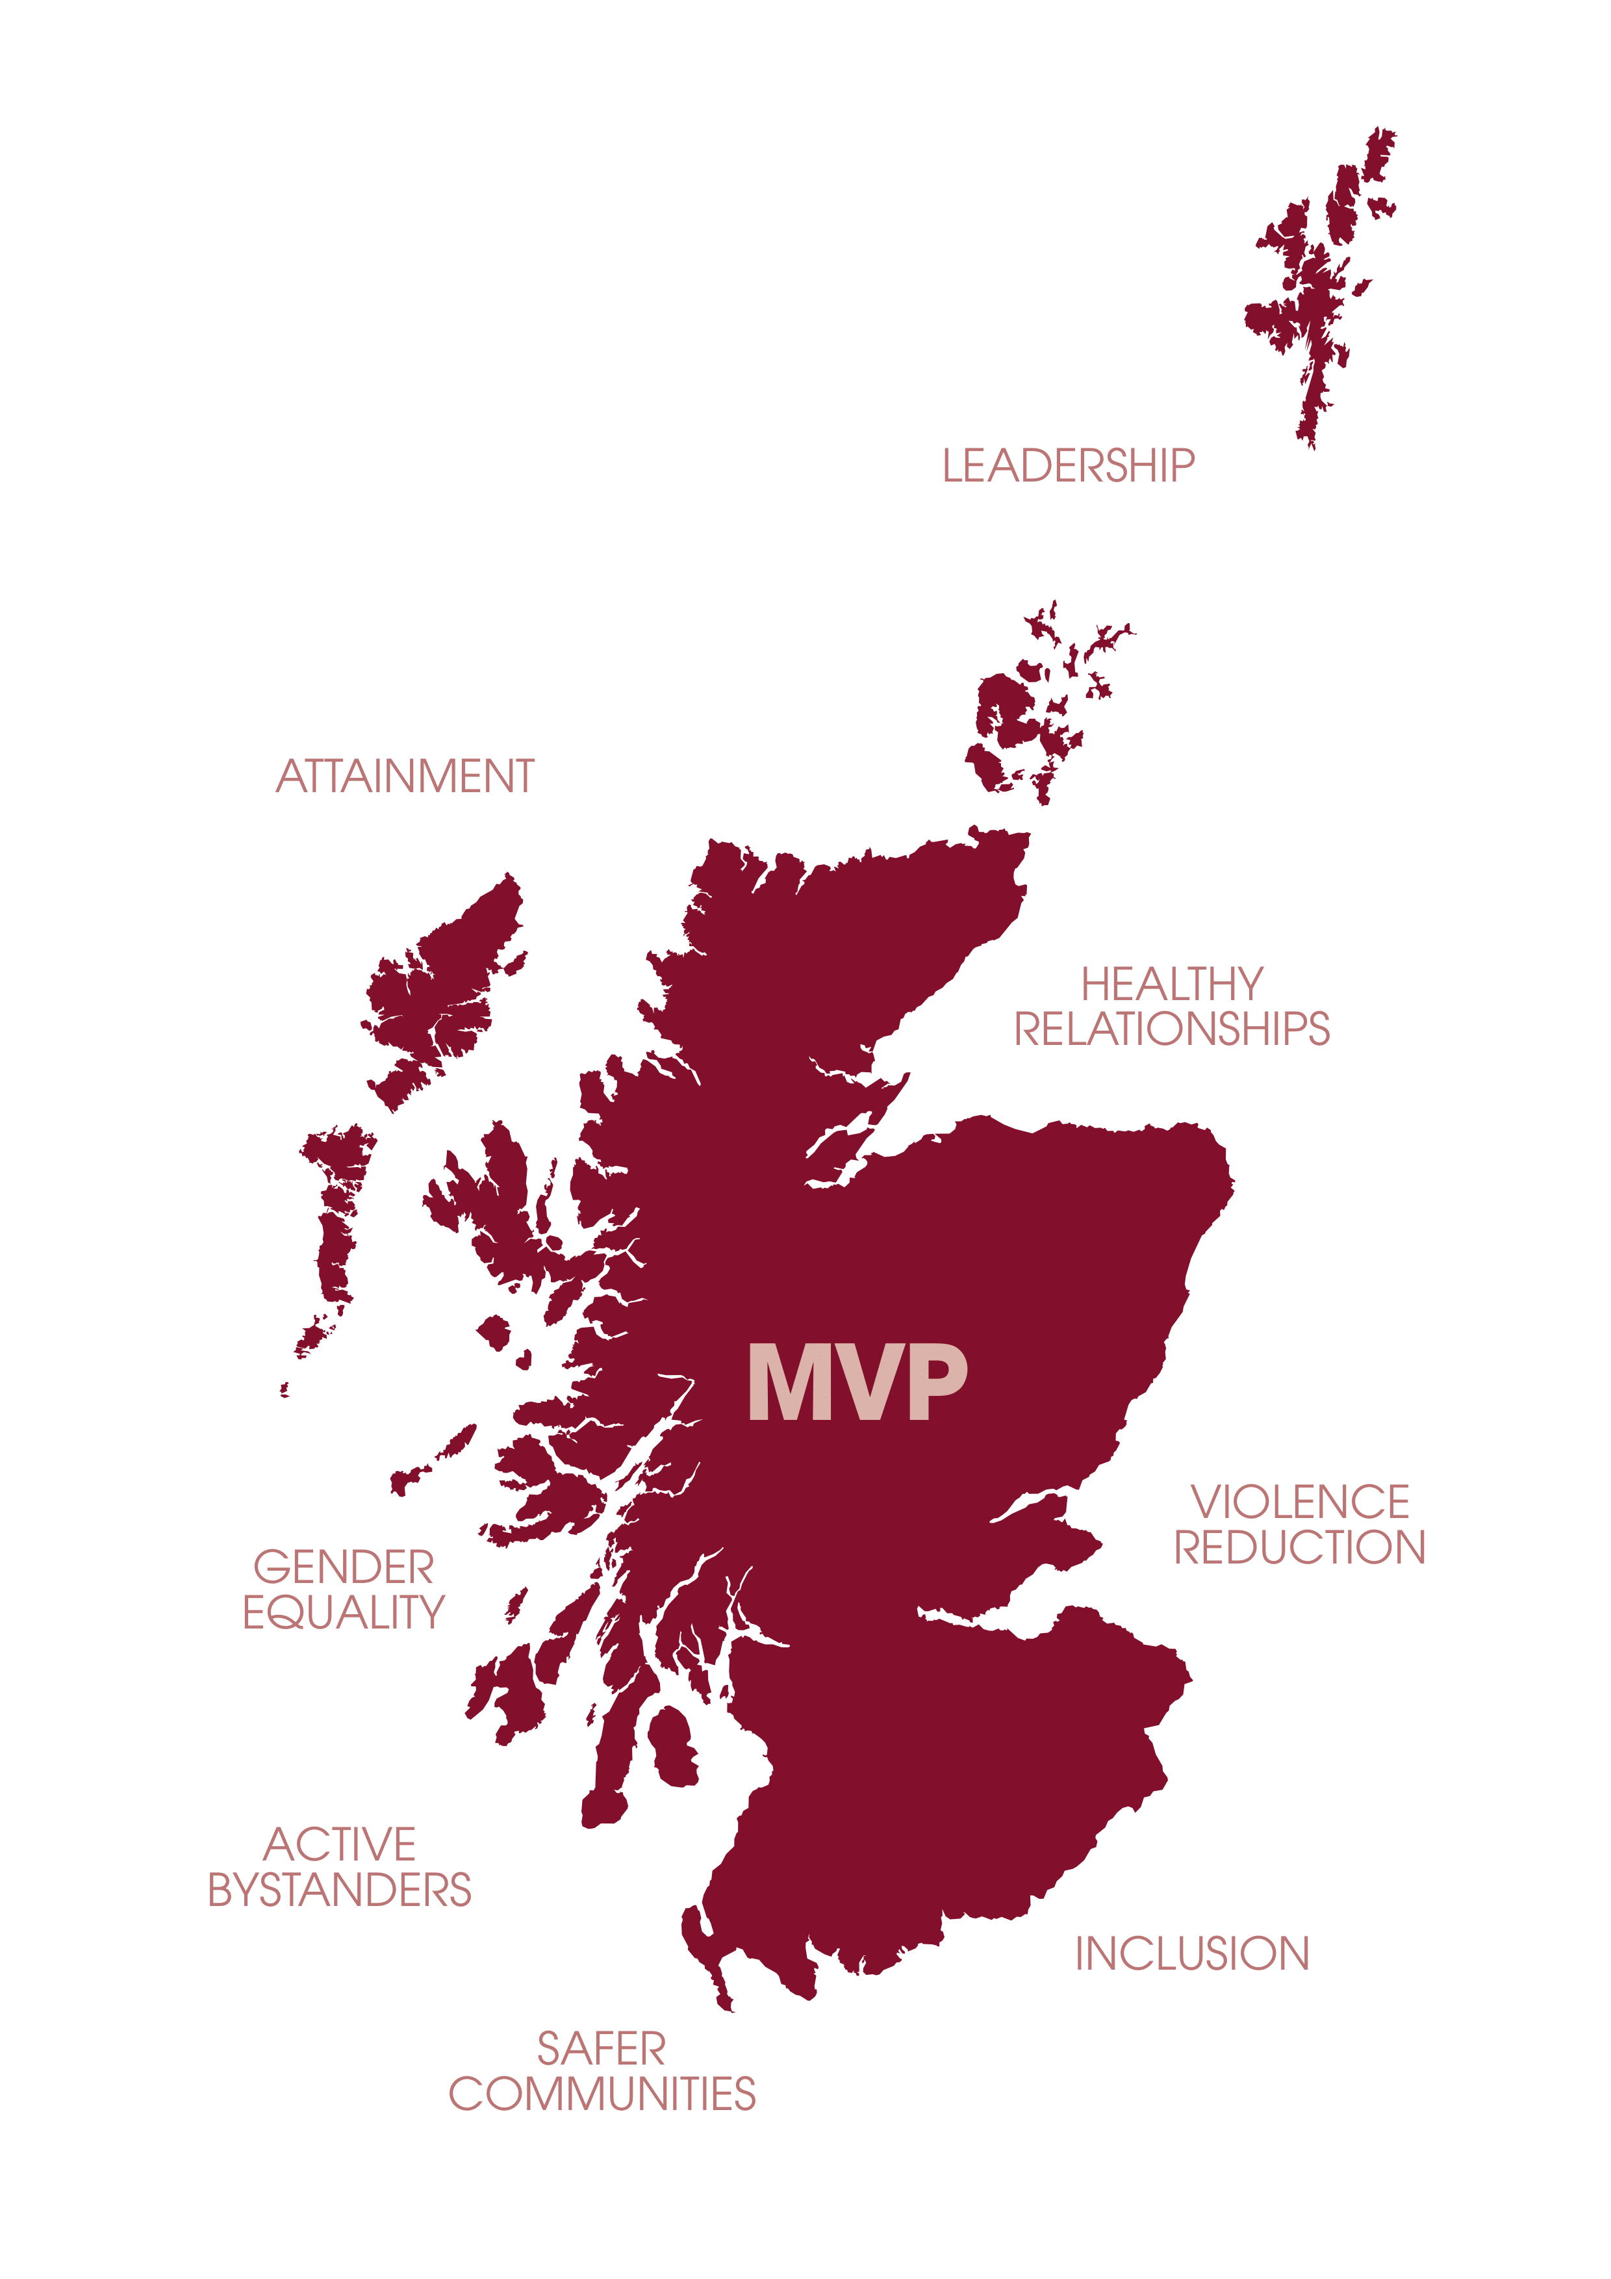
Information for pupils & parents

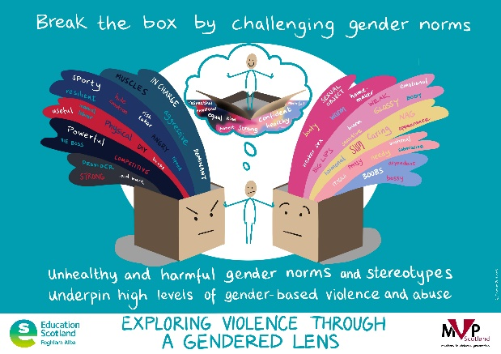
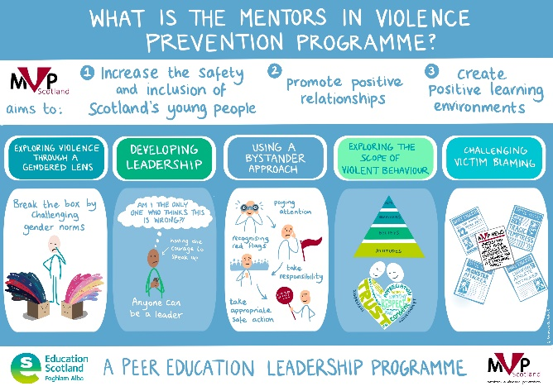
Support for mentors
A number of school staff and community partners are trained in the MVP programme and form the mentor support team. Their role is to prepare and support the mentors throughout the school year.
Child protection training and facilitation skills training are also given to mentors before they deliver any workshops.
Regular meetings are held between mentors and the mentor support team to ensure every person feels comfortable delivering sessions.

INSERT SCHOOL PHOTO
Leadership skills
MVP gives an excellent opportunity for mentors to be leaders both inside and outside of the classroom. Everyone who takes part in the programme is encouraged to develop their presentation and communication skills and act as positive role models within their schools and communities.
Active bystanders
MVP sessions encourage young people to think of themselves as ‘bystanders’ to a situation. That is someone who sees, hears or has knowledge of a situation. Time is spent looking at ways every person has the potential to influence a situation positively and safely.
Gender Stereotypes
Many of the activities delivered in MVP are designed to start conversations about the ways that gender stereotypes can lead to abuse, exclusion and harmful behaviours.
Promoting respect
Violence takes many forms and MVP defines it as physical, verbal, emotional and sexual acts which can cause harm. Mentors are encouraged to consider what healthy, respectful relationships look like.
Victim blaming
In the media victims of sexual violence are often portrayed as partly to blame. MVP challenges this.
What is MVP?
The Mentors in Violence Prevention programme is a gender-based violence prevention resource that uses a peer education model, within schools and community groups, to discuss important issues faced by young people in Scotland.
The programme asks senior phase pupils to mentor younger pupils through the delivery of interactive workshops in school.
Mentors receive training in 5 key areas:
- Leadership skills
- Using a bystander approach
- Exploring violence through a gendered lens
- Recognising violent behavior
- Challenging victim blaming
Lessons include topics such as abuse within relationships, sexual harassment, image sharing and homophobia.

