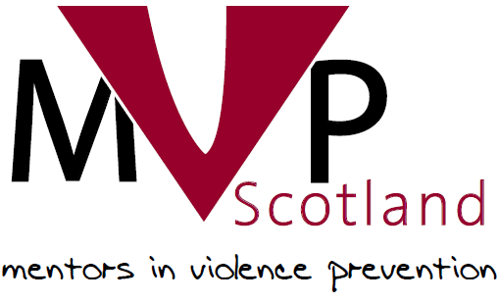

Mentors in Violence Prevention

Mentor Log
Academic Year:
Mentor Name:
School:

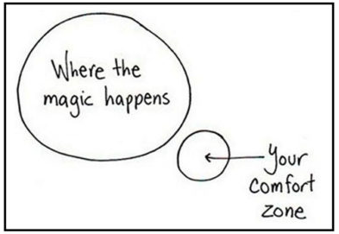

The log offers guidance to help you plan and reflect on your MVP delivery in your school. Please use to support your planning and evaluations.

Pre MVP Training

Use the spaces provided below to write down your thoughts on the following questions:

Why did you want to become a Mentors in Violence Prevention Mentor?

What do you hope to get out of becoming an MVP Mentor?

Skills Development

Using the table below give an indication of where you feel your skill level is at in the following areas:

 | Weak | Average | Strong | Very Strong
Presentation Skills
Communication Skills
Team Work

Organisational skills
Leadership skills
At the end of your MVP training and delivery of your MVP sessions you will be asked to reflect on these areas again. Do not worry if you do not feel confident in the above, MVP is a great opportunity to practice these transferable skills.

Definition: Transferable Skills

Transferable skills are a core set of skills and abilities, which can be applied to a wide range of different jobs and industries. They’re usually picked up over time, and can be gained from previous positions, charity or voluntary work, your hobbies, or even at home.

After your training please reflect on the following areas:
What did you enjoy the most about your MVP mentor training?
What did you learn during your MVP mentor training?

On the scale below, with 1 being not at all confident and 10 being very confident, circle how you feel about delivering your first MVP session:

1 2 3 4 5 6 7 8 9 10

MVP Session Delivery

Congratulations on completing your MVP training! We hope you feel prepared to deliver your schools chosen MVP scenarios to your younger peers. You will be developing many skills throughout the programme.

Overleaf please tick the sessions you have agreed to deliver with your school’s staff team (teachers, youth workers, school police officer etc.). Please note that any new year group being exposed to MVP for the first time must have Core Session 1 and Core Session Two delivered to them before any of the other scenarios.

If your school’s staff team have planned delivery dates in place then please write
the date and time you are delivering each session on the next page.

Session plans, session PowerPoints, session introduction video and other relevant resources are available for download on the MVP website on GLOW Blogs

Your school MVP staff team will download these materials for you.

Session Name | Topic | Delivering | Date of Delivery | Time | Room Number
Core  Session 1 | Mandatory for any new year group starting MVP
Core  Session 2 | Mandatory for any new year group starting MVP
Insults | Name Calling
Group Chat | Online Abuse
Left Out | Isolation
Rumours | Gossip
Corridor | Domestic Violence in Young Relationships
Text Message | Controlling Behaviour
Pressure | Sexting - Coercion
Photos | Sexting - Images
Labelled | Shaming
Knife | Carrying of Weapons
Words | Homophobic Language
Names | Transgender Bullying
Exposure | Viewing Pornography
Harassment | Sexual harassment in school
Expectations * | Impact of Pornography on Relationships
Party * | Alcohol and Consent
* Should only be delivered by trained staff.
Pre Delivery Checklist

Please use these checklists to help you prepare for your MVP delivery in your MVP team.

Facilitation Checklist:

Pre MVP Session Activity | Completed
We have met with our allocated MVP school staff team member before our first MVP session.
We have checked with our MVP staff team if we are unsure about any aspect of MVP.
We have allocated a lead person for each section of our MVP session Introduction | Icebreaker | Scenario | Train of Thought | ADU | Options | Conclusion
We have finalised which media clips we will use for our MVP sessions.
We have some up to date statistics we can use for each session to support our delivery and our messages.
We have made plans with staff to make sure we take an accurate register at the start of each session.
We have made up name tags prior to our first MVP session.
We are clear who our schools named child protection officer is should we have to share anything that is disclosed to us by younger peers during MVP.
We have met with the class teacher to get a better understanding of the class dynamics and if any pupils have any individual needs we need to accommodate.

Practical Checklist:

Pre MVP Session Activity | Completed
We have checked with our teachers what school work we have missed and how we will catch up if we are missing a lesson during MVP.
We know the room number and location of each MVP session.
We are clear of the time and date of each MVP session.
We have discussed with the teachers who are using the room prior to and after our MVP sessions so they are aware will be using the room.
We are clear about how we will access the school network in the room we are delivering in. We have also logged onto the computer in the room prior to delivery.
We have the web links for each MVP session saved and easily available before each session.
We have hard copies of each media clip available to us as a backup should school networks go down.
We know how the sound set up in the room works and have tested it prior to our MVP delivery.
We have planned how we are going to organise the room.
We have paper copies of each MVP session plan we are delivering.
We have printed Agree | Unsure | Disagree signs before our MVP delivery.
We have access to and have viewed the PowerPoints for each session.
We have access to the MVP animation for the start of each session.
We have a plan to take a group photo and share this on our school’s social media channels to help support our MVP messages.
We are aware of our schools policy on photography of students.

Equipment Checklist:

Equipment Check | Completed
Group Agreement from previous weeks
Blu Tac
Flip chart paper
Flip chart pens
Whiteboard pens
Name tags

Room Set Up

It is important to consider how you will set up the room. We recommend either of the following styles although this may not always be possible.
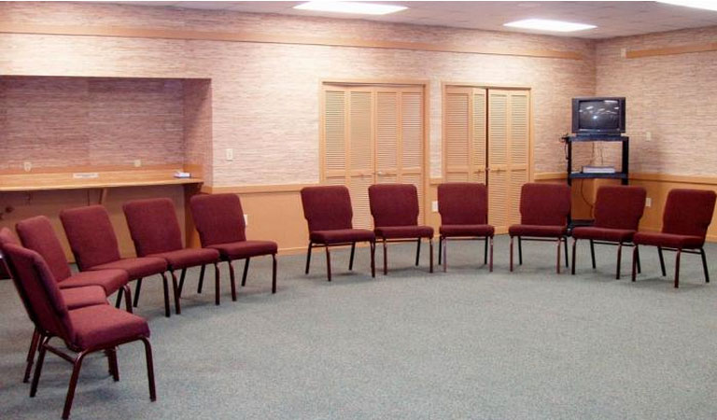

Horse Shoe Style

Advantages:
- Encourages group discussion.
- Clear view of whiteboard.
- Encourages everyone to become involved.
- Creates a space for mentors to command the room.

Disadvantages:
- Younger pupils may not always be familiar with this set up.
- Students may tend to cluster around their friends which can sometimes, but not always, hold back discussions.
- Not always easy for younger pupils to write on the flip chart paper for activities such as the gender box.

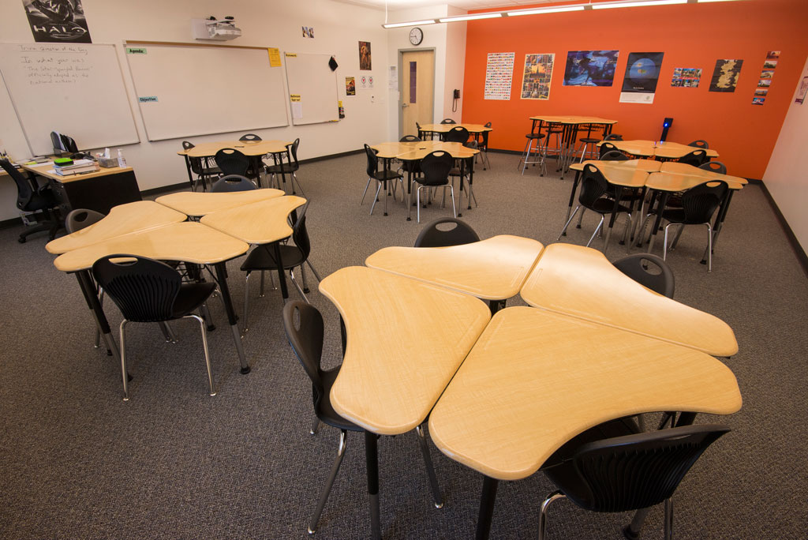

Cabaret Style

Advantages:
- Allows for active discussion in smaller groups.
- Allows mentors to keep younger pupils ‘on task’.
- Younger pupils will find writing on flip chart paper easier.

Disadvantages:
- Can take up a great deal of room
- Gives you less space for the ADU exercises (consider using the corners of the rooms for Agree | Unsure | Disagree instead).

Whatever layout you decide upon remember the three golden rules for the room:

1. Arrive early
2. Ensure the room is organised
3. Know how ALL the equipment works
4. Consider the room users before and after your MVP session (especially schools where rooms are shared by multiple teachers)

Formative Assessment

During your sessions you can use the following techniques to gather feedback from your mentees about how they felt the session went. You can use this feedback to improve for your following session.

If you have time to get some feedback from your Mentees then it can help you improve for the following week.

Formative Assessment Techniques
Fist to Five | Ask the students to hide their hand behind their back and at the end of the session on the count of three they can reveal how they felt the session went. This will give you instant feedback for planning your next delivery.  Five fingers – I completely understand.  Four fingers – I mostly understand.  Three fingers – I understand pretty well.  Two fingers – I could use more practice.  One finger – I need help.  Fist – I do not understand at all.
Traffic Lighting | Using red/amber/green materials (cards, cups, pencils etc…) ask the mentees at the end of each session to show you their level of understanding.  Red: I do not understand the scenario.  Amber: I think I understand the scenario.  Green: I understand the scenario.
Make a Summary | Ask the group to summarise what they have learned during each session.  Individual mentees can be invited to write these onto a whiteboard or flipchart paper to share with the group.  You can then use the conclusion from each session to ensure that the take home messages are covered before the end of each session.  Conclusions from the Insults scenario are below as an example:  ✓ Verbally abusing a person is wrong and hurtful.  ✓ Insults can be hurtful in the long term.  ✓ The effects of insults can be wide ranging and long lasting.  ✓ There are a number of options we can choose from to challenge behaviour when we don’t agree with it.  We have a responsibility to help our friends and keep ourselves safe.

Self – Evaluation

Please use the following templates to log how you feel each MVP session has gone. It is important to reflect each time you deliver an MVP session as this will help you improve your confidence and your skills after each session.

The first one is an example to give you a guide as to what you could include in your self-evaluation.

MVP Session Mentor Delivery Self – Evaluation (Example)

MVP Session 1 | Name of Session: | Intro session 1
Name of MVP School Team Supporter: |  | Dr Katz
Thinking about your delivery and class participation what went well?

- We were able to create a strong group agreement which we will keep for future sessions.

- The pupils gave us great feedback after we used the empathy exercise. We generated some great discussion around the bystander.

- The young people tried very hard to write as many examples of Abuse/Respect onto the flip chart as they could.
Thinking about your delivery and class participation what did you find challenging?

- At the start we had to remind the young people not to shout out their answers all at once. We put this into the group agreement.

- I read the empathy exercise too quickly as I was feeling a little nervous. Our MVP supporter read it again to the class slowly which helped generate discussion around empathy and the bystander.

- We forgot to bring blue tac to the room so we were not able to put up the abuse/respect flip chart answers in the specified order on the wall so kept them on the floor instead.

What can I improve on for my next MVP session?

- Make sure we have checked all the materials are working and have everything prepared.

- Take my time when reading out to the group. Read statements twice if required.

- Make sure we go over the group agreement at the start of each session.
Actions for next MVP session delivery.

- We must make sure we have all the materials we need before our session.

- Think about our timings and work hard to stick to our allocated time for each section.

If a trained member of staff observed the session then please use this space to provide the mentors with feedback:

This particular group of mentors delivered a great session today especially as it was their first delivery. They built a great rapport with the younger pupils and there were some really excellent discussions around what empathy is and how it can look and feel. There were also some great discussions about our responsibility as potential bystanders. We have discussed some of the areas that they can improve on for next week. An excellent group of young leaders – well done

MVP Session Mentor Delivery Self – Evaluation

MVP Session 1 | Name of Session:
Name of MVP School Team Supporter:
Thinking about your delivery and class participation what went well?

Thinking about your delivery and class participation what did you find challenging?

What can I improve on for my next MVP session?

Actions for next MVP session delivery.

If a trained member of staff observed the session then please use this space to provide the mentors with feedback:

MVP Session Mentor Delivery Self – Evaluation

MVP Session 2 | Name of Session:
Name of MVP School Team Supporter:
Thinking about your delivery and class participation what went well?

Thinking about your delivery and class participation what did you find challenging?

What can I improve on for my next MVP session?

Actions for next MVP session delivery.

If a trained member of staff observed the session then please use this space to provide the mentors with feedback:

MVP Session Mentor Delivery Self – Evaluation

MVP Session 3 | Name of Session:
Name of MVP School Team Supporter:
Thinking about your delivery and class participation what went well?

Thinking about your delivery and class participation what did you find challenging?

What can I improve on for my next MVP session?

Actions for next MVP session delivery.

If a trained member of staff observed the session then please use this space to provide the mentors with feedback:

MVP Session Mentor Delivery Self – Evaluation

MVP Session 4 | Name of Session:
Name of MVP School Team Supporter:
Thinking about your delivery and class participation what went well?

Thinking about your delivery and class participation what did you find challenging?

What can I improve on for my next MVP session?

Actions for next MVP session delivery.

If a trained member of staff observed the session then please use this space to provide the mentors with feedback:

MVP Session Mentor Delivery Self – Evaluation

MVP Session 5 | Name of Session:
Name of MVP School Team Supporter:
Thinking about your delivery and class participation what went well?

Thinking about your delivery and class participation what did you find challenging?

What can I improve on for my next MVP session?

Actions for next MVP session delivery.

If a trained member of staff observed the session then please use this space to provide the mentors with feedback:

MVP Session Mentor Delivery Self – Evaluation

MVP Session 6 | Name of Session:
Name of MVP School Team Supporter:
Thinking about your delivery and class participation what went well?

Thinking about your delivery and class participation what did you find challenging?

What can I improve on for my next MVP session?

Actions for next MVP session delivery.

If a trained member of staff observed the session then please use this space to provide the mentors with feedback:

Final Reflections

What have I learned as a mentor?

Using the table below give an indication of where you feel your skill level is now in the following areas:

 | Weak | Average | Strong | Very Strong
Presentation Skills
Communication Skills
Team Work

Organisational skills
Leadership skills

In what ways has my experience as a mentor changed me? (Think about your values, beliefs, knowledge, skills, behaviour)

What has been the main benefit of being a mentor?

How has being an MVP mentor helped my employability skills?

Well Done

