An
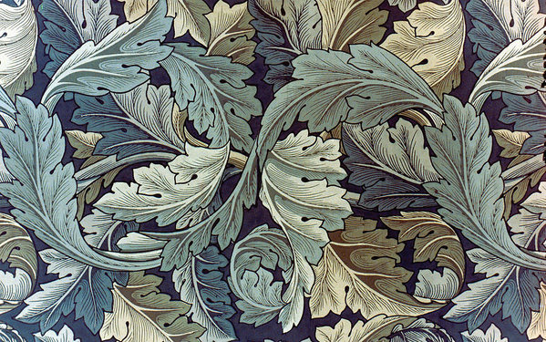

Poetry anthology
Carol Ann Duffy
Scottish Set Text
National 5

Contents
Valentine 1
Originally 2
The Way My Mother Speaks 3
War Photographer 4
Mrs Midas 5
In Mrs Tilcher’s Class 8

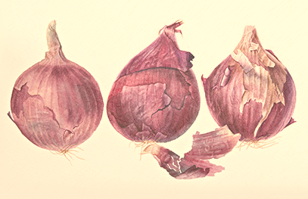
Valentine
Not a red rose or a satin heart.

I give you an onion.
It is a moon wrapped in brown paper.
It promises light
like the careful undressing of love.

Here.
It will blind you with tears
like a lover.
It will make your reflection
a wobbling photo of grief.

I am trying to be truthful.

Not a cute card or a kissogram.

I give you an onion.
Its fierce kiss will stay on your lips,
possessive and faithful
as we are,
for as long as we are.

Take it.
Its platinum loops shrink to a wedding ring,
if you like.
Lethal.
Its scent will cling to your fingers,
cling to your knife.
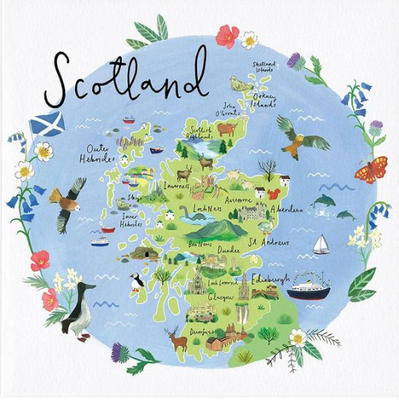
Originally
We came from our own country in a red room
which fell through the fields, our mother singing
our father’s name to the turn of the wheels.
My brothers cried, one of them bawling, Home,
Home, as the miles rushed back to the city,
the street, the house, the vacant rooms
where we didn’t live any more. I stared
at the eyes of a blind toy, holding its paw.

All childhood is an emigration. Some are slow,
leaving you standing, resigned, up an avenue
where no one you know stays. Others are sudden.
Your accent wrong. Corners, which seem familiar,
leading to unimagined pebble-dashed estates, big boys
eating worms and shouting words you don’t understand.
My parents’ anxiety stirred like a loose tooth
in my head. I want our own country, I said.

But then you forget, or don’t recall, or change,
and, seeing your brother swallow a slug, feel only
a skelf of shame. I remember my tongue
shedding its skin like a snake, my voice
in the classroom sounding just like the rest. Do I only think
I lost a river, culture, speech, sense of first space
and the right place? Now: Where do you come from?
strangers ask. Originally? And I hesitate.
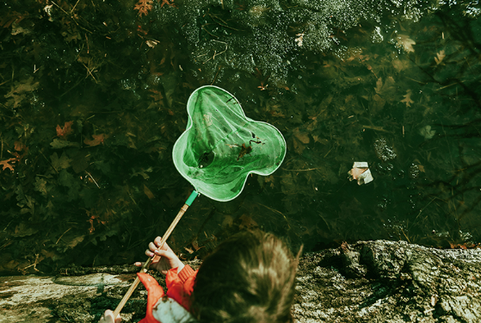
The Way My Mother Speaks
I say her phrases to myself
in my head
or under the shallows of my breath,
restful shapes moving.
The day and ever. The day and ever.
The train this slow evening
goes down England
browsing for the right sky,
too blue swapped for a cool grey.
For miles I have been saying
What like is it.
The way I say things when I think.
Nothing is silent. Nothing is not silent.
What like is it.
Only tonight
I am happy and sad
like a child
who stood at the end of summer
and dipped a net
in a green, erotic pond. The day
and ever. The day and ever.
I am homesick, free, in love
with the way my mother speaks.
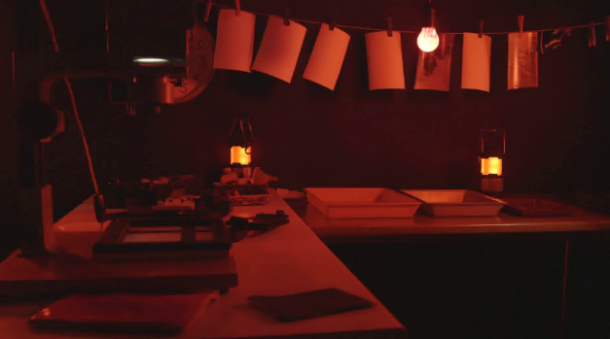
War Photographer
In his dark room he is finally alone
with spools of suffering set out in ordered rows.
The only light is red and softly glows,
as though this were a church and he
a priest preparing to intone a Mass.
Belfast. Beirut. Phnom Penh. All flesh is grass.

He has a job to do. Solutions slop in trays
beneath his hands, which did not tremble then
though seem to now. Rural England. Home again
to ordinary pain which simple weather can dispel,
to fields which don’t explode beneath the feet
of running children in a nightmare heat.

Something is happening. A stranger’s features
faintly start to twist before his eyes,
a half-formed ghost. He remembers the cries
of this man’s wife, how he sought approval
without words to do what someone must
and how the blood stained into foreign dust.

A hundred agonies in black and white
from which his editor will pick out five or six
for Sunday’s supplement. The reader’s eyeballs prick
with tears between the bath and pre-lunch beers.
From the aeroplane he stares impassively at where
he earns his living and they do not care.

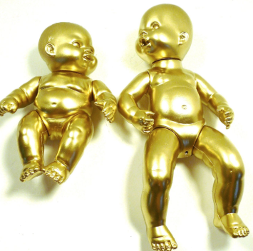
Mrs Midas
It was late September. I’d just poured a glass of wine, begun
to unwind, while the vegetables cooked. The kitchen
filled with the smell of itself, relaxed, its steamy breath
gently blanching the windows. So I opened one,
then with my fingers wiped the other’s glass like a brow.
He was standing under the pear tree snapping a twig.

Now the garden was long and the visibility poor, the way
the dark of the ground seems to drink the light of the sky,
but that twig in his hand was gold. And then he plucked
a pear from a branch. – we grew Fondante d’Automne –
and it sat in his palm, like a lightbulb. On.
I thought to myself, Is he putting fairy lights in the tree?

He came into the house. The doorknobs gleamed.
He drew the blinds. You know the mind; I thought of
the Field of the Cloth of Gold and of Miss Macready.
He sat in that chair like a king on a burnished throne.
The look on his face was strange, wild, vain. I said,
What in the name of God is going on? He started to laugh.

I served up the meal. For starters, corn on the cob.
Within seconds he was spitting out the teeth of the rich.
He toyed with his spoon, then mine, then with the knives, the forks.
He asked where was the wine. I poured with a shaking hand,
a fragrant, bone-dry white from Italy, then watched
as he picked up the glass, goblet, golden chalice, drank.

It was then that I started to scream. He sank to his knees.
After we’d both calmed down, I finished the wine
on my own, hearing him out. I made him sit
on the other side of the room and keep his hands to himself.
I locked the cat in the cellar. I moved the phone.
The toilet I didn’t mind. I couldn’t believe my ears:

how he’d had a wish. Look, we all have wishes; granted.
But who has wishes granted? Him. Do you know about gold?
It feeds no one; aurum, soft, untarnishable; slakes
no thirst. He tried to light a cigarette; I gazed, entranced,
as the blue flame played on its luteous stem. At least,
I said, you’ll be able to give up smoking for good.

Separate beds. in fact, I put a chair against my door,
near petrified. He was below, turning the spare room
into the tomb of Tutankhamun. You see, we were passionate then,
in those halcyon days; unwrapping each other, rapidly,
like presents, fast food. But now I feared his honeyed embrace,
the kiss that would turn my lips to a work of art.

And who, when it comes to the crunch, can live
with a heart of gold? That night, I dreamt I bore
his child, its perfect ore limbs, its little tongue
like a precious latch, its amber eyes
holding their pupils like flies. My dream milk
burned in my breasts. I woke to the streaming sun.

So he had to move out. We’d a caravan
in the wilds, in a glade of its own. I drove him up
under the cover of dark. He sat in the back.
And then I came home, the woman who married the fool
who wished for gold. At first, I visited, odd times,
parking the car a good way off, then walking.

You knew you were getting close. Golden trout
on the grass. One day, a hare hung from a larch,
a beautiful lemon mistake. And then his footprints,
glistening next to the river’s path. He was thin,
delirious; hearing, he said, the music of Pan
from the woods. Listen. That was the last straw.

What gets me now is not the idiocy or greed
but lack of thought for me. Pure selfishness. I sold
the contents of the house and came down here.
I think of him in certain lights, dawn, late afternoon,
and once a bowl of apples stopped me dead. I miss most,
even now, his hands, his warm hands on my skin, his touch.

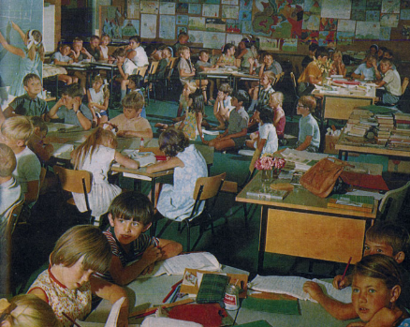
In Mrs Tilcher’s Class

You could travel up the Blue Nile
with your finger, tracing the route
while Mrs Tilscher chanted the scenery.
Tana. Ethiopia. Khartoum. Aswân.
That for an hour, then a skittle of milk
and the chalky Pyramids rubbed into dust.
A window opened with a long pole.
The laugh of a bell swung by a running child.

This was better than home. Enthralling books.
The classroom glowed like a sweet shop.
Sugar paper. Coloured shapes. Brady and Hindley
faded, like the faint, uneasy smudge of a mistake.
Mrs Tilscher loved you. Some mornings, you found
she’d left a good gold star by your name.
The scent of a pencil slowly, carefully, shaved.
A xylophone’s nonsense heard from another form.

Over the Easter term, the inky tadpoles changed
from commas into exclamation marks. Three frogs
hopped in the playground, freed by a dunce,
followed by a line of kids, jumping and croaking
away from the lunch queue. A rough boy
told you how you were born. You kicked him, but stared
at your parents, appalled, when you got back home.

That feverish July, the air tasted of electricity.
A tangible alarm made you always untidy, hot,
fractious under the heavy, sexy sky. You asked her
how you were born and Mrs Tilscher smiled,
then turned away. Reports were handed out.
You ran through the gates, impatient to be grown,
as the sky split open into a thunderstorm.

