Alison Hennessy and Sonia Grant
August 2017

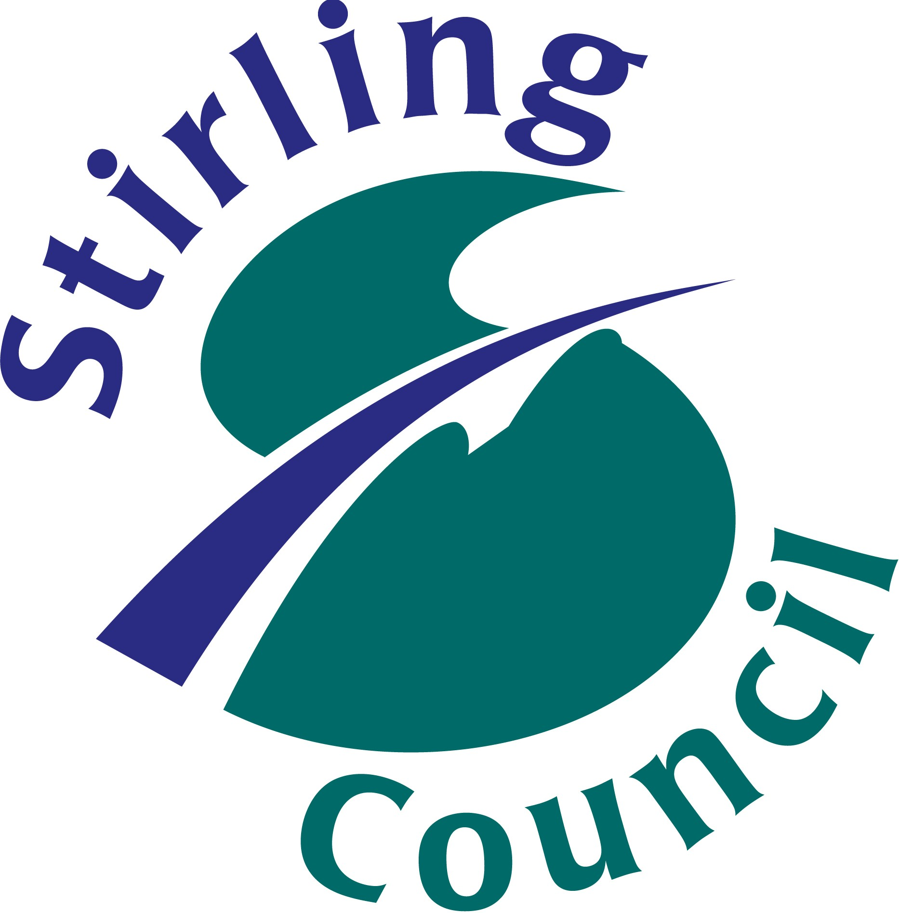
Case study
Using peer feedback to bring story-writing to life in the classroom.

A Stirling study.

Introduction
Primary seven pupils in a Stirling school were given the opportunity to write a book of their own. The children were taught how to plan and discuss their story, and how to give growth mindset feedback. They then worked in pairs to give kind, specific and helpful feedback to each other. This feedback was used by the pupils to improve their writing in their individual books. Teachers observed improvements in engagement and skill levels with children achieving at all levels, and reflected that this novel approach allowed the teacher to focus more on developing more advanced literacy skills of the pupils.

Key Findings

Engagement and skill within creative writing increased. Teachers reflected that this was due to:

Having a sense of purpose for the writing;

Fostering a growth mindset attitude towards feedback and skill development by modelling the behaviours and attitudes of a famous author;

Building of learner identity as the children thought of themselves as authors;

Large chunks of time dedicated to planning and writing;

The bonding process between writing partners;

Increased quality of teacher marking and feedback due to decreased marking load and ability to focus on advanced literacy skill development;

Inclusion of art and ICT as part of the writing process.

Background

Meta-analyses by John Hattie place effective feedback at the top of classroom interventions that have a positive impact on children’s learning. (Hattie, 2009). Peer feedback is powerful; however, Nuthall (2007) warned that while 80% of feedback received by primary school pupils is from their fellow pupils, 80% of this feedback is flawed. It is therefore important that pupils know what effective feedback looks like. Peer tutoring is an excellent way for pupils to enhance their own learning through teaching others. This effect is increased further when pupils have some control over goal setting and monitoring and evaluating progress. (Rohrbeck et al, 2003)

Effective feedback is a key aspect of the growth-mindset classroom. An environment where mistakes and setbacks are seen as learning opportunities will thrive on meaningful feedback. (Dweck, 2006)

Methodology
Primary seven pupils in two primary seven classes in a Stirling school were tasked with writing their own individual books. The class project involved creation of a book by each child, written for the purpose of reading the books to their ‘buddies’ (young children who were paired with the older children for support and pro-social role modelling), and ultimately publishing their books. The teachers taught their pupils about the process of being an author, including drafting and redrafting of work based on editor feedback.
The pupils were given time to plan their writing and time to write before pairing up with a ‘writing partner’ to give and receive feedback. The pupils were taught how to do this effectively. The work progressed throughout the school year with alternating periods of working alone and reflection sessions with writing partners. The classroom teachers were also present to give instruction and advice; however, the writing and feedback were largely pupil-led. The writing was done using a word processing application, and the books were fully illustrated by the children.
The two classroom teachers were interviewed at the end of the school year to determine the impact of this way of working on the pupils and teachers.

Findings
At interview, the teachers reflected that they had decided to alter the way they taught story writing because it became apparent at the start of the year that pupils were disengaged from the subject; they were extremely demotivated and responded negatively towards writing. Teacher frustration had been high because the pupils did not appear to respond to or learn from feedback. Marking time was largely spent correcting basic grammar and punctuation, rather than supporting the development of more advanced literacy skills.
The teachers reflected that discussing author strategies helped the pupils to develop a growth mindset attitude towards feedback:

Teacher 1: “So the idea was that the children then realise that you only write a small bit of the story first, then see how it’s going. And we were saying that happens in real life, in a publishing company.”
Teacher 2 “And you’ve no idea how much of a culture shift (there was). For them to know that actually an author is just not a supremely gifted writer, they go through this same process. It’s a lot of hard work, and there’s a lot feedback they get from various people, inspiration from various other people. I think previously when they were given feedback on things, I think they maybe saw it as ‘Oh that’s obviously not good enough’
Teacher 1: “Yes, very much as a criticism previously. Nowadays, in my class, if I ask them, “How could you improve it?” It’s not “Oh she doesn’t like my story.”

Having the sense of purpose of publishing and sharing their work with another year group was said to be a motivator for the pupils when it came to re-drafting their work:

“I think previously it was maybe a case of a redrafting for the sake of it: let’s change this; the spelling is incorrect, or capital letter; let’s change that. There was never really a purpose to it, and I think with this project there’s always a purpose to it. And the end result is they’re reading their stories to another year group. Because of that, they don’t go ‘Oh what’s the point in this, why are we redrafting?’ They see the value in it.”
Exploring literacy in this way has led to a level of engagement with the subject that was not seen before:

“Now you see children in the class who previously you wouldn’t see with a thesaurus, you wouldn’t see them using any resources in the class, and you hear really rich discussions about ‘Oh, what do you think about this?’ ‘Is there a better word for ‘said’? ‘Is there a better word for ‘run’?’ ‘Is there a better way of describing this situation or this object?’ and it’s a brilliant atmosphere to be a part of.”

The teachers revealed that another reason for the success of the project was the sheer time dedicated to planning and writing a single piece of work; previously pupils would have worked on many writing tasks throughout the year. Pupils were encouraged to think their stories through before they started, and to stick loosely with the plan; although, it could evolve over time. The time dedicated to this project was welcomed by the children, who responded by becoming more engaged in their writing.
Pupils were given the autonomy to select their own writing partners, and the developing bond between them was said to extend across the curricular areas:

“Quite often I say to people ‘Right I’m wanting you to do a maths task today, why not work with your writing partner?’ There’s a real bond between the two of them. They’re doing problem solving with their writing partners. Quite often if they’re doing a task, they’ll get up and they’ll just say ‘I’m just checking with my writing partner about…’ there’s a real bond part.”

Working with a writing partner further developed the pupils’ writing and communication skills. The pupils were taught how to give effective feedback by being ‘kind, specific and helpful’

“We’ve got little sentence starters; how they can start off their feedback with their partner. The phrase is kind of hard on content, but kind and soft on people. So, you’re not hurting their feelings and they’re much more receptive obviously as a result of that.”

But the teachers observed the evolution of the feedback over time, as the peer relationships developed and trust increased.
“You think to yourself that they really are into this dialogue, and you’ll hear things like ‘Oh you’ve started off too often with this, I think you should change that’ or ‘What about this idea?’ And they're really sharing ideas…One of them had said along the lines of ‘If you’d read that story to me I would have been a wee bit disappointed, I think you need to…’ Previously, before this, you’d hear ‘Your handwriting has improved’ you know and you think to yourself, ‘Well what’s that got to do with the whole context?’ The children have really got the idea of what they should be saying now.”

In addition to the increase in the standard of writing, the teachers reported another advantage to this way of working. Because the writing partners were able to support each other with basic punctuation errors, the teachers were able to focus their feedback on ways to improve writing skills.

“Now they’ve got partners who are … checking over and going, “Oh you missed a capital letter there, you’ve missed a comma there.” “That should be a full stop and a new sentence.” We (the teachers) are looking at the writing and we’re giving them really valuable feedback on how to improve their work, rather than picking up things that they probably knew already, but previously didn’t have the opportunity to go back and correct themselves.”

Using ICT and art to complement the writing process was thought to be a valuable addition to the process:

“In primary 1-3 you’d always have a piece of writing and then you’d have a nice picture at the end of that, it would be part of the real excitement of writing. And then from primary 4-7 I would say, generally, it would just be – No, we don’t have time for that, let’s get through it, let’s get all the points that we need in there. And they love it, they love the kind of art side of things. They love using the ICT, they find it…much more efficient, and the changes that we’ve made and the feedback that we’ve given on the computer, very easy for us to do, very easy for them to kind of change and edit. I think you’ve got children in the class who really enjoy art, who really enjoy using ICT and that adds to the experience for them.”

The pupils took a pride in their work, in sharp contrast to how they felt at the start of the session:

“I remember him at the start of the year being very, very negative towards writing and at the end of this project he said ‘I’m really proud of that’. I thought that’s brilliant. Whereas the pieces of work at the start of the year, … it’s not a piece of work they cared about, spent a lot of time thinking about, something they were maybe forced to do, they didn’t see the purpose of it. The project has changed the attitudes completely.”

Conclusion
This project illustrates a novel approach to creative writing in a primary seven classroom.
The time spent and importance placed on the project allowed it to thrive, and engagement of the pupils in the subject increased substantially during the project. Pupils were taught basic feedback coaching tools, and developed these with their writing partners. A growth mindset towards feedback and skill development was developed in pupils as they modelled the behaviours and attitudes of published authors. They were given autonomy and plenty of time to plan, write and develop their work, and they chose their own writing partners. Giving and receiving feedback with their partners was said to develop significant peer to peer bonds, which were not limited to the project, but were sustained in other curricular areas.
The holistic nature of the project, which included art and ICT as well as creative writing was said to enhance the children’s experience. Teacher feedback was extremely positive, focusing on the increase in children’s achievement, engagement and motivation towards creative writing. Teachers also reflected on a decreased marking load. This was said to be due to the role of the writing partners, who highlighted basic punctuation and grammatical errors, therefore freeing the teachers to teach more advanced literacy skills.
References

Hattie, J. (2009). Visible Learning a synthesis of over 800 meta-analyses relating to achievement. Routelage: London and New York

Nuthall, (2007) The hidden lives of learners. Wellington, New Zealand: New Zealand Council for Educational Research

Rohrbeck, C.A., Ginsburg-Block, M.D., Fantuzzo, J.W. and Miller, T.R. (2003). Peer-assisted learning interventions with elementary school studies: a meta-analytic review. Journal of Educational Psychology, 95 (2), 240 - 257
Dweck, C. (2006) Mindset: How you can fulfil your potential. New York: Random House.
Ferre Laevers (Ed.) (2005) Well-being and Involvement in Care Settings. A Process-oriented Self-evaluation Instrument, Research Centre for Experiential Education: Leuven University.

Acknowledgements
We thank Alex Henderson and Jane McNab, the primary seven classroom teachers from Braehead Primary School, Stirling, who created and carried out this project. Thanks also go to the pupils at Braehead Primary School, who worked so enthusiastically on their books.

