Dr. Alison Hennessy
December 2016

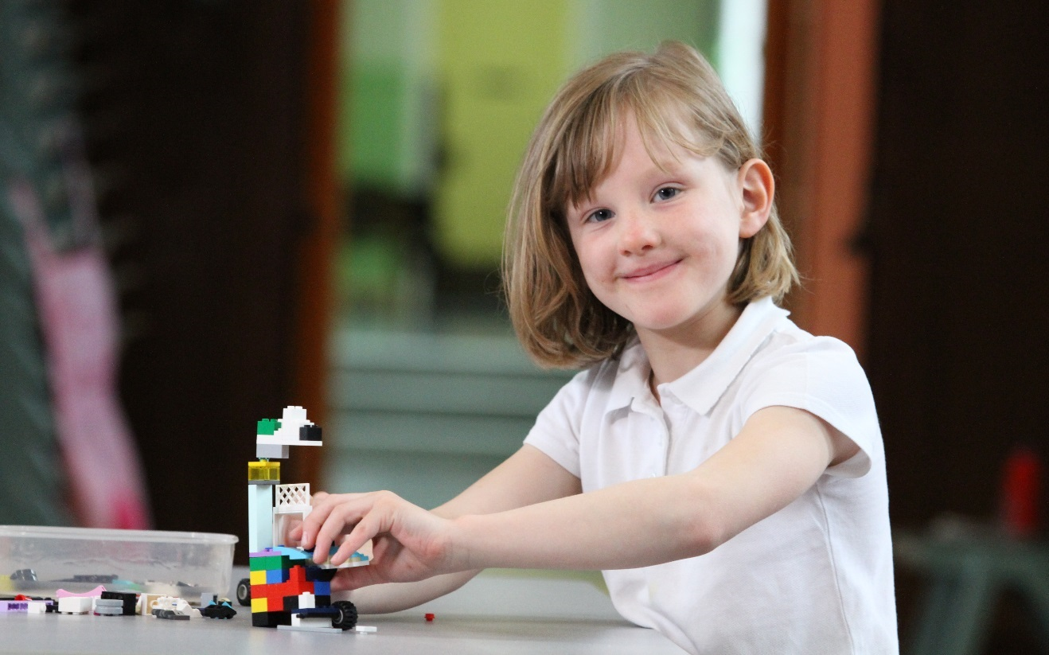
Case Study
Overcoming mathematical misconceptions with conceptual maths

Introduction

A classroom teacher in St Luke’s and St. Matthew’s Dundee used conceptual maths techniques with her primary seven class. Conceptual maths is strongly linked to growth mindset, as it promotes deep thinking and reflection, use of strategies and celebration of mistakes. The teacher made use of ‘number talks’, championed by Jo Boaler, and ‘think boards’, which are based on research carried out by Jerome Bruner. The children enjoyed this approach to learning mathematics, which was also found to encourage a growth mindset culture in the lessons.

Findings
- Using conceptual maths techniques encouraged the class teacher to be a more reflective practitioner;
- Taking part in the project helped the teacher to maintain a focus on conceptual maths;
- Conceptual maths techniques improved pupil engagement and enjoyment of maths;
- Flexible grouping combined with conceptual maths allowed all pupils to attempt challenging work, with dramatic results for some;
- Pupils were able to explain their thinking using mathematical language;
- Pupils enjoyed their maths lessons, and were keen to take part.

Background
Carol Dweck has described beliefs about intelligence as growth or fixed mindset (Dweck 2006). People with a growth mindset believe that intelligence can grow and develop, while people with a fixed mindset believe that intelligence is fixed. Fixed mindsets are common in mathematics. This is mainly due to a series of misconceptions. These misconceptions include: some people have a maths brain and some do not; being fast at carrying out calculations means you are good at maths, while being slow means you are bad at maths; boys are better at maths than girls. The misconceptions are often held by pupils, parents and teachers, and they are reinforced in maths classrooms which concentrate on times tables, speed and repetition.
Ability grouping persists in Scottish maths classrooms, in spite of meta-analyses which show that they are ineffective, and even damaging to pupils (Hattie, 2008). The groups children are placed in at a young age are linked to their age relative to their classmates, but being placed in a low ability group at a young age can follow children all the way though their mathematical school career, as they start to perceive themselves as low ability and struggle to move up through the maths groups, (Campbell 2014) It is much better for maths classrooms to be heterogeneous, or for any groupings to be completely flexible.
Jo Boaler’s number talks move the focus away from silent completion of worksheets to whole class discussions about a mathematical problem. The teacher may ask the class to solve a problem, and then discuss and compare the different strategies the pupils used to work out the answer. Pupils are encouraged to try out all of the strategies discussed. Mistakes form discussion points, rather than failure, and there is an emphasis on deep understanding rather than speed.
In its most basic form, mathematics can be learned by handling physical objects. This allows children to see and feel the maths they are doing. At a later stage, a drawing of the objects will suffice, and eventually, abstract symbols will replace the objects and pictures. The researcher Jerome Bruner suggests that all three steps are needed for children to understand a concept. Think boards encourage pupils to make connections and consider a variety of strategies depending on their stage of development. (Department of Education, 2004) They encourage children to tackle word problems and sums using a flexible approach to number based on a deep understanding of math concepts. Ultimately, it is hoped that children will design their own think boards and select their preferred strategies to both understand and solve the problem. An example of a think board question is given in Figure 1.

There are nine boxes. Each one can hold five snowboards. How many snowboards will we need to fill all the boxes?
Bar modelling | Draw a Picture
Use a blank array | What sums did you have to do to solve the problem?
Figure 1: Specimen think board

Improvement methodology was used to trial the use of conceptual maths techniques in one primary school. The school is in an area of multiple deprivation, and there is a focus on numeracy because standardised test results have revealed a significant dip in numeracy attainment in the primary 7 children. The conceptual maths approach was identified as a way to address this dip in attainment and enjoyment of numeracy.
Improvement methodology is a form of action research where practitioners lead improvements using Plan Do Study Act (PDSA) cycles. (Langley 2009) After the initial planning stages, the teacher involved in this study implemented changes that she thought would lead to improvement. Measures were taken and monitored on a continuous basis. The action research reported here represents the first PDSA cycle.

Methodology
Conceptual maths techniques were used in primary 7 class for every maths lesson over a period of six weeks. This included use of number talks, think boards and flexible groupings. The class followed Jo Boaler’s advice on her website ‘Youcubed’ to set maths norms for the class, including understanding what they like to hear, feel and see during maths lessons. Measurements were taken throughout the period. The teacher measured the engagement of six pupils on a regular basis throughout the coaching period using the Leuven engagement scale (pupil engagement over a two-minute time period assessed on a scale of 1:5) (Laevers 2005). The scores were used to inform a qualitative interview with the class teacher at the end of the process.

Findings
Impact on teacher
The teacher reflected that using conceptual maths techniques had changed her teaching style, and encouraged her to be a reflective practitioner.

“Before I was introduced to conceptual maths I used text books and I taught procedures and rote learning, and when a child didn’t understand I had nowhere else to go. I had taught the procedure, I had told them what to do, so why were they not able to do it? It was extremely frustrating. I went into the staff room many a time saying, “Oh that child, oh that child, I don’t know what I can do.” I blamed it on the child. Now with conceptual maths, because I teach for understanding, if the children do not understand I know it’s because I’m not teaching it properly, so I think conceptual maths has really encouraged me to be a reflective practitioner. It is up to me to find activities which firstly engage children to want to learn, and secondly are varied to help ensure understanding for all – whatever the learning style.”

While she had used conceptual maths techniques in the past, the teacher felt that completing the action research project kept conceptual maths at the front of her mind.

Impact on class
Flexible grouping was used in this conceptual maths classroom, as opposed to static ability groups:
“'In my experience children are often put into groups: circles/squares/triangles, and quite often those children will be static in those groups. It might get reviewed every six weeks, at the end of every six week block, but generally that’s where they’ll stay.”

The teacher reflected that the flexible grouping combined with conceptual maths allowed pupils to attempt challenging work, with dramatic results for some:

“That couldn’t have happened if those children had been stuck in the group, they would always be in that group because that’s the work that they’re getting and that’s what their group is. Whereas because they’ve had the chance to try something more challenging, oh look now…during the project, the initial assessment results would have traditionally placed one (child) in a lower to middle ability group, but soon (the child) was attempting very challenging work. I think because of the conceptual maths (the child) has been equipped with the skills and the knowledge and the materials to go off and try it for themselves.”

Conceptual maths encourages deep thinking, and the teacher commented that pupils are now able to explain their thinking using mathematical language. She was pleased to say that the pupils enjoyed their maths lessons, and were keen to take part. The Leuven engagement score for the class rose from 3.8 to 4.3 over the course of the project. The children enjoyed the freedom of trying out new strategies and being encouraged to make mistakes and talk about them.

“(One child) got very despondent if (they) were getting things wrong. Now when (they) make mistakes (they) are much more willing to go ‘Well where did I make that mistake?’ you know and actually try and take part in and often lead conversations. (They’re) willing to look for the mistake. So I’ve noticed a big change in (that child).”

Next steps
When asked whether she would make any changes in her conceptual maths teaching moving forward, the teacher reflected that the maths classroom was perhaps still too teacher-led, and she would like to see more child-led number talks:

“I feel I should be giving more space and more of the lead role to the children by encouraging them to talk through what they have done not only with me and the class as a whole, but with each other. Through explaining their thinking and understanding to others, they become reflective learners and can assess themselves.”

Conceptual maths techniques complement the principles of growth mindset completely, with the emphasis on deep thinking, use of strategies and celebration of mistakes. ‘Mindset fatigue’ is a common phenomenon being reported by teaching practitioners attempting to create a growth mindset culture, where pupils and staff tire of hearing about growth mindset. Conceptual maths may provide a platform to embed and create a growth mindset culture without having to refer to it explicitly. Teachers can then refer to the attitudes and beliefs of the maths classroom to support teaching across the rest of the curriculum.

After the research interview had taken place, the classroom teacher sent an email which shows how the conceptual maths approach has had an effect on other areas of the curriculum. An extract is given here:
“Interestingly, only the other day the RCT teacher commented to me that during an art activity she had observed a growth mindset from my class. This was without any prompting from her. She heard the children make comments to each other such as ‘Keep trying, it’ll get easier,’ and ‘The more you try the better you’ll get.’ I have enjoyed using this project to embed growth mindset through the delivery of the curriculum, as it then becomes part of our day-to-day interactions and eventually just part of who the children are.

Conclusion
Conceptual maths techniques improved pupil engagement and enjoyment of maths. Flexible grouping combined with conceptual maths allowed all pupils to attempt challenging work, with dramatic results for some. Pupils were able to explain their thinking using mathematical language. They enjoyed their maths lessons, and were keen to take part.

References
Dweck, C. (2006) Mindset: How you can fulfil your potential. New York: Random House.
Hattie, J., 2008. Visible Learning.
Campbell, T (2014) Stratified at seven: in-class ability grouping and the relative age effect, British Educational Research Journal
Department of Education (2004) First steps in Mathematics: Number – Book 2. Understanding operations; Calculate; Reason about number patterns
Langley, G.J., Moen, K.M., Nolan, T.W., Norman, C.L. & Provost, P.P. (2009). The improvement guide: A practical approach to enhancing organisational performance (2nd ed.). San Francisco: Jossey-Bass.
http://www.jamesnottingham.co.uk/learning-pit/Leuven scale
Ferre Laevers (Ed.) (2005) Well-being and Involvement in Care Settings. A Process-oriented Self-evaluation Instrument, Research Centre for Experiential Education: Leuven University.

Acknowledgements
We acknowledge the energy and efforts of Aileen Wallace, the class teacher in Dundee who was involved in this work. We are also grateful to Jamie McBrearty for initiating and supporting the project.

https://www.youcubed.org/from-stanford-onlines-how-to-learn-math-for-teachers-and-parents-number-talks-2/
http://www.mathsnoproblem.co.uk/concrete-pictorial-abstract
https://www.youcubed.org

