Dr. Alison Hennessy
August 2017
Case study
Learning about perseverance using peer coaching in the early years

A Stirling study

Introduction

Nursery children in Braehead nursery, Stirling, completed a project with the support of nursery staff and a small group of primary 6 children, called Growth Mindset Ambassadors. The staff and ambassadors supported the children to develop specific skills over time by delivering growth mindset feedback and modelling growth mindset behaviour. They helped the children to visualise their progress and to understand the relationship between practice and mastery.

Key Findings
- Engagement of the nursery children remained high at the end of the project, partly due to the involvement of the P6 ambassadors
- The nursery children developed skills and an increased ability to focus, and learned the relationship between practice and mastery
- The project was said to support the transition from nursery to primary school
- The competitive element of the project was managed by the Senior Early Childhood Educator (SECE) for those children who were not ‘winning’ by encouraging an approach that celebrates achievement of a personal best
- The primary six ambassadors developed their own mindsets during the project
- Taking measurements helped the teacher to reflect on her practice and had the effect of motivating the nursery children

Background
Growth mindset is the belief that ability is not fixed, but can grow within a nurturing environment which promotes perseverance, challenge and learning from mistakes (Dweck, 2006). Development of a growth mindset, like all self-beliefs, is heavily influenced by the environment and culture that a child is exposed to, and early intervention is key. The developing brain is affected by the presence or absence of love (Ainsworth and Bowlby, 1991), trauma (van der Kolk, 2005), activities offered from birth (including use of gender-oriented toys) and the nature of praise (Mueller and Dweck, 1998). Habits and attitudes formed in the early years can have long-lasting effects, so development of a growth mindset attitude towards failure and the power of practice at an early age are highly beneficial.

Methodology
A group of twelve preschool children were selected to take part in the project. They were taught some of the key principles of growth mindset using the Class Dojo video series with reinforcement from nursery staff. There was a focus on perseverance and thinking of the brain as a muscle which grows when exposed to both challenge and effort. A group of six mindset ambassadors were trained in growth mindset, including how to deliver growth mindset encouragement and feedback. Along with nursery staff, the ambassadors worked closely with small groups of pre-school children to develop skills in skipping, shoelace tying, cutting out or writing their own names. Sessions between the pre-school children and the ambassadors took place once/ week, and sessions with nursery staff twice/ week over a six week period. Progress was visualised and measured by the children using a ‘brain board’ (Figure 1). Whenever a child practiced a skill, a length of thread was passed between the child’s picture and the brain, symbolising a neural connection. One member of staff measured and recorded the engagement of a six of the children after each session using the Leuven involvement scale (Ferre Laevers, 2005); she also gave context and qualitative data at this time. Qualitative interview data were obtained from this member of staff and the mindset ambassadors after a six week period.

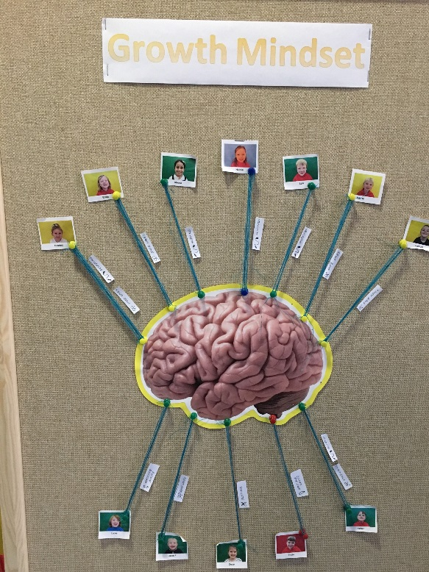
Figure 1: The brain board

Findings
At interview the Senior Early Childhood Educator (SECE) reflected that home lives can be busy, with some parents finding it easier to do everything for their children. This can lead to children being unwilling to ‘have a go’, which can affect self-confidence. She felt that the sheer time spent teaching children new skills was a key part of this project, and one which she found worthwhile.

“Staff taking time to work through things, either with individual children or with small groups, to bolster their confidence, to help them develop a positive attitude towards learning from a very early age…It’s got to have been well spent. Anything that supports the children’s developing their self-confidence has to be worthwhile time.”

The engagement of the four members of the group was measured after each session using the Leuven Involvement scale, and their average engagement was high at the start of the project, dipped a little during the next session, but then increased again as the mindset ambassadors became involved. The primary six ambassadors were coached in growth mindset, and were therefore able to model and support growth mindset behaviours and attitudes. The SECE reflected that this may have been one of the main reasons for the success of the project.

“We did see a difference when the buddies came in because they love working with the older children.”

The children experienced the relationship between practice and mastery in a methodical way, the nursery teacher noting in her questionnaire that the explanation about the growth of neurons appeared to resonate with the children:

“Pupil 3 continues to work hard at his task and talks frequently about the neurons in his brain making connections. He is demonstrating a positive attitude towards his task (shoe laces), occasionally becoming a little frustrated if he does not complete the task successfully, however he is happy to try again until he experiences success.”

The SECE noted an improved attitude to challenge, and the pre-school children were able to confidently complete activities which would support their transition into primary school:

“We’ve got wee ones tying their shoelaces, that some of the older children can’t do. Some of them have learnt to skip. Some of them are quite confidently writing their name who previously would have been reluctant to put pencil to paper. So for the children making the move onto primary one, they’re valuable skills, but it’s also the attitude towards trying something challenging.”

The primary 6 ambassadors also saw the significance of growth mindset in the transition from nursery to primary:

“Yeah, we’ve gave them an example of what it’s gonna be like in school and it’s not always gonna be easy, but you just can’t give up at it and you need to keep on going and keep on going and keep on going.”

While the mastery of specific skills is important for self-confidence and transition, the SECE reflected that the mindset of one child was affected by the project in a profound way. She noted that nursery culture differs from school in that children usually have free choice about which activities they engage in. The project steered some children in a different direction to their usual interests, which was seen to have a positive impact:

“I think bringing the children out with the group, we’ve been able to really push for that level of focus and engagement with the tasks. And I’m thinking of one particular child with his writing. We have seen that come in within his own free play time, because he is accessing the writing and drawing table and he’s quite confident doing his name... And he’s a very active, run about child, so for him to actually, of his own volition, come to the writing table, sit down and take time to do something, that’s quite a step forward for him.”

The ambassadors were taken on a mindset journey along with the nursery children. This was observed by the SECE and the children themselves:

“Initially he was the one whose own personal growth mindset was not always there, and he needed a bit of encouragement from staff. But by the end, we saw huge difference with him and we saw that with both children that he worked with…and his language by the end of it was very good with them, which was super.”
Senior Early Childhood Educator (SECE)

“Before, say you went a couple of goals down (in football) or you went a couple of goals up, you would just sort of give up on that a bit and then just hope that… it was more like a bit of a hoping game before growth mindset, and then when we learned about growth mindset, we learned that for however many minutes you play, you always have to keep on going and you can just never give up. And if you never give up you will always get better and better.”
P6 ambassador

Children learn in different ways, which can include independently, collaboratively and competitively. An unintentional element of competition emerged during the project, and the teacher was aware of and had to manage the feelings this produced in the children.

“From a very early age it’s - who’s the biggest? Who’s the tallest? Who’s the fastest? I think it can be beneficial in spurring some children on. But for other children, to feel that they’re not as good as, that’s not helpful.”

The teacher took a growth mindset approach to this, explaining to those children who were not ‘winning’ that competition can also be internal, supporting each child to be their own personal best:

“It’s about doing your best and trying hard, which is obviously a big part of the growth mindset. It doesn’t really matter what other children are doing, look at what you’ve done, what you’ve achieved and let’s see how far we can go with it. I think that’s the important thing.”

Although the ambassadors may have been unaware of the subtleties of the teacher’s approach, they observed a change in the attitudes of the younger children over the course of the project:

“As much as they all wanted to get more strings than each other (at the start) they all… near the end they all just forgot about the strings and just carried on with what they’re doing and they all got a lot more concentrated on the laces or the skipping or whatever they were doing. They all got a lot more concentrated.”

The SECE felt that taking regular measures supported the project, as it helped her to reflect on her own practice.

“I think it probably focuses you in on the children’s level of engagement - you might not have previously been thinking so much in depth about what they’re doing. It’s encouraged me to kind of stop and actually think and take stock in a maybe more detailed way.”

The children were also said to benefit from taking their own measures, which involved winding cotton thread around pins to symbolise neuron growth, as it spurred them on.

“I think the board, as a visual, has been really important for them to actually… cause they’re visually seeing that progress of the strings, the strings have got thicker and that there’s…they're very competitive at this age, I don’t know if it continues right throughout the school, but “I’ve got five strings, how many strings have you got?”. We’ve kept the conversation going about the strings are representative of the connections with the neurons, but I think the actual visual for them to see that has been really important.”

Next steps
While the SECE was pleased by the progress the children had made, and felt that the time spent developing skills was valuable, she reflected that it would be difficult to scale this up to a whole class.

“I think we would need to, through observation and getting to know the children, pick out the ones that we feel would benefit from it the most.”

It was felt that the flexible nature of nursery day would lend itself to a flexibility in how the project was developed year after year:

“It might be a bit of trial and error. You know, we might try one way and think that’s not quite hit the mark this time. Assess why - It could be the group of children that we’re working with. It could be that for this year we’re just needing to find another way to make it happen. We’ll give it a go, if it doesn’t work, to sustain it we need to find another way to make it work. It’s just about taking a step back, reflecting and reassessing it.”

Conclusion
This project was designed to teach pre-school children about the power of practice and perseverance, and to use peer coaching as a medium to support young children to develop their understanding of growth mindset. Primary six ambassadors modelled and supported growth mindset attitudes and behaviours, developing their own mindsets in the process, and engagement of the nursery children was maintained throughout the project. The nursery children developed key skills to aid them in the transition from nursery to primary school. Perhaps more importantly, they developed a healthy attitude towards challenge and were able to see the connection between practice and achievement. The project was seen as an excellent use of time by the staff involved.
References
Dweck, C.S. (2006) Mindset: How you can fulfil your potential. New York: Random House.
Ainsworth, M.D.S. and Bowlby, J. (1991) An ethological approach to personality development, American Psychologist, 46, 331-341

van der Kolk. B.A. (2005) Developmental Trauma Disorder: Toward a rational diagnosis for children with complex trauma histories. Psychiatric Annals, 35(5), 401 - 408
Mueller, C., and Dweck, C.S. (1998) Praise for intelligence can undermine children’s motivation and performance. Journal of Personality and Social Psychology, 75(1), 33 – 52

Ferre Laevers (Ed.) (2005) Well-being and Involvement in Care Settings. A Process-oriented Self-evaluation Instrument, Research Centre for Experiential Education: Leuven University.

Acknowledgements
We acknowledge the energy and efforts of Kerry Lapsley, SECE from Braehead Nursery who was involved in this work. Thank you to the primary six ambassadors of Braehead Primary School for their commitment to the project and for their contribution to the research. We are also hugely grateful to Sonia Grant for her strong involvement and support throughout. Sonia is director of MindsetUK, and is mindset lead for Stirling Council.

http://lettoysbetoys.org.uk/toys-and-learning/
https://ideas.classdojo.com/b/growth-mindset

