Dr. Alison Hennessy August 2016

**Introduction to**

**the learning pit**

Primary 5, 6, 7

3 x 1 hour lessons

**Lesson 1**

**Learning intentions and success criteria**

WALT – reflect on our own learning through the context of the Learning Pit

WILF –

* Understand what is meant by the learning pit and how it can impact on our learning
* Consider a time when you’ve been in the learning pit
* Reflect on how this impacted on your learning

1. **Play both videos’ using these links;**

<https://vimeo.com/117364809>

<https://vimeo.com/130324029>

Have a general class discussion after each video (look for them linking it to GM)

1. **Get into 2’s – Think, pair, share and discuss the following**

* What do you understand about the pit?
* Can you think of a time when you’ve been in the pit? (as the teacher you give an example of when you have been in the pit)
* What happened?
* How did you feel?
* Are you still there?
* How did you get out?
* If they can’t think of a time they were in ‘the pit’ help them by giving more examples or get them to think of someone else who has been in ‘the pit’

1. **Draw an example of your learning pit (if not theirs, someone else’s).** Use example images to give them ideas
2. **Think about times at school where this will be helpful for you or others in the class and discuss**

**Lesson 2**

**Learning intentions and success criteria**

WALT – make a display to help us when we are in the learning pit

WILF –

* Consider how you feel when dropping into the pit
* Identify the barriers stopping you getting out of the pit
* Suggest strategies (mental, emotional and practical) which will help get you out of the pit
* Consider how you feel when you are out of the pit

Discuss with class using the following questions;

* What’s the challenge?
* How do you feel about taking it on and dropping into the pit?
* What’s the barriers or what’s stopping you?
* How do you start to climb out and what strategies can you use? Think of both practical things to do and mental/emotional things do to.
* Discuss the Eureka moment

**Lesson 3**

Finish the lesson from last week ie discuss in more detail the strategies they could use. See table below

|  |  |  |
| --- | --- | --- |
| **Practical strategies** | **Mental strategies** | **Emotional strategies** |
| * 5 B’s – book, board, brain, buddy, boss * Break tasks into smaller steps * Ask for feedback * Listen to feedback * Act on feedback * Explore different ways to do the task | * Ignore distractions * Keep your focus * Concentrate * Stick at it even when its hard * When you’re really stuck take a short break and refocus | * Deep breathing * Positive self talk * Visualise yourself doing it well |

1. Discuss with class using the following questions;
   1. How can you use the learning pit to help you take on challenges?
   2. When could you use it?
   3. Why would you use it?

Notes; can be used to help child understand why they are feeling the way they are feeling and recognise its ok to feel this way.

1. Ask children to think of a time in school when using the learning pit can help them to focus more on school work – this could help transfer what they have learned into practice in the classroom.

**Example of Learning Pit drawing – P7 pupil**

End of Lesson 2

Copyright © 2016 Winning Scotland Foundation

**Lesson 2**

**Learning intentions and success criteria**

WALT – make a display to help us when we are in the learning pit

WILF –

* Consider how you feel when dropping into the pit
* Identify the barriers stopping you getting out of the pit
* Suggest strategies (mental, emotional and practical) which will help get you out of the pit
* Consider how you feel when you are out of the pit

Discuss with class using the following questions;

* What’s the challenge?
* How do you feel about taking it on and dropping into the pit?
* What’s the barriers or what’s stopping you?
* How do you start to climb out and what strategies can you use? Think of both practical things to do and mental/emotional things do to.
* Discuss the Eureka moment

**Lesson 3**

Finish the lesson from last week ie discuss in more detail the strategies they could use. See table below

|  |  |  |
| --- | --- | --- |
| **Practical strategies** | **Mental strategies** | **Emotional strategies** |
| * 5 B’s – book, board, brain, buddy, boss * Break tasks into smaller steps * Ask for feedback * Listen to feedback * Act on feedback * Explore different ways to do the task | * Ignore distractions * Keep your focus * Concentrate * Stick at it even when its hard * When you’re really stuck take a short break and refocus | * Deep breathing * Positive self talk * Visualise yourself doing it well |

1. Discuss with class using the following questions;
   1. How can you use the learning pit to help you take on challenges?
   2. When could you use it?
   3. Why would you use it?

Notes; can be used to help child understand why they are feeling the way they are feeling and recognise its ok to feel this way.

1. Ask children to think of a time in school when using the learning pit can help them to focus more on school work – this could help transfer what they have learned into practice in the classroom.

**Example of Learning Pit drawing – P7 pupil**

End of Lesson 2

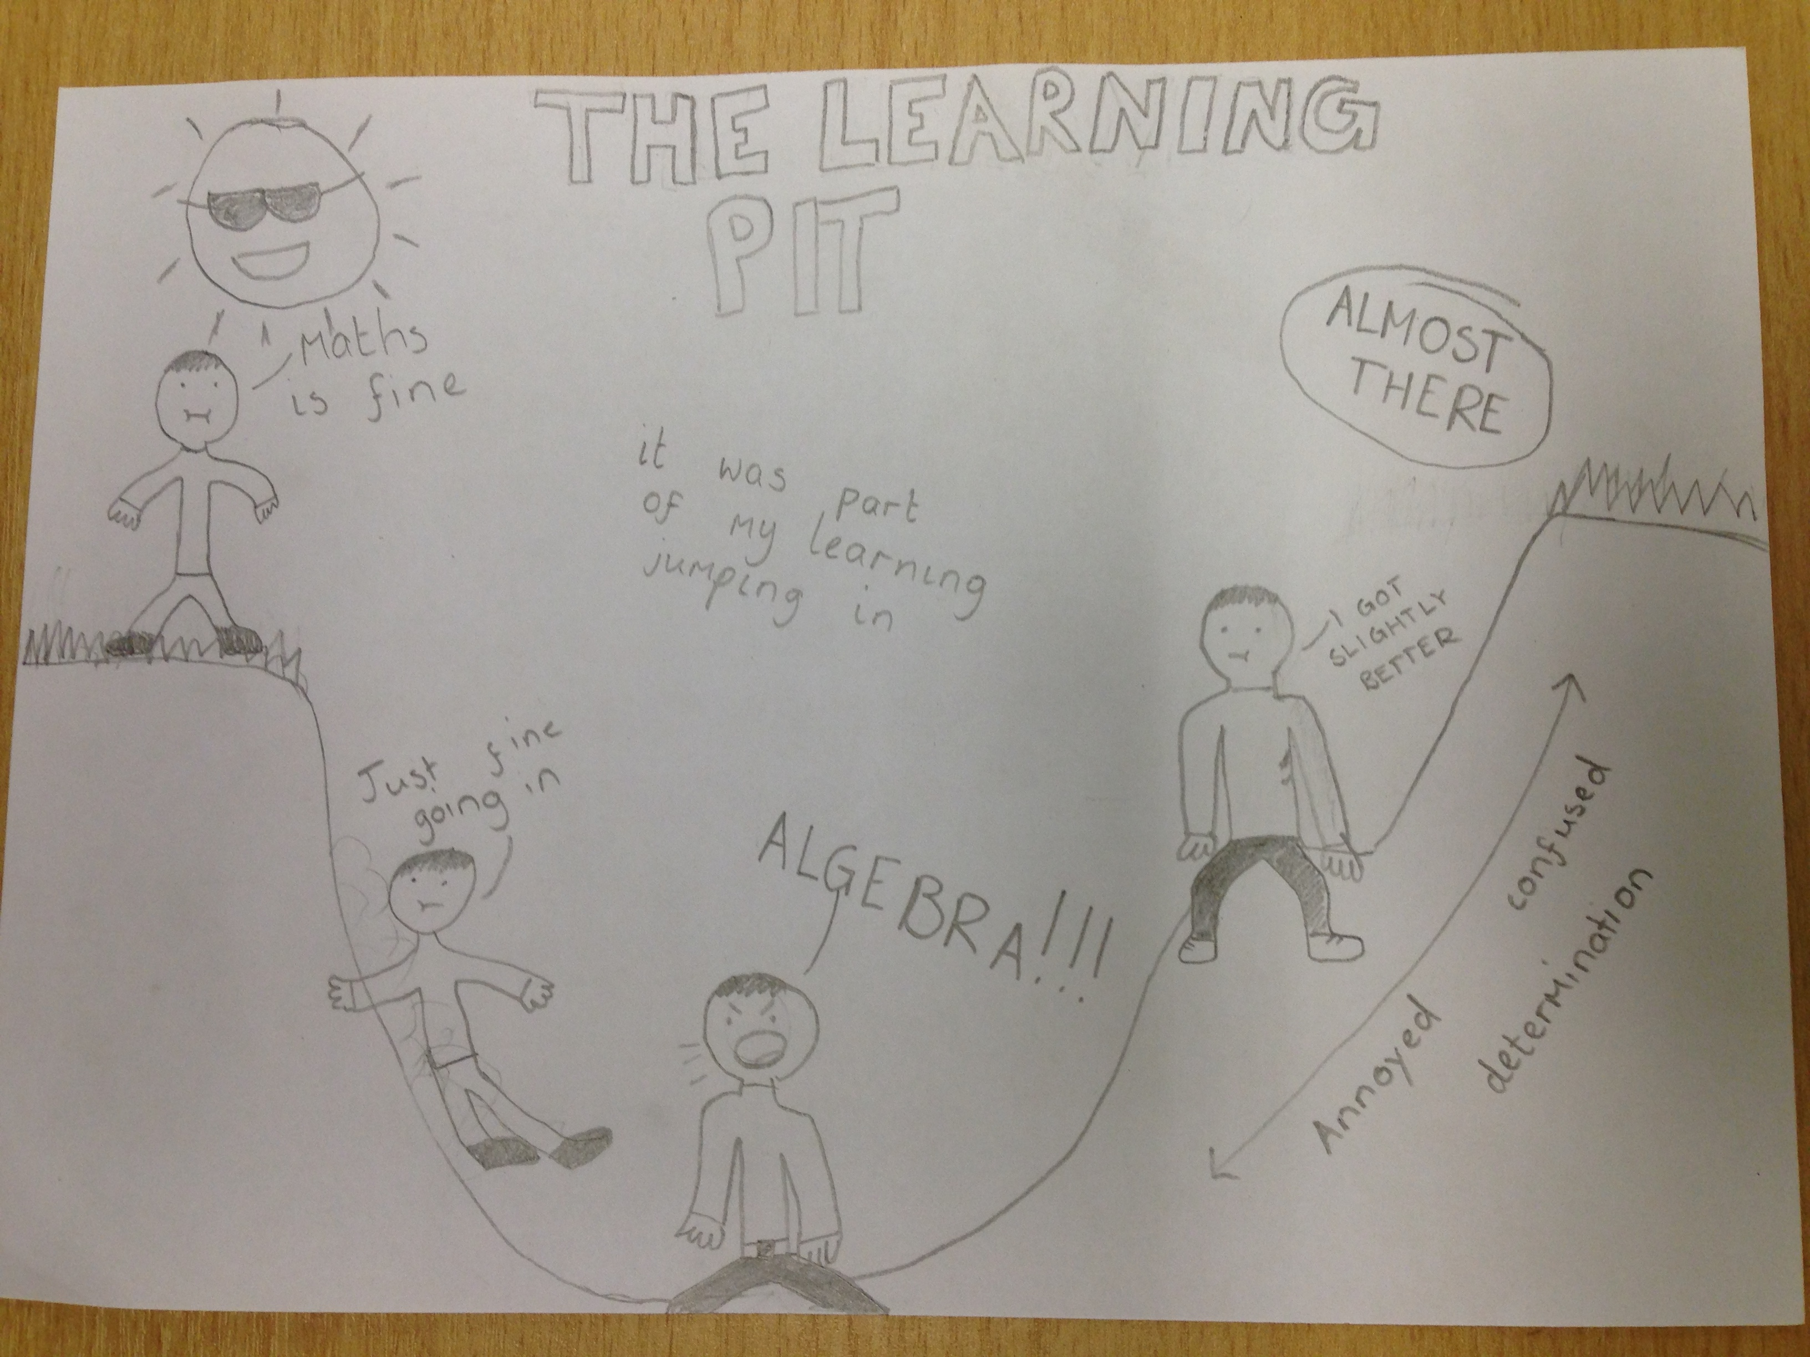

End of lesson 3

