

Education Service
Largs Early Years Centre
Improvement Plan
2026-2027


Vision, Values and Aims

Largs Early Years Centre will provide a welcoming, safe, secure, nurturing environment that offers high quality early learning and childcare. We acknowledge each child is unique and therefore plan a tailored based approach to meet the needs of our individual children and families within our local community.

Our Main aims are:

- To provide an inspiring environment indoors and outdoors which motivates children to be happy and excited to learn, ensuring they reach their full potential.

- To promote the children’s confidence, self-esteem, creativity and Independence through offering a wide range of choices in a fun play-based approach.

- To promote inclusion and equality ensuring children’s individual needs and learning is celebrated and supported.

- To engage with parents in a meaningful way to support their child’s development and learning at home and within the centre.

- To provide opportunities for staff for life- long learning and to further develop their skills, qualities and knowledge to confidently provide a quality curriculum.

- To provide a nurturing ethos which promotes positive relationships for all our children, families, staff and wider partners which includes mutual respect.

Our parents, children and staff were involved in identifying values for our centre. The values are Kind, Learning, Caring and Inclusive. We ensure these values are brought to life within the centre and that everyone understands them.

EDUCATION SERVICE: IMPROVEMENT PLAN SUMMARY 2026/7 – 2028/9

The Education Service Improvement Plan is organised under three main priorities. Individual establishments should create their own plan under these three priority areas, based on rigorous self-evaluation and analysis of performance evidence. Stakeholders should be fully engaged in the development of the plan. In the diagram below, the light blue show the thematic areas under each priority which the service intends to focus on in the year ahead.
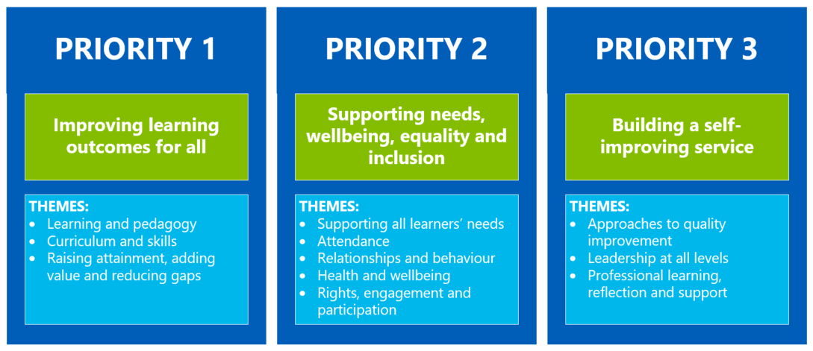

PRIORITY 1: Improving learning outcomes for all
Strategic Objective:

In session 2026–27, we will enhance speech, language and communication outcomes for two-year-olds through the implementation of the CYPIC Chatting Together Bundles, supported by a quality improvement methodology. This work will focus on strengthening practitioner interactions with our youngest children in the 2–3 playroom, while recognising that all children will benefit from the key principles of this approach.

Practitioners will engage in targeted professional learning to develop a shared understanding of the CYPIC quality improvement framework. This will support the consistent delivery of high-quality interactions that promote children’s speech and language development.

The intended strategic outcomes are to improve children’s speech and language development, increase practitioner confidence and consistency in practice, and reduce the poverty-related attainment gap through the delivery of high-quality, evidence-informed approaches. Our senior will ensure the learning and approaches will be shared with all staff.
Select the KEY drivers for this improvement priority
National Improvement Framework  Please select the relevant NIF priority | NIF Drivers of Improvement  Please select up to three NIF drivers | How Good Is Our School 4  Please select up to three quality indicators for this priority | Quality Improvement Framework for ELC settings  Please select up to three quality indicators for this priority
1. Improvement in attainment, particularly literacy and numeracy  2. Closing the attainment gap between the most and least disadvantaged children and young people | 2. Teaching and practitioner professionalism  1. School & ELC leadership  4. Curriculum and assessment |  | 1.2 Staff skills, knowledge, values and deployment  3.3 Learning, teaching and assessment  3.2 Curriculum
Rationale for Change
Current evidence and observations highlight that early speech, language and communication development is a key predictor of later learning and wellbeing. We will identify two-year-olds who require additional support in this area. There is a need for shared understanding of effective, evidence-informed approaches to promoting early communication skills.
By adopting a clear quality improvement methodology, we can ensure that changes to practice are purposeful, measurable and sustainable. This change will Improve the quality and consistency of practitioner interactions. Support early identification and targeted intervention for children at risk of speech and language delay. This will build practitioner knowledge, skills and confidence through a shared professional learning approach and ensure all children benefit from responsive communication-rich environments. This will be shared with the wider staff team to enhance their pedagogy approaches.

PRIORITY 1: Action Plan
Pupil Outcomes | Implementation Plan | Timescales/  Responsibility | Measurement of Impact | Analysis & Evaluation of Progress | Cost  (PEF)
Specifically, what will change for our learners? | How will we achieve this?  What do we plan to do? | What are our timescales? Who will lead? | How will we know the change is an improvement? Can you quantify this?  What data will be collated and analysed to demonstrate progress? Consider baseline data. | How do we know that the experiences & outcomes for learners have improved? What does the data tell us which demonstrates impact?
Children will demonstrate improved language skills and will use a wider vocabulary to communicate their needs, ideas and experiences. | Head of centre/senior EYP will attend all CYPIC meetings and disseminate the learning to all staff.  Use QI data to identify gaps in speech and language. | SMT & 2-3 staff  September 2026 – June 2027 | Observations will show measurable improvement in the quality of adult–child interactions and children’s engagement in communication.
Children will show increased confidence in communication, engaging more frequently in conversations with adults and peers. | Early Years Practitioners will consistently apply the CYPIC bundle when interacting with children | SMT & 2-3 staff  September 2026 – June 2027 | Children trackers & CYPIC data will indicate progress in children’s speech, language and communication, including increased vocabulary, improved listening skills, and greater participation in conversations.
Children will develop stronger listening and attention skills, enabling them to respond appropriately and participate in play experiences. | Practitioners will use the fishbone tool to analyse the reasons behind those children whose attainment is not improving and work with other practitioners to consider how to best support these children | SMT & 2-3 staff  September 2026 – June 2027 | Practitioner confidence and consistency improve, evidenced through self-evaluation, peer observations, and professional dialogue aligned with CYPIC methodology.

PRIORITY 2: Supporting needs, wellbeing, equality and inclusion
Strategic Objective:

The centre will develop and embed the New Authority as a universal whole centre approach informed by the principles of Building Positive Relationships. This program forms an important aspect of North Ayrshires relationships and behaviour policy. Implementing this program will support a consistent approach to behaviour across the setting from all adults.

Select the KEY drivers for this improvement priority
National Improvement Framework  Please select the relevant NIF priority | NIF Drivers of Improvement  Please select up to three NIF drivers | How Good Is Our School 4  Please select up to three quality indicators for this priority | Quality Improvement Framework for ELC settings  Please select up to three quality indicators for this priority
4. Improvement in children and young people's health and wellbeing  5. Placing human rights and needs of every child and young person at the centre of education | 2. Teaching and practitioner professionalism  5. School & ELC improvement  1. School & ELC leadership |  | 4.1 Nurturing care and support  4.2 Wellbeing, inclusion and equality  1.3 Leadership of continuous improvement
Rationale for Change

Over the last few years, the range of children’s needs and behaviours has changed. This has been a challenge and as a staff team we have reflected and adapted a range of materials and interventions to support this. Some staff have attended training however as deregulated behaviour has increased staff require further support to manage this consistently across the centre.

This priority along with the training and key principles will provide a clear and consistent approach to responding to behaviours. It will highlight and recognise the importance of adult self-control and calm presence and maintain positive relationships across the community. We want to, create safe predictable supportive environments and work collaboratively to ensure all behaviours are understood.

PRIORITY 2: Action Plan
Pupil Outcomes | Implementation Plan | Timescales/  Responsibility | Measurement of Impact | Analysis & Evaluation of Progress | Cost  (PEF)
Specifically, what will change for our learners? | How will we achieve this?  What do we plan to do? | What are our timescales? Who will lead? | How will we know the change is an improvement? Can you quantify this?  What data will be collated and analysed to demonstrate progress? Consider baseline data. | How do we know that the experiences & outcomes for learners have improved? What does the data tell us which demonstrates impact? | Please enter the cost to the nearest £
There will be strengthened approaches to the new authority implementation (nurture) across the centre. | Identify staff to attend the train the trainer training and attend ongoing termly coaching sessions. | SMT  November 26 – June 2027 | Observations within the playroom of staff practice and interactions with the children.
Consistent approaches used by the staff team which will support the children with effective strategies. | Deliver professional learning to full staff team on the BPR and New Authority. | SMT & staff leads  November 26 – June 2027 | Pre and post baseline evaluations of staff learning and understanding.
Increased staff confidence in dealing with and supporting deregulated behaviours using this approach. | Staff to develop shared language and expectations. Reflect and use training materials where required. | SMT & staff leads  November 26– June 2027 | Progress will be monitored through staff self-evaluations and feedback.
Children will feel supported, understood and able to regulate supported by staff. | Embed consistent strategies for deescalation and self-regulation.  Utilise and use NAC materials to support. | SMT & staff leads  November 26– June 2027 | Improved relationships between staff and children, reduced escalation and assure forms.

PRIORITY 3: Improving learning outcomes for all/ Building a self-improving service
Strategic Objective:

Over this session we will focus on building staff skills and knowledge using trackers for all children. The 2-3 years trackers will be implemented along with the complex needs tracker and our planning tools refreshed to support these. All staff will take part in training to support SMART targets specifically for supporting our children with complex needs.
Moderation discussions at the In-Service days will take place using the 3-5 trackers to support staff understanding and provide increased confidence using their professional judgement. This will support effective tracking and monitoring of all our children and a shared understanding through our progress and achievement meetings.
.
Select the KEY drivers for this improvement priority
National Improvement Framework  Please select the relevant NIF priority | NIF Drivers of Improvement  Please select up to three NIF drivers | How Good Is Our School 4  Please select up to three quality indicators for this priority | Quality Improvement Framework for ELC settings  Please select up to three quality indicators for this priority
1. Improvement in attainment, particularly literacy and numeracy  2. Closing the attainment gap between the most and least disadvantaged children and young people | 1. School & ELC leadership  2. Teaching and practitioner professionalism  4. Curriculum and assessment |  | 3.3 Learning, teaching and assessment  3.2 Curriculum  4.3 Children's progress
Rationale for Change

The introduction of the new NAC trackers has been welcomed however staff have needed time to adjust and use these meaningfully. All staff did attend twilight training however being a model 1 establishment it has been difficult to get protected time to engage meaningfully with staff. Alongside this the progress and achievement meetings three times per year have replaced our twice-yearly key group supervision which is a different way of working. This process has been new for all staff including the SMT. The Head of Centre attended a data clinic which was helpful however is keen to further expand her learning and share this with other staff. This needs further work and enhanced professional dialogue to develop and build staff confidence. Parents/carers feedback was they would be keen to see and understand the tracker to support their child’s learning. This is something we would be keen to develop this year. Through the 2-3 room staff time to talk meetings, they indicated they would like further opportunities/ training on child development to develop their understanding and awareness as many of our two-year-olds have needed more targeted responsive support this year.

PRIORITY 3: Action Plan
Pupil Outcomes | Implementation Plan | Timescales/  Responsibility | Measurement of Impact | Analysis & Evaluation of Progress | Cost  (PEF)
Specifically, what will change for our learners? | How will we achieve this?  What do we plan to do? | What are our timescales? Who will lead? | How will we know the change is an improvement? Can you quantify this?  What data will be collated and analysed to demonstrate progress? Consider baseline data. | How do we know that the experiences & outcomes for learners have improved? What does the data tell us which demonstrates impact? | Please enter the cost to the nearest £
Children will experience responsive, child centred learning that reflects their individual interests, development stage and next steps. | Share the new 2-3 planning and trackers with the staff team. Engage in professional dialogue and discussions. | SMT – All staff  August – September 26 | Regular professional discussions & self-evaluation activities with the 2-3 staff will capture impact.
Children’s learning and progress will be identified and monitored more effectively, ensuring timely support and meaningful experiences are planned to meet their needs. | Implement the 2-3 trackers and planning tools alongside the CYPIC program. | SMT – 2-3 staff  September – June 27 | Regular discussions and audits of the planning/ special books using the quality assurance system.  Pre and post questionnaire on improved staff confidence.
Children will benefit from clear, measurable learning targets that are tailored to their individual needs, enabling learning that builds on their skills. | Deliver SMART target training to all staff to support and develop their skills in target setting. | SMT  September – December 26 | Questionnaire from staff prior to accessing the training. Regular audits of children’s personal learning targets and staged intervention plans.
Children will benefit from staff having a deeper and shared understanding of their progress and achievement, ensuring planning is responsive to their stage of development. | All staff will engage in moderation activities and professional discussions of the 3-5 tracker/ P & A data. | SMT & 3-5 staff  September 26 – May 2027 | Through doing peer and self-evaluation with staff we will gather information which will show a greater understanding and effective use of the trackers to support planning.
Children will benefit from accurate and consistent identification of their stage of development, enabling appropriate learning experiences/ challenge/interventions. | SMT staff to attend data clinics and engage in professional dialogue with cluster colleagues. | SMT  September 26 – June 2027 | Through professional discussions and dialogue the SMT will have a clearer understanding of effective use of data.

