**LGBTIQ+ Young People in Scotland's Experiences of PE**

“Sport has the power to change the world. It has the power to inspire. It has the power to unite people in a way that little else does. It speaks to youth in a language they understand.”

*Nelson Mandela, 2000*

Introduction

Definitions

Homophobia in Sport

LGBTIQ+ Young People’s Experiences in School

Barriers to Sport for LGBTIQ+ Young People

Best Practices for Inclusivity

Teachers’ Responsibility

OutSport Toolkit

LEAP Sports Manifesto for Inclusive Physical Education

Closing Remarks

Useful Links

References

Introduction

Definitions

**PE**: Acronym for Physical Education

**LGBTIQ+**: Acronym for Lesbian, Gay, Bisexual, Transgender, Intersex, Queer and inclusion of all other sexual or gender identities

**Lesbian:** Refers to a woman who is emotionally and/or physically attracted to other women

**Gay**: Refers to someone who is emotionally and/or physically attracted to people of the same gender. Some women prefer to refer to themselves as gay women rather than lesbian, although the word gay is most commonly used in reference to men.

**Bisexual**: A person who is emotionally and/or physically attracted to people of more than one gender or regardless of gender. Historically definitions of bisexual refer to ‘an attraction towards men and women’ however many bisexual people recognise that there are more than two genders.

**Transgender**: An umbrella term for those whose gender identity or expression differs in some way from the gender assigned to them at birth and conflicts with the ‘norms’ expected by the society they live in. Included in the overall transgender umbrella are transsexual people, non-binary gender identities and cross-dressing people.

**Trans\***: An umbrella term (similar to transgender) that refers to all the identities in the gender identity spectrum. The asterisk makes special note in an effort to include all transgender, transsexual and non-binary identities.

**Intersex**: A person whose chromosomes, reproductive organs or genitalia vary in some way from what is traditionally considered clearly male or female in terms of biological sex. This may be apparent at birth or become apparent later in life - often at puberty, or in the case of some women, when they conceive or try to conceive. We recognise that this definition uses a medical model however it important to recognise that some people proudly identify with this term.

**Queer**: An umbrella term used for diverse sexual orientations or gender identities that are not heterosexual and do not fit within a gender binary. It may be used to challenge the idea of labels and categories such as lesbian, gay, bisexual, or transgender. It is important to note that it is an in-group term, and may be considered offensive to some people.

**Heterosexual/Straight**: Used to describe people who are emotionally and/or physically attracted to people of the ‘opposite’ gender.

**Sexual Orientation**: A person’s identity based on emotional and/or physical attraction to individuals of a different gender, the same gender, or more than one gender. Sexual orientation can also be seen as a complex mix of an individual’s identity, attraction and behaviour. However, identity is the most important aspect as sexual orientation can only be determined by the individual; attraction and/or behaviour alone do not determine someone’s sexual orientation.

**Gender Identity:** A person’s deeply felt internal and individual experience of gender, which may or may not correspond with the sex assigned to them at birth

**Cisgender**: Individuals who have a match between the gender they were assigned at birth, their bodies and their personal identity. In other words those who are not, or do not identify as transgender.

**Homophobia**: The irrational fear, dislike or prejudice against people who are or are perceived to be lesbian and gay people. It can also be used as an all-encompassing term to include the irrational fear, dislike or prejudice against bisexual people and transgender people. LGBTI Terminology leapsports.org Homophobia can manifest itself at different levels and may involve, but is not limited to verbal abuse and physical abuse.

**Biphobia**: The irrational fear, dislike or prejudice against those who are or are perceived to be bisexual. Bisexual people can experience homophobia (particularly when in same-sex relationships) and can experience biphobia from both heterosexual and lesbian and gay people.

**Transphobia**: The irrational fear, dislike or prejudice or discrimination against those who are or are perceived to be transgender. Transgender people can also experience homophobia when in same-sex relationships or for not conforming to gender norms.

**BAME**: Acronym for Black, Asian and Minorities Ethnicities

**ASN**: Acronym for Additional Support Needs

(LEAP Sports Terminology)

Homophobia in Sport

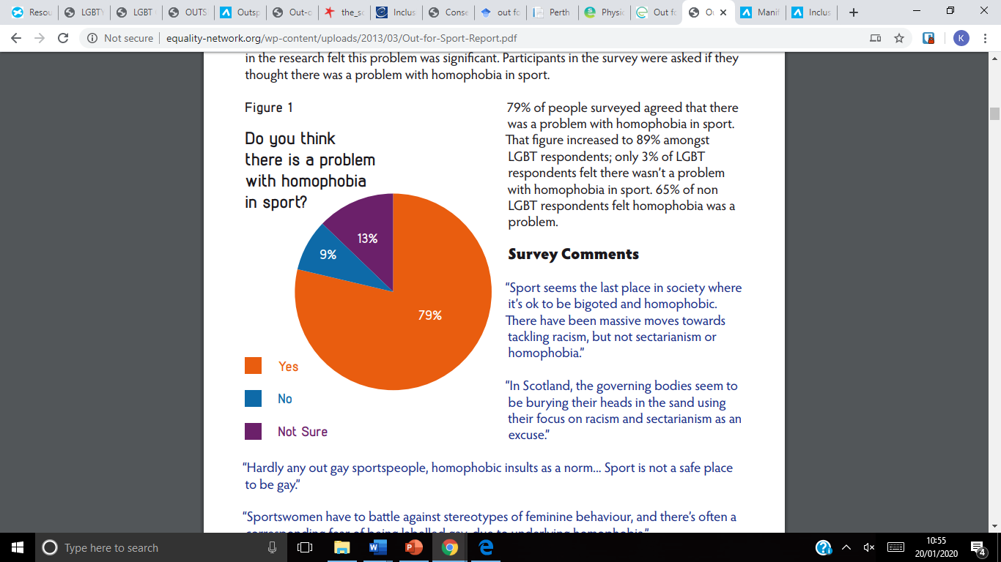The Out for Sport 2012 report carried out by the Equality Network Scotland found that 62% of LGBTIQ+ people have experienced homophobia, biphobia and transphobia in sport, with these rates reducing slightly in physical activity. These instances of discrimination have a negative impact upon LGBTIQ+ people and their willingness to partake in any physical sport or activity (Smith et al., 2012).

An international study was conducted by Out on the Fields (2015) of 9494 people – 7000 of whom identify as LGBTIQ+ - to research attitudes around being involved in sports as an LGBTIQ+ person. From this research, 80% believed that LGBTIQ+ people are not accepted in sport, with sport being seen as more homophobic than the rest of society. There are clear signs of fear of discrimination from both players and officials, shown through 70% of gay men and 73% of lesbians, remaining at least partially in the closet while participating in sport (Out on the Fields, 2015).

LGBTIQ+ Young People’s Experiences in School

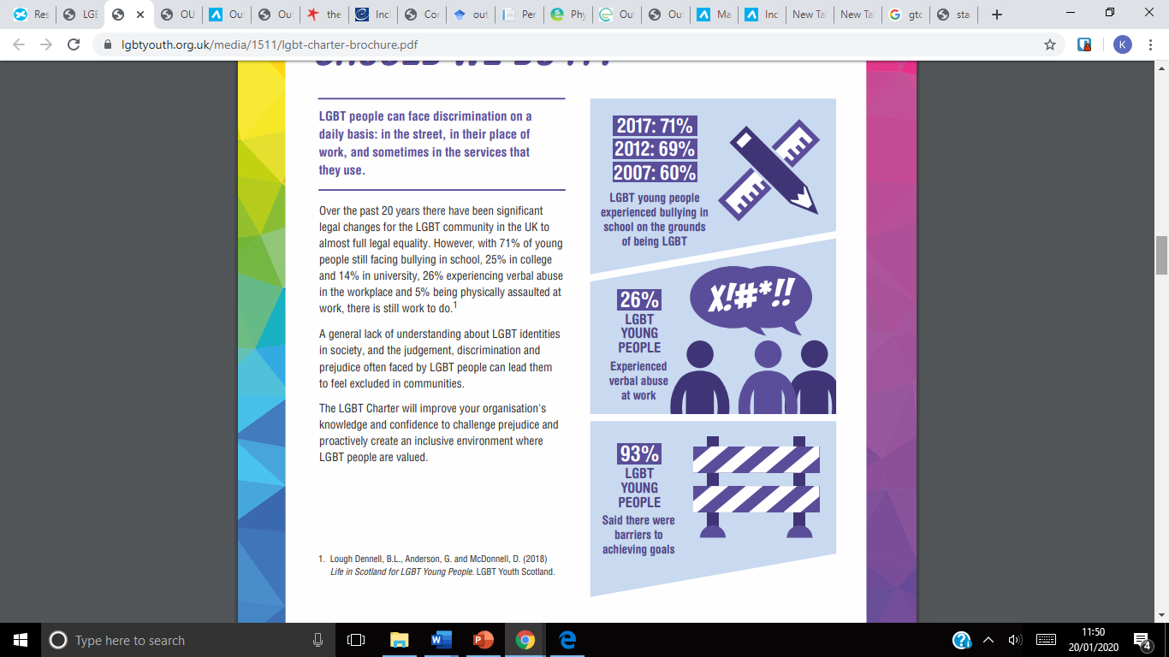The Stonewall School Report 2017, which took account of over 3700 LGBT+ young people living in the United Kingdom, found that in 2017, 48% of young people were bullied for being, or being perceived to be LGBTIQ+ in Britain’s schools. However, 44% of those who are bullied will never tell anyone about it, with 95% feeling the memory of bullying would live with them forever (TIE, 2016). The study also found that 1 in 4 lesbian, gay and bisexual young people had attempted suicide, with 3 in 5 having self-harmed. For transgender young people, these numbers increase to almost half having attempted to take their own life and 96% having self-harmed. Almost half of LGBTIQ+ young people say they don’t feel supported in school and cannot talk to a teacher about their experiences of being LGBTIQ+ (Stonewall, 2017). A further research project, “Life in Scotland for LGBT Young People” carried out by LGBT Youth Scotland also shows that 71% of lesbian, gay and bisexual young people and 82% of transgender young people experience homophobic, biphobic and/or transphobic bullying. 73% of those who experienced bullying, also disclosed at least one mental health problem (Lough Dennell et al, 2018).

Barriers to Sport for LGBTIQ+ Young People

As shown, school can be an unsafe environment for LGBTIQ+ young people, and this continues into the PE changing rooms. More than 20% of LGBTIQ+ report being bullied in changing rooms, including hearing homophobic, biphobic and transphobic remarks or insults, having things thrown at them, or even physical violence. Changing rooms in schools are often without adult supervision due to child protection procedures. This then makes them a place of vulnerability for LGBTIQ+ young people, with no adult to prevent or intervene with homophobic bullying. Furthermore, the Stonewall School Report found that one third of trans* young people did not feel they could use their correct pronouns at school, as well as 3 in 5 not being allowed to use the correct toilet or changing room for their gender identity (Stonewall, 2017). So before trans* young people have even began PE, they have met their first barrier of changing room facilities. As well as facing possible verbal or physical abuse, trans* young people may be put in the changing room which does not match their gender identity. There have also been concerns about trans* women being in a female changing room with many accusations that schools are endangering the cis-gender girls by allowing someone who is trans* into their changing room. In these arguments, there however would appear to be little concern for the safety of the trans* person who is being put in a potentially uncomfortable or discriminatory environment. As a result, many LGBTIQ+ young people admit to avoiding PE, for fear of bullying or discrimination (Evans & Chapman, 2014).

“I was often talked about in a derogatory manner while present by students in toilets and changing rooms. I was deliberately misgendered and excluded from activities as a male and forced to partake in school activities for women by staﬀ. I was often called a 'tranny' or 'dyke' and told to kill myself by numerous pupils throughout high school.” (Lough et al., 2018)

The “Let Me Be Brave” project found that there is a lack of awareness of trans* people in sport and the issues which they may face. Participants stated that they felt intimidated or uncomfortable when joining a new sport, particularly if they do not know if the environment will be safe or inclusive for them. There was also a concern that there is a lack of trans* role models in sport. For any young person, having someone to look up to, where they can see themselves reflected back, is important to allow them to feel that they can succeed in certain sports and achieve their own personal and sporting goals and aspirations (LEAP Sports, 20xx).

A further issue which studies have found with school PE is that sports are often gendered, which can be a difficult scenario for someone who is trans* or gender non-conforming. In the 21st century, there are still clear gender stereotypes in some school’s PE programmes. Across Scotland, the “boys” can be seen to be playing football or rugby, while the “girls” are taking part in gymnastics or badminton.

Best Practices for Inclusivity

Teachers can put in place preventative measures to prevent instances of homophobic and transphobic bullying in schools. This can be happen through education, as at the core of homophobic is a lack of knowledge and understanding. The Time for Inclusive Education (TIE) campaign has resources on the website to raise awareness of important LGBTIQ+ icons and moments throughout history, including sportspeople who identify as LGBTIQ+, such as Megan Rapinoe and Stefan Hoggan-Radu (TIE, 2020).

As well as this, every school should have a clear anti-bullying policy, which explicitly states homophobia and transphobia as an act of bullying. It is important that there is consistency when dealing with homophobic and transphobic bullying, so that it is clear these behaviours are unacceptable in the school and every member of staff within the establishment will deal with the issue in the same way, with urgency and efficiency.

With regards to changing room facilities, it is important that the trans* young person is kept at the centre and is asked for their input. It may be that they wish to remain in their current changing room or go to the changing room of their gender identity. If this is not a possibility, provisions for a private changing area should be made available for the trans* young person to access when necessary, in a discrete manner.

Teachers’ Responsibility

Teachers of PE are in a position to provide young people with first experiences of sports, in a safe and inclusive environment. Education Scotland’s “Raising the Bar” document was created to ensure that every child and young person in Scottish schools has 2 hours of quality physical education every week in school, which is well planned with a core focus on learning (Education Scotland, 2019). Health and Wellbeing is one of the core areas in Curriculum for Excellence and a key focus in the Nation Improvement Framework. It should ensure all learners' mental, physical and social wellbeing is a part of all aspects of teaching and learning across the curriculum.

However, Stonewall’s School Report 2017 found that 32% of teachers do intervene at the time of the LGBTIQ+ bullying, while only 7% of head teachers do so. Recent studies have revealed that more than half of LGBTIQ+ pupils have heard their school staff use homophobic language, as well as derogatory speech around gender identities and expression (Berry, 2018, cited in Goodboy & Martin, 2018). Here it can be noted that staff who fail to create an inclusive school environment cause further disruptions to feelings of safety and security for LGBTIQ+ young people.

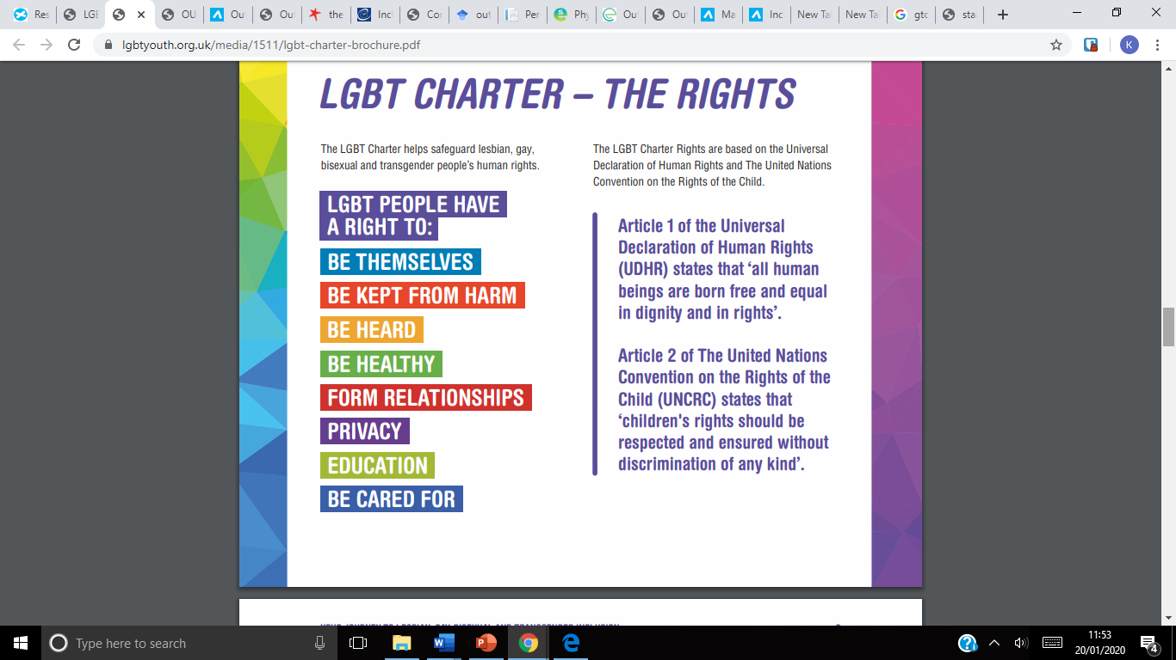There have been suggestions that a lack of appropriate training for teachers on best practice for working with LGBTIQ+ children and young people as a contributing factor to LGBTIQ+ children and young people being disillusioned by sport and physical education (Bailey, 2005). Further discussions have found that some teachers say they would feel unsure or uncomfortable if they were approached and ask to discuss LGBTIQ+ issues with a pupil. There seems to be a concern about providing too much information around LGBTIQ+ issues, which will “encourage” it, or that parents will not approve of LGBTIQ+ education (McIntyre, 2009). However, in spite of moral panic, teachers have a duty care to their pupils, and they negate this when gender stereotypes or homophobic and transphobic remarks or bullying go unchallenged.

The General Teaching Council for Scotland (GTCS) Standards for Registration, states that under Social Justice, it is required that every teacher in Scotland is;

* “Committing to the principles of democracy and social justice through fair, transparent, inclusive and sustainable policies and practices in relation to age, disability, gender and gender identity, race, ethnicity, religion and belief and sexual orientation.
* Valuing as well as respecting diversity…
* Respecting the rights of all learners…” (GTCS, 2012, p.5-6).

This clearly demonstrates what is expected from every teacher in Scotland, that they strive for inclusion for all, have respect for and protect children and young people who are at a higher risk of discrimination, such as LGBTIQ+, BAME, or ASN, to name a few. That is not to say that there have not been improvements to the treatment of LGBTIQ+ people, especially with regards to law and policy. Unfortunately, these advances are not as far along as would be preferred in sport, where LGBTIQ+ young people still do not feel safe or supported, due to homophobia and transphobia (Denison & Kitchen, 2015). For trans and intersex young people, there are further barriers to sports, particularly with regards to changing facilities. This can be seen within sport at all levels, from grassroots and community sport through to elite level.

OutSport Toolkit

[The OutSport project](http://www.out-sport.eu/about/) was the first initiative at European level to gather scientific evidence about discrimination based on sexual orientation and gender identity in sport. They then would go on to use sport as a way to tackle homophobic, biphobic and transphobic discrimination, by communicating and raising awareness of LGBTIQ+ issues, backed up by training and scientific research.

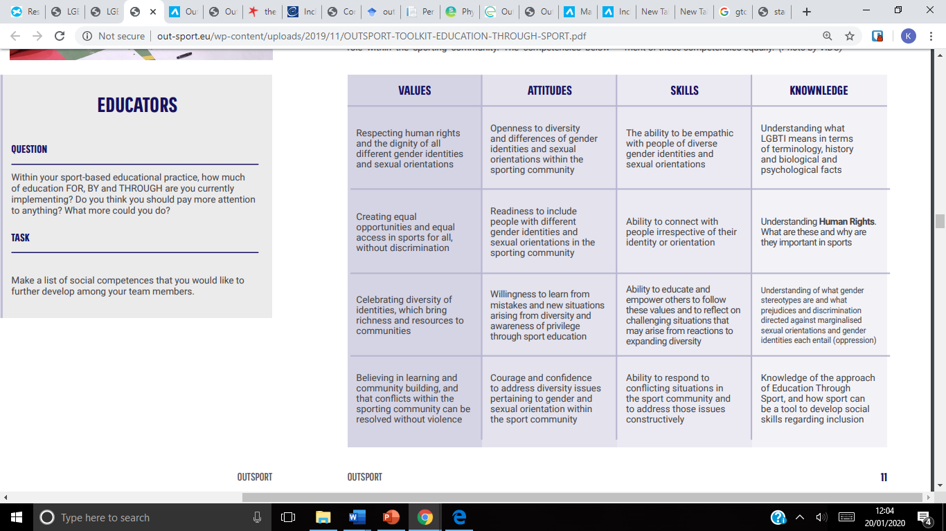This led to the creation of the OutSport Toolkit which offers methods which can be used in the education of LGBTIQ+ inclusion, within a PE or sport setting. The toolkit discusses how teachers can develop values, attitudes, skills and knowledge which will enable both teachers and students to create a safe and welcoming environment for LGBTIQ+ children and young people (OutSport, 2019).

LEAP Sports Manifesto for Inclusive Physical Education

For this reason, LEAP Sports Scotland worked collaboratively with Shawlands Academy in Glasgow to create the Manifesto for Inclusive Physical Education. This is a set of commitments which builds upon those pupils' lived experiences of taking part in school sport as LGBTIQ+ young people. By signing up to the Manifesto, schools can demonstrate a visible commitment to improving those experiences by working to make school sport fully LGBTIQ+ inclusive (LEAP Sports, 2017). The Manifesto has 6 clear steps which teachers must follow to ensure they are providing an LGBTIQ+ inclusive environment for sport and physical activity in their school.

Closing Remarks

Useful Links

References

Bailey, R. (2005). “*Evaluating the relationship between physical education, sport and social inclusion*”. Educational review. 57(1). 71-90.

Denison, E. & Kitchen, A. (2015). “*Out on the Fields: The First International Study on Homophobia in Sport”.* [Online]. Available at: http://www.outonthefields.com/wp-content/uploads/2016/04/Out-on-the-Fields-Final-Report.pdf.

Education Scotland. (2019). *“Raising The Bar”.* [Online]. Available at: https://education.gov.scot/improvement/learning-resources/improving-the-quality-of-core-physical-education/.

Evans, C. and Chapman, M. (2014). “*Bullied youth: The impact of bullying through lesbian, gay, and bisexual name calling*”. *American Journal of Orthopsychiatry*. 84(6). pp.644-652.

Goodboy, A. and Martin, M. (2018). “*LGBT bullying in school: perspectives on prevention”.* Communication Education. 67(4). pp.513-520.

LEAP Sports Scotland. (2017). “*Manifesto for Inclusive Physical Education”.* [Online]. Available at: <https://leapsports.org/events/campaigns-and-resources/manifesto-for-inclusive-physical-education>.

LEAP Sports Scotland. (xxxx). “*LGBTI Terminology”.* [Online]. Available at: <https://leapsports.org/files/2352-Terminology%20Guide.pdf>.

LEAP Sports Scotland. (20xx). “*Let Me Be Brave”.* [Online]. Available at:

Lough Dennell, B.L., Anderson, G. and McDonnell, D. (2018). “*Life in Scotland for LGBT Young People*”. LGBT Youth Scotland. [Online]. Available at: https://www.lgbtyouth.org.uk/media/1354/life-in-scotland-for-lgbt-young-people.pdf.

Mandela, N. (2000). “*Speech at the Inaugural Laureus Lifetime Achievement Award”*. Monaco. [Online]. Available at: http://db.nelsonmandela. org/speeches/pub_view.asp?pg=item&ItemID=NMS1148.

McIntyre, E. (2009). “*Teacher discourse on lesbian, gay and bisexual pupils in Scottish schools*”. Educational Psychology in Practice. *25*(4). 301-314.

OutSport. (2019). “*OutSport Toolkit: Education Through Sport”.* [Online]. Available at: http://www.out-sport.eu/wp-content/uploads/2019/11/OUTSPORT-TOOLKIT-EDUCATION-THROUGH-SPORT.pdf.

Smith, M., Cuthbertson, S. & Gale, N. (2012). “*Out For Sport: Tackling Homophobia and Transphobia in Sport”.* [Online]. Available at: http://www.equality-network.org/wp-content/uploads/2013/03/Out-for-Sport-Report.pdf

Stonewall. (2017). “*School Report*”. [Online]. Available at: https://www.stonewall.org.uk/sites/default/files/the_school_report_2017.pdf.

Time for Inclusive Education. (2016). “*Attitudes Towards LGBT in Scotiish Education”.* [Online]. Available at: https://www.tiecampaign.co.uk/our-work.

Time for Inclusive Education. (2020). “*Icons Who Made LGBT History”.* [Online]. Available at: https://www.tiecampaign.co.uk/resources.