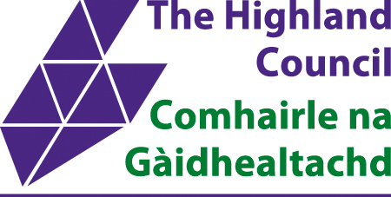

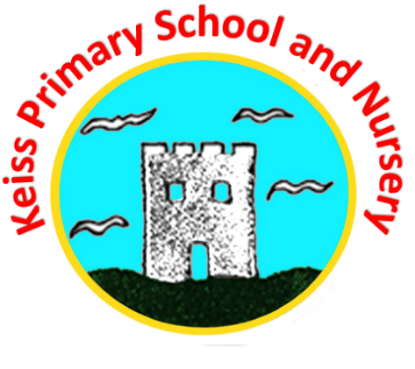
Keiss Primary School and Nursery
ESTABLISHMENT IMPROVEMENT PLAN
SESSION 2022/23
Contents
- Overview of Establishment 3 Year Cycle of Improvement Plan Priorities
- Strategic 3 Year Overview
- Develop professional understanding, knowledge and competence in the teaching of Reading and Writing by undertaking CLPL from Highland Council
- Understanding and Improving Assessment and Moderation Strategies in Learning, Teaching and Assessment
- Developing practice in Keiss Nursery

Overview of Establishment 3 Year Cycle of Improvement Plan Priorities |  |  |  |  |  |  | 2022 - 2025
National Improvement Framework Key Priorities
- Placing the human rights and needs of every child and young person at the centre of education
- Improvement in children and young people’s health and wellbeing
- Closing the attainment gap between the most and least disadvantaged children and young people
- Improvement in skills and sustained, positive school-leaver destinations for all young people
- Improvement in attainment, particularly in literacy and numeracy
National Improvement Framework Key Drivers | HGIOS/HGIOELC |  |  | HGIOURS |  | Highland Council Education Priorities
- School and ELC leadership  - Teacher and practitioner professionalism  - Parent/carer engagement and involvement  - Curriculum and assessment  - School and ELC improvement  - Performance information | School  - Leadership and Management  - Learning Provision  - Success and Achievements | Nursery  1.Leadership and Management  2.Learning Provision  3.Success and Achievements |  | Theme 1 Our relationships  Theme 2 Our learning and teaching  Theme 3 Our school and community  Theme 4 Our health and wellbeing  Theme 5 Our successes & achievements |  | - We will raise attainment and achievement for all, especially for those children from disadvantaged circumstances including rural deprivation.  - We will maximise health and wellbeing for all children and young people to give them the best possible start in life.  - We will ensure the highest quality of learning and teaching for each and every learner.  - We will develop leadership skills at all levels of the system for now and the future.
- 2.1 Safeguarding and child protection
- 2.2 Curriculum
- 2.3 Learning, teaching and assessment
- 2.4 Personalised support
- 2.5 Family learning
- 2.6 Transitions
- 2.7 Partnership
- 3.1 Ensuring wellbeing, equality and inclusion
- 3.2 Raising attainment and achievement/Securing children’s progress
  - Increasing creativity and employability/Developing creativity and skills for life and learning.

Strategic Priorities 3 Year Cycle
2022/23 |  |  | 2023/24 |  | 2024/25
- Develop professional understanding, knowledge and competence in the teaching of Reading and Writing by undertaking CLPL from Highland Council  - Continue to embed the practice of Number Talks  - Continue to use Wraparound Spelling in Literacy lessons  - Develop our approaches to the learning, teaching and assessment (Moderation) cycle in Reading  - Review Homework Policy and implement Homework Policy  - Continue to use Jigsaw and BMT as approaches to Physical Education  - Develop professional knowledge, understanding and practice in a Childrens Right and Equality and Diversity. |  |  | - Embed approaches in Reading and Writing from Highland Council  - Continue to embed the practice of Number Talks and wider approaches to Numeracy.  - Develop our approaches to the learning, teaching and assessment (Moderation) cycle in Numeracy |  | - Model approaches in Reading and Writing from Highland Council  - Model our approaches in Numeracy  - Develop our approaches to the learning, teaching and assessment (Moderation) cycle in Writing

Strategic 3 Year Overview |  |  | 2022 - 2025
Performance Information | Key Priorities | School and ELC Leadership
- Examples of effective use of SEEMIS, insight, BGE tracking tools, Development Overviews to analyse data and inform intervention  - Impact of planned interventions to reduce poverty related attainment gap  - Application of research/evidence to improve learning and teaching, and outcomes | See strategic priorities  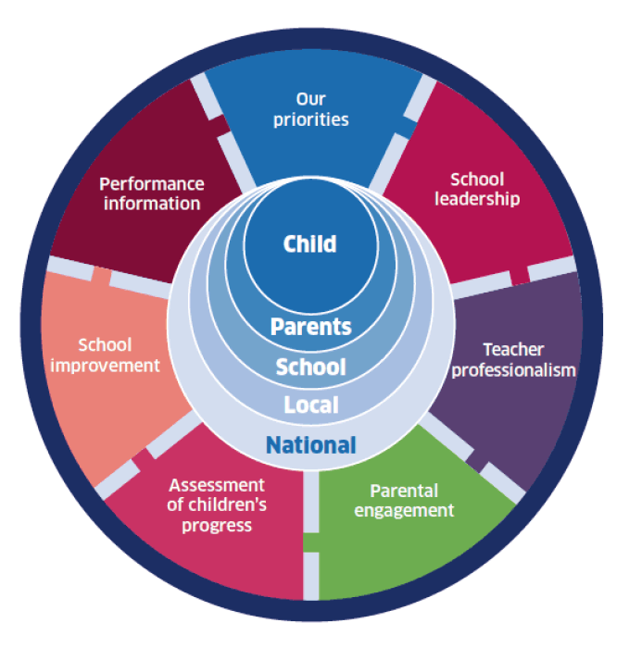 | - Detail of development of leadership at all level/across and range of contexts  - Development of data  - Arrangements to establish and enhance collaborative working  - Arrangements to implement a range of QA processes  - Development of mechanisms to further prioritise, monitor and enhance staff wellbeing  - Continue to develop leadership opportunities for children and young people  - Staff responsibilities in relation to UNCRC
School and ELC Improvement | Curriculum and Assessment | Teacher and Practitioner Professionalism
- Access to learning pathways  - Arrangements to develop skills for life, learning and work  - Securing positive destinations  - Examples of existing partnerships and development of new partnerships  - Links with Skills development Scotland, business and FE providers  - Examples of skills and vocational based learning opportunities  - Development of digital learning and teaching strategies to increase number and range of opportunities available to young people  - Development of professional learning programmes for ELC practitioners e.g., outdoor play-based learning or supporting early literacy and numeracy | - Plans to improve literacy attainment  - Plans to improve numeracy attainment  - Plans to implement of interventions and monitor their impact  - Enactment of policy  - Strategic approaches taken to raise attainment  - Effective approaches to tracking and monitoring  - Development of systems in place to review learner progress  - Development of effective pedagogical approaches to improve attainment  - Actions to improve learning, teaching and assessment  - Development of digital learning and teaching approaches to support improvement in literacy and numeracy  - Access to digital devices  - Arrangements in place to support moderation and reliability of teacher professional judgement within BGE | - Provision of professional learning programmes around leadership and self-evaluation processes  - Participation in professional learning programmes to strengthen practitioner approaches to reducing the poverty related attainment gap  - Plans for partnership work to provide opportunities for identified learners, and care experienced children and young people, to achieve and attain their full potential  - Development of plans around learning, teaching, assessment  - Development of moderation to ensure moderated evidence is used when tracking and monitoring the progress of learners  - Plans for high-quality professional learning opportunities and resources in place to improve health and wellbeing, with a particular focus on the mental and emotional wellbeing of children and young people
Parent/Carer Engagement and Involvement
- Examples of the range of ways parents and carers can engage with the establishment
- Examples of the use of digital approaches which increased engagement and accessibility
- Opportunities for family learning to support improvements e.g., in literacy and numeracy

Improvement Project 1: Further develop professional understanding, knowledge and competence in the teaching of Reading and Writing by undertaking CLPL from Highland Council
Purpose:
This project has been developed in response to dips in attainment in Reading and Writing.
Priorities
NIF Priority:  Improvement in attainment, particularly in literacy and numeracy  NIF Driver:  Teacher and practitioner professionalism |  | HGIOS/HGIOELC Quality Indicator:  2.3 Learning, teaching and assessment  HGIOURS Theme:  Our learning and teaching |  | Highland Council Priority:  We will ensure the highest quality of learning and teaching for each and every learner
RESOURCES | ACTIVITIES |  | EVIDENCE |  | SHORT TERM  IMPACT  (weeks/months) | MEDIUM TERM IMPACT  (months/years) |  | LONG TERM  IMPACT  (years/decades)
Time: staff time, WTA collegiate time, in-service time and PDR time.  Research  Highland Council Literacy CLPL  Self-Evaluation Tools | Inset and collegiate activity to further develop approaches to Reading and Writing |  | Baseline surveys to gauge confidence  Collegiate Tasks  Collegiate calendar  Assessments  Feedback surveys  Policy |  | Increased practitioner knowledge of Talk4Writing, Talk4Reading and other approaches to Literacy.  Impact on Pedagogy and use of High-Quality Assessments.  Able to identify in a clear plan - where we are now, where we want to get to and how we are going to do it. | Practitioners develop competency in their knowledge of Talk4Writing, Talk4Reading and other approaches to Literacy.  Learners become more aware of new teaching approach.  Tracking and monitoring conversations, professional dialogue to inform progress and any amendments to be made. |  | Practitioners demonstrate a sound understanding of new approaches and these are reflected during lessons.  Parental engagement sessions around Talk4Writing and Talk4Reading.  Amend planning tools if necessary to reflect change in practice.  Attainment in Literacy will increase.
CONTEXT/CONDITIONS OF YOUR WORK
Some very good practice already exists within the school regarding the teaching of Reading and Writing but it would be beneficial to align a cluster schools’ approach to teaching Reading and Writing.

In-Depth Action Plan
Implementation Process |  |  | By whom | Time scale and Progress |  | Resources | Monitoring
- Establish needs by gathering baseline information via self-evaluation and tracking and monitoring information. |  |  | SLT | June 2022 |  | Google Forms | SLT to collate and share results to inform WTA and SIP.
- Working time agreement discussed with time set aside across school. |  |  | All teaching staff  Separate survey for ELC staff | June 2022 |  |  | Finalised WTA to reflect time set aside for priority
- Comprehension strategies |  |  | Teaching Staff | 8.09.22 |  | MS Teams | Materials shared on staff Google classrooms
- Inset 2 – Talk4Writing |  |  | Teaching Staff | 12.9.22 |  | MS Teams | SLT to collate feedback and share class and ELC Assessment calendar.
- Phonics from the beginning and as an intervention |  |  | Teaching Staff | 29.09.22 |  | MS Teams | In stages staff to construct their own HQA and share with other stages.
- Literacy for all |  |  | Teaching Staff  ELC staff | 9.11.22 |  | MS Teams | SLT to monitor both teacher HQA and observations being carried out in ELC.
- Talk 4 Reading |  |  | Teaching Staff | 10.1.23  17.1.23  24.1.23 |  | MS Teams | SLT to host parent workshop (face to face if possible but online via Google Meet)  Issue survey and collate results
- Literacy: Assess and screen |  |  | Teaching Staff | 1.2.23  15.2.23 |  | MS Teams | ASG plan in place to include 4 sessions throughout the year.
- Literacy Intervention |  |  | Teaching Staff | 29.3.23 |  | MS Teams | SLT facilitating sessions, capturing feedback, what is going well, any issues etc.
- Literacy Data |  |  | Teaching Staff | 31.5.23 |  | MS Teams | SLT ensuring that relevant data is being collected and trackers are being updated.  Using ‘Big questions’ to track the progress and to predict who is on track/not on track and interventions needed.
- Embed practice and support learners |  |  | Teaching staff, PSA, HT
- Staff evaluation |  |  | Teachers/ HT | 1.6.23 |  | Google Forms
Evaluation: |  |  |  |  |  | Evidence:
- To what extent do we have a shared understanding of what effective teaching and learning looks like in Reading and Writing?  - What’s working well in our current practice and how can I implement what I have learned to enhance learner’s experiences.  - How can we collaborate with cluster colleagues to share what we do and streamline our approach?  Year 1:  Year 2:  Year 3: |  |  |  |  |  | Baseline Survey  Collegiate Tasks  Consultation Feedback during workshops and Learning  PRDs  Jamboards/Google Docs surveys  Year 1 evaluation against Challenge Questions HGIOS/HGIOELC and HGIOURS  Year 2 plan  Year 3 plan
Key
Establishment/Cluster wide action | ELC based action | Primary based action |  |  | Secondary based action |  |  | School specific action (if cluster)

Improvement Project 2: Understanding and Improving Assessment and Moderation Strategies in Learning, Teaching and Assessment
Purpose:
This project has been developed in response to dips in attainment in both Literacy and Numeracy across Highland. There is a variation in confidence across schools in using the Benchmarks.
Priorities
NIF Priority:  Improvement in attainment, particularly in literacy and numeracy  NIF Driver:  Curriculum and assessment |  | HGIOS/HGIOELC Quality Indicator:  2.3 Learning, teaching and assessment  HGIOURS Theme:  Our learning and teaching |  | Highland Council Priority:  We will raise attainment and achievement for all, especially for those children from disadvantaged circumstances including rural deprivation
RESOURCES | ACTIVITIES |  | EVIDENCE |  | SHORT TERM  IMPACT  (weeks/months) | MEDIUM TERM IMPACT  (months/years) |  | LONG TERM  IMPACT  (years/decades)
Time: staff time, parent time, pupil time, WTA collegiate time, in-service time and PDR time.  Research  Education Scotland QAMSO training programme (HT)  HC led training on Improving Teacher Judgements  HC Self Evaluation Tools  SWEIC (South West Educational Improvement Collaborative) resource | Self-evaluation activities to understand baseline.  Identify Moderation Leaders within school.  Ongoing QAMSO networks  Collegiate assessment and Moderation activities - sampling.  Ongoing monitoring and evaluation.  Collaborative Lead Officer to support at Feb inset 2023 |  | Baseline surveys to gauge confidence  Collegiate Tasks  Assessment/ Collegiate calendar  Assessments  Feedback surveys  Meeting minutes  Year 1 evaluation against Challenge Questions against HGIOS4 and HGIOURS |  | Increased knowledge of Assessment and Moderation strategies.  Impact on Pedagogy and use of High-Quality Assessments (HQA).  Able to identify in a clear plan - where we are now, where we want to get to and how we are going to do it. | Staff will have increased confidence in submitting ACEL judgements.  ACEL will be clearly linked to both ongoing and standardised assessments.  Moderation processes will be clear and embedded in our practice in Keiss Primary School. |  | Consistent judgements will be given based on an increased understanding of data.  Benchmarks will be used as the tool to guide assessment and moderation discussions across the Authority.  Attainment in both Literacy and Numeracy will increase.
CONTEXT/CONDITIONS OF YOUR WORK
Keiss Primary School and cluster school have made great strides around the Learning, Teaching and Assessment (Moderation) Cycle. Practice already exists within the school regarding both informal and formal assessment practices.
Time is planned throughout the year for Moderation to take place within the school setting. In 2021/22, the HT led a programme across both Wick/Thurso ASGs
There is a clear and consistent approach to ensuring judgements for Achievement of a Level in both Keiss and Bower Primary School.
Effective use needs to be made of the latest QAMSO training programme (Cohort Feb 22) to ensure that High Quality assessments and opportunities for moderation become embedded.

In-Depth Action Plan
Implementation Process |  |  | By whom | Time scale and Progress |  | Resources | Monitoring
- Working time agreement discussed with time set aside for Moderation across school, ASG and wider. |  |  | All teaching staff  Separate survey for ELC staff | June 2022 |  |  | Finalised WTA to reflect time set aside for priority
- Collegiate 1 to share the priority with Teaching Staff and time set aside to refresh understanding of the Moderation Cycle. |  |  | Teaching Staff  EYP Team | 17.08.22 |  |  | Materials shared on staff Google classrooms
- HT to work together on Assessment Calendar for the session both in classes and in ELC. |  |  | HT | Ongoing |  |  | SLT to collate feedback and share class and ELC Assessment calendar.
- Moderation Leaders work with staff and QAMSO around how to construct High Quality Assessments and Moderation exercise to share @ Inset 3.  P1-3 (P1) & P4-6 (P4) and P1-4 (P1) and P5-7 (P7).  - Sequence of four lessons and identify one learner in P1, 4 and 7, extract evidence from this learner and moderate through discussion at in school and cluster school event. Crossroads PS to link in. |  |  | Teachers | 13.09.22 |  | Moderation Documents | In stages staff to construct their own HQA and share with other stages.
- ELC staff – focusing on high quality observations and using these to track progress of individual learners, |  |  | ELC staff | 2022/23 |  |  | SLT to monitor both teacher HQA and observations being carried out in ELC.
- Parental engagement session to share with parents the purpose of the HQA’s and Pupil Profiles in ELC. Parental feedback sought as to how informative they find these and what further improvements could be made. |  |  | SLT | Term 2 2022 |  | refreshments  survey | SLT to host parent workshop (face to face if possible but online via Google Meet)  Issue survey and collate results
- ASG Moderation Event – HT has proposed to link up with other schools in both ASGs. Crossroads PS are linking up. |  |  | Teachers and ELC staff | February Inset |  |  | SLT facilitating sessions, capturing feedback, what is going well, any issues etc.
- Tracking and monitoring meetings across classes and ELC. Focus on language of learning, benchmarking when looking at progression of and through a level. |  |  | Teaching Staff  EYP Team | Once per terms |  |  | SLT ensuring that relevant data is being collected and trackers are being updated.  Using ‘Big questions’ to track the progress and to predict who is on track/not on track and interventions needed.
- Create assessment and moderation policy through consultation with all stakeholders. HT to link with interested HTs |  |  | HT | 2022/23 |  |  | Comments collated and draft policy put out for consultation.
- Survey pupils to see how effectively they can talk about not just their learning but the progress they are making and next steps needed. |  |  | SLT  Teaching staff  Pupils | 2022/23 |  |  | HGIOURS used in survey form to capture children’s understanding of their learning.
- Staff to bring samples of pieces of work/assessment information that they feel supports ACEL and discuss with SLT. Benchmarks used to highlight key areas represented.  - Session to inform Feb ACEL predictions.  - ELC staff to bring Profiles and Development overviews to Planning and attainment meeting to discuss with SLT. Use benchmarks to track progress of individuals. |  |  | SLT  Teaching staff  EYPs | Termly tracking and monitoring conversations  2022/23 |  |  | SLT to support discussions and help inform conversations where there is disagreement about whether evidence supports ACEL.
- Staff to attend Local Authority Moderation event during Feb Inset |  |  |  | Feb 2023 |  |  | LA to collate staff views and share with individual schools  Feedback will help to inform next steps.
- Organise a ‘Sharing of Learning’ event so that parents can come into school to view pupil work/HQAs and see progress made.  - ELC to have session in the nursery |  |  | Parents/Families  Staff  pupils | 2022/23/24 |  |  | Parental feedback gathered at event via post its and via jam boards for anyone who can’t attend.
- Survey teachers/ELC staff again to see if understanding and confidence has improved. Part of PRD process using Coaching wheels. |  |  |  | Termly meetings |  |  | Teacher feedback gathered to inform next steps.
Evaluation: |  |  |  |  |  | Evidence:
- To what extent do we have a shared understanding of what effective Assessment and Moderation is?  - Do we ensure that a quality body of evidence is used to support assessment judgements and decisions about next steps?  - Have we embedded Tracking and monitoring tools to ensure that they are well-understood and used effectively to secure improved outcomes for all learners, including the most deprived children and young people and those who are looked after?  - Have we ensured that our processes for assessment and reporting are manageable and very effective in informing improvements in learning and teaching?  Year 1:  Year 2:  Year 3: |  |  |  |  |  | Baseline Survey  Collegiate Tasks  Consultation Feedback during workshops and Learning Afternoons  Minutes of Meetings  PRDs  Jamboards/Google Docs surveys  Year 1 evaluation against Challenge Questions HGIOS/HGIOELC and HGIOURS  Year 2 plan  Year 3 plan
Key
Establishment/Cluster wide action | ELC based action | Primary based action |  |  | Secondary based action |  |  | School specific action (if cluster)

Improvement Project 3: Developing practice in Keiss Nursery
Purpose: We will further develop how we making effective use of assessments, providing universal support and develoing our digital skills.
Priorities
NIF Priority:  Improvement in children and young people’s health and wellbeing  NIF Driver:  School and ELC improvement |  | HGIOS/HGIOELC Quality Indicator:  1.2 Leadership of learning  HGIOURS Theme:  Our learning and teaching |  | Highland Council Priority:  We will ensure the highest quality of learning and teaching for each and every learner
RESOURCES | ACTIVITIES |  | EVIDENCE |  | SHORT TERM IMPACT  (weeks/months) | MEDIUM TERM IMPACT  (months/years) |  | LONG TERM IMPACT  (years/decades)
HC CLPL  Caithness/ Sutherland ELCs  ASN Team  National guidance  Nursery Teacher | Reciprocal visits between other ELCs to observe and share best practice  Link with Health Visitors, Ed Psych, Community EYPs to ensure accurate profiling of learners.  Attend HC Digital Skills training and in-house training  Agree routine and method for using quality framework for self-evaluation.  Nursery teacher implements experiences in HWB, Writing, Reading and Numeracy in line with High Quality Assessment calendar  Ensures experiences offered reflect curricular guidance. |  | Visits  Meetings and consultation  CLPL sessions  Digital skills used to enhance learner experience  Termly meetings to agree areas from the quality framework. |  | Learners benefit from new practice and develop new skills in new experiences.  Enthusiasm and curiosity increase.  Routines and practice are amended to reflect the needs of all learners | Practice reflects meaningful observations from other establishments  Decisions are made for the benefit of the learner, ELC and families  Policy is reviewed and adapted where necessary |  | Learners transition to Keiss Primary School  Families develop excellent relationships with ELC and school.  Staff team are acutely aware of learner profiles and developmental needs.
CONTEXT/CONDITIONS OF YOUR WORK
We have identified the areas mentioned from our self-evaluations. Over the last two years, staff have not been able to visit other establishments and so this will commence next session.

In-Depth Action Plan 3
Implementation Process |  |  | By whom | Time scale and Progress |  | Resources | Monitoring
Blether Twilight |  |  | Christine Gordon | 29.09.22  24.11.22  31.01.23  9.05.23 |  | ELC establishment | Evaluations from events
1+2 Languages – Play-based learning in the early years |  |  | Thea Pallut | 12.01.23 |  | MS Teams | Evaluations
Reciprocal visits |  |  | ELC Team | Termly |  |  | Professional dialogue with HT
Digital Skills CLPL |  |  | HT, ELC Team | Termly |  |  | Evaluations
Team around the child meetings |  |  | HT, ELC Team, Parents, Partners | Termly |  |  | Minutes from meetings
Team planned assessment focus in HWB, Reading, Writing and Numeracy |  |  | Nursery Teacher, EYPs, HT | Termly |  |  | Professional Dialogue
Evaluation: |  |  |  |  |  | Evidence:
How do we ensure that processes for planning, assessment and reporting are manageable and effective in improving learning and teaching?  How do we ensure that processes for tracking and monitoring are manageable and effective in improving learning and teaching?  To what extent are all stakeholders (children, practitioners, parents/ carers and partners) involved in self-evaluation and planning for improvement?  How well do we know our children, and their families? How do we use this knowledge to help children progress in their learning?  How do we know that all practitioners fully understand our approaches to personalised support? Do all  practitioners consistently use effective support strategies? How do we know these are having a positive impact?  What arrangements are in place to ensure all children and their parent/carer have regular discussions with their keyworker to review their progress and plan what they will learn next? In doing this, what difference is this making to children’s learning and development?  Are practitioners able to access effective levels of training and support to build their own capacity to support the diverse needs of children as they grow, learn and develop?  What can we do to ensure we are enhancing learning through the use of digital technologies?  Are children encouraged to recognise a range of technologies and their purpose in the setting, at home and the local environment? Do children know how to operate simple technological equipment? |  |  |  |  |  | Seesaw profiling, Child’s Plans  System to reflect staffing entitlement  Google Forms/ Consultation  Meetings with appropriate professionals  Parent appointments, Phone calls, Emails  Training opportunities
Key
Establishment/Cluster wide action | ELC based action | Primary based action |  |  | Secondary based action |  |  | School specific action (if cluster)

