Keiss Primary School and Nursery
HIGHLAND COUNCIL|High STreet, Keiss, Caithness, KW1 4XB
Standards and Quality Report
2021/22

This report is provided to families and partners to identify our achievements this session. The next steps in our improvement journey are also outlined.
Throughout the year we continuously evaluate what we do and how it makes a difference to our learners. We want to know what is working well for our school community and what needs further improvement.

Our children and young people are actively consulted and involved in this process. We also give staff, parents/carers, and other partners the opportunity to participate in discussions and activities to shape our improvement journey.

When we develop our improvement projects and we use key questions at planned review times throughout the session to know how well we are progressing towards achieving these positive outcomes and changes.

Our School and Nursery
Keiss Primary School and Nursery has been clustered with Bower Primary School since August 2018. I am a cluster Head Teacher and my name is Fraser Thomson. I consider it a tremendous honour and huge privilege to work with our pupils, staff, families and partners who help improve our school and nursery service.

The present school building was opened in August 1971. During the 2021/22 session, we celebrated our 50th birthday with our community where social restrictions permitted. There are records of schools in this area over two hundred years ago. These early schools were on different sites in Keiss, and in the neighbouring communities of Auckengill and Lyth. Keiss Primary School is non-denominational. No Gaelic learning is provided. In August 2020, we opened our new nursery building which has 1140 provision for 3 - 5 year olds. We are a relatively small establishment but aim to inspire, develop confidence, try our very best and put as much energy into our school community as possible.

As of this year, each teaching space now has a CleverTouch smartboard. Further to this, the school, nursery and parent council have worked in partnership to acquired funding to build a new play area and our very own Polycrub. Major developments in a very short space of time. We also plan to build an outdoor classroom.

We have an amazing staff team who have an array of talents and collaborate to bring these together and create outstanding experiences for our learners. This year we have had three classes: P1/2/3, P4/5 and P6/7.

P1/2 are taught by Miss Bremner who joined the team in August 2021. Miss Bremner has already established herself as a key part of the team demonstrating exemplary practice in play and learning experiences. Comic Club was a key feature of our after-school programme this year. Miss Bremner led our younger pupils in this extracurricular activity which was enjoyed immensely.

P4/5 are taught by Miss Sutherland. Miss Sutherland is a probationary teacher and did her final placement in Keiss Primary School as a student in Term 4 2020/21. Miss Sutherland has developed a learning gym after school club which has been hugely popular.

P6/7 are taught by Miss Munro. Miss Munro leads practice in many areas, not only in school but within our learning community. Mentoring our probationary teacher Miss Sutherland and leading the practice of Moderation in our school and local authority has helped further improve practice in our school. Miss Munro’s after school clubs have allowed pupils to further their interests in STEM and develop new skills in Badminton.

Mrs Bain provides support to all our pupils in school, whether that be in their learning or through medical protocols.

Our nursery team consist of Early Years Practitioners (EVPs) Mrs Manson and Mrs Morrison. They are supported by Early Years Support Worker, Mrs Taylor and Nursery Teacher, Mrs Ford.
They are committed to making positive change and are quick to put identified next steps into action. We have made lots of changes in the Nursery since our last Care Inspectorate visit including improving planning, improving the nursery environment (inside and out), adding in loose parts and finger gym play, a tinkering table and greater links between the school and nursery. A structured transition programme for our prospective Primary 1 pupil and Primary 7 pupils has taken part to ensure they are familiar with new faces and surroundings.

The school has a hall and stage area. The hall also serves as the dining area where our school cook, Mrs Pamela Jack provides exceptional meals cooked on the premises.

Mrs Richard is our clerical assistant and secretly runs the school and nursery. She works on a Tuesday, Wednesday, Thursday and Friday.

Our Additional Support Needs (ASN) provision dropped this year from one day per week to two days per month. Mrs Anne Moncrieff provides support in this capacity.

We are extremely fortunate to work with Gary MacDonald who is our Active Schools Coordinator and always looks to provide opportunities for our learners in and out of school and nursery.

Seesaw serves as our main digital platform to communicate with our families but in the last two years, we have further developed our use of digital technologies. We have a school and nursery website as a well as a Twitter feed. We communicate a termly school e-newsletter using Microsoft SWAY.

Over the last two years, the school and nursery have rallied to provide learning experiences in class and remotely. We have worked as a team to recognise the importance and power of self-evaluation and reflective practice. We have challenged existing attitudes and approaches in our practice to change the culture of our school and nursery ensuring there is an environment where dialogue is constructive and used to improve our school and nursery.

This year, the school team helped deliver initiatives to Maths Week Scotland, World Book Day and Children in Need. The school and nursery pupils present a Christmas Show which was shared on Seesaw.

1.3 Leadership of Change
At the end of last session, together, we developed a shared vision, values and aims (see below) specific to our school and nursery community. Consultation was sought with pupils, staff and families in agreeing clear standards that help provide us with a way to move forward.

Further to this, we consulted and agreed a Relationships Policy across our school and nursery. Staff took part in collegiate sessions with input from Laurie Morrison, Educational Psychologist and Linda Thom, Development Officer, Promoting Positive Relationships.

We consulted our school and nursery community around our curriculum map which we launched at the start of the year. We were delighted to receive suggestions from our pupils, staff and families which we incorporated into the design. Our design details features of our surrounding landscape such as Keiss Harbour, the hills of Morven, Scaraben and Stroupster Windfarm.

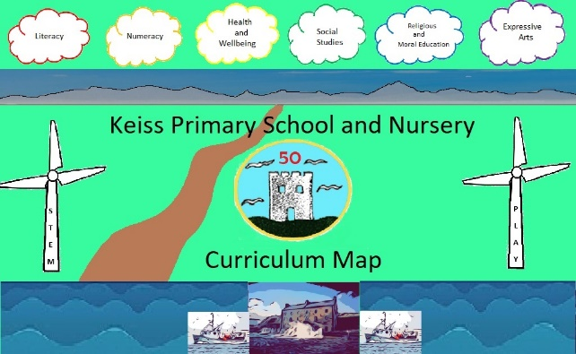

Staff agree working time for collegiate activity and this is appropriated across the school and nursery calendar to ensure that identified improvements are made. This year, our school improvements priorities have focused on continuing our recovery in education and ensuring that the health and wellbeing of our school and nursery community is positively developed. We continue to use Jigsaw to support personal, social and emotional experiences in Health and Wellbeing and continue to develop approaches in Physical Education using Better Movers Thinkers. We have started to embed the practice of Number Tasks in our teaching on Numeracy and Mathematics.

Our tracking and monitoring database supports our assessment information and provides an overview of learners’ attainment, progress and where appropriate, opportunities to further support learners. We have added key local and national assessment data to our database in the form of Accelerated Reading, Highland Numeracy and Scottish National Standardised Assessment (SNSA) information.

As always, there have been responsive and additional features of school and nursery improvement. This year, we launched a digital school and nursery handbook, re-introduced house challenges, increased pupil voice through our Pupil Council, Junior Road Safety Officers (JRSOs), Digital Leaders, School Nutrition Action Group (SNAG) and Rights Respecting School Community (RRS). Our RRS committee submitted our application to be recognised as a bronze status RRS and we were awarded this in June 2022.

As part of #WakeUpWednesday, we share guidance from the organisation, National Online Safety to help educate families around developments in Digital Technologies.

2.3 Learning, teaching and assessment
This year our teaching team took part in practice around the learning, teaching and assessment cycle (Moderation Cycle). This provided an opportunity to create an interdisciplinary (IDL) experience consisting of four lessons identifying one learner to assess. It provided focus on forming learning intentions and success criteria. The experiences considered the design principles of Curriculum for Excellence (CfE) to create a set of coherent experiences where feedback and next steps were provided to the learner based on the evidence created. This experience has further supported our judgments around achievement of an experience/ level and helped develop [practice specific to features of the Moderation Cycle.

This year, we have started to embed Number Talks into our practice in Numeracy. Staff took part in inset activity during inset and resources were purchased to support learning and teaching. Good practice was shared and practice was observed by the Head Teacher in Term 3.

Across the school, we encourage a range of teaching approaches and experiences to develop capacity in our learners. A range of assessment takes place within our school. Being a smaller school helps to provide greater focus and support to our learners.

At the start of the 2021/22 session, we introduced our curriculum framework to further support progressive teaching and learning experiences in all curricular areas.

In our nursery, we are continuing to improve the quality of our interactions with our learners placing an emphasis on Words Up and incorporating Blooms question stems into our language.

We are sharing are observations on Seesaw and recording achievement of milestones in personal plans.

At the end of every month, we have held informal Digital Technology sessions to improve our proficiency with Digital Technologies.

We have continued to plan experiences in partnership with our learners so that they engage in range of experiences that are adult-led, adult initiated, child initiated.

We have ensured free flow movement between outdoor and indoor settings

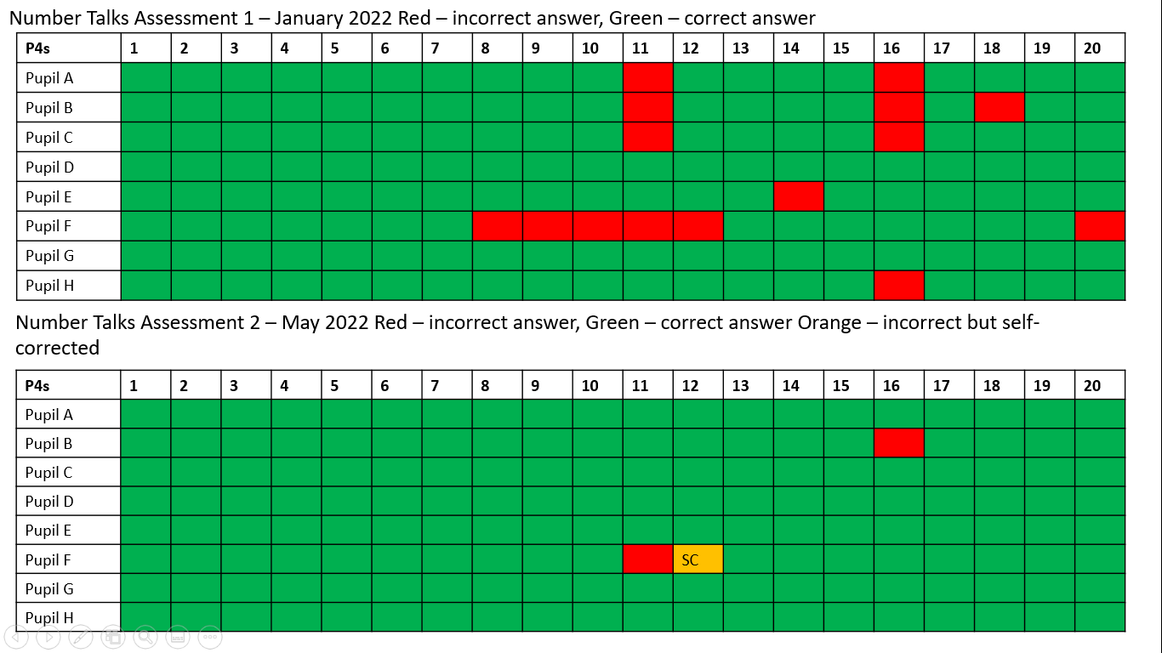
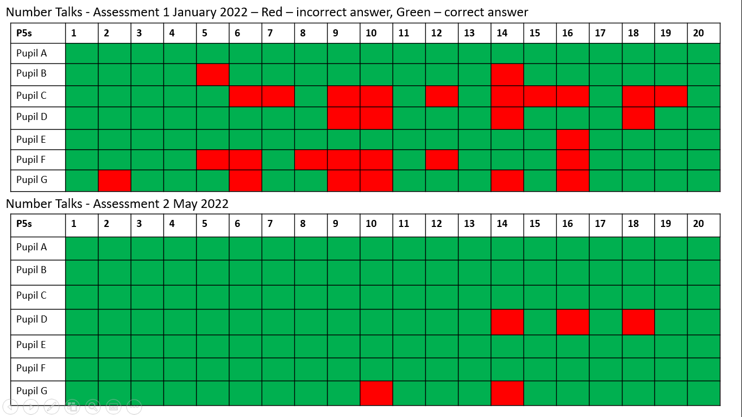

3.1 Ensuring wellbeing, equality and inclusion
Considering the pandemic, health and wellbeing has been of paramount importance within our school and nursery community. During lockdown and social restrictions, we provided a stimulating remote learning provision which inspired events and initiatives that further promote wellbeing. Events such as an online Parent Council Duck Race, Stepathon House Challenge, online assemblies and school tours, online Christmas quizzes, Sports Days, a two-hour minimum commitment to Physical Education, P7 cluster residential trip to Fairburn Activity Centre, Swimming Lessons, Bikeability training for all pupils in P5, 6 and 7 have helped to promote this.

Across the year, we have provided a range of dynamic after school and lunch time clubs. Thanks to our staff and partners, our pupils enjoy being physically active and learning new skills. A real success story of this year (minus a broken Chromebook) was the creation of a pupil-led Coding Club. Pupils took part in a remote, cluster, after school Code Club to take the initiative to lead their own club during Golden Time.

We have used our Pupil Equity Funding to employ our Early Years Support Worker in a Pupil Support Assistant (PSA), Mrs Taylor. Mrs Taylor has supported classes across the school.

During Term 3 and Term 4, we received funding from the Scottish Government for an additional teacher a day per week. Mrs Vicki Ross was appointed to the role. Using information from classroom observations, assessment data and tracking and monitoring database, Mrs Ross has supported targeted intervention groups in Numeracy and Literacy.

In Term 4, our Primary 6 and 7 pupils prepared a project and pitched to members of the Caithness Chamber of Commerce forming a Dragon’s Den panel at Wick High School.

Term 2
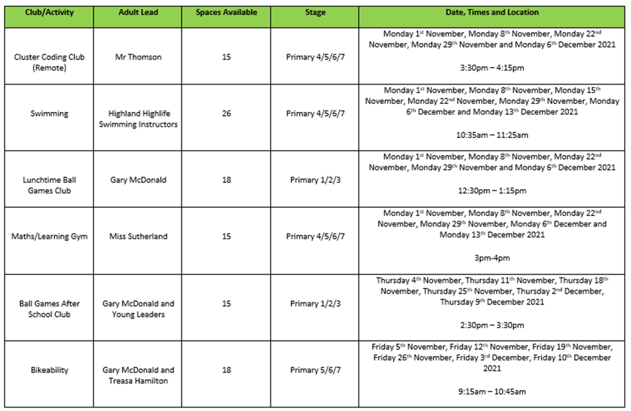
Term 3

Term 4
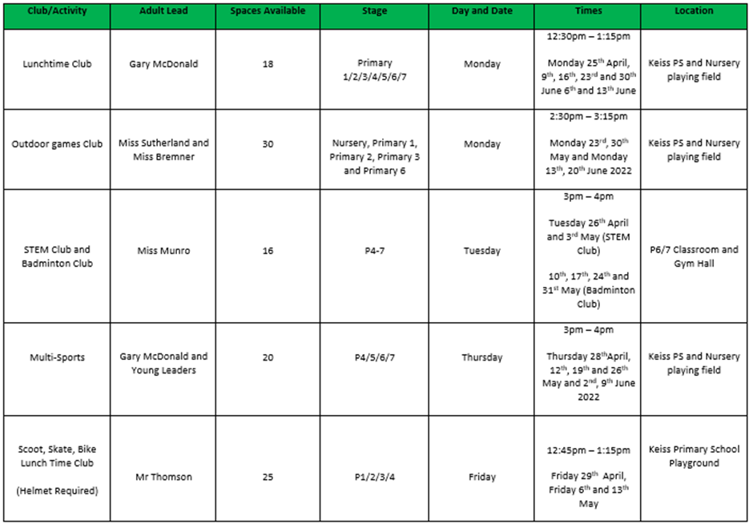

3.2 Raising attainment and achievement
The data in the first table reflects learner progress in our school. It reflects the levels set out in Curriculum for Excellence (CfE). This information is based on our tracking and monitoring database and teacher judgments across the academic session. These judgments are based on learning, teaching and assessments across the year. The percentages reflect the number of learners on track in their learning. The second table reflects pupils’ capacity and performance in P1, P4 and P7 in the Scottish National Standardised Assessments (SNSAs). The percentages reflect the number of pupils who are performing in line with the national norm or above. The colours correspond in P1, P4 and P7 to link ACEL judgments and SNSA performance.
Session 2020/21
Achievement of Curriculum for Excellence Levels (ACEL) 2020/21
 | Reading | Writing | Numeracy
Primary 1 | 33% | 83% | 33%
Primary 2 | 100% | 0% | 83%
Primary 3 | 86% | 71% | 100%
Primary 4 | 100% | 100% | 100%
Primary 5 | 75% | 75% | 100%
Primary 6 | 100% | 67% | 100%
Primary 7 | 78% | 56% | 67%

Scottish National Standardised Assessment data 2020/21
 | Reading | Writing | Numeracy
Primary 1 | 83% of pupils performing in line with national norm and above |  | 100% of pupils performing in line with national norm and above.
Primary 4 | 57% of pupils performing in line with national norm and above | 57% of pupils performing in line with national norm. | 57% of pupils performing in line with national norm.
Primary 7 | 100% of pupils performing in line with national norm and above. | 100% of pupils performing in line with national norm and above. | 100% of pupils performing in line with national norm and above.

Session 2021/22
Achievement of Curriculum for Excellence Levels (ACEL) 2021/22
 | Reading | Writing | Numeracy
Primary 1 | 83% | 83% | 83%
Primary 2 | 33% | 17% | 83%
Primary 3 | 17% | 17% | 100%
Primary 4 | 63% | 63% | 75%
Primary 5 | 57% | 100% | 100%
Primary 6 | 75% | 63% | 100%
Primary 7 | 100% | 100% | 100%

Scottish National Standardised Assessment data 2021/22
 | Reading | Writing | Numeracy
Primary 1 | 83% of pupils performing in line with national norm and above. |  | 67% of pupils performing in line with national norm and above.
Primary 4 | 100% of pupils performing in line with national norm and above. | 100% of pupils performing in line with national norm and above. | 75% of pupils performing in line with national norm and above.
Primary 7 | 100% of pupils performing above the national norm. | 100% of pupils performing in line with the national norm and above. | 100% of pupils performing in line with the national norm.

With reference to the ACEL data, the table below reflects changes in attainment.

Achievement of Curriculum for Excellence Levels (ACEL) 2021/22 – Increase/Decrease from previous year
+ Increase
- Decrease
* No change

 | Reading | Writing | Numeracy
Primary 2 | * | - | *
Primary 3 | - | + | +
Primary 4 | - | - | -
Primary 5 | - | * | *
Primary 6 | * | - | *
Primary 7 | * | + | *

Based on the data presented, it provides a clear rationale for improving processes in Reading and Writing. Particularly in the lower part of the school. This will be a key focus for school improvement over the next three years.

We will continue to improve our practice in Numeracy and Mathematics using Number Talks and revise our approach to homework.

Our School and Nursery Vision, Values and Aims

Pupil Voice: what is working well in our school?
Our children and young people identified the following strengths for our school this session:
Nursery – “I like to see my friends and play.”

Nursery – “I like the House Points. I get them if I help tidy up.”

Nursery – “I like learning new songs at nursery.”

Primary 1 – “It is a good place to learn.”

Primary 1 – “All pupils are helpful & Kind and they will help you if you feel sad or hurt.”

Primary 2 – “I love Keiss Primary School. I get choosing time!”

Primary 2 – “I get to see all my friends.”

Primary 3 – “We have nice pupils and a good playground.”

Primary 3 – “The pupils are really kind and helpful”

Primary 4 – “Mrs Jack’s food and I love the afterschool clubs.”

Primary 4 – “Keiss has a big playground and it is fun to be here.

Primary 4 – “There are lot of kind people at Keiss Primary School and I get a good education.”

Primary 4 – “Pupils at Keiss are responsible, fun and happy. Everybody treats each other fairly.”

Primary 5 – “You get fruit for tuck, and the lunches are good too.”

Primary 5 – “It is fun and I live in Keiss.”

Primary 5 – “I get to see all my friends and I love doing Art with Mrs Duffy!”

Primary 5 – “I like playing with my friends and doing writing and maths.”

Primary 5 - I like playing with my friends and the homework I get as it helps educate me.

Primary 6 – “Everyone is nice and we learns loads.

Primary 6 – “Everyone is kind, everyone is included and the teachers are fun.”

Primary 6 – “Everyone is nice, no bullying. Loads of friends and everyone is included.”

Primary 7 – “Keiss is very welcoming by all pupils and staff. It is a fun school.”

Pupil Voice: what changes would you like to see made?
Our children and young people identified the following changes they would like to see and the difference these changes could make.

“I think homework is fun but it takes up a lot of time. I don’t have that much time after school.” P5

“If it were less time consuming, that would be good. We could agree to do a set amount of time every night.” P7

“I don’t like the spelling homework. It’s too much. We have to write two sentences and two paragraphs” P5

“The school should have football, hockey and netball teams.” P4

“We’d love football goals and nets.” P5

“I would like an after school club where you create your own games.” P2

“I think it would be good to have after school clubs in your class groups.” P6

“A homework club would be a good help.” P7

“I would like if we had more of a say in what we learn about and the games in play. Like in P.E…” P4

“Story game for spelling including all pupils.” P2

“Other staff can help us learn in other subjects like P.E.” P5

“A book group would be good! That would help us with our Reading. There could be rewards.” P4

“The assemblies and house challenges have been brilliant.” All pupils

Our Improvement Journey Headlines
Session 2021/22
These projects are linked to the vision and priorities for Scottish Education based on delivering excellence and equity. Parent/Carer information is available here.
Improvement Project 1:
Primary focus: School and ELC improvement
Year of Project: 2
Purpose: Recovery from Covid-19: Health and wellbeing
Progress and impact:
Very good progress has made in this area. The school have continued to monitor the health and wellbeing of our school community. The majority of our pupils love coming to school and nursery and enjoy the experiences on offer.

A new vision, values and aims were set for our school and nursery providing a clear focus to everyone in our community.

Staff met with the HT on a monthly basis to monitor wellbeing in the workplace. This was moved to a termly basis as wellbeing improved.

Where necessary, counselling, positive development programmes, Young Carers and support from Childrens Service Worders (CSW) have been implemented to support the Health and Wellbeing of our pupils. The Jigsaw resources continues to be used in our school and we are continuing to use Better Movers Thinkers (BMT) as an approach to our two hours of teaching Physical Education.

Our school community was consulted and we introduced our relationships policy this year.

Our school and nursery now have a Trim Trail and Polycrub which were built this year. Funding has been secured for an outdoor classroom. We offer a wide range of dynamic after school and lunch time clubs across each term.

Next steps:
- Continue to monitor and support the HWB of pupils, staff and families
- Continue to offer lunch and after school clubs
- Continue to develop proficiency with BMT and Jigsaw resource.
- Link house and reward systems to Vision, Values and Aims
- Review and publish homework policy

Improvement Project 2:
Primary focus: School and ELC improvement
Year of Project: 2
Purpose: Recovery of learning, teaching and assessment and Attainment in session 21/22 (focusing on identifying new or widened gaps caused by the Covid-19 situation)
Progress and impact:
Very good progress has made in this area.

We have employed a PEF PSA and PSA to assist with targeted intervention using Number Talks and Reading. This will continue in session 2022/23.

We have received money from the Scottish Government to fund an additional teacher for the equivalent of a term. Mrs Vicki Ross supported targeted intervention of groups in each class and as a result, we have evidence an increase in attainment in Writing and Numeracy in Primary 3.

Our teaching team have participated in the Moderation process. Writing was the core focus and practitioners moderated in school, cross cluster and across the Wick ASG.

Our tracking and monitoring database is now providing a robust way to track and monitor learner progress and attainment. Using this data has provided clear areas for improvement in the coming years in our school.

Next steps:
- Continue to develop the tracking and monitoring database
- Continue the moderation process next year (Reading)
- Continue to embed the practice of Number Talks in our school
- Focus improvement priorities on Reading and Writing. Particularly in Primary 2-6

Improvement Project 3:
Primary focus: School and ELC improvement
Year of Project: 2
Purpose: Nursery
Progress and impact:
Very good progress has been made in this area.

We have improved the quality of our interactions by using Words Up and introducing Bloom’s question stems to our interactions with learners.

We have made effective use of our assessments and observations to change practice accordingly. Examples around toileting of pupils and extending learners in the experiences have been based around our observations. The team worked on a quality framework for self-evaluation which is now part of practice to measure our practice and performance and adapt accordingly.

Free flow play is now part of practice.

We have not improved family learning programmes.

On the last Thursday of every month, we have met to develop our use of Digital skills. Early Years Practitioners state intended learning and the Head Teacher has led sessions around intended areas.

Next steps:

- Continue to develop our effective use of assessment
- Develop universal support for all our learners and families
- Continue to develop digital skills

Evaluation of Progress
We believe we have made the following progress this session:

Quality Indicator | School self-evaluation
1.3  Leadership of Change | Very good
2.3  Learning, teaching and assessment | Very good
3.1  Ensuring wellbeing, equality and inclusion | Very good
3.2  Raising attainment and achievement | Satisfactory
Our children and young people believe we have made the following progress this session:
Theme 1  Our relationships | Excellent
Theme 2  Our learning and teaching | Very good
Theme 3  Our school and community | Excellent
Theme 4  Our health and wellbeing | Excellent
Theme 5  Our successes and achievements | Excellent
Our overall evaluation of our school and nursery’s capacity for continuous improvement is:

We are confident in our capacity for continous improvement.

Planning Ahead
Full details of the school’s 2022/23 improvement priorities and actions are detailed on the school improvement plan, which can be accessed on our website ADD LINK or by contacting the school office.

