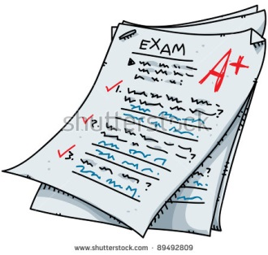

**Advice for exam day**

**Wake up early enough to have a healthy breakfast. Food fuels your body and mind!**

**Try to focus on relaxing your breathing and stay focused.**

**Don’t focus on anyone else! As the exam begins, remember the importance of timing and read each question carefully.**

**When the exam is done, give yourself a pat on the back and don’t stress about it!! ☺**

**If you finish early, check over your answers!!!**

**Get to school early enough so that you can relax and chat with friends and ready for check in by DHT**

**Turn of your phone!!**

**Make sure you’ve got all of the resources you will need: a pen, some water, a watch etc.**

**Set several alarms or have a family member makes sure you are up with enough time to get ready, relax and eat.**