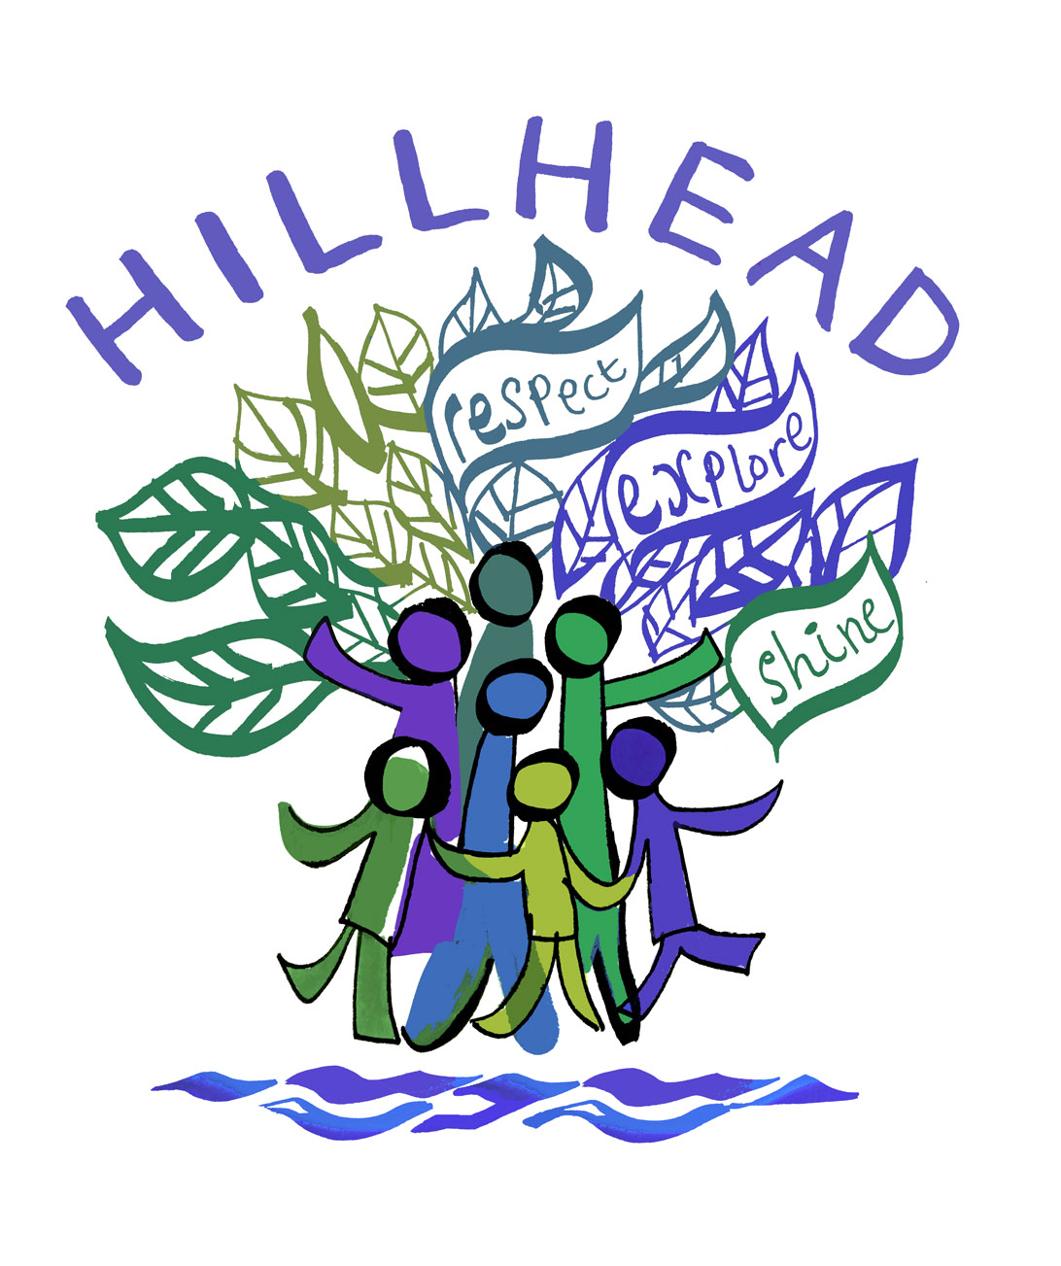

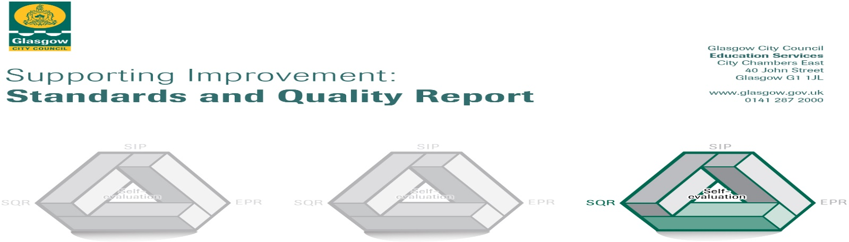

The summary report is provided for parents/careers and partners to outline our achievements this session and our priorities for next session. Throughout this session we have taken forward our priorities as detailed in our school improvement plan. Through our processes of self-evaluation, we have identified how we can improve outcomes for our children and young people.

Our achievements and improvements this year.
Hillhead Primary School – Standards and Quality Report 2024

We would like to highlight the following improvements and achievements:
- We have a welcoming and nurturing ethos which is evident throughout our school. Almost all children present as happy and demonstrate our school values of Respect, Honesty, Fairness and Courage.
- We have a school roll of 611 pupils and a community comprising of families representing more than 50 different countries with over 55 different languages spoken. The diverse nature of our families provides a rich environment from which our pupils flourish.
- We share our pupils’ learning through SWAY presentations for each stage, this provides a comprehensive overview of the learning pupils have engaged in each Term (there are 4 x Terms in a school year). We include a ‘Curriculum Newsletter’ that provides an overview of the teaching and learning that is planned to take place the following term. We have also enhanced our reporting to parents by sharing images and video clips of whole school events.
- We have recently completed installation of a brand new trim-trail in our Courtyard (P2/3) playground, this was made possible by donations from our wonderful Parent Council who raised £6,500 towards the costs.
- We have successfully achieved our Bronze Rights Respecting Schools Award and are working towards Silver during the 2024-25 school session.
- We have established a Digi-Den and our Digital Leaders of Learning supported by Ms Lizi Dunn use this space to provide training for pupils and to showcase digital and connected learning activity from across our school.
- We are working towards becoming a STEM (Science, Technology, Engineering and Mathematics) Nation Accredited school, we currently have achieved four of the five elements and are working towards achieving our final badge (Equity and Equality in STEM) during the 2024-25 school session.
- We are looking forward to further developing our STEM partnership working during Session 2024-25 with plans to implement a Coding Club after school for our Primary 5 pupils.
- Over the past three years all of our Primary 6 pupils have completed training to become Young Stem Leaders, they are able to deliver STEM lessons to our younger pupils as part of our curriculum offer.
- We were very excited to welcome Bonnie our Therapet and her owner Noelle to our school community during 2023-24 and they have been supporting building confidence in reading with pupils from Primary 1 – 7. This partnership will continue on into Session 2024-25.
- Our Primary 4 and Primary 5 pupils and staff worked in partnership with Scottish Opera to deliver a fantastic performance in May and we will be working in partnership once again during Session 2024-25.
- In partnership with our Parents and Carers we are planning to re-launch our International Evening for November 2024, lost to us during the pandemic it will be the first event since 2019! We look forward to sharing more news with you early in September 2024.

Progress in promoting wellbeing, equality and inclusion:
- We have continued to build our school’s capacity to support Emotional Health and Wellbeing by developing further partnership work with The Wheels Trust and Partick Trinity Church. Karen and Alan (dedicated outreach workers) have worked with multiple cohorts of pupils from P3/4 and P6/7 on building self-esteem groups; Jilliy the Giraffe and The Flourish programme.
- We now have all of our Emotion Works Cogs displayed in each of our three main playground spaces and the programme continues to positively impact on developing a shared vocabulary and practice for supporting pupils understanding of their emotions and how this affects their behaviours and feelings.
- We continue to provide Yoga, Mindfulness and Journaling input for specific groups of pupils from P1-7 and run two after school clubs for pupils in P2 and P3.
- We have an established ‘Soft Start’ for all of our Primary 1 pupils, this ensures a calm and purposeful start to the school day with all children being supported straight into their class rooms at 08.40am before school begins formally at 08.50am. This has been extremely positive and welcomed by staff and parents.
- We delivered Nursery/Primary 1 transitions in May/June 2024. Children enjoyed visiting in small groups to meet some of their new class mates and their new class teacher and parents and carers were invited to tour the school followed by a Q&A.
- Our Primary 7 pupils were all involved in transition events for their respective Secondary schools and enjoyed meeting key staff and some of the pupils they would be joining in August.
- We planned and implemented enhanced transition for selected groups of pupils to support a period of significant change for pupils with Additional Needs for Early Years into Primary 1 and for Primary 7 into S1..
- In partnership with our Parent Council we continue to support our school community by providing access to our Resilience Fund (Supermarket vouchers) at times of financial challenge. We also worked with our whole school community to deliver our hugely successful ‘Reverse Advent’ in November/December providing food and toiletries for Sprit Aid to distribute in our local area.
- We continue to work in partnership with ApparelXchange, a local charitable organisation that provides clothing at extremely low cost for families in the City and they have made vouchers and clothing bundles available for families accessing our Resilience Fund. They also recycle our unclaimed lost property and ensure it goes to support families across the City.
- We have a well established pre-loved uniform stock that can be accessed easily at our main reception and provides free good quality school clothes for all ages.
- We continue to develop our new promoting positive relationships policy, we continue to consult with our school community and completed Parent/Carer, Pupil and Staff surveys in April/May 2024. The feedback we receive will shape our next steps.
- We continue to ensure a consistent approach to promoting positive relationships across the whole school and all of our classes have a Class Charter, Message Box for pupil voice and Cosy Quiet Corner to support pupils during he school day. We will also have emotional check-ins for all pupils every morning.
- We will begin work with Glasgow’s Educational Psychology Team to train all staff in Restorative Approaches and to embed the practice across our school over the next two to three years. We are looking forward to engaging with our whole school community as we begin our journey in August 2024.
- We are a Bronze Rights Respecting School, working towards Silver. We take time during each of our weekly assemblies to focus on Children’s Rights and this underpins the work we plan for in all classes.

Achievement and Progress
- Our Primary 1, 4 and 7 pupils complete Scottish National Assessments in Literacy and Numeracy each school year and the information gathered is used to support progress. In P2, P3, P5 and P6 we use MaLT https://www.hoddereducation.com/malt assessments for Numeracy and PIRA assessments https://www.hoddereducation.com/malt for Literacy.

Children’s Learning over time
Primary 7
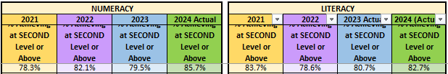

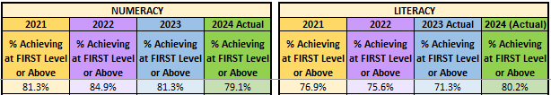
Primary 4

- We benefit from a fully immersive play model in Primary 1 and plan to continue increasing play opportunities for our Primary 2 pupils during Session 2024-25.

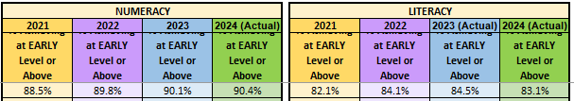
Primary 1

Our Pupil Equity Fund Allocation for Session 2023/24 was £74,700. We directed these funds to provide targeted support and to enrich the wider curriculum offer for pupils and families affected by the income-related attainment gap, this included:

- Additional staffing to continue to support our Play Pedagogy Pathways and to deliver early intervention strategies in Numeracy and Literacy.
- Increased provision for Emotional Health and Wellbeing interventions; counselling, developing positive self-esteem groups, Yoga & Mindfulness, Seasons for Growth, Nurture and providing alternative playtime and lunchtime provision.
- Financial support for Primary 7 families to maximise participation in our Residential Trip to Ardentinny.
- Increased provision of after school clubs, including GLEE Club (Singing and dancing) for all stages P1-7.

Learning, Teaching and Assessment
- Our Staff Development groups will continue their work to create curricular pathways from P1-7 to that focus on Play in to Enquiry-Based learning.
- We invested almost £5,000 on updating and improving our Big Cat Reading scheme, this included adding key titles supporting early phonological awareness and extending our library of Novels.
- We have an established Active Spelling approach across all stages and each class benefits from a bank of resources to support delivery of the programme.
- All of our classrooms have access to either a SMART board or Promethean Board that supports teaching and learning. We continue our rolling programme of upgrades with 14 class bases now benefitting from a promethean board being installed.
- We benefit enormously from Glasgow’s Connected Learning Citywide programme with all Primary 5, 6 and 7 pupils having access to their own school i-pads. We also have a large bank of shared i-pads that support digital learning across our P1-4 classes.
- Our pupils plan and lead class assemblies that are a staple feature of our weekly assemblies. All classes have the opportunity to present their learning three times in the school session.
- We benefit enormously from our strong, experienced English as an Additional Language (EAL) Team; with Mrs Leslie and Mrs Rodgers continuing to supporting bilingual and multi-lingual pupils and their families across our school community.
- All of our pupils have the opportunity to participate in school shows, our Infant pupils (P1-3) deliver a fantastic Winter Show in December, our Primary 6/7 pupils work in January and February to put on an outstanding Musical and our P4/5 pupils produce a Scottish Opera inspired performance in May. The experience of performing to audiences of 200 or more is one our pupils relish.
- We continued to deliver a range of interventions for individuals or pairs requiring targeted support in Literacy through our ‘Boosting Reading’, ‘Dyslexia Support’ and ‘International Dyslexia Learning’ online tool.

Engagement
Attendance Procedures
Parental Engagement
- Our Parent Council have organised a hybrid model of PC meetings, alternatively hosting on zoom then in-person. We continue to have strong representation on our Parent Council with 25 parents or carers participating.
- Our Parent Council organised a hugely successful ‘Summer Fayre’ in June 2024, this was very well attended and helped to raise funds that will be -re-directed to support school projects.
- Our Parent Council provided £6500 to support the improvement costs for our Courtyard playground, a further £500 for our school library and £600 for musical instruments.
- We continue to work in partnership with our Parent Council to provide pre-loved uniform stalls throughout the school year, including during our Primary 1 induction sessions in June 2024.
- The Parent Council have helped to establish a Food Group and they worked to produce two videos to help our parents and carers understand a little more about lunchtimes in Hillhead Primary School. These can be found on our school website.

Here is what we plan to improve next year.
Our focus areas for Session 2024-25 are:

- Literacy – improving and developing our approaches to teaching writing in line with Glasgow’s Literacy for All pedagogy.

- Restorative Approaches – Working with Glasgow Educational Psychological Services to train all staff in Restorative Approaches to further enhance our commitment to promoting positive relationships for pupils, staff and parents/carers.

- Metacognition – Develop a whole school approach to support our pupils’ to better understand how they learn and how they improve in their learning.

- Rights Respecting Schools – Work towards gaining our Silver Award.

- STEM Nation Awards – To achieve STEM Nation accreditation for our school by overcoming work on ‘Equity and Equality in STEM’.

How can you find out more information about our school?
Please contact us directly if you require further information or if you wish to comment on the report.

The contact e-mail address is: headteacher@hillhead-pri.glasgow.sch.uk

Our telephone number is: 0141 339 1365

Our school address is: 110 Otago Street, Glasgow, G12 8NR

Further information is available in: newsletters, the school website www.hillheadprimaryglasgow.org , twitter @HillheadPrimary and the school handbook.

