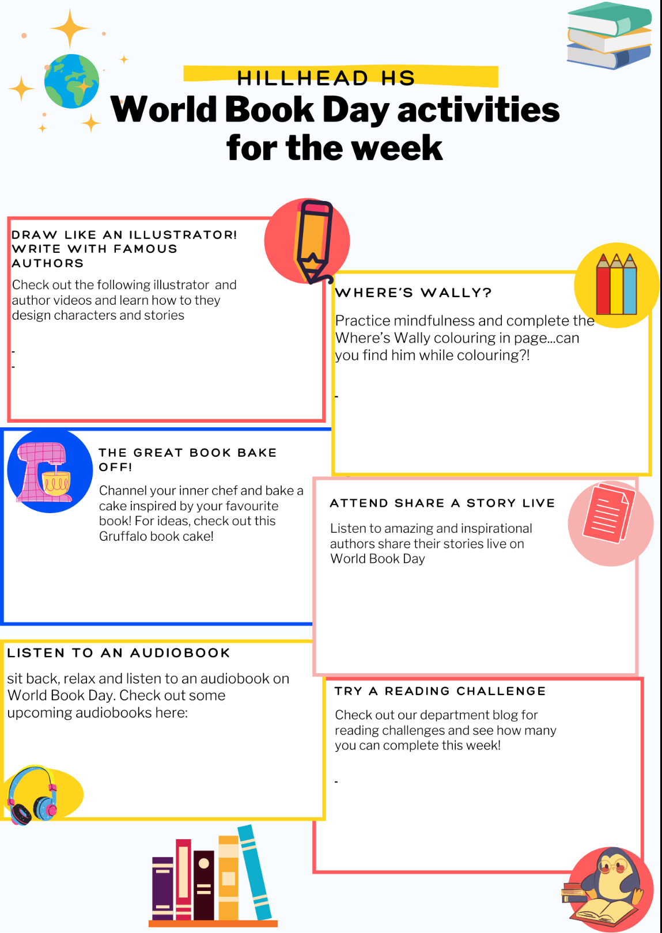

[**Department Reading Challenges**](https://blogs.glowscotland.org.uk/glowblogs/hillheadhighenglish/bge/summer-reading-challenge/)

[**Audiobooks**](https://www.worldbookday.com/world-of-stories/)

[**Share a story Live**](https://www.worldbookday.com/events/)

[**Book inspired cakes**](https://www.worldbookday.com/resource/the-gruffalo-cake/)

[**Colouring in page**](https://www.worldbookday.com/resource/wheres-wally/)

[**Author and illustrator Academy**](https://www.worldbookday.com/online-masterclasses/)