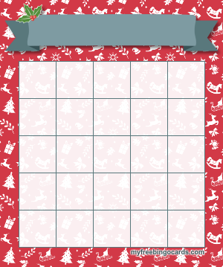

**Warm up with a good book!**

**Winter reading challenge**

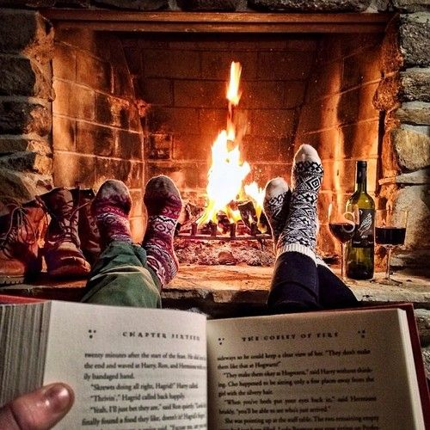

**Tweet us your winter reading @EnglishDept_HHS  
Happy holidays! -Hillhead HS English Department** 😊

**Read Dr Seuss’s ‘How the Grinch Stole Christmas’**

**SUPER SUPER CHALLENGE: write your own short story sent during winter!!**

**SUPER CHALLENGE: read 10 new books!**

**Read a collection of poems**

**Read ‘A Christmas Carol’ by Charles Dickens**

**Read a story set in winter**

**Read a short story about love, giving or gratitude**

**Read 3 new books**

**Read 5 new books**

**Read something chilling! A horror or thriller**

**Read a graphic novel**

**Research and read about holiday traditions worldwide**

**Read a newspaper article**

**Read ‘The Lion, The Witch and the Wardrobe’**

**Listen to an audiobook while drinking hot chocolate!**

**Read a story about kindness**

**Read a non-fiction book**

**Read a holiday-inspired recipe**