My Urban Environment

I live in a small village called Blackwood; the village is bordered by another small village called Kirkmuirhill. I feel that both of these places build up my urban environment. The area is totally enveloped by green space although the village has grown significantly over the last ten years with two housing developments taking place. The first taking up a significant amount of ground space, the second was built on the site of an old factory. Within the villages the main type of buildings are houses and these come in a variety of shapes and sizes,
Bing Maps (2016)
including flats, terraced and detached. There is one main road which runs through the centre of the two villages and this is the B7078 (Carlisle Road), the village also lies adjacent to the M74, with direct links from either end of the village.

Transport

The main transport in and around the area is cars, a large number of people within the village have access to one and due to the location of Blackwood this is the easiest way to commute.
There is a public bus service which also runs through the village from Coalburn to Hamilton (253), this is a regular service and there is a bus every half hour. There is a less regular bus service which only passes through the top end of Kirkmuirhill and this is the service from Lesmahagow to Lanark (258) which comes every hour and ten minutes and does not run on a Sunday. The bus service is ran by Whitelaws and is used by a large number of people and is often very busy.
Also running through the village are lorries which transport to and from the quarry, their main route is through the village as this provides direct access to all main transport routes for example the motorway.

Community Spaces

Within Blackwood and Kirkmuirhill there are three Primary schools, in the centre of the village there is Blackwood Primary School and Our Lady and St John’s Primary School, further out into the countryside there is Bent Primary School.
Within Blackwood Primary School there is a community wing which is run by South Lanarkshire Leisure and Culture and was opened in 2012. The facility has a Sports Hall, Dance Studio, Community Hall, Fitness Suite, Library and an Outdoor 3G area with 3 x 5’s or 1 x 7 a-side football pitches with floodlights.
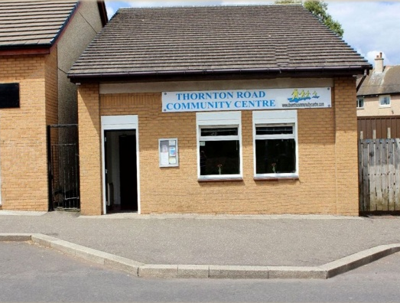
Also situated on the main street of Kirkmuirhill is Thornton Road Community Centre which is now a registered charity. The aim of the centre is to provide a community space which is available for people to use for a variety of different functions. There are also a range of activities put on within the centre, these include Gaelic for Beginners, Line Dancing and Cupcakes and Crafts. The variety aims to provide something for all age groups and volunteers work hard to provide a haven for young people in particular. The website details what the Community Centre aims to provide and what is on.

Industry and Work

The most recent type of work which has came to the villages of Blackwood and Kirkmuirhill is power in the form of wind turbines. In a number of green spaces around the village they have been put up, particularly in fields belonging to farmers. The biggest project has been Auchrobert Wind Farm which has been put into place by Falck Renewables Wind Ltd, in order to put these towers in there has had to be road modifications to allow them to travel to the site successfully. This meant putting in a road that lead directly to the site and widening pre-existing junctions and corners, barriers also had to be made removable to allow the trucks through. As stated on the website Auchrobert Wind Farm will have
- 12 turbine wind farm with associated infrastructure
- Turbine rating of between 2.5MW and 3MW
- Innovative community benefit and investment proposals for local South Lanarkshire residents
- Estimated to generate electricity to meet the annual demand of approximately 15,000 average UK homes¹
- Estimated to annually displace approximately 44,000 tonnes of C0₂ emissions²
More information can be found on: http://www.auchrobertwindfarm.co.uk/auchrobert-wind-farm.aspx
The second industry which has a large place in our community is Patersons Quarries Ltd at Dunduff Quarry, they are a company that provide aggregate products. This industry impacts our village as all of the products are transported by lorry through the village and onto the M74.
Also a large part of our community is farming, this takes place all round the village and there are a number of farms which are mainly dairy and beef. These include Dykehead and High Blackwood Yards Farm.
Within the villages there is a small cluster of shops on the main street, these include 3 takeaways, a butcher, a baker, a charity shop, a newsagents and a barber. There are also three hairdresser shops in the village, two small convenience shops and a co-operative which has a fuel station.Blackwood and Kirkmuirhill are also host to a small number of services a doctor surgery, a dentist, the pharmacy and a post office.

Recreation Areas

In Blackwood and Kirkmuirhill, there is not much in the way of recreational space other than the community wing which includes a gym, a sports hall and a library. There is also an outdoor bowling green called Blackwood Victoria Bowling Club which is opened throughout the summer months. To participate in bowling you must be a member of the club. For children there are a number of small play parks.

Peri – Urban Space

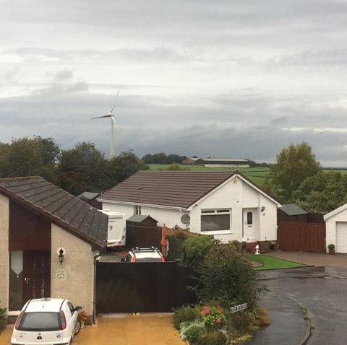
As I have stated above, there have been two housing developments within my urban environment, the Wimpey Development meant that considerable amount of green space was taken away, this also involved cutting down a large number of trees and reworking the surrounding areas. This involved putting in a pond to drain the area. Another concern within the village has been the implementation of renewable energy in the form of wind turbines, as allow beneficial in the long run there has been a lot of construction on green areas to build them as well as road pollution and many see them as an eye sore.

Population Density

Blackwood and Kirmuirhill are located in the county of South Lanarkshire which has a population density of 178 people per square kilometre (National Records of Scotland, 2014). When the last census was carried out in 2014 (City Population, 2016) the population was 4330 which showed a drastic increase since previous years and I believe that this was due to the increase in housing.

Air Pollution
The air pollution which was recorded for my area postcode (ML11) today was at the highest two which is a low reading on the scale. The measurements in the area took into consideration ozone, nitrogen dioxide and sulphur dioxide. The hourly average for nitrogen dioxide was measured at low (1) and there was no measure for the other two pollutants.

References

Bing Maps (2016) Blackwood [online] Available: https://www.bing.com/mapspreview [ Accessed: 29 September 2016]

City Population (2016) Kirkmuirhill [online] Available: http://www.citypopulation.de/php/uk-scotland.php?cityid=S19000994 [Accessed: 29 September 2016]

Falck Renewables & Corilis Energy (2016) Auchrobert Wind Farm [online] Available: http://www.auchrobertwindfarm.co.uk/default.aspx [Accessed: 29 September 2016]

National Records of Scotland (2014) Population and Migration [online] Available: http://www.neighbourhood.statistics.gov.uk/HTMLDocs/dvc134_c/index.html [Accessed: 29 September 2016]

