Climate Change
On consideration of the Climate Change (Scotland) Act 2009 I can see how there is an overall goal for the reduction of emissions by 2050, in order to do this there are annual goals set. To do this there will be responsibilities placed on public bodies, processes of mitigation and adaptation will be advanced and provisions for energy efficiency and recycling will be made.
One policy implemented to help reduce the emissions by 80% of the baseline for 2050 is the Government 5p Carrier Bag Charge. This was introduced in the hope that charging for all single use carrier bags would decrease the amount of them as they cause litter and it would encourage people to reuse bags as before the introduction of this policy Scotland used 800 million bags per year. After the first year of implementation “650 million fewer carrier bags were given out by the major grocery retailers alone, equivalent to 4,000 tonnes of material and 2,500 tonnes of CO₂ equivalent released” (Zero Waste Scotland, n.d). The impact that this has had on me personally is little, I do take reusable bags when I am going for some items at the supermarket but when going shopping I tend to buy a carrier bag and I feel that this is very vein as the reason for this is because I like it to look nice and to be able to see where I have bought my clothing and such like from. But I have seen a significant change within my work life as I work in Tesco and over the last year a significant number of people are regularly bringing their own reusable bags or as an alternative, using the cardboard boxes to carry their shopping which the store would be throwing out.
Within the act there is a large focus on greenhouse gases and how they are a major part of Scotland’s emissions. The emissions which are being released from this country are attributable to human activity and therefore there are steps being put into place to begin to remove these greenhouse gases. This means that we have to consider how we contribute to international aviation and shipping, I feel that this is important for our country as due to our location it is our main way of trade and there are a large number of imports and exports. As well as this it is part of the culture within this country to take vacations to different parts of the world and this puts a pressure on aviation and the amount of emissions created. I myself travelled throughout the summer period and this meant that I was on three flights outbound and three inbound flights; I feel that this shows travel is becoming more accessible to people and will involve more aviation and ships and think this is a concern in regards to reducing our greenhouse gases.
Within my local authority there has been a new recycling system implemented over the last couple of months. This meant that we have received two new bins and two that we previously had will be now have different recyclables put into them. Before this system was put into place we had a bin for general waste, general recyclables (paper, tin and plastic) and glass. Sustainable South Lanarkshire has now given us a bin for garden and food waste, a kitchen caddy to place the food waste in, a grey bin for recyclables (tin, glass and plastic), one for paper and cardboard and a general waste bin. Over the past couple of weeks there has been a lot of community discussion about the new system. Within my household we were using the previous system to its full capacity and I feel that these slight adjustments will take place quite well. There is generally a fair amount of food waste in my house so I feel that it will make a real difference being able to recycle it rather than it going to the rubbish dump where there are a lot of harmful gases being produced because of the amount of refuse being produced.
All of the issues that I have discussed above were brought to light by reading the Climate Change (Scotland) Act 2009 but also carrying out the WWF Footprint Calculator. My carbon footprint was calculated at 162% and I was extremely shocked by this result.

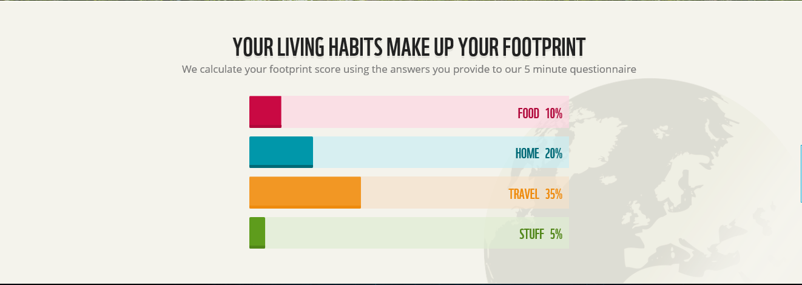

As shown in the diagram of my results above a large part of my footprint comes from travel. I would love to be able to reduce this but within my community there is very little in the way of public transport. This is made up from my commute to university which is roughly 40 miles from my house and I am taking this journey there and back around three times a day. If the government were to make transport which was accessible and a fair price it is definitely something I would consider changing.
I was surprised by some of the questions that this toolkit asked, for example how much money is spent in restaurants and takeaways per week or how much money was spent on clothes/toiletries per week. I had never before though that this would impact on carbon emissions and therefore will begin to think carefully about where I am eating, what I am eating and materialistic items that I buy.
Although I always ensure I turn off lights within my household when they are not in use and we use energy efficient light bulbs we are very guilty of leaving our electrical products on standby. I feel that this is a very small change which we could make which would contribute to our reduction of carbon footprint.
The issues that I have discussed throughout are very current and have been very thought provoking. I would like to make small changes which can hopefully support achieving the goals set for 2050.

Reference List

Scottish Parliament (2009) Climate Change (Scotland) Act 2009 [online] Available: http://www.legislation.gov.uk/asp/2009/12/introduction [Accessed: 12 October 2016]

WWF (n.d) Footprint Calculator [online] Available: http://footprint.wwf.org.uk/ [Accessed: 13 October 2016]

Zero Waste Scotland (n.d) Carrier Bag Charge Scotland [online] Available: http://carrierbagchargescotland.org.uk/faqs/ [Accessed: 12 October 2016]

