Creating a Post
How to make a very basic Post

1. Log onto your blog dashboard
Click on Site Admin in the sidebar of your blog.
If you are not logged into glow you will be redirected to the glow logon screen
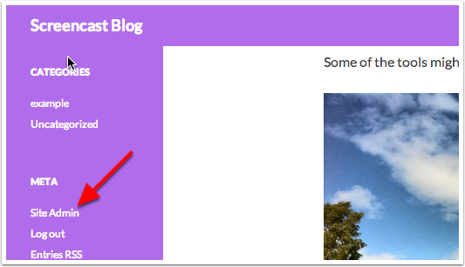

2. Create a New Post
Click on the + New this is a feature of the WordPress Admin bar that will appear to logged on users, both on the blog and the dashboard. Hovering over the + New will drop a menu, so that you can choose: Post, Media or Page.
The Admin bar is a new feature for Glow blogs as of January 2015 it allows you access to your blogs and administration features from both the dashboard and the blog itself.
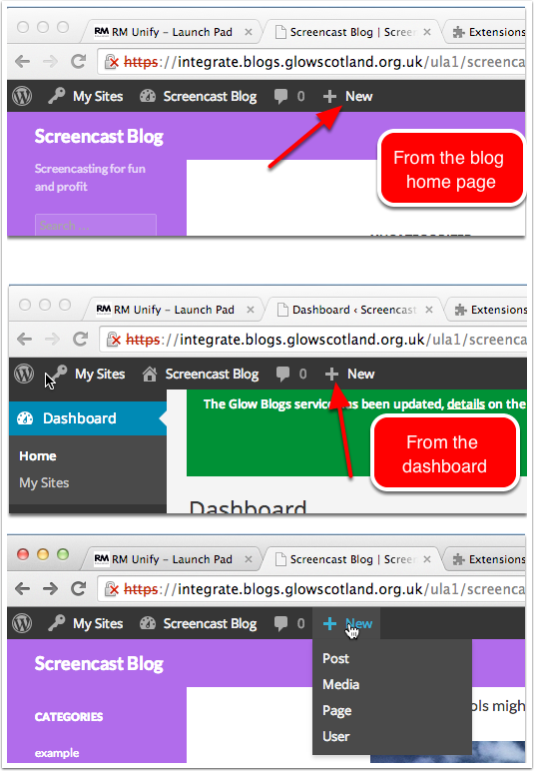

Write your post
All a post needs is a title and some text:
- Fill in the title
- Fill in the body text
- Click Publish
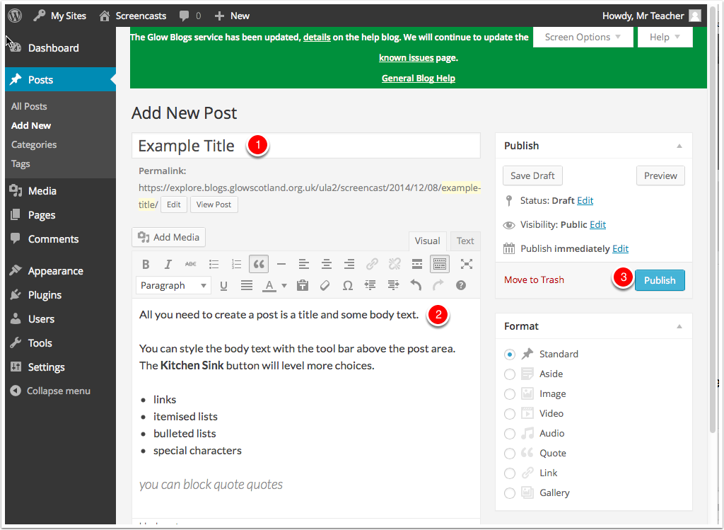

View Post
After clicking publish, you get notified [1], The Status [2] changes, and you can click View Post [3]. The Publish button has changed to Update [4].
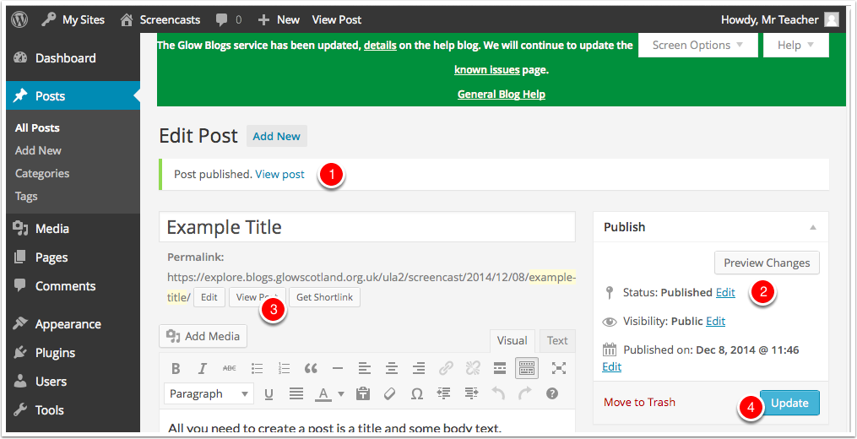

Live View
