Adding Audio and Video
Video and audio files can be displayed in players in a blog post or page.

Create a post
You start by creating a post in the usual way.
Put the cursor where you want the gallery to appear and click the Add Media button. This will open the Insert Media Screen.
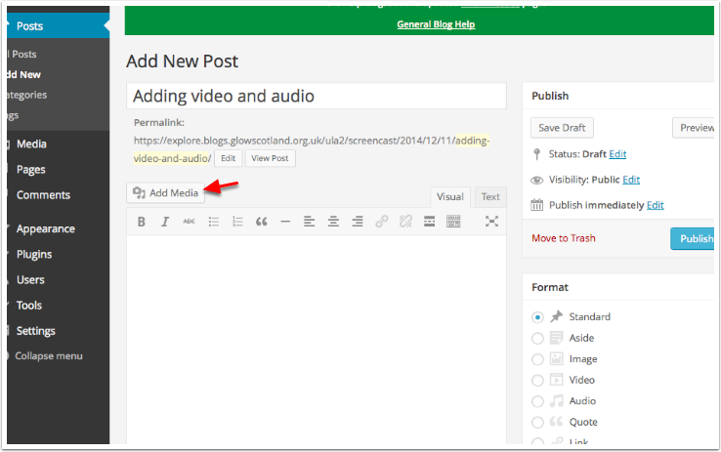

Insert Media
If you have already uploaded the media you want to add then you can select it from the Media Library. If you need to upload click the Upload Files Tab.
You can then either drag and drop files onto the screen or click Select Files.
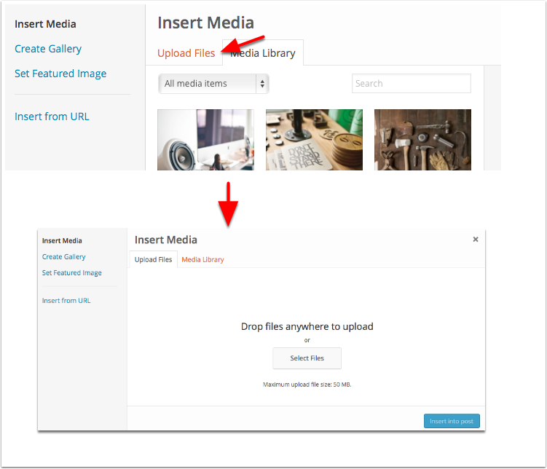

Choose Media
If yuo clicked Select Files in the previous step the system standard file browser will open. You can select files and Click Choose (or select). The File will upload.
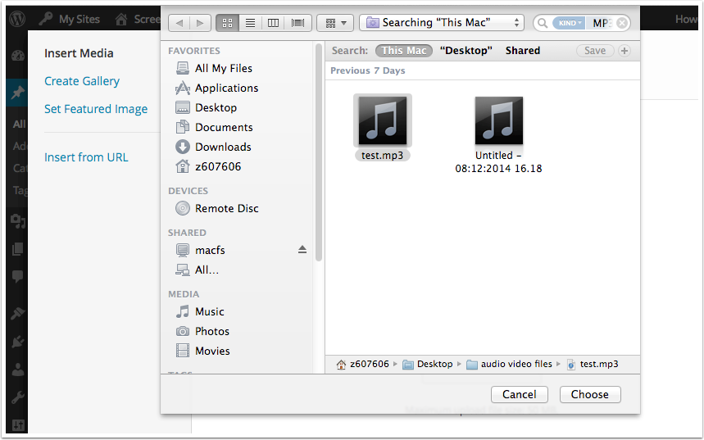

Insert Media Settings
Once your file is uploaded it will be selected in the media picker [1]. Any metadata from mp3s will be displayed [2]. You can choose how you want the media to be displayed [3].
Gernerally you will wnat to embed the media so that it can be played or viewed. When you are ready cilic Insert into post.
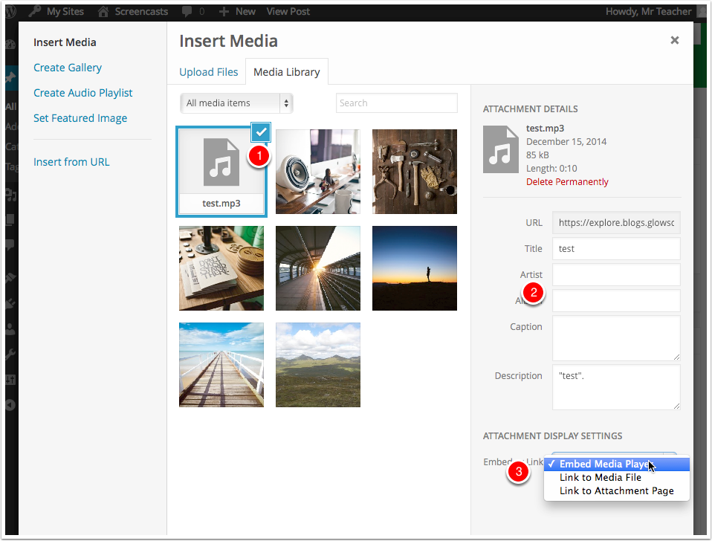

The Media is inserted into the post editor.
You can now finish off the post in the usual manner.
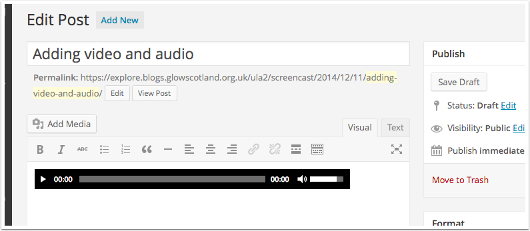

Media Notes
Different browsers and operating systems will treat media differently. Different versions of browsers and operating systems will also affect things. for example .ogg audio files will play in Firefox, but will download in some other browsers. WMA files may not play on a macintosh system.

