Creating a blog
This document cover the new service from January 2015 using Wordpress 4+

Before you start
You need to be aware of several things factors you create a blog. The settings involved can be changed at a later date.
Any glow user can create a blog.
A blog can be public, private or glow only. A public blog can be viewed by anyone with an internet connection. A private blog can only be viewed by users with a Wordpress role on the blog. A Glow only blog can only be viewed by a glow user who is logged onto glow.
Only a glow user who has a teacher or non-teaching staff glow account can make a blog public. A pupil can create a blog and make it either private or glow only. If a pupil wants to have a public blog they need to give a member of staff an administrator role on their blog, that staff member can then make the blog public.
Users should consider the consequences publishing to a public blog. Publishing publicly can give pupils a real audience for their work, make tasks more authentic but they need to be aware internet safety and data protection issues.
Users can have different roles on a blog, these will come with different affordances:
Administrator – somebody who has access to all the administration features within a single site.
Editor – somebody who can publish and manage posts including the posts of other users.
Author – somebody who can publish and manage their own posts.
Contributor – somebody who can write and manage their own posts but cannot publish them.
Subscriber – somebody who can only manage their profile.
The Subscribe role can be used to allow glow users to see a private blog.
The roles of Administrator and Author are the most commonly used roles.
Note: in the 'old glow' environment user roles were set in the glow group the blog belonged to. This mapped roles from glow to WordPress, the contributor role mapped to author. This can lead to confusion, if you make users contributors in Wordpress they will not be able to publish the posts that they create.

Create a Blog
To create a blog you log onto glow and click on the blogs tile. You will go to the blog home page for your Local Authority.
Click on Create a Blog
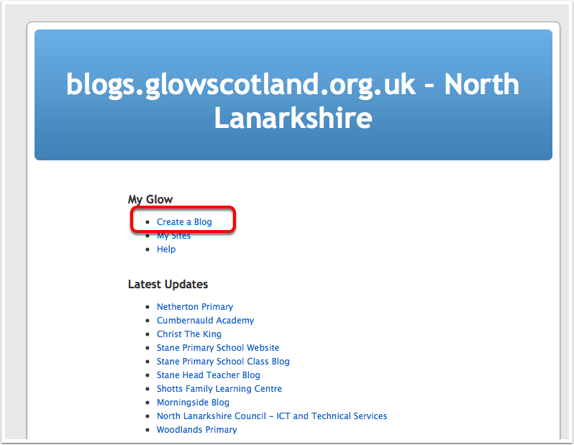

Name your blog
After clicking Create a Blog you will be taken to a page that lists the blogs you are already a member of and has fields to create a new blog.
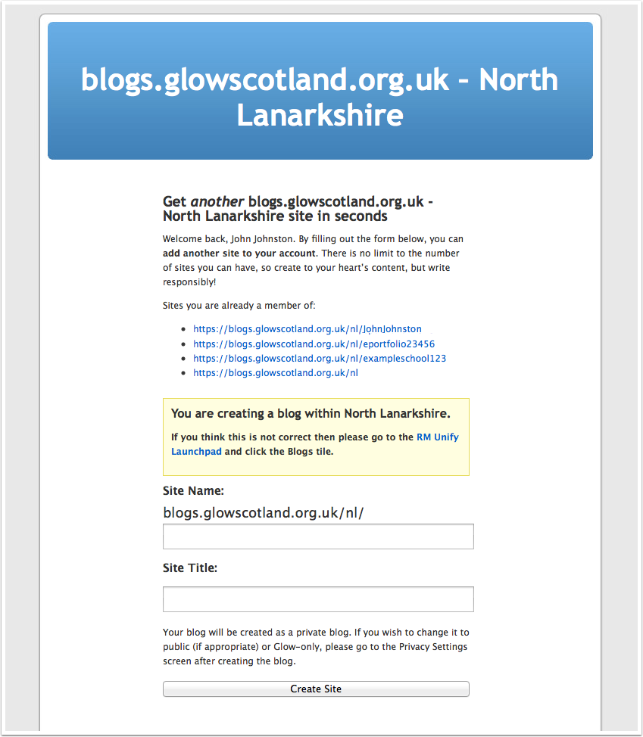

Name your blog
Be aware that the field for this are firstly the blog name as part of the url and secondly the Title of the blog. You can change the Title in the dashboard of your blog at any time.
So this blog will have the url:
http://blogs.glowscotland.org.uk/nl/screenshot
and will have the title Screenshot Blog after you click Create Site
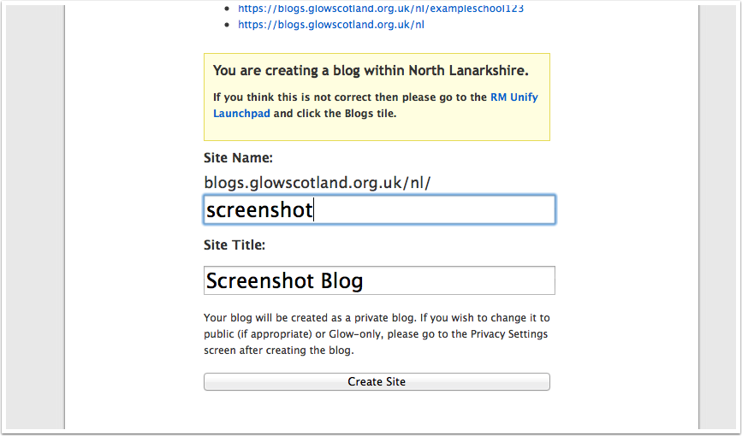

Your blog will be created
The next page will let you know the blog has been created and give you links to the blog itself and the dashboard.
Remember that your newly created blog will be private and the only person that will be able to view it will be yourself unless you change the privacy settings.
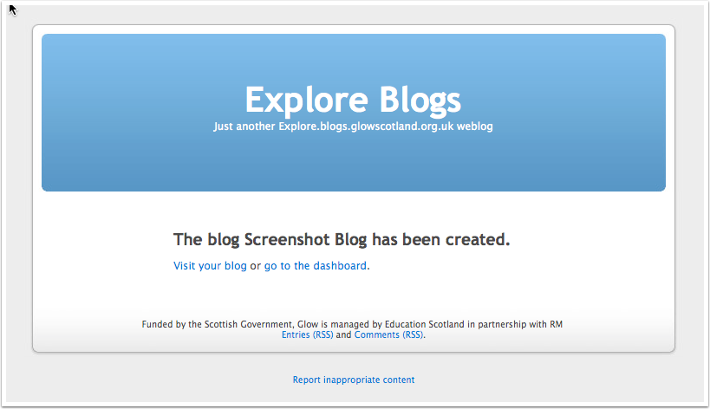

REUSE, REMIX AND RECYCLE

