Plugins
Plugins are programming scripts that add additional functionality to your blog. These are often features which either enhance already available features or add them to your blog.

Manage plugins settings
You can access the manage plugins screen in the dashbaord from the navigation menu on the left[1].
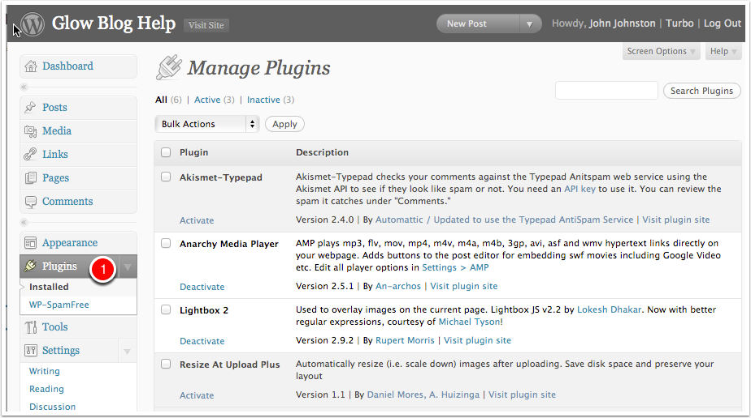

Activating a pluging
Individual plugins can be activated or deactivated with the Activate and Deactivate links at appear under the plugin name in the list.
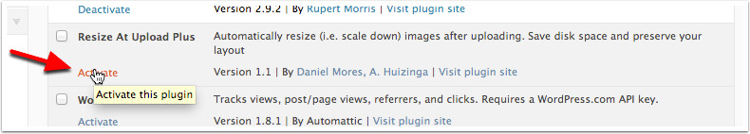

Activating several plugins
Yuo can activate or deactivate more than one plugin at a time by checking the boxes beside their name [1 & 2].
You then choose the Action from the popup at the top of the list [3] (or the one at the bottom) and click Apply [4].
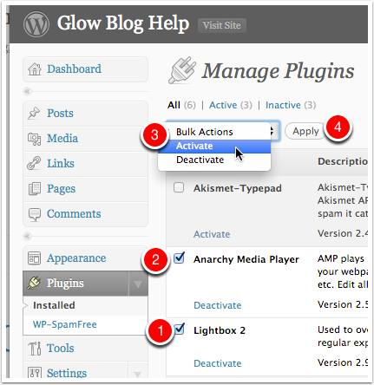

Plugin Options
After activation the plugin my add a screen to your dashboard for configuration settings. The Screen below shows the Lightbox 2 options and points out the links to the other plugin settings screens.
The screens may be added to the settings section of the dashboard or elsewhere depending on the plugin.
