Widgets
Widgets are used

Widgets
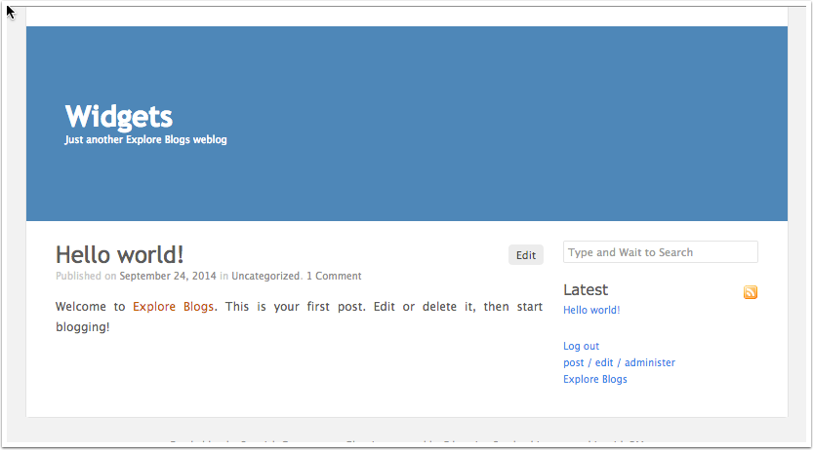

Dashboard ‹ Widgets — WordPress
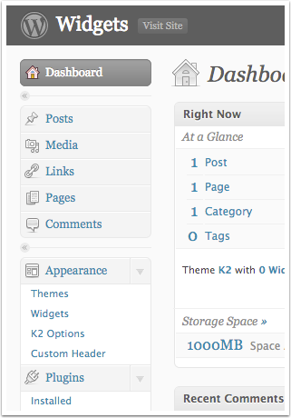

Widgets ‹ Widgets — WordPress
