Glow Blogs Privacy Settings
Glow blogs can be set to have three different privacy settings:
Private, this is the default for newly created blogs, only members of the blog can view it.
Glow only, these blogs can only be viewed by authenticated (logged on) glow users.
Public, these blogs are open for anyone with an internet connection to view.

Accessing the settings
After you log onto glow and visit the Dashboard of your blog the Settings menu is at the bottom of the left hand navigation menu.
If the Setting menu is collapsed you can expand it by clicking on the disclosure arrow [1]
Then Click Privacy [2]

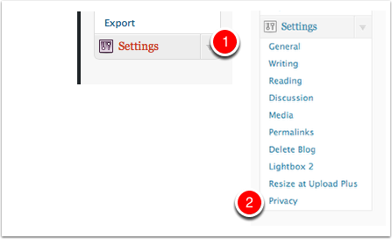

Privacy Settings
The settings screen is very straightforward, you just choose the radio button for the setting you want and click Save Changes,
NB: Staff are the only user who will be able to make a blog public. Pupils cannot make a blog public.
If a pupil has a blog and want to make it public they would have to add a teacher to the blogs users with an Admin role.
A pupil can make a blog that they have an Admin role private or glow only. If they have a blog where a teacher has made the blog public they can make that blog private or glow only. They cannot revert it to public, they will again need a staff user to make the blog public again.
