Summer Stories Recommendations
These books were selected and promoted by SLO staff during summer 2021 on Twitter under #SummerStories to encourage reading for pleasure among children across Glasgow.
SCHOOL LIBRARY OUTREACH
The Mitchell Library
North Street, Glasgow, G3 7DN
Web: Glow (or via tile on GCC Launch pad)
Twitter: @GlasgowSLO
Picture Books
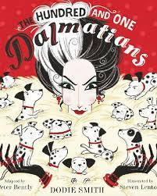 | 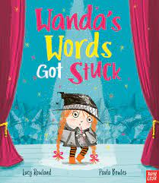 | 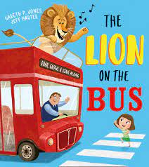 | 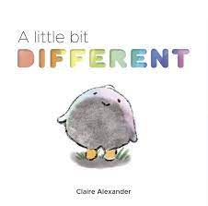
The Hundred and One Dalmations  Dodie Smith, Peter Bently & Steven Lenton | Wanda’s Words Got Stuck  Lucy Rowland & Paula Bowles | The Lion on the Bus  Gareth P. Jones & Jeff Harter | A little bit Different  Claire Alexander

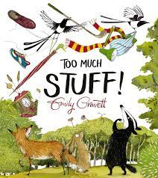 | 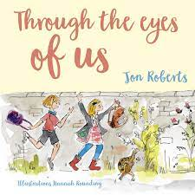 | 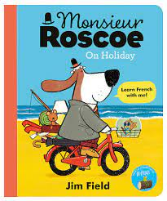 | 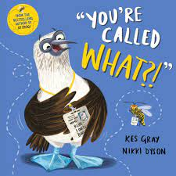
Too Much Stuff  Emily Gravett | Through the eyes of us  Jon Roberts & Hannah Rounding | Monsieur Roscoe on Holiday  Jim Field | You’re called What?!  Kes Gray & Nikki Dyson

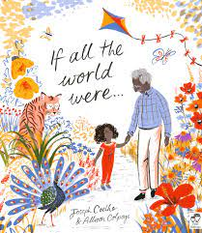 | 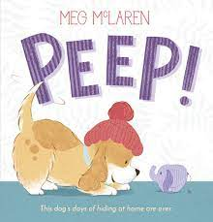 | 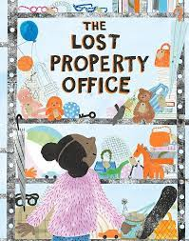
If all the world were…  Joseph Coelho & Allison Colpoys | Peep!  Meg McLaren | The Lost Property Office  Emily Rand

Fiction [6 – 8 years]
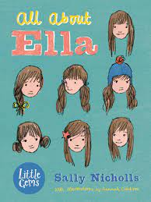 | 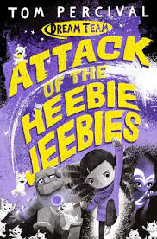 | 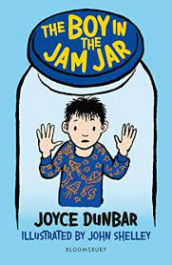
All about Ella  Sally Nicholls & Hannah Coulson | Attack of the Heebie Jeebies  Tom Percival | The Boy in the Jam Jar  Joyce Dunbar & John Shelley

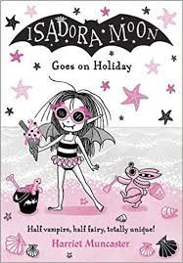 | 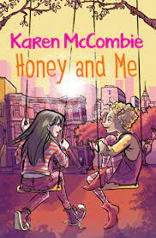 | 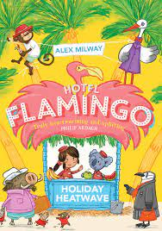
Isadora Moon Goes on Holiday  Harriet Muncaster | Honey and Me  Karen McCombie & Cathy Brett | Hotel Flamingo: Holiday Heatwave  Alex Milway

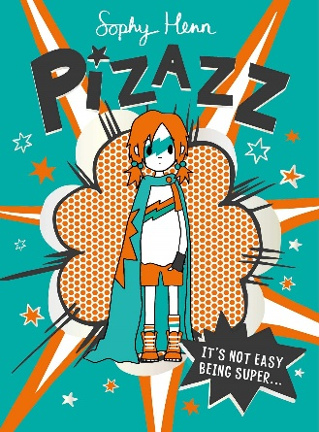 | 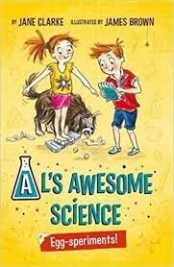 | 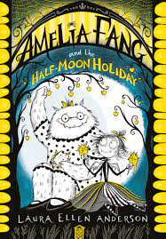
Pizazz  Sophy Henn | Al’s Awesome Science: Egg-speriments!  Jane Clarke & James Brown | Amelia Fang and the Half-Moon Holiday  Laura Ellen Anderson

Fiction [8 – 10 years]
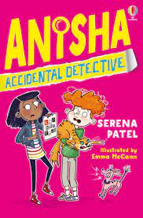 | 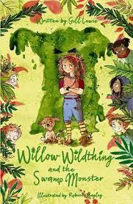 | 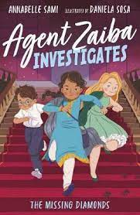
Anisha: Accidental Detective  Serena Patel & Emma McCann | Willow Wildthing and the Swamp Monster  Gill Lewis & Rebecca Bagley | Agent Zaiba Investigates: The Missing Diamonds  Annabelle Sami & Daniela Sosa

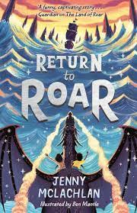 | 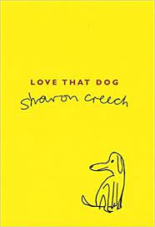 | 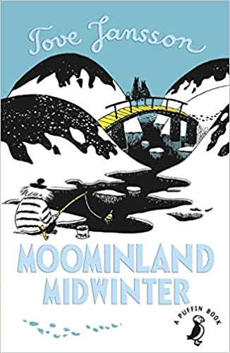
Return to Roar  Jenny McLachlan & Ben Mantle | Love that Dog  Sharon Creech | Moominland Midwinter  Tove Jansson
Fiction [10 – 12 years]
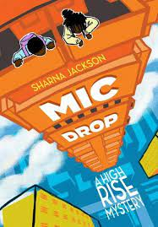 | 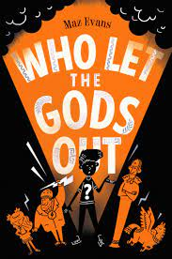 | 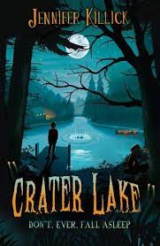
Mic Drop: A High Rise Mystery  Sharna Jackson | Who Let the Gods Out  Maz Evans | Crater Lake  Jennifer Killick

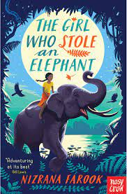 | 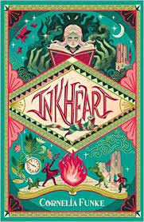 | 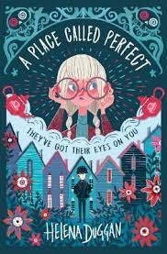
The Girl who Stole an Elephant  Nizrana Farook | Inkheart  Cornelia Funke | A Place Called Perfect  Helena Duggan

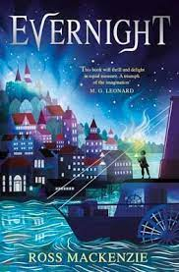 | 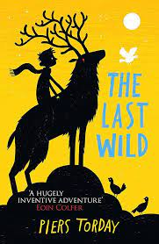 | 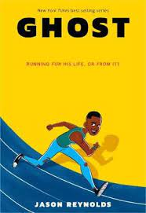
Evenight  Ross MacKenzie | The Last Wild  Piers Torday | Ghost  Jason Reynolds

