**Loss, Change and Grief for College Students with Care-Experience**

Glasgow Educational Psychology Service (GEPS) undertook participatory research in 2023, with students with care experience who attended City of Glasgow College and Clyde College. The research asked about the lived experience of the participants around loss, change and grief.

This paper examines the themes which emerged from the research, accompanied by quotes from the participants. The themes are presented in a mind map format, allowing a visual presentation of the key themes with sub themes. The accompanying quotes illustrate the themes in the participants’ own words.

**Method**

All Further Education colleges in Glasgow were contacted to gauge interest in participating in the research. Two colleges, City of Glasgow College and Glasgow Clyde College, agreed to take part.

An email outlining the research, along with an information sheet, was sent to the Student Support team at City of Glasgow College and the Student Information and Welfare Team at Glasgow Clyde College, both of whom name supporting learners with care-experience as part of their remit. Both teams distributed the information sheet to all current students with care-experience. Eight students responded and took part in the research.

The GEPS ethics protocol was followed, ensuring participants were kept informed throughout their involvement in the research.

The research set out to explore loss in its widest sense for children and young people with care experience. The questions were open-ended allowing the respondents to share their own unique experiences around loss.

Individual meetings between the participants and a GEPS researcher were held on TEAMS. Consent was gathered before conducting a semi-structured interview. Interviews took approximately 30 minutes. The six questions were as follows:

* What was it that interested you/made you want to come along today?
* What does the word loss mean to you?
* Would you be happy to share some examples of any experiences of loss?
* Would you be ok to speak about what impact these experiences had on you or continue to have?
* What were your experiences of support? If so, what was helpful about this support and what was less helpful?
* Do you have any ideas/suggestions for support that could be offered to other young people with care experience who have experienced loss? What would you like schools/colleges/education staff to know/understand?

**Results**

**Reasons for Participating**

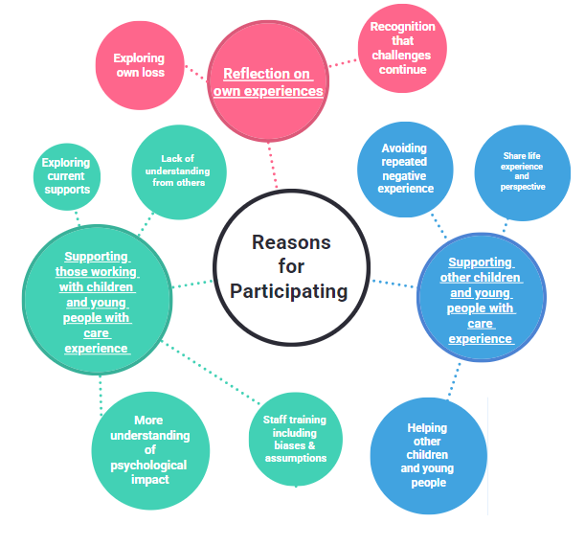

The reasons given by the participants for taking part were primarily around a desire to change things for other young people with care experience coming through the care and education systems. Participants also shared that they wanted to explore, understand and process their own experiences.

*‘I like to think my words and experiences in care could help to change things for those in the system now’*

*‘It’s maybe a bit of a kind of research for myself….just to kind of help process it and figure it out for myself’*

**Experiences of Loss**

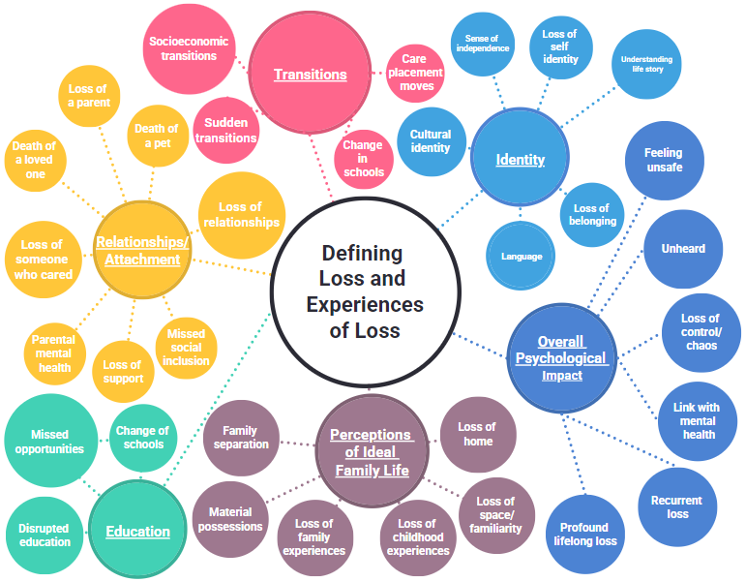

*‘I mean we’re talking about loss and this sort of thing… but I’ve always been lost. I’ve always been lost. I don’t know who I am. I lost my identity many years ago’*

*‘I still have this constant anxiety of… I can lose everything at any given moment…and I know logically that’s not the case, but it still feels like that in my body’*

Participants were initially asked**: What does loss mean to you?** and **Would you be happy to share some examples of any experiences of loss?**

The mind map above shows the breadth and scope of the loss participants experienced. The responses were grouped under the themes **of overall psychological impact, identity, perceptions of ideal family life, relationships and attachment, education and transitions**. Each of these themes will be further illustrated below.

**Overall Psychological Impact**

‘For a child in care, the losses are concurrent and cascading, and the grief is always complicated’(Office of the Children’s Advocate, 2016).The impact of loss and grief for our children and young people with care experience should not be underestimated. Participants told us that this had a marked effect on their lives as they moved into and through adulthood.

*‘It was something I could never talk about with social workers’*

*‘Definitely someone should have looked into what was going on with me at the time. I was having panic attacks as I entered school. No one bothered to look into why that was happening’*

For children and young people with care experience, the recurring, multiple and cumulative experiences of loss can lead to chronic sorrow, affecting their behaviour and ability to life their live to their full potential.

Chronic sorrow can be defined as ‘*the periodic recurrence of permanent, pervasive sadness or other grief related feelings associated with a significant loss’* (Eakes, Burke and Harris, 1998). Our research highlights the compounding psychological impact recurring experiences of loss can have. The complexity of this was illustrated through participants reporting that they felt **unsafe and unheard**, with an associated **loss of control** over their lives. The participants also highlighted the impact of this on their **mental health** and a sense of **profound life-long recurrent loss.**

*‘I’ve been struggling with my mental health till this day...there’s something wrong with me...it all feels a bit hopeless’*

Children and young people with care experience may not know when they will see their family next, how long they will stay in their current care setting, what adults are going to be in their life and what school they are going to attend and for how long. These types of losses, which are difficult to define, create more complicated grief responses. Those losses which lack such a sense of closure or a clear understanding of the loss can be understood as ambiguous losses.

*‘I lost my sense of self and my control over a lot of areas in my life’*

***Identity Losses***

Children develop their identity over time, shaped by their experiences and environment. Entering care, and the traumatic experiences which precede entering care, disrupt children’s developing sense of identity. This is frequently compounded by the material losses and frequent changes in a child’s life which make it difficult for them to build up a coherent sense of their life story.

The research highlighted the experience of loss of identity through a loss of customs, values and characteristics associated with some of the participants’ **culture and family background**. It also highlighted losses of a **sense of independence, self-identity, understanding of their life story** and **belonging and language.**

It is vital that we recognise these losses and support our children and young people with care experience in developing a positive sense of identity as this a key protective factor in wellbeing and positive mental health.

As Colebridge et al (2017) quoted in their research with female care-leavers, ‘*You’re constantly being moved your sense of self changes because you’re just sort attaching yourself on to whoever you’re living with . . . you’re there trying on loads of different personalities . . . you try so hard to fit yourself into these sort of social groups or even sort of boxes …’*

*‘I don’t really see that loss being talked about… it’s not just a loss of self-identity, it’s a loss of cultural identity and almost being made to feel like I was othered… all the time’*

*‘I had to lose my accent…the way I ate…I had to lose all of that’*

***Perceptions of Ideal Family Life***

The losses associated with what is perceived as a normal family life were profoundly felt by the participants. Key subthemes that emerged from the interviews included **family separation**, **loss of family and childhood experiences**, **loss of space and familiarity** and **loss of home.**

*‘They got all that extra time when we were younger and that… they got to do all the family activities, have dinner every night, have conversations, things like that, I never got that… the only time I got that was when I was home for the holidays’*

*‘I just lost it all. I went from a safe environment to a nightmare – that just totally threw me completely. I thought this was going to be my place to live till I grew up and made a life for myself. That never happened’*

*‘I’ve always felt I’ve missed out on something … there’s a space in here … it’s just empty because I never had the father figure to show me right and wrong sort of thing, to guide my life sort of thing’*

*‘I had 6 moves in the space of two years so I never had a settled home during that time”*

A key area shared by the participants was **material losses.** Children and young people with care experience may have had to leave behind personal belongings, things may get lost during placement transitions, or adults may not realise the significance of certain items that are precious to the child. Children and young people with care experience therefore may not have the photographs and mementos of childhood that contribute to our sense of belonging and allow us to build up a coherent narrative of their life.

*‘Even just acknowledge… if one of the social workers just sat down with me and said ‘I’m so sorry you’ve lost all your things’*

***Relationships/Attachment***

Relationships and attachments were a consistent theme throughout all of the interviews. Key aspects of this included **loss of relationships, loss of a parent or someone who cared, death of a loved one or a pet, loss of support** and **poor parental mental health.** Loss was not only associated with loss of birth family relationships, but also loss of those relationships made in foster families and other care placements.

*‘I didn’t know my mother, I didn’t know my father…until a strange woman turned up and said ‘I’m taking you home’. That was a loss for me because I was secure there…that was my home. I felt loved, I felt like I was in a safe place but that didn’t happen when I went to stay with my mum’* (GEPS, 2023)

*‘That upheaval was hard. Leaving the pet dog. We had a greyhound there. Every morning there we would go out and feed the horses and it was hard to leave that’* (GEPS, 2023)

***Loss and Education***

Education was consistently discussed as an issue by all participants. **Disruptions to their education,** **missed opportunities** and **changes of schools** were some of the issues discussed.

*‘A lot of my potential got lost at school cos I wasn’t coping’*

*‘My school days were so disrupted. I barely had a full day at school’*

*‘For me in terms of education…..I’ve never felt any sort of understanding of my background’*

*‘It was like, you still need to get your school work, still need to do this and do that, this is still expected of you kind of thing and that…’*

*‘A lot of my potential got lost at school cos I wasn’t coping. If I felt off, I would disrupt the class. I would get up and leave and run about’*

***Transitions***

The multiple and complicated losses associated with being care experienced can make transitions very challenging. We found that many participants had experienced ambiguous loss (Boss, 1999). Boss and Yeats (2014) capture ambiguous loss as an ‘unclear loss that continues without resolution or closure’ during points of transition, for example, where there was uncertainty around where **young people would be living** and **where they would attend school.** Participants shared that transitions were often **sudden** and therefore unplanned.

*‘Someone in care going into their own is a bit of a transition – lots of loss, trying to start again, lost what they knew… having to deal with everything on their own… lost safe space’*

*‘I think there was an absence of support when I was younger… I think we got lost a bit because we were moving so much…’*

*‘Right now in college, I wish I wouldn’t have to explain to my lecturers and teachers or my guidance teacher, like look at my records…’*

Transitions are particularly difficult and complex for children and young people with care experience as they may not have the opportunity to build up a strong support network of friends or family. Children and young people with care experience may have negative associations between transitions and loss, and may not be used to, or know how to ask for help and trust adults. Given that most of their focus may be on keeping themselves safe, there may be reduced capacity for problem solving and managing stress.

**The Impact of Experiences of Loss**

Participants were then asked: **Would you be okay to speak about the impact these experiences had on you or continue to have?**

Participants spoke about the impact under 3 main themes: **psychological impact, relationships and attachment** and **education**. The mind map above illustrates the extent of impact at the time and the ongoing impact on their lives currently.

***Psychological Impact***

The psychological impact of experiences of loss for children and young people with care experience was wide ranging and lifelong. Impacts ranged from **influencing behaviour** such as **drug and alcohol misuse** to **loss of identity** with examples of **feeling invisible** and a sense that **no one cared.**

*‘The loss of identity…..it’s weird saying that now because obviously we all have people saying we identify as……when people in care say that they don’t feel like them any more, it doesn’t necessarily mean that, it’s more their place in the world, they don’t know who they are. It’s not that they want to be someone else, they no longer know where they fit in society I think…..they feel ostracised’ (*

*‘It wasn’t like I had just lost my identity….I feel like I had lost my worth as a human’*

For young people of colour, there is an additional layer of complexity and trauma;

*‘Even with care experience…..there’s such a taboo with being a person of colour…..and having to live in white homes, being under the care of white people who take no consideration of their ethnic identity’*

***Relationships/Attachment***

The impact on relationships and attachment shared by participants was mostly around the impact on those relationships with immediate family. This included **feeling excluded from their family** and **different from their siblings.** Having **no attachment with their parent** and **a lack of a father figure** were also mentioned.

*‘I knew my father and I think … I’ve always thought there was something missing, that connection missing between the two of us. I have tried to find him. He’s gone from this earth somehow. I don’t know’*

***Education***

Struggles with education were widespread. Participants mentioned having a **disrupted education** with **changes of school** along with **not attending school**, **leaving school early** and ultimately, **not reaching their potential**.

*‘I definitely think I was wasting away potential at the time … I could have gone to uni or got a better job after school’*

*‘My school day was so disrupted. I barely had a full day in school. Even now I think I would struggle to hold down a full-time job’*

**Experiences of Support**

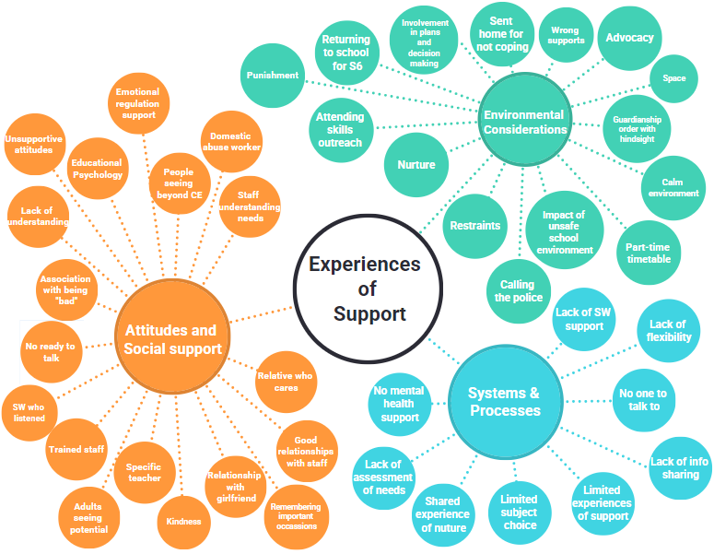

The participants’ experiences of support covered the themes of **attitudes and social support, environmental considerations** and **systems and processes**.

***Attitudes and Social Support***

Within this section there were areas of positivity. Most of these were because of an **individual relative, social worker,** or **teacher** had taken time to **get to know** the young person, who had **listened to them** and when necessary **advocated** for them. Participants spoke about the importance of adults who **saw beyond their care experience.**

*‘A social worker ……who really cared about me...she really listened to what I wanted. She was really there for me and not pushing what my mum was wanting’*

*‘I’ve got such a good relationship with my aunty…..the way feel loved by her is the way I’d want to be loved by my mum’*

*‘I’ve been to a lot of high schools…..so I’m thinking of a specific high school and a specific teacher…..I think that was the first time I’d cried in a year and a half….. I felt seen’*

*‘I’ve been lucky in life… there’s been a lot of good people in my corner who have seen who I really am and have gone above and beyond for me which I appreciate’*

Continuing bonds are important throughout life, and for those with care experience these are particularly significant. As documented above there can be many transitions with new beginnings and endings which can signify loss of relationships, loss of material things, loss of identity when leaving one family and joining another. Ensuring that there are continued bonds, can help in some part, to ameliorate those losses.

*‘Domestic abuse worker… he’s really sound, really understand and laid back… I’m still in touch with him now actually’*

*‘Mr X, he was my IT teacher and whenever I was having a really bad day or whatever I could always go to him and like his door was always open to every student no matter what you were going through in life. If ever I needed anything, he was the person’*

*‘It was just like that somebody was…went out their way to, not just listen to me…but just like actually take into consideration where I come from… and just do something nice’*

*‘They didn’t hold my experiences against me, they understood my problems and that’s where I started to speak about my feelings. Without them I don’t think I’d be here speaking about my feelings’*

*‘Maybe one of two (adults showed understanding of circumstances) but then again that may have been about the fact that they may have experienced the same kind of loss or …understood where I was coming from’*

Other participants experienced individuals with **unsupportive attitudes**, a **lack of understanding,** and an **association between care experience with being ‘bad’**.

*‘In schools I think there needs to be someone who understands what kids are going through. I almost feel like I got punished because I was in care’*

***Environment Considerations and Systems and Processes***

Most of the participants shared their experiences of being a pupil in school and their involvement with Social Work. The **inflexibility of some school systems** to provide a **safe environment** with the support that was needed at that time of their lives was a key feature. **Lack of supports** in general were discussed and more specifically**, mental health supports.** Participants spoke about **being sent home** or the **police being called in response to distressed behaviour.**

*‘One time the head teacher called the police on me and there was no real need for it. I wasn’t being violent, I was just running about and being me’*

*‘A regular check in for me would’ve been really helpful for me…. like someone to make sure there’s a bit structure and support there for me. No one ever explained why it would be good to work hard to get a job….people just assume that’s’ understood’*

*‘Lunch club was not what I needed…..the whole system is rubbish it’s not helpful at all…..it all feels a bit hopeless’*

**Conclusion**

This research illustrates the extent and complexity of loss experienced by children and young people with care experience.

Many of these experiences illustrate non-finite or living losses, which are enduring and often involve the loss of hopes and dreams ([Schultz & Harris, 2011](https://connect.springerpub.com/highwire_display/entity_view/node/116727/content_details#bid_8_29)).

*‘The biggest impact I’d probably say is … I still feel like I’m in limbo … I feel like I’m gonna lose everything at any minute’*

People experiencing non-finite loss are expected to adjust and accommodate to the loss over and over again. However, as participants have described, non-finite loss is often not well understood and individuals can often be expected to cope without acknowledgement of the difficulties or adequate support to manage the loss and grief experienced. This highlights the ongoing need for education and social work to be aware of, and to prioritise the needs of our young people with care experience.

Many of the quotes above have given examples of ambiguous loss, chronic sorrow and non-finite losses, which in turn often result in disenfranchised grief. Doka (1999) describes disenfranchised grief as *‘*a loss that is not, or cannot be, opening acknowledged, publicly mourned or socially supported’.

Most participants spoke positively about having a key trusted adult who recognised and understood their loss:

*‘I think he has almost taken a father role to me … He was like, you said you were going to do this (go into further education study’ and you can do this, so why aren’t you doing it? So that was the nudge I kind of needed’* (GEPS, 2023

**Next steps**

Next steps include sharing this summary with the participants and their colleges. It will also be added as an appendix to the *Whole School Approach to Loss and Bereavement guidelines,* with an expectation that Glasgow establishments will be more aware of the extent and complexity of loss that can be felt by young people with care experience, as well as the key supports they identify*.*

A Doodly which shows the key themes shared above in video format can also be found [here.](https://youtu.be/rD6QMhFIB4I)

The research team would like to convey their thanks and appreciation to the participants who contributed to this research.

**References**

Boss, P. (1999). *Ambiguous loss.* Cambridge, MA: Harvard University Press.

Boss, P. & Yeats, J.R. (2014). *Ambiguous loss: a complicated type of grief when loved ones disappear.* Cruise Bereavement Care.

Colebridge, A. K., Hassett, A. & Sisley, E. (2017). “Who am I?” How female care leavers construct and make sense of their identity. *SAGE Open* 7(1).

Doka, K.J. (1999). Disenfranchised grief. *Bereavement Care*, 18(3): 37-39.

Eakes, G. G., Burke, M.L., Hainsworth, M. A. (1998). Middle-range theory of chronic sorrow. *The Journal of Nursing Scholarship,* 30(2):179-84.

Glasgow Educational Psychology Service (2023) *Loss Change and Grief in Young People with Care Experience*

Office of the Children’s Advocate, Manitoba. (2016) *Don’t call me resilient: What loss and grief look like for children and youth in care.* Office of the Children’s Advocate, Manitoba.

Schultz, C. L., & Harris, D. L. (2011). Giving voice to nonfinite loss and grief in bereavement. In R. Neimeyer, D. Harris, H. Winokuer, & G. Thornton (Eds.), *Grief and bereavement in contemporary society: Bridging research and practice* (pp. 235–245). New York, NY: Routledge.