Glasgow Educational Psychology Service Consent Form for Parents and Carers
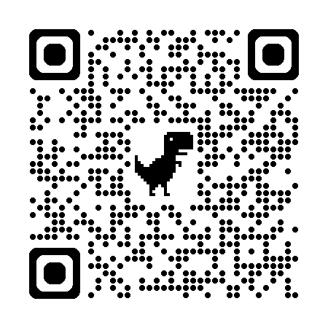
Glasgow Educational Psychology Service (GEPS) works to support inclusion of children and young people. More details about how we work can be found on our webpage or by watching our information video by scanning this QR code.

An Educational Psychologist can work in different ways, using different approaches in their role. This might look like meeting with adults who know your child or at times may involve more direct work, like observation or meeting with your child. This will be decided at the meeting.

To provide a psychological service, we ask parents/carers, children/young people, and other professionals in Glasgow City Council and other agencies (NHS; Social Work; voluntary agencies; other local authorities) for information about the child/young person including:
- Name, date of birth and address of the child/young person; and names and details of family contacts.
- Identifying additional support needs
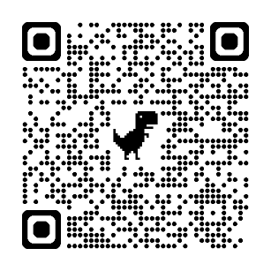
- Information about health and wellbeing

This information is kept electronically in our secure Glasgow City Council database. We will retain your information in line with legislative, council and nationally recognised retention periods. For more information, please see our privacy notice or scan this QR code.

Please sign to indicate that you give your consent for the Educational Psychology Service to become involved with your child and gather the data specified above.
Name of child _____________________________________________________
Your name (please print) ______________________________________________________
Your signature ______________________________________________________
Date ______________________________________________________

You can withdraw your consent at any time by contacting GEPS and we will end our involvement. Your child’s information will still be kept in line with the process above.

