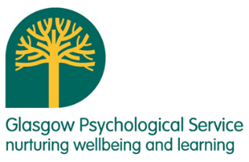****

*“The sessions and discussions have given me confidence in my own practice.”*

*“A safe and inclusive environment that enables us to share individual experiences.”*

*“Talking with colleagues and sharing good practise with the guidance of the course leaders has been very valuable.”*

When?

All sessions will take place between **3:30-5pm** on the following dates:

## 1. Tuesday 7th October 2025

## 2. Tuesday 4th November 2025

## 3. Tuesday 2nd December 2025

## 4. Tuesday 3rd February 2026

## 5. Tuesday 3rd March 2026

## 6. Tuesday 12th May 2026

Where?

GEPS (NW), Knightswood Secondary School, 60 Knightswood Road, Glasgow, G13 2XD

How?

Please book your place on your Area (NE, NW, South) Group via **CPD Manager** using your **GLOW** email **address**

Please sign up using your **GLOW email address** .

For further information please contact:

Sharon Fitzpatrick (Educational Psychologist)

Glasgow Educational Psychology Service

0141 276 2070

Sharon.Fitzpatrick@glasgow.gov.uk

The group provides a forum to:

Reduce barriers and support the needs of children in your class/ establishment

Increase awareness of universal and targeted support

Increase awareness of information and approaches which support inclusive education

Consider how to promote a communication supportive environment

Discuss case-related issues with colleagues from other Primary establishments, GEPS and SLT

Implement supportive strategies and reflect on their success

Explore frameworks and resources to support staged intervention planning

**Primary (North West)** **2025-26** 2019/20

This is an opportunity for Primary school staff to share good practice and increase awareness of approaches which support inclusion.

The sessions are facilitated by representatives from Glasgow Educational Psychology Service (GEPS) and Speech and Language Therapy Service (SLT).

It is recommended that participants attend **all** sixsessions and that there are structures in place to support sharing of their learning with colleagues in their respective establishments.

Places are limited to **two** members of staff per establishment.

**Inclusion support and development GrouP**