Emotionally Based School Non-Attendance (EBSNA)
Career Long Professional Learning Framework
Information for Schools


What is EBSNA?

EBSNA is an overarching term used to describe children and young people who have a profile of additional support needs which includes a difficulty in engaging with and/or attending school. This difficulty is often due to wide ranging factors which can include anxiety, issues related to Autism and neurodevelopmental profiles of need and other mental health presentations.

What is Glasgow’s EBSNA CLPL Framework?

Glasgow’s EBSNA CLPL framework aims to support both primary and secondary schools to develop their knowledge, understanding and confidence in relation to responding to EBSNA. Each practitioner will have an opportunity to network and share good practice which will allow them to apply their learning within their own context, both at a whole school and individual practice level.
Who is the CLPL for?
The CLPL framework can be accessed by colleagues who fulfil a diverse range of remits which involves supporting CYP and their families who experience EBSNA. Who engages with the training framework will depend on the mode of delivery chosen and will be at the discretion of the individual establishment. Establishments engaging with the framework are encouraged to identify a lead practitioner who will support ongoing implementation. In addition, it is helpful to have a wider implementation team from within individual establishments or across a learning community.
What does the CLPL framework involve?
The CLPL framework is made up of 3 core workshops which aim to provide a detailed overview of EBSNA and how to respond effectively, each workshop is roughly 90-120 minutes in length. Following the completion of 3 core workshops, schools will have access to a range of supplementary workshops which focus on more specific topics in relation to understanding and responding to EBSNA effectively. Practitioners can choose to engage with supplementary workshops to meet the needs of CYP within their establishments.
Are there different models of delivery?
The CLPL framework aims to be as flexible as possible to meet the needs of individual practitioners, their establishments and wider learning communities. For example, schools can choose to engage with the CLPL framework as an individual establishment or delivery can be considered across a whole learning community involving key members of staff being identified to attend each workshop from across the primary and secondary school sector. When engaging with the framework as a learning community it will be important to consider how learning will be disseminated following each workshop.
Anxiety, Risk/ Resilience and EBSNA
Workshop 1 aims to introduce EBSNA highlighting the relevance of discussing this topic in relation to understanding and responding to anxiety. Early intervention is emphasised along with the identification of risk and resilience factors related to EBSNA. Aligned to early intervention, a range of strategies to respond to anxiety are included.
Information Gathering and Analysis
Workshop 2 aims to introduce how those working with CYP who experience EBSNA can effectively gather assessment information to inform planning, this includes an overview of the importance of analysis within this process. Content is aligned to the national and local policy, including GIRFEC and staged intervention. The importance of stakeholder voice is emphasised and explored.
Intervention and Planning
Workshop 3 aims to support those working with CYP who experience EBSNA to effectively develop action plans in response to need. Suggested interventions are based on good practice examples informed by research and literature. The role of wider services within this process is introduced.

- Speech, Language and Communication Differences and EBSNA
- Parent/Carer Engagement and EBSNA
- Solution Oriented Practice and EBSNA

Evaluation of Impact and Outcomes
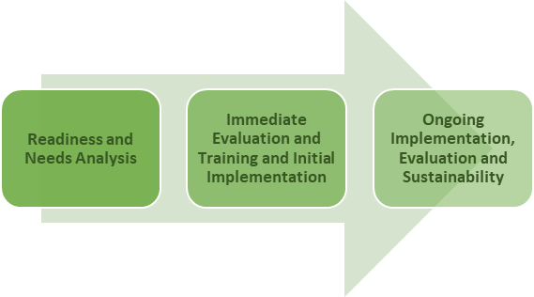
How can I access Glasgow’s EBSNA CLPL Framework?
For more information, please contact Alison White (Educational Psychologist) or the link Educational Psychologist for your establishment.
Alison.white@education.glasgow.gov.uk

