A guide to

Goal Attainment Scaling

Goal Attainment Scaling is a 5-point scale
which can be used to
evaluate progress towards educational goals.

-2 | Baseline
-1 | Less than expected outcome
0 | Expected outcome
1 | More than expected outcome
2 | Much more than expected outcome

Step 1: Prioritise and establish goals
- Prioritise a maximum of 3 words to focus on
- Goals should be positively worded and Specific, Measurable, Achievable, Realistic and Time-limited
- Keep in mind the principle "Small changes can lead to bigger changes" when setting realistic goals

Step 2: Set baseline descriptor
- The baseline descriptor is where you are now in relation to the goal
- An accurate description of the baseline descriptor is important to ensuring change can be effectively evaluated
- This constitutes '-2' on the scale

Step 3: Set your expected outcome
- Your expected outcome is what you expect to achieve following a determined period of intervention
- This ensures that everyone has a realistic expectation and shared understanding of what is hoped to be achieved
- This constitutes '0' on the scale

Step 4: Outline remaining elements of the scale
- This ensures shared understanding of expected and possible outcomes
- Now that we know what we want to achieve and where we are now, what would -1, +1 and +2 on the scale look like?

Step 5: Evaluate outcome
- Use pre-determined scaling to identify what has been achieved following intervention
- Has the intervention been effective?
- Keep in mind the principle "If it works do more of it; if it doesn’t work, try something else" to determine next steps
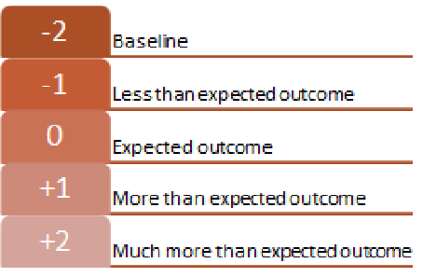

An example

-2 | Baseline
-1 | Less than expected outcome
0 | Expected outcome
1 | More than expected outcome
2 | Much more than expected outcome

Jamie will attend school 2/5 afternoons per week
Jamie will attend school 3/5 afternoons per week
Jamie will attend school 3/5 afternoons per week & 1 morning
Jamie will attend school 3/5 afternoons per week & 2 mornings
Jamie will attend school 3/5 afternoons per week & 3 mornings

