Solution Circles
The solution circle approach aims to help staff discuss issues as a group. This assumes and demonstrates that people within the establishment have the capacity to help. It is a flexible tool which encourages participants to maintain a positive, creative approach to problem-solving and generates strategies to problems and concerns.

Find your circle
Ideally you want 6 to 8 people in your circle.
Appoint a timekeeper and a scribe.

Problem talk

The presenter has 6 minutes to talk about their concerns, without interruption.

Clarifying questions
For the next 6 minutes, the circle can ask follow-up questions for further clarification or information.

Generate solutions
The circle should make suggestions about what to do next - these can be as creative as you like!

Plan

The presenter chooses one suggestion to try, and one circle volunteer agrees to follow up with them in a week.

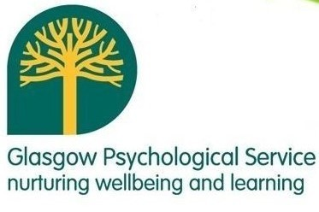

Glasgow Educational Psychology Service

