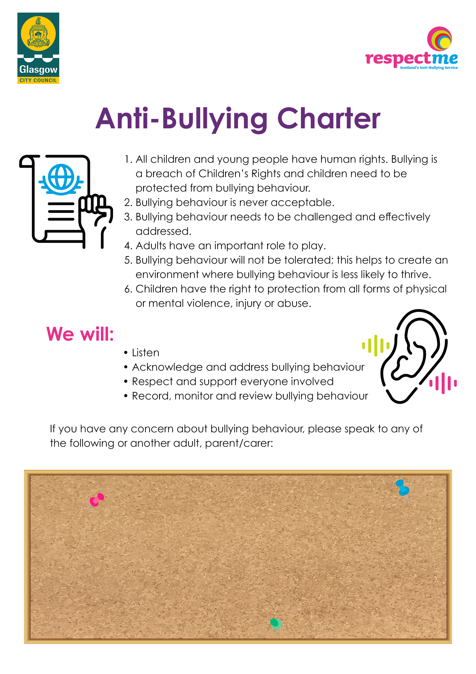
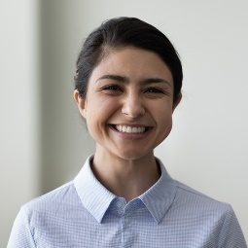
Deputy Head Teacher
Deputy Head Teacher
PT Pastoral Care
PT Pastoral Care
Head Teacher
Instructions:
- Profile images:
  - Please crop the profile image that you want to use into a perfect square shape. To do this, please follow these instructions:
    - Right click on image file and select ‘Edit with Paint 3D’.
    - Click on ‘Crop’ in the top left-hand corner:
    - Choose 1:1 framing in the top right selection panel:
      - 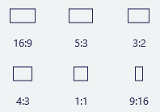
    - Move the framing box around until you are happy with the positioning. You can also drag the circles around the image, if you would like to focus in on the picture.
      - 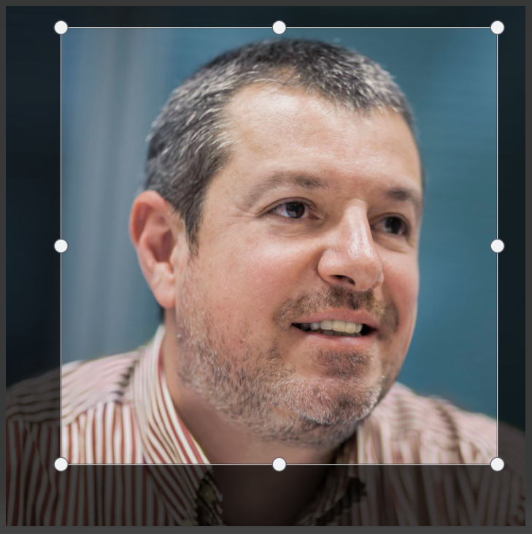
    - Once happy with your changes, click on ‘Done’ in the right-hand panel:
      - 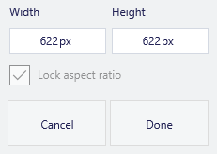
    - Go to ‘Menu’ in the top left-hand corner, select ‘Save as’ and then ‘Image’:
    - Save the image.
  - To replace a profile image, please right click on the image that you want to change, select ‘Change picture’ > ‘From a file’. Choose the square profile picture that you would like to use and click ‘Insert’.
- Text title:
  - The title of the teacher is a simple text box, so simply select inside the text box and update the text.

